**Amanox AWS Cloudformation Workshop**

**Powered by Amanox**

Lab Guide

Using



|  |  |
| --- | --- |
| Authors: | David Horvath |
|  | John Guentensperger |
|  | Istvan Kappelmayer |

Contents

1. Starting Small Lab 3

1.1 Common Lab Info 3

1.2 AWS Login 3

2. Part 1: Creating a Virtual Private Cloud Stack 4

2.1 Introduction 4

2.2 Learning Goals 4

2.3 Duration 4

3. Part 1 - Task 1: Upload a CloudFormation template 5

3.1 Introduction 5

3.2 Learning Goals 5

3.3 Task Instructions 6

3.4 Summary 10

4. Part 1 - Task 2: Create RDS 11

4.1 Introduction 11

4.2 Learning Goals 11

4.3 Duration 11

4.4 Task Instructions 12

4.4.1 Store the VPC template in an S3 Bucket preparing for reuse 12

4.4.2 Create an RDS template 13

4.4.3 Create your stack based on your new template 17

4.5 Summary 17

5. Part 2 – A stripped-down Drupal deployment 18

5.1 Introduction 18

5.2 Learning Goals 19

5.3 Duration 19

5.4 Task Instructions 19

5.4.1 Store the VPC template structure in an S3 Bucket 19

5.4.2 Generate the stack from Amazon S3 URL 21

5.5 Summary 24

6. Part 3: Add Elasticache to the previous drupal stack 25

6.1 Introduction 25

6.2 Learning Goals 25

6.3 Instructions 26

6.3.1 Look at the change 26

6.3.2 Update the S3 bucket 26

6.3.3 Update the stack 26

6.4 Summary 28

7. Conclusion 29

# Starting Small Lab

This lab shows you how to start out with AWS CloudFormation.

In this lab you will:

* see CloudFormation in action making use of a ready-made open-source CloudFormation Stack File producing network components of a VPC.
* reuse this template and deploy an RDS database inside your VCP

## Common Lab Info

You will find several red X markers in the lab guide. You will have to replace this X with a new value based on your name. Please follow this example: for **Mi**ke **Mo**sses,X = MiMo.

All snippets and results are served using this git repo: <https://github.com/amanoxsolutions/cloudformation-lab>

## AWS Login

Your e-mail address, unless specified otherwise by the Public Cloud Team

In the top-right corner of the AWS Management Console, choose the region you are going to work in. We are going to use ***Europe (Frankfurt) eu-central-1***.

# Part 1: Creating a Virtual Private Cloud Stack

## Introduction

Services provided by AWS can be daunting at first. The learning curve is steep. Once you learned the tidbits of a service a new kind of problem arises: mundane repetitive tasks. This is where CloudFormation shines, taking away some burden making it easier to reuse commonly applicable building blocks. With the Infrastructure as Code approach people can share their take on configuration just like any other open-source developer would do.

You will deploy a CloudFormation Stack configuration and see:

• A CloudFormation template

• Configuration parameters GUI

• Usable outputs

## Learning Goals

You are going to learn how to create a stack from an on-the-fly uploaded template file and how to compose complex structures nesting template inside template. You will learn how to use outputs from the generated stack as input for a consumer stack.

## Duration

This task requires approximately **20 minutes** to complete.

# Part 1 - Task 1: Upload a CloudFormation template

## Introduction

You will begin by downloading a template for an Amazon Virtual Private Cloud (VPC).

A template file provides full description for CloudFormation of the resources it will produce for you including input parameters, rules for them, interdependencies and outputs.

## Learning Goals

The goal is to familiarize yourself with the creation steps of a CloudFormation Stack. Then you will update it changing its parameters, finally clean up and dispose the resources. We will work with a ready-made big template, but no worries. In a real-world scenario it is also unlikely you can understand every internals of a third-party before it changes again. We will showcase how CloudFormation takes your parameters, produces resources and gives its outputs for further reuse.

## Task Instructions

* Download this template which we took directly from the official quickstart-aws-vpc github repo: <https://github.com/amanoxsolutions/cloudformation-lab/blob/master/part1/aws-vpc.template.yaml>
  1. You can either clone the whole repo as mentioned at the beginning
  2. Or at the top right of the above url right-click “Raw” button and save the file as **aws-vpc.template.yaml**.

The template is huge. You can have a look into it, but do not feel intimidated by it. The goal is not to understand everything inside, rather to get acquainted how the CloudFormation UI works for you based on your templates.

In the top-right corner of the AWS Management Console, make sure you are using the right region intended for this workshop.

* In the AWS Management Console, on the ***Services*** menu, search for ***CloudFormation***.

The CloudFormation console offers a wizard where you can create, update and destroy your infrastructure or application as stacks.

* In the right navigation pane, click ***Create stack***.

A wizard is shown. On top leave **Template is ready** selected, and specify your template you just downloaded via the **Upload a template file** option it.

* Then click **View in Designer.**

You will be presented with an auto-generated overview of the resources CloudFormation is about to generate. The Designer is very powerful for visualizing the connections between the components based on the template file.

* Click any of the components and notice that the editor will highlight the corresponding declaration.

* Using the Cloud icon top right, return to the Create stack menu:  
  Graphical user interface, application

  Description automatically generated
* Click **Next** to specify stack details page

Name your stack VPC-Stack-X

Plenty of parameters are shown. Select exactly two **Availability Zones**.

You can configure any interesting other parameter if you’d like to.

On the bottom of the page click **next.**

* You land on the **Configure stack options** page.

There are two options to be highlighted here.

* **Permissions**: Here you can explicitly set what IAM role to be used during resource creation. For sake of simplicity we leave this as is, but in a more controlled environment you would have the possibility to prepare a template with your power-user rights and then test here how it would work for your restricted consumers.
* Stack creation options > **Rollback on failure:** more complex infrastructures fail frequently during experimentation. By default everything will be rolled back and the half-baked infra is destroyed. Instead of restarting everything from scratch you can **Disable** the “Rollback on failure option”, fix your error and update the stack to continue where you left off.

For now, we leave the defaults here as they are. At the bottom of the page click **next**.

* Review
* Once you have reviewed your planned stack, scroll down, **acknowledge** the implication of potentially creating IAM resources
* Click **Create stack**
* Watch as your resources get created.
* On the overview there are several tabs.

Examine **Events**, where you can see how subparts of the template get provisioned.

Everything on the **Resources** tab is from now on managed by this stack. Locate the VPC item and open its physical ID, you will land on the usual interface where you can inspect the details of the VPC.

* Wait for the stack to get ready in ca. 3 minutes.

On the **Outputs** tab you will find details about your resources and other produced values the template defined *once the stack creation has finished successfully*.

* Open again the Resources Tab.

Notice that there are as many Elastic Ips or Nat Gateways as many Availability Zones we specified (2). Let’s **Update** the stack to include a third one. On top click **Update**.



Here you could choose to edit your template in the designer on the fly. **Use current template** for now and click **next**.

Add the third Availability Zone and set the Number of Availability Zones to 3.

Note: Don’t forget to also set the Number of Availability Zones to 3.

Click **Next** and on the Configure stack options again **Next**. Acknowledge and **Update stack**.

Notice on the **Events** and **Resources** tabs that CloudFormation creates the extra resources leaving the existing ones in place. The Stack update takes ca. 3 minutes.

* Once you see the **UPDATE_COMPLETE** status of the Stack, on the top click **Delete** to remove the Stack and its associated resources.

## Summary

You now have played with a ready-made template, created a Stack based on it, updated it and finally destroyed it. The next step will be starting an RDS db reusing this VPC template but first let’s jump back to the presentation.

# Part 1 - Task 2: Create RDS

## Introduction

RDS is the Relational Database Service offering from AWS where the mainstream database engines are covered. AWS manages the tiresome updates, patching and scaling of your database instances offering durability, high availability and security for you while you can focus on creating more value. RDS is at the heart of many web applications, at the mercy of the agile nature of application changes so it is another great candidate to demonstrate the power of Infrastructure as Code.

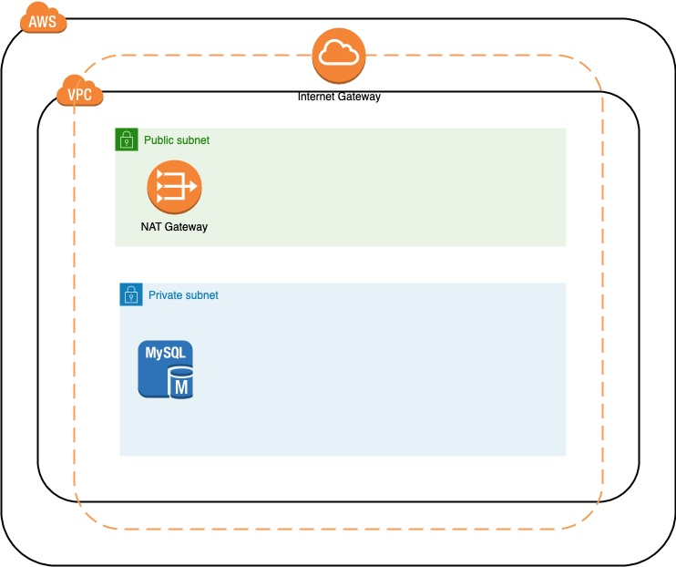

## Learning Goals

The goal is to learn and see the creation steps of an RDS instance started into a similar VPC reusing the template we have seen previously, creating a nested stack.

This task takes approximately 45 minutes. If you get stuck it is recommended to use the provided snippets, but please try to struggle through the task, try to also understand what you do, not just copy and paste.

## Duration

The preparation takes ca. 25 minutes, then 20 minutes stack creation.

## Task Instructions

### Store the VPC template in an S3 Bucket preparing for reuse

* In the AWS Management Console, on the ***Services*** menu, search for ***S3***.
* Click ***Create bucket*** and configure:
* Bucket name (all lower-case): cflab-part1-x

Make sure to NOT have any whitespace in the bucket name

* AWS Region: as specified at the beginning of this guide.
* Leave the other set of options as is.

At the bottom, click create bucket.

You can efficiently search for your bucket entering your X part to the filter field:

* Click the name of your new bucket
* **Upload** your aws-vpc.template.yaml file.
* Click the created object in the Name Column to open its details. You will need the **Object URL** later.

You can use the handy copy icon:

### Create an RDS template

* Create a new textfile named e.g. myrds.template.yaml and start editing it with your IDE of choice.

We will use several snippets to assemble our working db.

You can find the template Skeleton here: <https://docs.aws.amazon.com/AWSCloudFormation/latest/UserGuide/template-anatomy.html> Copy the YAML format into your new template.

Set the **AWSTemplateFormatVersion** to '2010-09-09'

Write a **Description**, e.g. 'db template'

You can remove the **Metadata**, **Rules, Mappings, Conditions, Transform, Outputs** sections

At the Resources section we add our DB. At the bottom of the **Amazon RDS template snippets** page we will make use of the section **Amazon RDS database instance in a VPC security group**’s YAML code: <https://docs.aws.amazon.com/AWSCloudFormation/latest/UserGuide/quickref-rds.html#w2ab1c27c21c76c15>

* Notice that (for YAML) you need to indent with 2 blank spaces the copied code to become a subsection of Resources.
* The **DBInstance**’s **VPCSecurityGroups** property refers to **!GetAtt DBEC2SecurityGroup.GroupId** which says basically “once **DBEC2SecurityGroup** exists, take it’s **GroupId** attribute”
* There are many other properties in the form **Ref: SomeParameter**. We will need to add these at the **Parameters** section as string values. The format can be found here: <https://docs.aws.amazon.com/AWSCloudFormation/latest/UserGuide/parameters-section-structure.html> For our purpose now, these all will be strings.

Parameters:

DBAllocatedStorage:

Type: String

Default: '20'

DBName:

Type: String

Default: MyDB

DBUser:

Type: String

Default: admin

DBPassword:

Type: String

NoEcho: 'True'

MaxLength: '41'

MinLength: '8'

DBClass:

Type: String

AllowedValues:

- db.t2.small

- db.t2.medium

- db.r3.large

- db.r3.xlarge

- db.r3.2xlarge

- db.r3.4xlarge

- db.r3.8xlarge

Default: db.t2.small

MultiAZDatabase:

Type: String

AllowedValues:

- 'true'

- 'false'

Default: 'true'

* Now let’s have a look at **DBEC2SecurityGroup**’s **SecurityGroupIngress** section, there is a reference pointing to **WebServerSecurityGroup**. This would be relevant if we configured some application working with the db, but for the purpose of this demo we can remove this property.

However, we want to launch our DB instance into a VPC, which will come from our existing VPC template, instantiated through a Stack resource: <https://docs.aws.amazon.com/AWSCloudFormation/latest/UserGuide/aws-properties-stack.html>

We recommend to name your stack resource VPCStack*.*

To create a stack resource, you need to specify the **TemplateURL** to be the same S3 url you noted at the beginning, e.g. https://cflab-part1-x.s3.eu-central-1.amazonaws.com/aws-vpc.template.yaml

As you can remember there are a lot of parameters for the VPC template available, however for the purpose of this lab we expose only few of them. We propagate these exposed parameters towards the vpc stack resource, omitting all the other vpc stack parameters, leaving them as default.

Parameters:

#...

VPCAvailabilityZones:

Description: 'List of Availability Zones to use for the subnets in the VPC'

Type: List<AWS::EC2::AvailabilityZone::Name>

VPCNumberOfAZs:

AllowedValues:

- '2'

- '3'

- '4'

Default: '2'

Description: Number of Availability Zones to use in the VPC

Type: String

Resources:

VPCStack:

Type: AWS::CloudFormation::Stack

Properties:

TemplateURL: "https://cflab-part1-x.s3.eu-central-1.amazonaws.com/aws-vpc.template.yaml"

# ^ TODO adjust your bucket url

Parameters:

AvailabilityZones: !Join

- ','

- !Ref 'VPCAvailabilityZones'

NumberOfAZs: !Ref 'VPCNumberOfAZs'

And that is it: we just “imported” our existing VPC template. We made some of it configurable for the consumers of our future template as well. We can now build onto the VPC.

* Now, according to <https://docs.amazonaws.cn/en_us/AmazonRDS/latest/UserGuide/USER_VPC.WorkingWithRDSInstanceinaVPC.html#USER_VPC.InstanceInVPC> let’s create a DB subnet group making use of our VPCStack’s output: <https://docs.aws.amazon.com/AWSCloudFormation/latest/UserGuide/aws-resource-rds-dbsubnet-group.html>

DBSubnetGroup:

Type: AWS::RDS::DBSubnetGroup

Properties:

DBSubnetGroupDescription: Subnets available for the DB Instance

SubnetIds:

- !GetAtt VPCStack.Outputs.PrivateSubnet1AID

- !GetAtt VPCStack.Outputs.PrivateSubnet2AID

* Then we need to adjust our Security Group for the DB. As mentioned, we don’t care for the SecurityGroupIngress for now, but have to attach to the VpcId:

DBEC2SecurityGroup:

Type: AWS::EC2::SecurityGroup

Properties:

GroupDescription: Security group for the DB

VpcId: !GetAtt VPCStack.Outputs.VPCID

* Finally we have to specify the **DBSubnetGroup** for the **DBInstance** using the **DBSubnetGroupName property**

DBInstance:

Type: AWS::RDS::DBInstance

Properties:

#...

VPCSecurityGroups:

- !GetAtt DBEC2SecurityGroup.GroupId

DBSubnetGroupName: !Ref DBSubnetGroup

### Create your stack based on your new template

In AWS Console go to the **CloudFormation** Service and chose **Create stack**.

Similarly to the earlier example, click **Upload a template file** andupload your newly created template yaml file. Click **Next.**

**Note: the VPC will be created based on the template you have uploaded to the S3 bucket. Make sure, the Bucket URL is correct in the yml file.**

Name your stack rds-X and take care of the following parameters:

* DBPassword
* Select exactly two VPCAvailabilityZones
* Leave VPCNumberOfAZs as the default 2

Click **Next.**

At the Stack creation options it is now strongly recommended to **Disable Rollback on failure** to spare some time in case of failures. Click **Next.**

On the next page **Acknowledge** everything and **Create Stack**

Notice how the process instantiates first the nested VPCStack and once it is up will be the dbinstance configured.

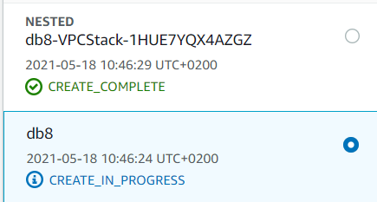

Once it gets to the db creation, it takes relatively long. If you don’t see any failure once the VPC Stack is ready, congratulation. The whole stack takes ca. 21 minutes.

If you get stuck with too many failures, feel free to take a look at the fully working example:

<https://github.com/amanoxsolutions/cloudformation-lab/blob/master/part1/myrds.template.yaml>

Once ready, delete all your stacks.

## Summary

Now you have seen a nested stack in action. Let’s return to the presentation.

# Part 2 – A stripped-down Drupal deployment

## Introduction

There is a full-fledged template-set reference deployment on aws for **Drupal on AWS** here: <https://aws.amazon.com/quickstart/architecture/drupal/>

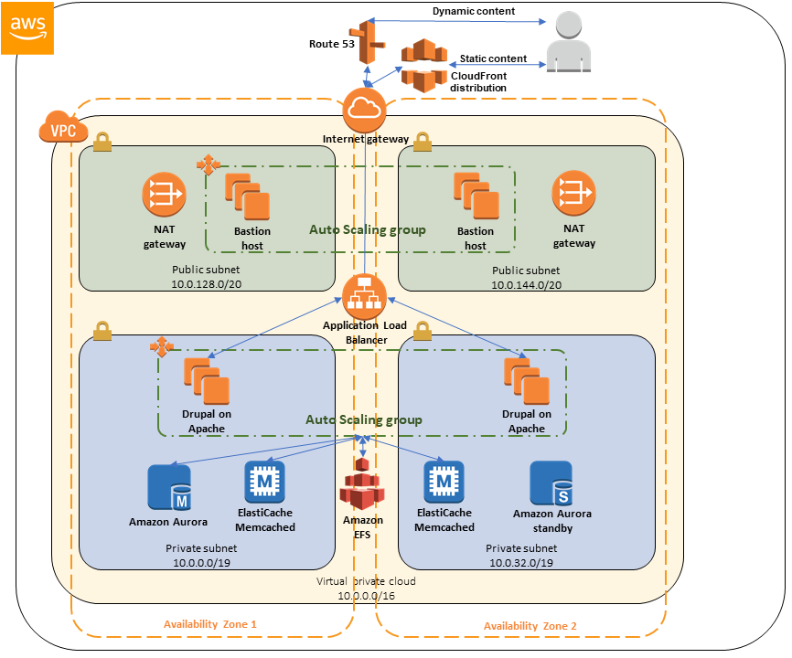

Drupal is a CMS which is strongly depending on a real domain name. To avoid having to work with own domains, we tweaked a little with the config, dropping the *Route 53* zone. For the purpose of this demo we also don’t need *CloudFront* or any *bastion* host. We use the dns name implicitly provided by the Application Load Balancer:

## Learning Goals

The goal is to see a bigger set of resources composed from well-rounded stack templates deployed using S3 bucket.

## Duration

The preparation takes ca. 20 minutes. The whole stack creation takes ca. 30 minutes.

## Task Instructions

We will work with the template structure from the git repo’s following folder:

<https://github.com/amanoxsolutions/cloudformation-lab/tree/master/part2/quickstart-drupal>

There is a master-template where everything can be configured, and it nests other stacks to produce the drupal-stack:

### Store the VPC template structure in an S3 Bucket

* In the AWS Management Console, on the ***Services*** menu, search for ***S3***.
* Click ***Create bucket*** and configure:
* Bucket name: cflab-part2-X

Make sure to NOT have any whitespace in the bucket name

* AWS Region: as specified at the beginning of this guide.
* Leave the other set of options as is.

At the bottom, click create bucket.

* Create the same folder structure in S3 as in the part2 git folder:

<https://github.com/amanoxsolutions/cloudformation-lab/tree/master/part2>

It is important to have the same structure, meaning the top-most folder in the bucket should be named quickstart-drupal.

The desired structure:

quickstart-drupal

├───submodules

│ └───quickstart-aws-vpc

│ └───templates

│ aws-vpc.template.yaml

│

└───templates

create-ami.template.yaml

drupal-master.template.yaml

drupal.template.yaml

rdsaurora.template.yaml

securitygroups.template.yaml

webserver.template.yaml

Open the whole part2 directory with your IDE. Locate some or all of the **AWS::CloudFormation::Stack** code fragments using your local IDE.

You will see a pattern like the following. Notice how the TemplateURL combines 4 parameters resulting in the TemplateURL property for a Stack. This is a good practice to make one’s template really reusable and independent from regions.

SecurityGroupsStack:

Type: AWS::CloudFormation::Stack

Properties:

TemplateURL:

!Sub

- 'https://${S3Bucket}.s3.${S3Region}.${AWS::URLSuffix}/${QSS3KeyPrefix}templates/securitygroups.template.yaml'

- S3Region: !If [UsingDefaultBucket, !Ref 'AWS::Region', !Ref QSS3BucketRegion]

S3Bucket: !If [UsingDefaultBucket, !Sub '${QSS3BucketName}-${AWS::Region}', !Ref QSS3BucketName]

Parameters:

VPC: !Ref 'VPCID'

VPCCIDR: !Ref 'VPCCIDR'

### Generate the stack from Amazon S3 URL

Copy the master template url from S3 clicking onto the Object and locating the **Object URL**. It should look like the following:

https://cflab-part2-x.s3.eu-central-1.amazonaws.com/quickstart-drupal/templates/drupal-master.template.yaml

Go to the **CloudFormation** Service and create a stack:

* Click the created object in the Name Column to open its details. You will need the **Object URL** later.
* Name your stack drupal-X
* Fill in the following parameters carefully:

|  |  |  |
| --- | --- | --- |
| availability zones | eu-central-1a, eu-central-1b |  |
| database admin password | dbadminpw | At your discretion, min 8 chars |
| drupal site admin email | Your mail |  |
| drupal site admin password | siteadminpw | At your discretion, min 8 chars |
| drupal database password | databasepw | At your discretion, min 8 chars |
| autoscaling notification email | Your mail |  |
| quick start s3 bucket name | cflab-part2-x | This one is really really important |

* Click **Next**
* At **Stack creation options**, **Disable** **Rollback on failure** as this stack takes average 30 minutes to deploy.
* Click **Next**
* **Acknowledge** all, **Create stack**

The stack creation takes ca. 31 minutes. The building blocks in a column depend on the blocks above them:

During stack creation, you can inspect what is currently happening using the Events Tab if you click onto the nested stacks (which get created first due to dependencies):

Examine the webserver instance code at: <https://github.com/amanoxsolutions/cloudformation-lab/blob/master/part2/quickstart-drupal/templates/webserver.template.yaml#L331>

This is where CloudFormation configures the ec2 instance upon startup. You can find more info about this here:

<https://docs.aws.amazon.com/AWSCloudFormation/latest/UserGuide/aws-resource-init.html>

While getting acquainted with the code, periodically look at the process of the stack creation. After it gets to the stage when the WebserverStack is being deployed, open the Resources Tab, locate the instance id and navigate to it.

Select the sole instance, and open the **Actions | Monitor and troubleshoot | Get system log** menu.

You will get a more or less live log what is happening on the host:

Once everything is ready, the stack will create an AMI from the configured instance, then it will configure its LaunchConfiguration for the Autoscaling group and things speed up from that point.

Once ready, on the Outputs tab you will find the ELBURL which is basically where the application is available:

If you see this, congratulations. Don’t delete the stack just yet, we will enhance this later. We’d like to avoid waiting another half hour to provision everything again.

## Summary

You had a glimpse what’s possible with multiple nested stacks.

# Part 3: Add Elasticache to the previous drupal stack

## Introduction

In this second part, you will enhance the drupal webserver stack with Elasticache (using memcached).

The templates marked with red are involved in the structural extension, and the yellow boxes show the propagation of new parameters:

## Learning Goals

The goal is to showcase updating the structure in a cross-cutting aspect.

## Instructions

### Look at the change

<https://github.com/amanoxsolutions/cloudformation-lab/commit/956719353fbcacb79e6d0144a49291f3b1816150>

There are 4 changes:

* The drupal-master.template.yml and drupal.template.yaml templates got new parameters for the elasticache configuration. As visible on the structure picture above these are merely propagating the configs to their nested sets.
* The drupal.template.yaml has an interesting construct:

It creates a **Condition** to determine whether to produce the elasticache stack: <https://github.com/amanoxsolutions/cloudformation-lab/commit/956719353fbcacb79e6d0144a49291f3b1816150#diff-e6559fbbe40f78dae5503b3a30a20846e459eda32218afdd2631df477f5cd531R417>

If this evaluates to true, <https://github.com/amanoxsolutions/cloudformation-lab/commit/956719353fbcacb79e6d0144a49291f3b1816150#diff-e6559fbbe40f78dae5503b3a30a20846e459eda32218afdd2631df477f5cd531R454> will go live

* elasticache.template.yaml is the stack where the required resources will be produced.
* The webserver.template.yaml is the most involved, installing Memcached, registering with the cluster, etc.

### Update the S3 bucket

In S3 update the contents of your part2 bucket to represent <https://github.com/amanoxsolutions/cloudformation-lab/tree/master/part3>

### Update the stack

In CloudFormation on the stack overview click Update and update the root stack.

Leave every parameter as is and click **Next, Next.**

Notice in the preview that CloudFormation detects existing parts and will not replace but rather modify the stack:

**Acknowledge** all**, Update stack**

The update takes about 7 minutes to complete.

## Summary

To sum up, you now have seen a really complex system fully provisioned and configured via nested CloudFormation stacks.

# Conclusion

Congratulations! You completed the Lab.

You now have learned how to:

* Understand, parts of CloudFormation template files, write and extend upon them
* Modularize cohesive subsets of your infrastructure with nested stacks and reuse parts in other scenarios.
* Organize your templates in an S3 bucket
* Update stacks