Random Forest Classifier for Remote Sensing Classification

Mahesh Pal
Department of Civil Engineering
National Institute of Technology
Kurukshetra, 136119, Haryana
India
Fax No. 91-1744-238050, E-mail: mpce_pal@yahoo.co.uk

Abstract. Growing an ensemble of decision trees and allowing them to vote for the most popular class, produced a significant increase in classification accuracy for land cover classification (Friedl et al., 1999, Pal and Mather, 2003a). The objective of this study is to present results obtained with the random forest classifier (Breiman, 1999) and compare its performance with the support vector machines in term of classification accuracy, training time and user defined parameters. ETM+ data of an area in the UK with seven different land covers was used. Results from this study suggest that the random forest classifier perform equally well to support vector machines (SVMs) in term of classification accuracy and training time. This study also concludes that the number of user-defined parameters required by random forest classifiers are fewer than SVMs and easier to define.

1. Introduction

In recent years, a number of papers reported the use of a combination of multiple classifiers to produce a single classification in the remote sensing literature (Giacinto and Roli, 1997; Breim et. al., 2002). The resulting classifier, referred to as an ensemble classifier, is generally found to be more accurate than any of the individual classifiers making up the ensemble (Dietterich, 2002). An ensemble classifier combines the decision of a set of classifiers by weighted or unweighted voting to classify unknown examples. Studies using boosting (Freund and Schapire, 1996) with a decision tree as a base classifier have reported significant increase in classification accuracy for land cover classification studies (Friedl et al., 1999; Muchoney et.al., 2000; Pal and Mather, 2003a). The aim of this letter is to discuss the results obtained using the random forest classifier as proposed by Breiman (1999). This classifier involves in choosing a set of features randomly and creating a classifier with a bootstrapped sample of the training data. A large number of trees (classifiers) are generated in this way and finally unweighted voting is used to assign an unknown pixel to a class. Further, the performance of the random forest classifier is compared with support vector machines in term of classification accuracy, training time and user-defined parameters.

Classification Algorithms

The random forest classifier, which is a tree-based classifier, and support vector machines, a technique based on maximising the margin between two different classes, are used in this study. Details of these two algorithms are described in sections 2.1 and 2.2.

2.1. Random Forest Classifier
The random forest classifier consists of a combination of tree classifiers where each classifier is generated using a random vector sampled independently from the input vector, and each tree casts a unit vote for the most popular class to classify an input vector (Breiman, 1999). The random forest classifier used for this study consists of using randomly selected features or a combination of features at each node to grow a tree. Bagging, a method to generate a training data set by randomly drawing with replacement N examples, where N is the size of the original training set (Breiman, 1996), was used for each feature/feature combination selected. Any examples (pixel) are classified by taking the most popular voted class from all the tree predictors in the forest (Breiman, 1999). Design of a decision tree required the choice of an attribute selection measure and a pruning method. There are many approaches to the selection of attributes used for decision tree induction and most approaches assign a quality measure directly to the attribute. The most frequently used attribute selection measures in decision tree induction are Information Gain Ratio criterion (Quinlan1993) and Gini Index (Brieman et. al., 1984). The random forest classifier uses the Gini Index as an attribute selection measure, which measures the impurity of an attribute with respect to the classes. For a given training set T, selecting one case (pixel) at random and saying that it belongs to some class 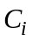, the Gini index can be written as:
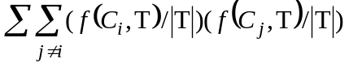
where f (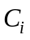, T)/ |T| is the probability that the selected case belongs to class .
Each time a tree is grown to the maximum depth on new training data using a combination of features. These full-grown trees are not pruned. This is one of the major advantages of the random forest classifier over other decision tree methods like the one proposed by Quinlan (1993). As the studies suggest that the choice of the pruning methods, and not the attribute selection measures, affect the performance of tree based classifiers (Mingers, 1989; Pal and Mather, 2003a). Breiman (1999) suggests that as the number of trees increases, the generalisation error always converges even without pruning the tree and overfitting is not a problem because of the Strong Law of Large Numbers (Feller, 1968). The number of features used at each node to generate a tree and the number of trees to be grown are two user-defined parameters required to generate a random forest classifier. At each node, only selected features are searched for the best split. Thus, the random forest classifier consists of N trees, where N is the number of trees to be grown which can be any value defined by the user. To classify a new data set, each case of the data sets is passed down to each of the N trees. The forest chooses a class having the most out of N votes, for that case.

2.2 Support Vector Machines (SVMs)
SVMs are based on statistical learning theory and have the aim of determining the location of decision boundaries that produce the optimal separation of classes (Vapnik 1995). In a two-class pattern recognition problem where classes are linearly separable, the SVMs select the one linear decision boundary that leaves the greatest margin between the two classes. The margin is defined as the sum of the distances to the hyperplane from the closest points of the two classes (Vapnik, 1995). This problem of maximising the margin can be solved using standard Quadratic Programming (QP) optimisation techniques. The data points that are closest to the hyperplane are used to measure the margin. Therefore, these data points are termed ‘support vectors’ and are always small in number (Vapnik, 1995).
If the two classes are not linearly separable, the SVMs tries to find the hyperplane that maximises the margin, while at the same time, minimising a quantity proportional to the number of misclassification errors. The trade-off between margin and misclassification error is controlled by a positive user-defined parameter C (Cortes and Vapnik, 1995). SVMs can also be extended to handle non-linear decision surfaces. Boser et al. (1992) proposed a method of projecting the input data into a high-dimensional feature space through some nonlinear mapping, and formulating a linear classification problem in that feature space. Kernel functions are used to reduce the computational cost of dealing with high-dimensional feature space (Vapnik 1995).
SVMs were initially designed for binary (two-class) problems. When dealing with multiple classes, an appropriate multi-class method is needed. Techniques such as ‘ one against one’ and the ‘one against the rest’ are in frequent use for the multi-class problems (Vapnik 1995; Cristianini and Shawe-Taylor 2000).

Application

For this study, Landsat-7 Enhanced Thematic Mapper (ETM+) data (19/06/2000) of an agricultural area near Littleport (Cambridgeshire), UK was used. An area of 307-pixel (columns) by 330-pixel (rows) covering the area of interest was used for this study. The classification problem involved the identification of seven land cover types (wheat, potato, sugar beet, onion, peas, lettuce and beans). Field Data printouts for the relevant crop season were collected from farmers and their representative agencies. The other areas were surveyed on the ground to prepare the ground reference image. A total of 4737 pixels were selected for all seven classes by using equalised random sampling. Pixels were then divided into two parts so as to remove any possible bias caused by using the same pixels for training and testing the classifiers. A total of 2700 training and 2037 test pixels were used (Table 1).
[Insert table 1]
A number of trials were carried out to select the user-defined parameters for random forest classifier (Figures 1 and 2). For this study 3 numbers of features at each node and a total of 100 trees were used.
[Insert Figure 1]
[Insert Figure 2]
A set of user-defined parameters is required to design SVMs. Choice of kernel, kernel specific parameters and the value of the regularisation parameter (C) are found to influence the classification accuracy achieved by SVMs. A radial basis kernel function with kernel width = 2 and regularisation parameter C = 5000 was used. The ‘one against one’ method was used to generate multi-class classifier (Chang and Lin 2001). For further details of SVMs in remote sensing classifications, readers are referred to Pal and Mather (2003b). All the processing with support vector machines was done on a Sun workstation while a window based Pentium IV processor was used for the random forest classifier.
[Insert table 2]
[Insert table 3]
[Insert table 4]

Tables 2 and 3 provide per-class while table 4 provides overall classification accuracies achieved by random forest and SVM classifier, suggesting a comparable performance by both classifiers. The time and experimentation required to select the user-defined parameters for random forest classifier are quite small in comparison to SVMs for this data set (Table 4). This is because the design of SVMs involves choosing a suitable kernel, kernel specific parameters and the regularisation parameter C, which requires a lot of experimentation and processing time. Classification accuracy changes from 88.37% to 88.02% when the number of trees increases from 100 to 12000 (Figure 2). This indicates that the random forest classifier is almost insensitive to overfitting for this data set.

Conclusions

The results reported in section 3 suggest that the random forest classifier can achieve a classification accuracy which is comparable to that achieved by SVMs. Another advantage of the random forest classifier is that it requires setting of two parameters only whereas the SVMs require a number of user-defined parameters. The random forest classifier can handle categorical data, unbalanced data as well as the data with missing values, which is still not possible with SVMs. This classifier also provides the relative importance of different features during classification process, which can be useful in feature selection. Further, the random forest classifier provides a way to detect outliers by using proximity analysis and can be used for unsupervised learning. At present, investigations are still in progress to further evaluate the performance of the random forest classifier for outlier detection, feature selection and clustering with remote sensing data.

ACKNOWLWDGEMENT
Author is grateful for the critical comments of two anonymous referees, whose advice has led to an improvement in the presentation of this paper.

REFERENCES
BOSER, B., GUYON, I. and VAPNIK, V. N., 1992, A training algorithm for optimal margin classifiers. Proceedings of 5th Annual Workshop on Computer Learning Theory, Morgan Kaufman, S. Mateo, CA, 144–152.
BREIMAN, L., 1996, bagging predictors, Machine Learning, 26, 123-140.
BREIMAN, L., FRIEDMAN, J.H. OLSHEN, R.A., and STONE, C.J., 1984, Classification and Regression Trees, Wadsworth, Monterey, CA.
BREIMAN, L., 1999, Random forests - Random Features. Technical Report 567, Statistics Department, University of California, Berkeley, ftp://ftp.stat.berkeley.edu/pub/users/breiman.
BRIEM, G. J., BENEDIKTSSON, J., A., and SVEINSSON, J., R., 2002, Multiple Classifiers Applied to Multisource Remote Sensing Data. IEEE Transactions on Geoscience and Remote Sensing, 40, 2291-2299.
CHANG, C., and LIN, C., 2001, LIBSVM: A Library for Support Vector Machines. Department of Computer Science and Information Engineering, National Taiwan University, Taiwan, http://www.csie.ntu.edu.tw/~cjlin/libsvm.
CORTES, C. and VAPNIK, V. N., 1995, Support vector networks. Machine Learning, 20, 273 - 297.
CRISTIANINI, N. and SHAWE-TAYLOR, J., 2000, An Introduction to Support Vector Machines. London, Cambridge University Press.
DIETTERICH, T. G., 2002, Ensemble learning. The handbook of brain theory and neural networks, Edited by M. A. Arbib, The MIT Press, Cambridge: MA.
FELLER, W., 1968, An Introduction to Probability Theory and Its Application, Vol. 1, 3rd edition, New York: Wiley.
FREUND, Y. and SCHAPIRE, R., 1996, Experiments with a new boosting algorithm. Machine Learning: Proceedings of the Thirteenth International conference, 148-156.
FRIEDL, M. A., BRODLEY, C. E., and STRAHLER, A. H., 1999, Maximizing land cover classification accuracies produced by decision tree at continental to global scales. IEEE Transactions on Geoscience and Remote Sensing, 37, 969-977.
GIACINTO, G., and ROLI, F., 1997, Ensembles of neural networks for soft classification of remote sensing images, Proceedings of the European Symposium on Intelligent Techniques, European Network for Fuzzy Logic and Uncertainty Modelling in Information Technology, Bari, Italy, 166-170.
MINGERS, J., 1989, An empirical comparison of pruning methods for decision tree induction. Machine Learning, 4, 227-243.
MUCHONEY, D., BORAK, J., CHI, H., FRIEDL, M., GOPAL, S., HODGES, J., MORROW, N., and STRAHLER, A., 2000, Application of MODIS global supervised classification model to vegetation and land cover mapping of Central America. International Journal of Remote Sensing, 21, 1115– 1138.
PAL, M., and MATHER, P. M., 2003a, An assessment of the effectiveness of decision tree methods for land cover classification. Remote Sensing of Environment, 86, 554-565.
PAL, M., and MATHER, P. M., 2003b, Support vector classifiers for land cover classification. Map India 2003, New Delhi, January 28-31, www.gisdevelopment.net/technology/rs/pdf/23.pdf.
QUINLAN, J. R., 1993, C4.5: Programs for Machine Learning. San Mateo: Morgan Kaufmann.
VAPNIK, V. N., 1995, The Nature of Statistical Learning Theory. New York: Springer-Verlag.

Figure Captions

Figure 1. Variation in classification accuracy with varying number of features using 100 number of trees.

Figure 2. Variation in classification accuracy with varying number of trees using 3 numbers of features.

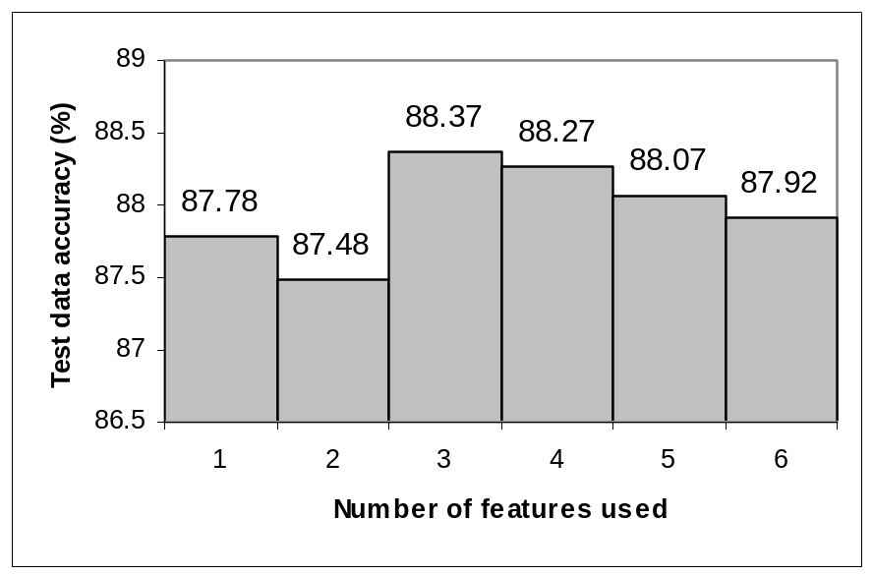
Figure 1.

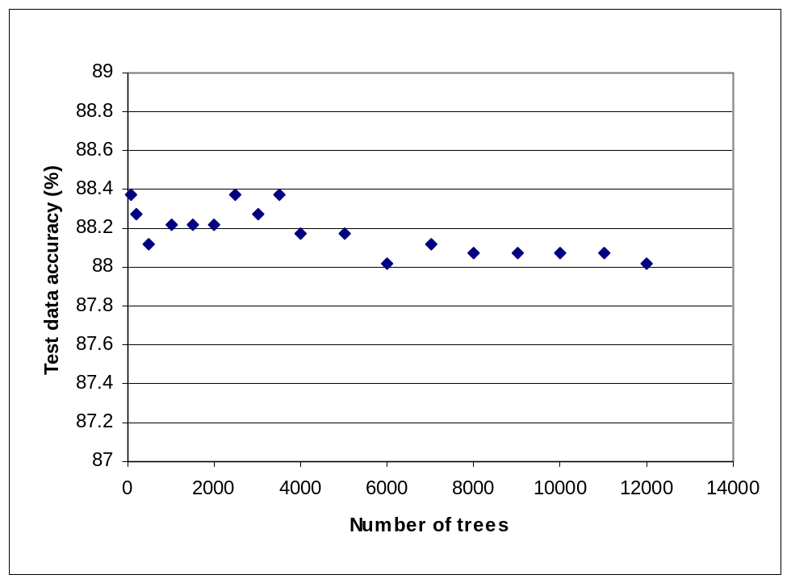

Figure 2.

Table Captions

Table 1. Number of pixels used for different classes during training and testing.
Table 2. Confusion matrix by random forest classifier using 3 features and 100 trees.
Table 3. Confusion matrix by support vector machines using ‘one against one’ multi-class approach.
Table 4. Final classification accuracy, kappa coefficient and training time of both classifiers.

Table 1.

Class | Number assigned to different classes | Training Pixels | Test pixels
Wheat | 1 | 400 | 300
Sugar beat | 2 | 400 | 300
Potato | 3 | 400 | 300
Onion | 4 | 400 | 300
Peas | 5 | 400 | 300
Lettuce | 6 | 400 | 300
Beans | 7 | 300 | 237

Table 2.
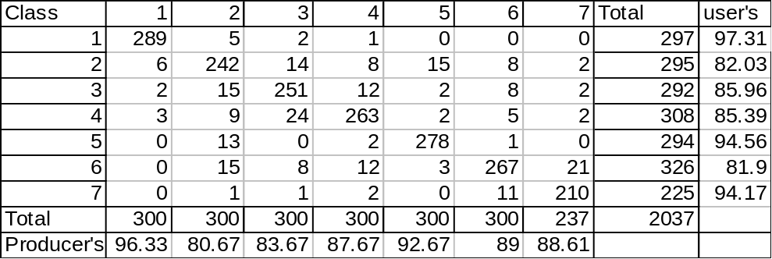

Table 3.

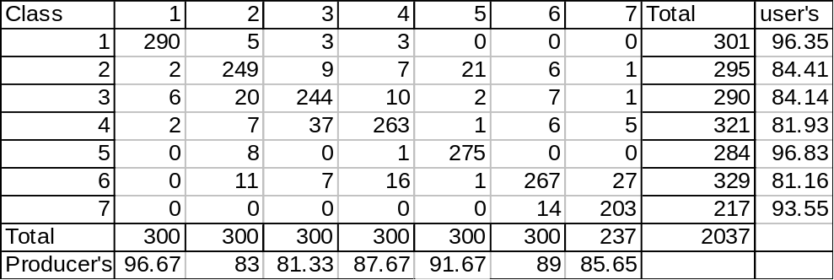

Table 4.

Classifier used | Random forest classifier | Support vector machines
Accuracy (%) and Kappa value | 88.37 (0.864) | 87.9 (0.86)
Training time | 12.98 seconds on P-IV | 18 seconds on sun machine

