**Basic Noise Reduction Function in R for log Ratio signal of 2 samples**

Graphical data displays are very useful in identifying (observing) outliers.

Box plot of available data.

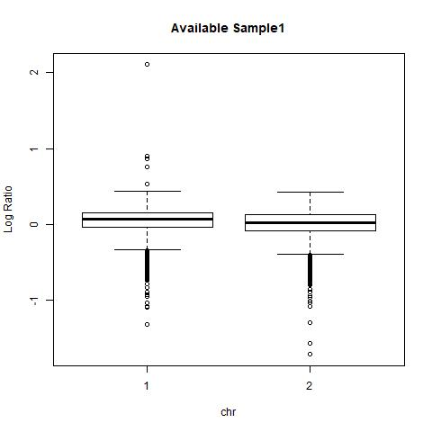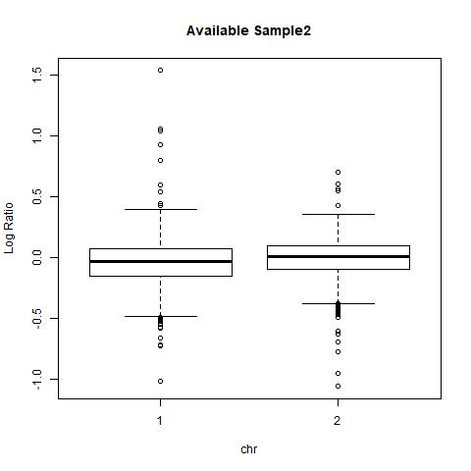

As many data points are outside whiskers of the box plot, conventional formula (1.5*IQR) for identifying outliers has to be improved.

Script Function.R finds the appropriate value to be multiplied with interquartile range so that we don’t lose acceptable data points.

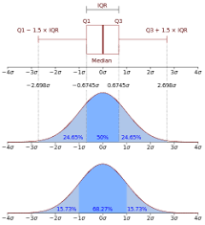Generally outliers are less than 1% of the total data points, which in normal bell shaped curve is .70% of the total data.

(.7/100)*total data points

**Comparison:**

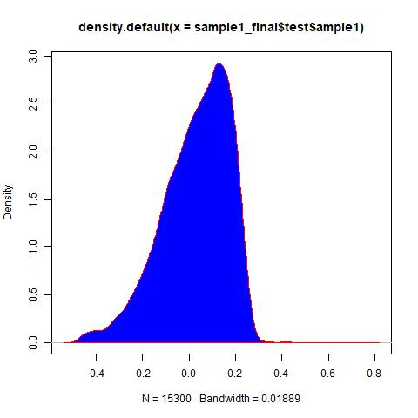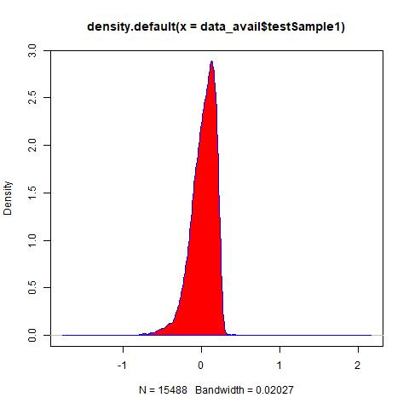  
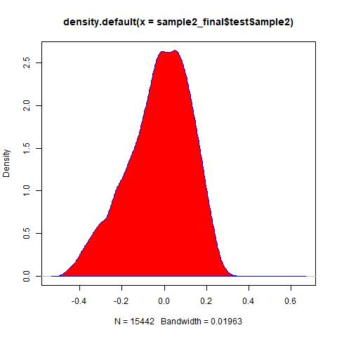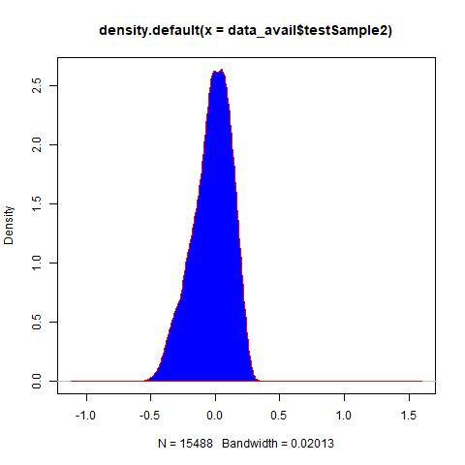Noise reduced plots on the right are show that the extreme and close to extreme mild outliers are removed from the available data.

Sample 1 above

Sample2 below

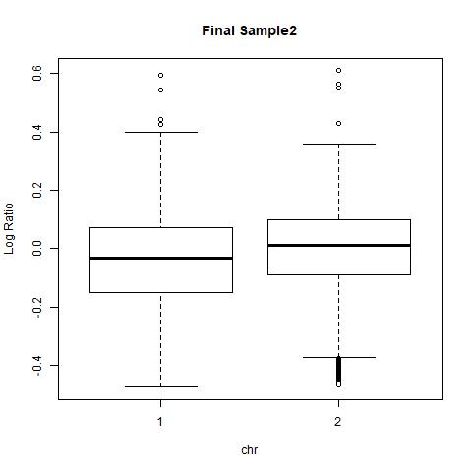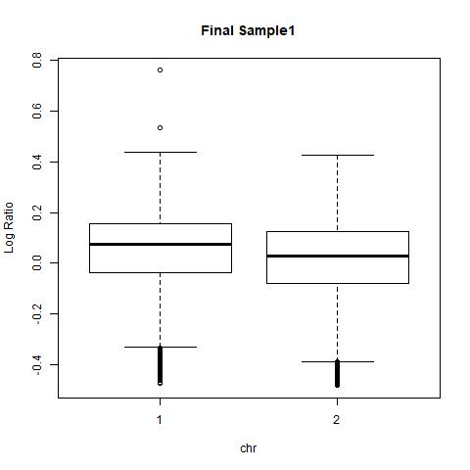Minimum and maximum value range has been modified.

Sample1: (Q1-3*IQR) < acceptable range < (Q3+3*IQR)

Sample2: (Q1-2.7*IQR) < acceptable range < (Q3+2.7*IQR)