***A Mini Project Report***

***Submitted in Partial Fulfilment for the Award of***

BACHELOR OF TECHNOLOGY

IN

COMPUTER SCIENCE & ENGINEERING (CS-A)

By

Aman Prajapati (2016617)

4th Semester 2021-22

To



Guided by:

Ms. Meenakshi Maindola

(Resource Person)

**DEPARTMENT OF COMPUTER SCIENCE AND ENGINEERING**

GRAPHIC ERA DEEMED TO BE UNVERSITY, DEHRADUN

# Acknowledgement

I would like to express my sincere gratitude to Ms. Meenakshi Maindola of the department of Computer Science, whose role as project guide was invaluable for the project. I am extremely thankful for the keen interest he took in advising me. I convey my gratitude to all the teachers for providing us the technical skill that will always remain as my asset.

Last but not the least, I wish to thank my parents for financing my studies in this college as well as for constantly encouraging me to learn new things.

Place: Dehradun

Aman Prajapati

Roll No. 2016617

**RESUME SCREENING BASED ON JOB DESCRIPTION USING PYTHON**

**AIM:**

Perform resume screening based on the job description using python and able to see that by what percentage the resume is matching with the job description.

**SOFTWARE REQUIRED:**

1. Anaconda
2. Jupyter Notebook.
3. Data in the form of csv file.

**Introduction:**

Writing a resume is not a trivial task, especially when it comes to the right selection of keywords. People spend hours writing and formatting the perfect resume hoping it to be read by a talent acquisition professional and, eventually, help them land a job interview. Unfortunately, around 75% of resumes submitted are never seen by a human eye.

Due to the high number of applicants and resumes submissions to job postings, manual resumes screening processes become tedious, ineffective and time consuming for talent acquisition professionals. Therefore, standardized automated screening methods are necessary to categorize **qualified** from **unqualified** candidates based on their background, education, and professional experience faster, with more efficiency and more accurate results to streamline hiring processes.

**WHAT IS RESUME SCREENING?**

Resume screening is the process of identifying if a candidate qualifies for a job by matching the requirements of the role with the information on their resumes such as education, skills, certifications, experience, and achievements. Resume screening is crucial to determine whether a candidate moves to the next stage of the heiring process or not, specially in high volume application scenarios.

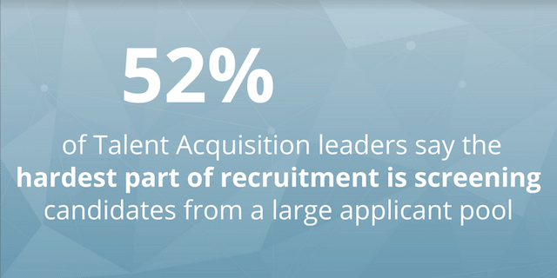

**THEORY:**

The process involves several steps to achieve this:

1. Import the necessary library and the data(here csv file).
2. Look and visualize at the categories.
3. Visualize the distribution of categories.
4. Remove the URls, hashtag, mentions, special letter and punctuations.
5. Cleared the dataset, the next task is to have a look at the Word Cloud.
6. Training Machine learning Model.

**STEP I.**

Import the necessary library and the data:

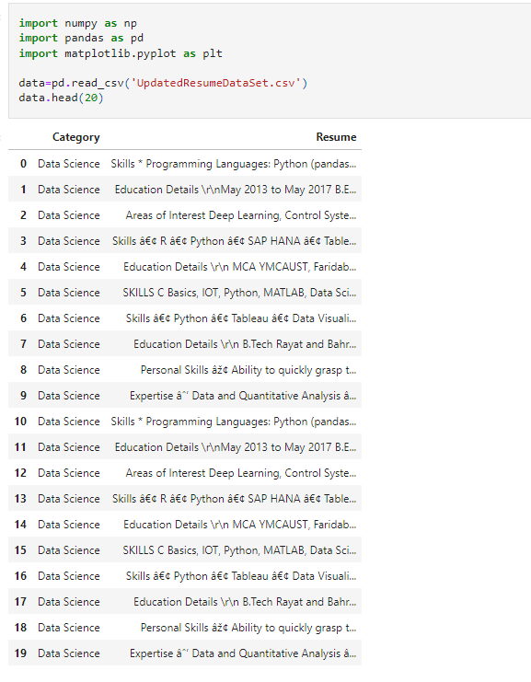

**STEP II.**

Look and visualize at the categories:

**STEP III.**

Visualize the distribution of categories:

**STEP IV.**

Remove the URLs, hashtag, mentions, special letters and punctuations:

**STEP V.**

Plot word cloud image:

**STEP VI.**

Training Machine Learning Model:

**Conclusion:**

It is essential to hire the right people. It is also crucial to hire them at right them. Streamlining the resume screening process is vital step in that direction. Resume screening software is an excellent means to achieve that.

