***A Mini Project Report***

***Submitted in Partial Fulfillment for the Award of***

BACHELOR OF TECHNOLOGY

IN

COMPUTER SCIENCE & ENGINEERING (CS-A)

By

Aman Prajapati (2016617)

3rd Semester 2021-22

To



Guided by:

Mr. Piyush Agarwal

(Resource Person)

**DEPARTMENT OF COMPUTER SCIENCE AND ENGINEERING**

GRAPHIC ERA DEEMED TO BE UNVERSITY, DEHRADUN

# Acknowledgement

I would like to express my sincere gratitude to Mr. Piyush Agarwal of the department of Computer Science, whose role as project guide was invaluable for the project. I am extremely thankful for the keen interest he took in advising me. I convey my gratitude to all the teachers for providing us the technical skill that will always remain as my asset.

Last but not the least, I wish to thank my parents for financing my studies in this college as well as for constantly encouraging me to learn new things.

Place: Dehradun

Aman Prajapati

Roll No. 2016617

**SMART TICKET ISSUE AND PAYMENT SYSTEM FOR PUBLIC TRANSPORT**

**AIM:**

To book ticket for public transport using smart card , making ticketing process paperless and hence making it economically efficient.

**MATERIAL REQUIRED:**

1. **Hardware:**
2. Arduino UNO
3. HC-05 Bluetooth Module
4. RFID-RC522 Scanner
5. RFID card
6. Jumper wires
7. **Software:**
8. Arduino IDE
9. Android application: Named- RFID_TICKETING_MACHINE

**RFID_TICKETING_MACHINE:** It is an android application made from MIT app inventor. Its working steps are:-

1. Open the android application and open Bluetooth in your mobile phone and pair with Bluetooth named HC05.
2. After doing first step click on “SELECT BLUETOOTH” in the application and select HC05, then the label will changes to “BLUETOOTH CONNECTED”.
3. Then click on “SELECT STARTING”, list of places from where you start your journey after selecting any one from the list the label changes to “FROM: XXXXXX”.
4. After that click on “SELECT DESTINATION”, select your destination of the journey after selecting it the label changes to “TO: XXXXXXXXX”.
5. Then a message will appear “Journey selected from XXXXXX to XXXXXXX. Click Book Ticket”.
6. At the last click on “BOOK TICKET”.

**THEORY:**

It is a portable machine for booking ticket using RFID card. After using the android application we scan the RFID card and the details of journey, ticket price and remaining amount will get displayed on the monitor. If the access is not allowed to any RFID card message will get displayed “Access Denied”.

**PIN CONNECTIONS:**

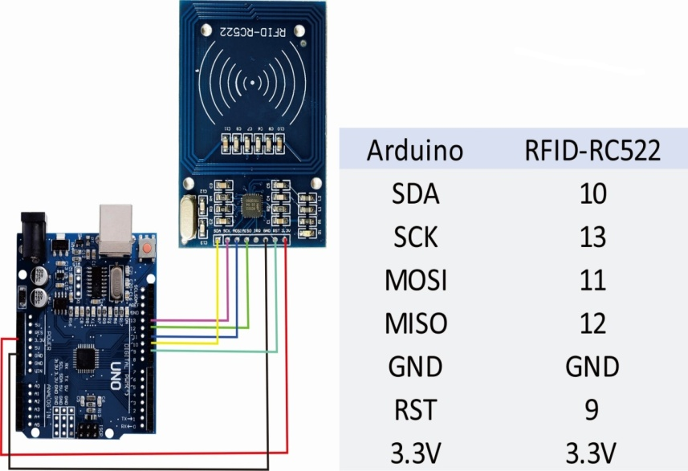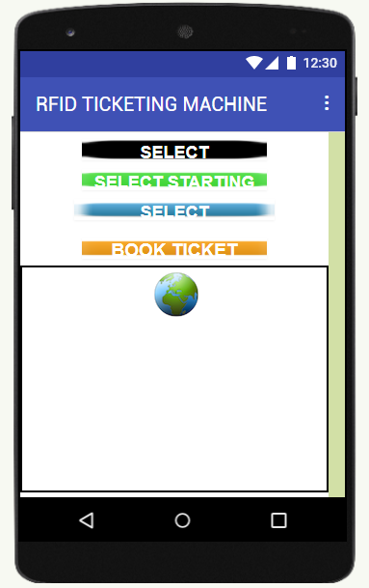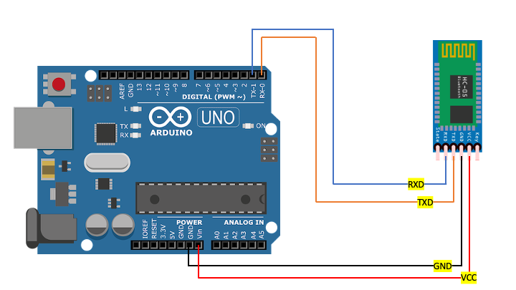

**ARDUINO CODE:**

#include <SPI.h>

#include <MFRC522.h>

#include <SoftwareSerial.h>

#include <EEPROM.h>

SoftwareSerial rfid(2, 3);

#define SS_PIN 10

#define RST_PIN 9

const int granted = 12, denied = 13;

String route1 = "UTTARPRADESH-DELHI", route2 = "UTTARPRADESH-DEHRADUN", route3 = "DELHI-UTTARPRADESH";

String route4 = "DELHI-DEHRADUN", route5 = "DEHRADUN-DELHI", route6 = "DEHRADUN-UTTARPRADESH";

String current_route,temp;

int route,route1_ticket = 15, route2_ticket = 30, route3_ticket = 15, route4_ticket = 20, route5_ticket = 20, route6_ticket = 30;

int total_amount = 5000, used_amount,remaining_amount;

MFRC522 mfrc522(SS_PIN , RST_PIN);

void setup()

{

Serial.begin(9600);

SPI.begin();

rfid.begin(9600);

pinMode(granted, OUTPUT);

pinMode(denied, OUTPUT);

while (!Serial);

SPI.begin();

mfrc522.PCD_Init();

delay(4);

if(digitalRead(10) == LOW){

EEPROM.put(0, total_amount);

Serial.println("Amount Recharged");

Serial.print("Remaining Amount : ");Serial.println(total_amount);

while(1);

}else{

EEPROM.get(0, remaining_amount);

}

}

void loop() {

if ( ! mfrc522.PICC_IsNewCardPresent()) {

return;

}

if ( ! mfrc522.PICC_ReadCardSerial()) {

return;

}

String content = "";

byte letter;

Serial.print("UID : ");

for(byte i = 0 ; i < mfrc522.uid.size ; i++)

{

Serial.print(mfrc522.uid.uidByte[i] < 0x10 ? "0" : " ");

Serial.print(mfrc522.uid.uidByte[i] , HEX);

content.concat(String(mfrc522.uid.uidByte[i] < 0x10 ? "0" : " "));

content.concat(String(mfrc522.uid.uidByte[i] , HEX));

}

Serial.println();

content.toUpperCase();

if (content.substring(1) == "A1 31 6E 1B") {

while (Serial.available()) {

delay(10);

char c = Serial.read();

//Serial.print(c);

if (c == '#') {

current_route = temp;

current_route.toUpperCase();

temp = "";

Serial.print("Journey Details : ");

if (current_route.indexOf(route1) != -1) {

Serial.println(route1);

route = 1;

}

else if (current_route.indexOf(route2) != -1) {

Serial.println(route2);

route =2;

}

else if (current_route.indexOf(route3) != -1) {

Serial.println(route3);

route = 3;

}

else if (current_route.indexOf(route4) != -1) {

Serial.println(route4);

route =4;

}

else if (current_route.indexOf(route5) != -1) {

Serial.println(route5);

route = 5;

}

else if (current_route.indexOf(route6) != -1) {

Serial.println(route6);

route = 6;

}

else{

Serial.print(current_route);

Serial.println(" is not Valid");

current_route = "";

route = 0;

}

break;

}

temp += c;

}

if(route == 0){

Serial.println("Journey Route not selected");

}

else if(route == 1){

remaining_amount = remaining_amount - route1_ticket;

Serial.print("Ticket Rate : ");Serial.println(route1_ticket);

current_route = "";route = 0;

}

else if(route == 2){

remaining_amount = remaining_amount - route2_ticket;

Serial.print("Ticket Rate : ");Serial.println(route2_ticket);

current_route = "";route = 0;

}

else if(route == 3){

remaining_amount = remaining_amount - route3_ticket;

Serial.print("Ticket Rate : ");Serial.println(route3_ticket);

current_route = "";route = 0;

}

else if(route == 4){

remaining_amount = remaining_amount - route4_ticket;

Serial.print("Ticket Rate : ");Serial.println(route4_ticket);

current_route = "";route = 0;

}

else if(route == 5){

remaining_amount = remaining_amount - route5_ticket;

Serial.print("Ticket Rate : ");Serial.println(route5_ticket);

current_route = "";route = 0;

}

else if(route == 6){

remaining_amount = remaining_amount - route6_ticket;

Serial.print("Ticket Rate : ");Serial.println(route6_ticket);

current_route = "";route = 0;

}

EEPROM.put(0, remaining_amount);

Serial.print("Remaining Amount : ");Serial.println(remaining_amount);

}

else {

Serial.println("Access Denied");

}

}

**CODE OUTPUT:**

1. If route is not selected and we use the accessible RFID card:

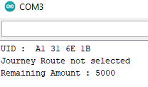

1. If we use the RFID card which is not accessible:

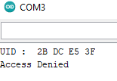

1. If route is selected and we use the accessible RFID card:

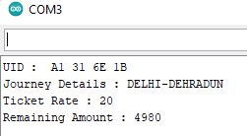

**APPLICATION:** Used in public transport for providing paperless ticket to travellers using smart card.