**MEDIAWIKI PROBLEM STATEMENT**

**Objective:**

We want to automate the deployment of app called Mediawiki.

Deployment - Launching the Mediawiki

* Performing all these tasks in a windows machine

Prerequisites:

* An AWS Account
* AWS cli configured on local machine
* Terraform installed
* Docker installed
* Helm installed

Steps to Perform Sequentially in the solution directory:

* Update value in terraform.tfvars file
* Perform commands below-
* 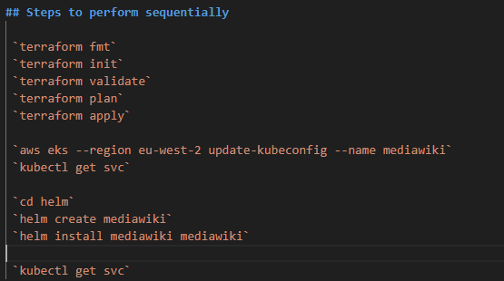
* After terraform apply you will get cluster name in output
* 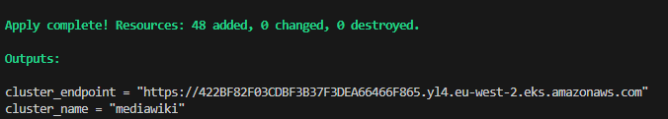
* You will get output like below --



* Copy the external IP and hit the browser and it gives a response like below-
* 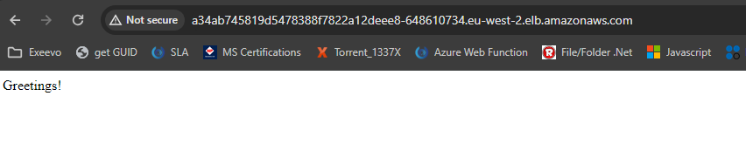

**Final Output:**



**Challenges**

* The first challenge I faced was setting up a docker. It was not starting up, to resolve that going through multiple blogs and finding hyper V should be enabled if wsl not supported. I enabled this through Gui taking help from Microsoft doc.
* Another challenge was to create docker image through terraform and store it to aws ecr. Tried multiple docker provider but was not successful. So, write some null resources to perform the commands.
* Again, I am new to helm so faced the challenge to configure basic helm chart. Even after successful deployment. My service did not get external IP tried multiple times and found my service type is not correct so, I changed to load balancer. It works.