A PROJECT REPORT ON
TRENDIFY – “TRACK TRENDS. PREDICT SMARTER”
Designed and Developed By
AMANPREET KAUR SAHOTA
TYCS/B SEMESTER VI
Seat No:- 3048260
UNDER THE GUIDANCE OF
PROF. KAVITA VERMA AND VAISHALI KADAM
SUBMITTED IN PARTIAL FULFILMENT OF ACADEMIC PROJECT
BACHELOR OF SCIENCE IN COMPUTER SCIENCE


UNIVERSITY OF MUMBAI
Shree Shankar Narayan Education Trust's
SHREE SHANKAR NARAYAN COLLEGE OFARTS, COMMERCE AND SELF FINANCE
BACHELOR OF SCIENCE IN COMPUTER SCIENCE
ACADEMIC YEAR 2025-26I

ACKNOWLEDGEMENT

Firstly, I would like to express my sincere thanks to Principal Dr. V. N. Yadav and the Head of the Department Prof. Vaishali Kadam of Shankar Narayan college for giving us the opportunity to accomplish this project work.
I would also like to thank Prof. Kavita Verma for her guidance, support, and valuable insights throughout the project. Their expertise and continuous encouragement have been instrumental in shaping the direction of my project and ensuring its successful execution.
We also thank the faculty and staff of SHANKAR NARAYAN COLLEGE specifically the Department of Computer Science, for providing me with the necessary resources and facilities to carry out this project. Their commitment to academic excellence and dedication to fostering a conducive learning environment have been invaluable.
Furthermore, I am grateful to my classmates and friends who provided me with their unwavering support and encouragement throughout this journey. Their discussions, feedback, and collaborative efforts have greatly enriched my understanding and perspective on the subject matter.
Finally, this project would not have been possible without the collective efforts of these individuals and institutions. I am truly grateful for their contributions and the impact they have had on my academic journey

Project Associate
“AMANPREET KAUR SAHOTA”

ABSTRACT

In today’s dynamic financial markets, timely and informed decisions are critical for investors. Trendify is an intelligent stock market analysis and prediction platform designed to assist both novice and experienced investors in making data-driven investment choices. The system integrates historical and live stock data, technical indicators, fundamental analysis, and machine learning models to deliver actionable insights.
The platform provides visualizations of key indicators such as SMA (Simple Moving Averages) and RSI (Relative Strength Index), coupled with predictive models that forecast next-day and 5–7 day stock prices. Additionally, Trendify evaluates stock fundamentals and generates automated investment recommendations along with explanations to enhance user understanding through a Learning Mode. A personalized portfolio management system allows users to track and update their holdings, while a real-time news feed keeps them informed of market developments.
Built with Python, Streamlit, Plotly, and scikit-learn, Trendify offers a user-friendly interface with interactive dashboards that present stock trends, predictions, and health scores. By combining technical, fundamental, and predictive analytics, Trendify empowers users to make smarter investment decisions efficiently.

PLAGIARISM REPORT

Plagiarism Report
Unique
96
%
Exact Match
4
%
Partial Match
0
%
4
%
Plagiarism

This project, Trendify – Stock Market Analysis and Prediction Platform, is an original work developed independently by the author, [Your Name], as part of the academic curriculum in the field of Computer Science. The objective of this project is to design and implement a comprehensive system for analyzing, predicting, and providing insights into the stock market, integrating both technical and fundamental financial data.
The work presented in this project is entirely original, and all coding, analysis, and system design have been carried out by the author. The system incorporates publicly available libraries and frameworks such as pandas, NumPy, scikit-learn, Plotly, Streamlit, yfinance, and standard APIs for fetching live financial data and news. While these libraries provide the foundational functions for data processing and visualization, all usage of these tools has been implemented uniquely for this project.
The project includes multiple modules:
- Data Acquisition Module – Collects historical stock data from CSV files and live data via the Yahoo Finance API, ensuring up-to-date market information.
- Technical Analysis Module – Implements indicators such as Simple Moving Averages (SMA 20, SMA 50) and Relative Strength Index (RSI 14), which are calculated manually and integrated into predictive analytics.
- Machine Learning Prediction Module – Uses Random Forest Regression models trained on historical stock data to predict the next-day price and a 5–7 day forecast. Features have been engineered independently for optimal model performance.
- Fundamental Analysis Module – Analyzes financial health metrics of companies including growth rates, profitability, and valuation ratios. This module is implemented with an original logic combining available financial data to produce a Stock Health Score.
- Investment Recommendation Module – Generates actionable investment recommendations (BUY, HOLD, SELL) based on technical indicators, fundamental health, and predicted price trends, with explanations for each suggestion.
- User Learning Mode – Educates users about the meaning of each metric, predicted price changes, and financial insights, thereby increasing financial literacy.
- Portfolio Management Module – Allows users to track, add, update, and manage their stock portfolio in a structured interface.

ACTIVITY SHEET

Name : AMANPREET KAUR SAHOTA
Class : TYCS-B
Roll No : 77
Seat No : 3048260
Project Name : TRENDIFY – “TRACK TRENDS. PREDICT SMARTER”

Sr.No | Content | Planned Date |  | Actual Date |  | Sign
 |  | Start Date | End Date | Start Date | End Date
1 | Introduction & Proposed System | 10-11-25 | 22-11-25 | 10-11-25 | 24-11-25
2 | System Requirements | 24-11-25 | 13-12-25 | 25-11-25 | 17-12-25
3 | Fact Finding & UML Diagrams | 15-12-25 | 22-12-25 | 17-12-25 | 22-12-25
4 | System Implementation & Coding | 23-12-25 | 10-01-26 | 23-12-25 | 12-01-26
5 | Screen Layouts & reports | 12-01-26 | 19-01-26 | 13-01-26 | 21-01-26
6 | Future Scope & Conclusion | 20-01-26 | 27-01-26 | 23-01-26 | 29-01-26

GANTT CHART
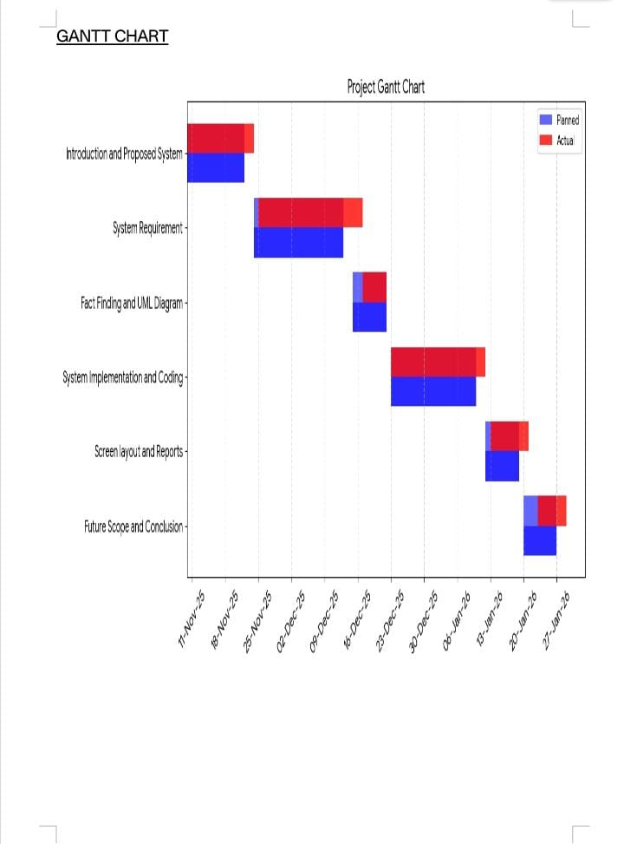

INDEX
Sr. No. | Section Title | Page No.
1 | INTRODUCTION | 11-12
1.1 | Problem Definition | 13
1.2 | Objectives of the Project | 14-15
1.3 | Scope of the Project | 16-17
1.4 | Existing System | 18
1.5 | Proposed System | 19
2 | SYSTEM ANALYSIS | 20-22
2.1 | Feasibility Study | 23
2.2 | Requirement Analysis | 24-25
2.3 | Software Requirements | 26-27
2.4 | Hardware Requirements | 28
3 | SYSTEM DESIGN | 29
3.1 | System Architecture | 30
3.2 | Data Flow Diagram | 31
3.3 | ER Diagram / UML Diagrams | 32
3.4 | Database Design | 33
4 | IMPLEMENTATION | 34
4.1 | Module Description | 35-35
4.2 | Algorithm Used | 37
4.3 | Coding (Sample/Important Screen) | 38-52
5 | TESTING | 53
5.1 | Test Cases | 54
5.2 | Output Screens | 55-57
5.3 | Error Handling | 58

6 | RESULT & DISCUSSION | 59
6.1 | Output Summary | 60
6.2 | Performance Analysis | 61
7 | CONCLUSION & FUTURE SCOPE | 62
7.1 | Conclusion | 63
7.2 | Future Enhancements | 64
8 | REFERENCES / BIBLIOGRAPHY | 65-66
9 | APPENDIX | 67-70

PHASE 1: INTRODUCTION

INTRODUCTION

The stock market is a complex and dynamic system where the prices of securities fluctuate based on multiple factors, including company performance, economic indicators, investor sentiment, and global events. Accurate analysis and prediction of stock prices are crucial for investors, traders, and financial analysts to make informed decisions, minimize risks, and maximize returns. However, due to the high volatility and non-linear behavior of financial markets, traditional approaches often fail to provide actionable insights in a timely manner.
The Trendify project addresses this challenge by combining technical analysis, fundamental analysis, and machine learning-based predictive models into a single, interactive platform. The system allows users to visualize historical trends, understand market behavior through key indicators, and receive actionable predictions for short-term price movements. Technical indicators such as Simple Moving Averages (SMA 20, SMA 50) and Relative Strength Index (RSI 14) are calculated to assess market trends and potential buy/sell signals. Additionally, the platform integrates fundamental metrics to evaluate the financial health of companies, providing a comprehensive Stock Health Score and actionable investment recommendations.
To enhance user experience and promote financial literacy, Trendify incorporates a learning mode, which explains the meaning of each metric, the rationale behind predictions, and the implications of stock movements. Users can also manage a personalized portfolio, monitor performance, and explore curated financial news related to their selected assets.
From a technical perspective, Trendify leverages Python and widely-used open-source libraries such as pandas, NumPy, scikit-learn, Plotly, and Streamlit, along with APIs like Yahoo Finance for live and historical stock data. Machine learning models, specifically Random Forest Regression, are trained on historical market data to predict next-day and short-term future prices. The system also includes features like SMA/RSI visualization, 5–7 day forecasting, and investment recommendation generation.

  - PROBLEM DEFINITION

Investing in the stock market has always been associated with risk and uncertainty. Stock prices fluctuate rapidly due to multiple factors including company performance, macroeconomic indicators, investor sentiment, and global market conditions. For many investors, especially beginners, it is challenging to make informed decisions based on raw data alone. Key problems faced in the current investment landscape include:

Information Overload:
Investors are overwhelmed with massive amounts of market data, news, and reports, making it difficult to analyze trends effectively or identify profitable opportunities.

Complexity in Technical Analysis:
While technical indicators such as Simple Moving Averages (SMA), Relative Strength Index (RSI), and Bollinger Bands can provide valuable insights, manual calculation and interpretation require expertise and time, limiting accessibility for novice investors.

Limited Predictive Guidance:
Traditional investment approaches often rely on historical trends and intuition, offering little guidance on short-term future stock price movements. Investors lack reliable predictive tools that are easy to use and explainable.

Insufficient Integration of Fundamental and Technical Metrics:
While some platforms focus solely on technical analysis or fundamental data, few provide a combined view of both, leaving investors without a holistic understanding of stock health and potential risk factors.

Lack of Educational Support:
Many retail investors do not fully understand the meaning and implications of financial metrics, leading to uninformed decisions and potential financial losses.

The Trendify project aims to address these problems by providing a unified platform that integrates historical stock data, technical indicators, fundamental analysis, and machine learning-based price prediction. The system provides:

- Automated calculation and visualization of SMA (20, 50) and RSI (14) indicators.

- Short-term 5–7 day price forecasts using Random Forest Regression.

- Fundamental analysis including key financial ratios, stock health scoring, and investment recommendations.

- A learning mode that explains metrics, trends, and predictions for user education.
1.2 OBJECTIVES OF THE PROJECT
The primary objective of the Trendify project is to empower investors with data-driven insights, predictive analytics, and educational guidance to make informed stock market decisions. The specific objectives are as follows:
- Data Aggregation and Processing:
  - Collect historical and live stock data from reliable sources such as Yahoo Finance.
  - Preprocess and clean the data to ensure accuracy and consistency for analysis and prediction.
- Technical Analysis Automation:
  - Calculate widely-used technical indicators including Simple Moving Averages (SMA 20 and SMA 50) and Relative Strength Index (RSI 14).
  - Visualize stock trends and indicators using interactive charts for easier interpretation.
- Machine Learning-Based Price Prediction:
  - Train a regression model to forecast short-term stock prices (5–7 days) based on historical and derived features.
  - Provide users with predicted prices and expected percentage changes to support investment planning.
- Fundamental Analysis and Stock Health Evaluation:
  - Retrieve key financial ratios and company data to assess stock health.
  - Compute a stock health score based on growth, stability, and risk factors.
  - Offer AI-driven buy/hold/sell recommendations backed by fundamental and technical insights.
- User Learning and Education:
  - Implement a “Learning Mode” to explain indicators, metrics, and predictions in simple terms.
  - Help users understand market trends and build financial literacy for more informed decision-making.
- Portfolio Management:
  - Allow users to track their investments and maintain a personal portfolio.
  - Provide performance summaries, gains/losses analysis, and historical trends for each asset.
- Real-Time Updates and News Integration:
  - Present the latest financial news relevant to selected stocks.
  - Keep users informed about market events that may impact their investments.
- User-Friendly Interface:
  - Design a clear, interactive dashboard that displays crucial information upfront, including current price, predicted price, and expected changes.
  - Ensure accessibility for users with varying levels of financial expertise.

  - SCOPE OF THE PROJECT

The scope of the Trendify – Stock Market Analysis and Prediction Platform project defines the boundaries, functionalities, and potential applications of the system. It emphasizes what the project covers and the value it delivers to its users.
- Stock Data Coverage:
  - The platform supports major Indian stocks (NSE-listed) such as TCS, INFY, RELIANCE, and HDFCBANK.
  - It can be extended to include more stocks and financial instruments over time.
  - Data includes historical stock prices, trading volumes, and key financial indicators.
- Technical Analysis Capabilities:
  - The system automatically computes popular technical indicators such as SMA (20 & 50) and RSI (14).
  - Interactive charts allow users to visualize price trends, moving averages, and overbought/oversold conditions.
  - These indicators help users identify potential entry and exit points.
- Machine Learning Predictions:
  - Short-term price predictions (5–7 days) are generated using a trained regression model.
  - The predictions assist users in planning trades and anticipating market movements.
  - Future scope includes enhancing prediction accuracy using more advanced ML models or deep learning techniques.
- Fundamental Analysis and Stock Health:
  - Key financial metrics such as P/E ratio, EPS, and growth trends are analyzed.
  - A stock health score is provided based on financial stability and growth potential.
  - The platform offers AI-driven recommendations (Buy/Hold/Sell) supported by fundamental and technical analysis.
- User Education & Learning Mode:
  - Users can enable a “Learning Mode” to get explanations for indicators, metrics, and predictions.
  - This feature promotes financial literacy and helps users make informed decisions.
- Portfolio Management:
  - Users can track their investments, monitor gains/losses, and manage multiple assets.
  - Performance summaries provide a clear view of individual and total portfolio health.
- Financial News Integration:
  - The system aggregates the latest stock-related news to keep users informed.
  - Relevant news articles are filtered for selected stocks to aid timely decision-making.
- User Interface & Experience:
  - A clean, interactive, and intuitive dashboard ensures key information such as current price, predicted price, and expected percentage change is visible immediately after login.
  - Tabs and sections allow users to navigate between portfolio, stock analysis, predictions, and educational content seamlessly.

  - EXISTING SYSTEMS

- Manual Analysis:
  - Investors track stocks using charts, news, and spreadsheets.
  - Limitations: Time-consuming, error-prone, hard to track multiple stocks.
- Brokerage Platforms:
  - Provide real-time prices and basic indicators.
  - Limitations: No predictive analytics or educational insights.
- Financial News Websites:
  - Offer news, stock data, and company fundamentals.
  - Limitations: Generic info, no personalized analysis or prediction.
- Technical Analysis Software:
  - Advanced charting and indicators like TradingView.
  - Limitations: Complex for beginners, lacks fundamental + ML integration.
- AI/ML-Based Tools:
  - Provide stock predictions.
  - Limitations: Expensive, not interactive, limited educational support.
Gap: Existing systems are either too complex, fragmented, or lack predictive + educational features.

  - PROPOSED SYSTEM

The proposed system, Trendify, is an integrated stock market analysis and prediction platform designed to assist investors in making informed decisions.

Key Features:
- Technical Analysis: Calculates indicators like SMA (20 & 50) and RSI (14) with interactive charts.
- ML-Based Prediction: Predicts next-day and 5–7 day stock prices using trained models.
- Fundamental Analysis: Provides company financials, growth metrics, and stock health scores.
- Investment Recommendations: AI-based buy/sell/hold suggestions with reasoning for users.
- User Learning Mode: Explains metrics, indicators, and predictions in simple terms for beginners.
- Portfolio Management: Allows tracking of user investments in a secure, interactive dashboard.
- Financial News Integration: Displays latest stock-related news filtered for relevance.

Advantages:
- Combines technical, fundamental, and predictive analysis in one platform.
- Interactive, beginner-friendly, and educational.
- Provides actionable insights with clear reasoning.

Goal: To simplify stock analysis, provide predictive insights, and enhance user learning, reducing reliance on multiple tools or complex platforms.

SYSTEM ANALYSIS

SYSTEM ANALYSIS

1. Existing System Analysis
In current stock market platforms and trading tools, most systems provide either basic stock tracking or limited analysis:
- Features:
  - Display of current stock price and historical charts.
  - Some platforms provide SMA, RSI, or other basic indicators.
  - Some allow manual portfolio tracking.
- Limitations:
  - No integrated machine learning prediction for future prices.
  - Lack of combined technical and fundamental analysis in one platform.
  - Minimal or no explanation for metrics, making it hard for beginners to learn.
  - News and investment recommendation features are often separate or generic.
  - Limited interactivity and customization in dashboards.
Conclusion: The existing systems provide fragmented tools, mostly focusing on price tracking without predictive insights or educational support.

2. Proposed System Analysis
Trendify is designed to overcome the limitations of existing systems by integrating multiple functionalities into a single platform:
- Features:
  - Fetches historical and live stock data.
  - Calculates key technical indicators like SMA (20 & 50), RSI (14), daily returns.
  - Provides short-term price predictions using machine learning (Random Forest).
  - Offers fundamental analysis, stock health score, and AI-driven investment recommendations.
  - Provides Learning Mode for users to understand the metrics and predictions.
  - Integrates latest financial news related to selected stocks.
  - Interactive dashboards with tabs for Price Analysis, Portfolio, Predictions, Fundamentals, News.
- Advantages:
  - Single platform for technical, fundamental, and predictive analysis.
  - Personalized investment insights and recommendations.
  - Beginner-friendly with educational explanations of metrics.
  - Scalable design allows easy addition of more stocks, indicators, or models.
Conclusion: The proposed system is a comprehensive tool for informed investing, learning, and portfolio management.

3. Feasibility Study
Feasibility study evaluates the practicality of developing and deploying Trendify:
- Technical Feasibility:
  - Uses Python and Streamlit for web interface.
  - Integrates APIs like Yahoo Finance and Finnhub for data.
  - Uses Pandas, NumPy, and scikit-learn for computation and prediction.
  - Cloud deployment possible (e.g., Streamlit Cloud).
- Economic Feasibility:
  - Minimal cost: open-source tools and free APIs.
  - Reduces need for multiple paid platforms for analysis.
- Operational Feasibility:
  - User-friendly interface with interactive charts and tabs.
  - Provides educational content for novice investors.
  - Real-time updates via live market mode.
Conclusion: The project is technically, economically, and operationally feasible.

4. System Requirements
Hardware Requirements:
- Standard PC or Laptop with at least 4 GB RAM.
- Internet connectivity for live market data.
Software Requirements:
- Programming Language: Python 3.x
- Libraries & Tools:
  - Streamlit (UI)
  - Pandas, NumPy (Data processing)
  - Plotly (Visualization)
  - scikit-learn (Machine learning)
  - yfinance (Stock data)
  - requests (News API)
- Operating System: Windows/Linux/Mac
Conclusion: Trendify can run efficiently on standard hardware and leverages widely used open-source software for ease of deployment.

2.1 FEASIBILITY STUDY

1. Technical Feasibility
Technical feasibility examines whether the project can be developed with the available technology and resources.
- Programming Language & Tools: Python 3.x is used for data analysis, machine learning, and web app development.
- Frameworks & Libraries:
  - Streamlit – for building interactive dashboards.
  - Pandas & NumPy – for data processing and calculations.
  - scikit-learn – for machine learning predictions.
  - Plotly – for visualization of price charts, SMA, RSI, and future predictions.
  - yfinance – for fetching historical and live stock data.
  - requests – for retrieving latest news via APIs.
- Infrastructure:
  - Can be deployed on Streamlit Cloud or any standard cloud platform.
  - Requires minimal hardware: a standard PC or laptop with 4 GB+ RAM.

2. Economic Feasibility
Economic feasibility determines whether the project is cost-effective and whether its benefits outweigh the costs.
- Development Costs:
  - Mostly zero, as all tools and libraries used are open-source.
  - Optional: Premium API subscription for more detailed news or financial data.
- Benefits:
  - Provides a single platform combining technical, fundamental, and predictive analysis.
  - Reduces dependence on multiple paid stock analysis tools.
  - Offers educational insights through learning mode for beginners.

3. Operational Feasibility
Operational feasibility assesses how well the system will function in a real-world environment.
- User-Friendly Interface: Streamlit provides interactive charts, dashboards, and tabs.
- Comprehensive Analysis: Combines price trends, SMA, RSI, fundamental analysis, prediction, and news in one platform.
- Learning Mode: Educates users about technical indicators, predictions, and investment decisions.
- Portfolio Management: Users can track investments and monitor performance.

2.2 REQUIREMENT ANALYSIS

1. Hardware Requirements
The hardware requirements specify the minimum and recommended system specifications for smooth operation of the application.
Component | Minimum Requirement | Recommended Requirement
Processor | Intel i3 / AMD Ryzen 3 | Intel i5 / AMD Ryzen 5 or higher
RAM | 4 GB | 8 GB or more
Storage | 10 GB free | 20 GB SSD for faster data access
Internet Connection | Required for live stock data & news | Stable high-speed connection
Display | 1366x768 resolution | 1920x1080 resolution or higher

2. Software Requirements
Software requirements include the operating system, programming languages, libraries, and tools needed to run the system.
Component | Requirement
Operating System | Windows 10/11, macOS, Linux
Programming Language | Python 3.x
Frameworks & Libraries | Streamlit, Pandas, NumPy, scikit-learn, Plotly, yfinance, requests
Web Browser | Chrome, Firefox, Edge (for web app deployment)
Optional | Finnhub API key (for financial news)

3. Functional Requirements
Functional requirements describe the specific features and functions the system must perform.
- User Authentication:
  - Users can register, log in, and log out.
  - User session management to personalize experience.
- Stock Selection:
  - Users can select stocks from a predefined list.
  - Option to fetch live data or use historical data.
- Data Processing & Indicators:
  - Fetch stock data via CSV or Yahoo Finance.
  - Calculate technical indicators like SMA (20, 50) and RSI (14).
- Prediction & Forecasting:
  - Predict next-day stock price using Random Forest regression.
  - Forecast prices for the next 5–7 days.
- Visualization & Dashboard:
  - Candlestick chart with SMA overlays.
  - RSI chart with overbought/oversold levels.
  - 5–7 day price forecast chart.
- Fundamental Analysis:
  - Display key financial metrics for selected stocks.
  - Provide stock health score and investment recommendations.
- User Learning Mode:
  - Explain indicators, metrics, and predictions.
  - Educate users about investment decisions and technical analysis.
- Portfolio Management:
  - Users can add, update, delete portfolio entries.
  - Track overall investment performance.
- Financial News Integration:
  - Fetch latest stock-related news articles.
  - Filter relevant news for selected stocks.

4. Non-Functional Requirements
Non-functional requirements describe the system’s performance, usability, and quality attributes.
- Performance:
  - Charts and predictions must load within 2–3 seconds.
- Reliability:
  - System should handle network failures gracefully.
- Usability:
  - User-friendly interface with intuitive navigation.
  - Clear visualization of indicators and predictions.
- Security:
  - Secure storage of user credentials.
  - Optional: HTTPS deployment for web app.

2.3 SOFTWARE REQUIREMENTS
1. Operating System
The system is platform-independent but requires modern operating systems to ensure compatibility with Python and supporting libraries.
- Minimum Requirement:
  - Windows 10, macOS 10.15+, Linux Ubuntu 18.04+
- Recommended Requirement:
  - Windows 11, macOS 12+, Linux Ubuntu 20.04+
2. Programming Language
The primary programming language for Trendify is Python 3.x due to its extensive support for data analysis, machine learning, and visualization.
- Minimum Version: Python 3.8
- Recommended Version: Python 3.11+
3. Web Framework
- Streamlit – for building an interactive web dashboard for users to view stock data, predictions, charts, and portfolio management.
- Provides easy integration of visualizations and allows quick deployment.
4. Libraries and Modules
The project uses several Python libraries for various functionalities:
Library / Module | Purpose
Pandas | Data handling and processing (CSV, DataFrames, calculations)
NumPy | Mathematical and numerical operations
scikit-learn | Machine learning (Random Forest regression for price prediction)
Plotly | Interactive charts and visualization (candlestick, SMA, RSI charts)
yfinance | Fetch historical and live stock data from Yahoo Finance
requests | Fetch news data from APIs such as Finnhub
joblib | Save and load trained ML models
datetime | Handle dates for time series and forecasting
os | File and directory management

5. APIs
- Yahoo Finance (via yfinance) – for live stock prices and historical market data.
- Finnhub API (optional) – to fetch latest financial news and updates for stocks.
6. Database / Storage
- Local CSV files are used to store historical stock data and portfolio data.
- Optionally, SQLite or another database can be used for persistent storage.
7. Browser / Deployment
- Web Browser: Chrome, Firefox, Edge (for Streamlit app access)
- Deployment Platforms:
  - Local machine
  - Streamlit Cloud (online access)

2.4 HARDWARE REQUIREMENTS

1. Minimum Hardware Requirements
Component | Specification
Processor (CPU) | Dual-core 2.0 GHz or higher
RAM | 4 GB
Storage | 50 GB free space (for Python environment, libraries, and CSV data files)
Graphics | Integrated graphics (sufficient for 2D plots and visualizations)
Display | 13-inch screen, resolution 1280x720 or higher
Internet | Stable internet connection (for fetching live stock data & news)

2. Recommended Hardware Requirements
Component | Specification
Processor (CPU) | Quad-core 2.5 GHz or higher (Intel i5/i7, AMD Ryzen 5/7)
RAM | 8 GB or higher
Storage | 100 GB SSD or higher (faster read/write for large datasets and ML models)
Graphics | Dedicated GPU (optional, for faster rendering of interactive plots)
Display | 15-inch or larger, resolution 1920x1080 or higher
Internet | High-speed internet (for live data, API calls, and cloud deployment)

3. Peripheral Requirements
- Keyboard & Mouse: Standard input devices for development and user interaction
- Web Browser: Chrome, Firefox, or Edge to access the Streamlit dashboard
- Optional: External monitor for multi-screen visualization

SYSTEM DESIGN

3.1 SYSTEM ARCHITECTURE

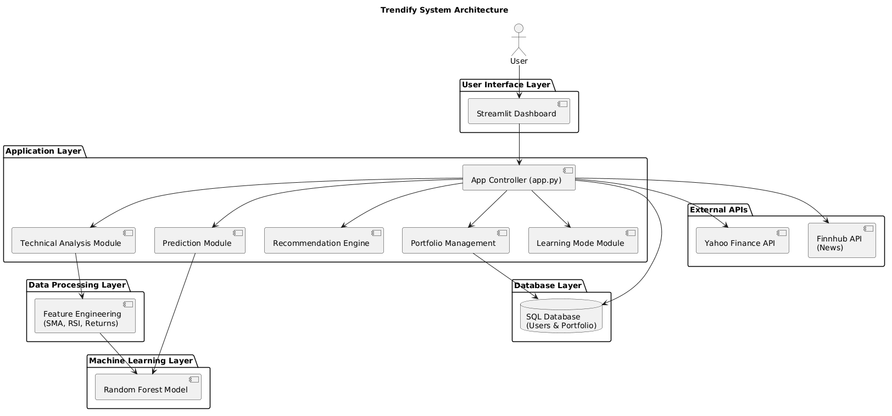

3.2 DATA FLOW DIAGRAM

Figure 1: DFD Level 0 – Context Diagram

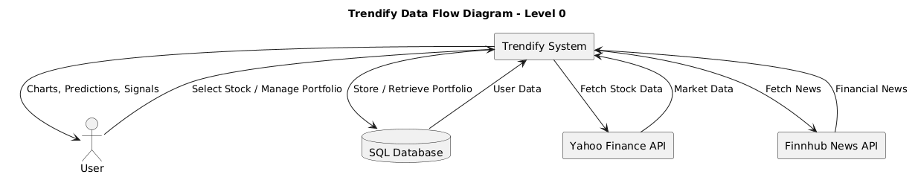

Figure 2: DFD Level 1 – Detailed Diagram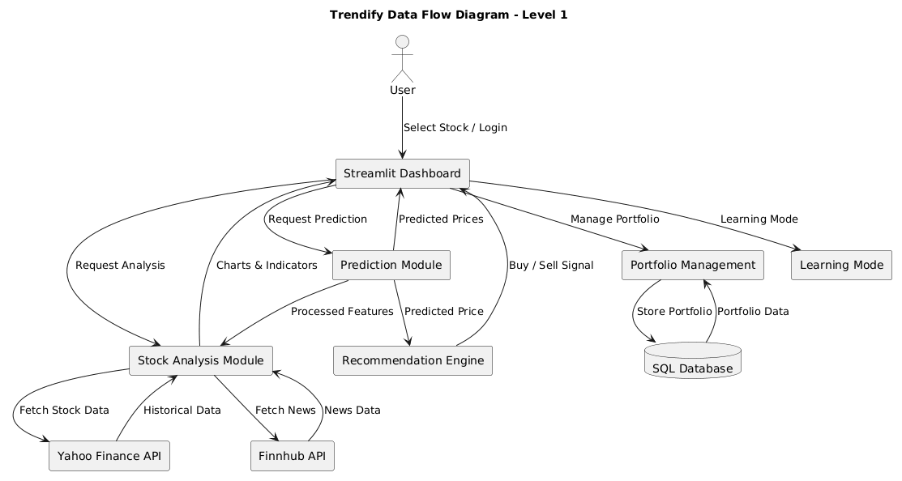

3.3 ENTITY RELATIONSHIP DIAGRAM

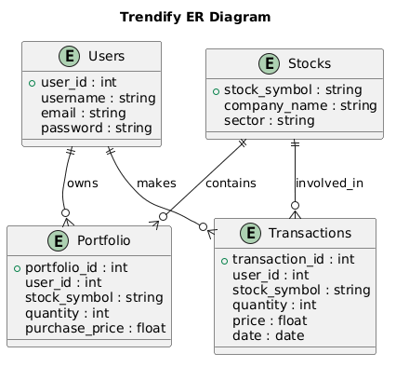

3.4 DATABASE DESIGN

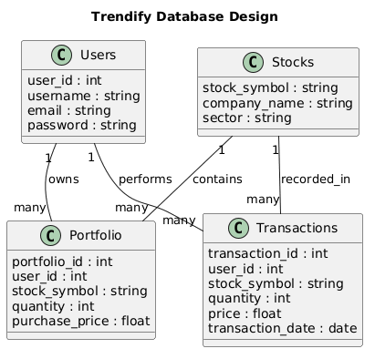

IMPLEMENTATION

4.1 MODULE DESCRIPTION

1. User Authentication Module
The User Authentication Module manages user registration, login, and logout functionalities. It verifies user credentials and allows only authorized users to access the system. User details such as username, email, and password are stored in the SQL database. This module ensures secure access to personalized features like portfolio management.
2. Stock Analysis Module
The Stock Analysis Module is responsible for analyzing stock market data. It fetches historical and live stock data from external APIs and processes it using data analysis libraries. The module calculates technical indicators such as Simple Moving Average (SMA) and Relative Strength Index (RSI), which help users understand market trends and stock performance.
3. Machine Learning Prediction Module
The Machine Learning Prediction Module predicts the future price of stocks using a trained Random Forest Regression model. Historical stock data and engineered features such as open price, close price, volume, and moving averages are used as inputs for the model. The module generates predictions for the next trading day and short-term forecasts.
4. Recommendation Engine Module
The Recommendation Engine analyzes the predicted stock prices and technical indicators to generate investment signals. Based on this analysis, the system provides suggestions such as BUY or SELL signals. This module helps users make better investment decisions by combining prediction results with technical analysis.
5. Portfolio Management Module
The Portfolio Management Module allows users to manage their personal investment portfolio. Users can add stocks, update their holdings, delete entries, and view their portfolio performance. All portfolio data is stored in the SQL database and linked to the user account.
6. News Integration Module
The News Integration Module fetches the latest financial news related to selected stocks using the Finnhub API. This module displays relevant news headlines within the dashboard, helping users stay informed about market events that may influence stock prices.
7. Learning Mode Module
The Learning Mode Module is designed for beginners who want to understand stock market concepts. When this mode is enabled, the system explains technical indicators, prediction logic, and investment signals. This module makes the platform both analytical and educational.
8. Visualization Module
The Visualization Module generates interactive charts and graphical representations of stock data. Using Plotly, the system displays candlestick charts, moving averages, and RSI indicators. These visualizations help users easily interpret stock trends and market behavior.

4.2 ALGORITHMS USED

1. Random Forest Regression Algorithm
Random Forest Regression is a machine learning algorithm used to predict future stock prices. It works by creating multiple decision trees during training and combining their outputs to produce a more accurate prediction. The model analyzes historical stock data such as open price, close price, volume, and technical indicators to estimate the next day’s closing price. Random Forest is chosen because it handles non-linear relationships and reduces overfitting compared to a single decision tree.
2. Simple Moving Average (SMA)
The Simple Moving Average algorithm is used to analyze stock price trends over a specific period. It calculates the average of stock prices for a defined number of days, such as 20-day or 50-day periods. SMA helps identify whether the stock is in an upward or downward trend and is widely used in technical analysis.
Formula:
SMA = (Sum of closing prices over N days) / N
3. Relative Strength Index (RSI)
The Relative Strength Index is a momentum indicator used to measure the speed and change of price movements. It helps determine whether a stock is overbought or oversold.
- RSI > 70 → Overbought condition
- RSI < 30 → Oversold condition
RSI assists the system in generating buy or sell signals.
4. Iterative Forecasting Algorithm
The system uses an iterative forecasting approach to predict stock prices for the next 5–7 days. The predicted value from the model is fed back as input for the next prediction step, allowing the system to generate a short-term forecast of future prices.
5. Recommendation Logic Algorithm
The recommendation engine combines machine learning predictions and technical indicators to generate investment signals. If the predicted price trend is positive and indicators show bullish signals, the system suggests a BUY recommendation. If the trend is negative or indicators show bearish signals, the system generates a SELL signal.

4.3 CODING
App.py
import streamlit as st
import pandas as pd
import numpy as np
import joblib
import os
import yfinance as yf
import requests
from datetime import datetime, timedelta
import plotly.graph_objects as go

# Custom modules
from db_manager import get_users, add_user, get_portfolio, add_portfolio_entry, update_portfolio_entry, delete_portfolio_entry
from analysis import show_analysis
from fundamentals import show_fundamentals
from recommendation import generate_recommendation
from portfolio import show_portfolio
from prediction import show_price_prediction

# PAGE CONFIG
st.set_page_config(page_title="Trendify – Track Trends. Predict Smarter.",layout="wide",initial_sidebar_state="expanded")

# CSS
st.markdown("""
<style>
html, body, [class*="css"] {font-family: 'Inter', sans-serif; background-color: #F8FAFC;}
.main .block-container {padding-top: 2rem; max-width: 1100px;}
.balance-header {background: linear-gradient(135deg, #0061FF 0%, #60EFFF 100%); color:white; padding:40px; border-radius:35px; margin-bottom:30px; box-shadow: 0 10px 20px rgba(0,97,255,0.2);}
.stock-card {background:white; padding:24px; border-radius:24px; box-shadow: 0 4px 12px rgba(0,0,0,0.03); margin-bottom:20px; border:1px solid #F1F5F9;}
.news-row {display:flex; align-items:center; padding:15px; background:white; border-radius:20px; margin-bottom:12px; border:1px solid #F1F5F9; transition:0.2s;}
.news-row:hover {transform: scale(1.01); border-color:#0061FF;}
.rec-pill {padding:8px 20px; border-radius:50px; font-weight:700; display:inline-block; color:white; text-transform:uppercase; font-size:14px;}
#MainMenu {visibility: hidden;} footer {visibility: hidden;}
</style>
""", unsafe_allow_html=True)

# ================= PATHS =================
BASE_DIR = os.path.dirname(os.path.dirname(os.path.abspath(__file__)))
DATA_PATH = os.path.join(BASE_DIR, "data_features")
MODEL_PATH = os.path.join(BASE_DIR, "models")

# ================= SESSION STATE =================
if "users" not in st.session_state: st.session_state.users = get_users()
if "logged_in" not in st.session_state: st.session_state.logged_in = False
if "username" not in st.session_state: st.session_state.username = ""
if "user_id" not in st.session_state: st.session_state.user_id = None
if "learning_mode" not in st.session_state: st.session_state.learning_mode = False

# ================= AUTH UI =================
def login_signup_ui():
st.markdown("<h1 style='text-align:center; color:#1E293B;'>Trendify</h1>", unsafe_allow_html=True)
tab1, tab2 = st.tabs(["Login", "Signup"])
with tab1:
u = st.text_input("Username")
p = st.text_input("Password", type="password")
if st.button("Sign In", use_container_width=True):
users = st.session_state.users
if u in users and users[u][1] == p:
st.session_state.logged_in = True
st.session_state.username = u
st.session_state.user_id = users[u][0]
st.rerun()
else: st.error("Invalid credentials")
if not st.session_state.logged_in:
login_signup_ui()
st.stop()

# ================= SIDEBAR =================
with st.sidebar:
st.markdown(f"### Hello, **{st.session_state.username}** 👋")
stocks = {"TCS": "TCS.NS.csv", "INFY": "INFY.NS.csv", "RELIANCE": "RELIANCE.NS.csv", "HDFCBANK": "HDFCBANK.NS.csv"}
stock_name = st.selectbox("Select Asset", list(stocks.keys()))
st.session_state.learning_mode = st.toggle("🎓 Learning Mode", st.session_state.learning_mode)
use_live = st.toggle("🔴 Live Market", False)
if st.button("Log Out", use_container_width=True):
st.session_state.logged_in = False
st.rerun()

# ================= DATA FETCHING =================
@st.cache_data(ttl=300)
def get_processed_data(symbol, file_name, live=False):
if live:
df = yf.download(symbol + ".NS", period="6mo", interval="1d", progress=False)
if isinstance(df.columns, pd.MultiIndex): df.columns = df.columns.get_level_values(0)
df.reset_index(inplace=True)
df.columns = [col.lower() for col in df.columns]
else:
df = pd.read_csv(os.path.join(DATA_PATH, file_name))
df["date"] = pd.to_datetime(df["date"])
df["daily_return"] = df["close"].pct_change()
return df.dropna()

def calculate_indicators(df):
df["sma_20"] = df["close"].rolling(20).mean()
df["sma_50"] = df["close"].rolling(50).mean()
delta = df["close"].diff()
gain = delta.clip(lower=0)
loss = -delta.clip(upper=0)
avg_gain = gain.rolling(14).mean()
avg_loss = loss.rolling(14).mean()
rs = avg_gain / (avg_loss + 1e-6)
df["rsi"] = 100 - (100 / (1 + rs))
return df

df = get_processed_data(stock_name, stocks[stock_name], use_live)
df = calculate_indicators(df)
latest = df.iloc[-1]

# ================= FUNDAMENTALS =================
ticker = yf.Ticker(stock_name + ".NS")
info = ticker.info

# ================= ML PREDICTION =================
FEATURES = ["open","high","low","close","volume","daily_return","sma_20","sma_50"]
reg_model_path = os.path.join(MODEL_PATH, stocks[stock_name].replace(".csv","_rf_regression.pkl"))
reg_model = joblib.load(reg_model_path)

X = latest[FEATURES].values.reshape(1,-1)
try:
pred_price = reg_model.predict(X)[0]
except Exception:
pred_price = latest["close"]

# ================= TOP HEADER =================
change_pct = ((pred_price - latest["close"])/latest["close"])*100
st.markdown(f"""
<div class="balance-header">
<p style="margin:0; opacity:0.9; font-size:16px; font-weight:500;">Predicted Next Close • {stock_name}</p>
<h1 style="margin:5px 0; font-size:48px; font-weight:700;">₹ {pred_price:.2f}</h1>
<div style="background:rgba(255,255,255,0.2); padding:6px 16px; border-radius:50px; display:inline-block; font-size:14px;">
{'▲' if change_pct>0 else '▼'} {abs(change_pct):.2f}% Expected Move
</div>
<p style="margin-top:5px; font-size:16px;">Current Price: ₹ {latest['close']:.2f}</p>
</div>
""", unsafe_allow_html=True)

# ================= TABS =================
tab1, tab2, tab3, tab4 = st.tabs(["Portfolio","Stock Analysis","Fundamentals","News"])

with tab1:
show_portfolio()

with tab2:
st.subheader(f"📈 Price Chart with SMA & RSI • {stock_name}")
fig = go.Figure()
fig.add_trace(go.Candlestick(x=df["date"], open=df["open"], high=df["high"], low=df["low"], close=df["close"], increasing_line_color="#0061FF", decreasing_line_color="#FF4B4B", name="Price"))
fig.add_trace(go.Scatter(x=df["date"], y=df["sma_20"], mode="lines", line=dict(color="#FFA500"), name="SMA 20"))
fig.add_trace(go.Scatter(x=df["date"], y=df["sma_50"], mode="lines", line=dict(color="#00CFFF"), name="SMA 50"))
fig.update_layout(height=400, xaxis_rangeslider_visible=False, plot_bgcolor="white", paper_bgcolor="rgba(0,0,0,0)")
st.plotly_chart(fig, use_container_width=True)

st.subheader("📊 RSI (14)")
fig_rsi = go.Figure()
fig_rsi.add_trace(go.Scatter(x=df["date"], y=df["rsi"], mode="lines", line=dict(color="#6F42C1"), name="RSI"))
fig_rsi.add_hline(y=70, line_dash="dash", line_color="red", annotation_text="Overbought", annotation_position="top right")
fig_rsi.add_hline(y=30, line_dash="dash", line_color="green", annotation_text="Oversold", annotation_position="bottom right")
fig_rsi.update_layout(height=200, plot_bgcolor="white", paper_bgcolor="rgba(0,0,0,0)")
st.plotly_chart(fig_rsi, use_container_width=True)

st.subheader("🔮 5–7 Day Price Forecast")
future_prices = [latest["close"]]
last_row = latest.copy()
for _ in range(7):
X_future = last_row[FEATURES].values.reshape(1,-1)
try:
next_price = reg_model.predict(X_future)[0]
except:
next_price = last_row["close"]
future_prices.append(next_price)
# Update rolling features
last_row["open"] = last_row["close"]
last_row["high"] = next_price*1.01
last_row["low"] = next_price*0.99
last_row["close"] = next_price
last_row["sma_20"] = (last_row["sma_20"]*19 + next_price)/20
last_row["sma_50"] = (last_row["sma_50"]*49 + next_price)/50
future_dates = pd.date_range(df["date"].iloc[-1]+pd.Timedelta(days=1), periods=7)
fig_future = go.Figure()
fig_future.add_trace(go.Scatter(x=future_dates, y=future_prices[1:], mode="lines+markers", name="Predicted Price", line=dict(color="#22C55E")))
fig_future.update_layout(height=300, plot_bgcolor="white", paper_bgcolor="rgba(0,0,0,0)")
st.plotly_chart(fig_future, use_container_width=True)

with tab3:
show_fundamentals(stock_name, info, latest, st.session_state.learning_mode)

with tab4:
st.subheader("Latest News")
def get_filtered_financial_news(stock_name):
api_key = os.getenv("FINNHUB_API_KEY")
if not api_key: return []
url = f"https://finnhub.io/api/v1/news?category=general&token={api_key}"
try:
response = requests.get(url)
data = response.json()
if not isinstance(data, list): return []
filtered_news = [a for a in data if stock_name.lower() in a.get("headline","").lower() or stock_name.lower() in a.get("summary","").lower()]
return filtered_news[:5] if filtered_news else data[:5]
except: return []

news = get_filtered_financial_news(stock_name)
for article in news[:3]:
st.markdown(f"""
<div class="news-row">
<div style="background:#EFF6FF; padding:12px; border-radius:15px; margin-right:15px;">📰</div>
<div style="flex-grow:1;">
<h4 style="margin:0; font-size:15px; color:#1E293B;">{article.get('headline','')}</h4>
<p style="margin:0; font-size:12px; color:#64748B;">Source: Market Intel</p>
</div>
<a href="{article.get('url','#')}" target="_blank" style="text-decoration:none; color:#0061FF; font-weight:700;">VIEW</a>
</div>
""", unsafe_allow_html=True)

Prediction.py
import pandas as pd
import numpy as np
import streamlit as st

def show_price_prediction(df, reg_model, days=7):
st.subheader("🔮 Next 7 Days Price Prediction")

future_prices = []
temp_df = df.copy()

for i in range(days):
latest = temp_df.iloc[-1]

features = ["open", "high", "low", "close", "volume","daily_return", "sma_10", "sma_50"]

X = latest[features].values.reshape(1, -1)
pred_price = reg_model.predict(X)[0]

# Add small volatility for realism (optional but recommended)
volatility = np.random.normal(0, 0.003)
pred_price = pred_price * (1 + volatility)

future_prices.append(pred_price)

# Create new synthetic row
new_row = latest.copy()

new_row["open"] = latest["close"]
new_row["high"] = pred_price * 1.01
new_row["low"] = pred_price * 0.99
new_row["close"] = pred_price
new_row["volume"] = latest["volume"]

new_row["daily_return"] = (pred_price - latest["close"]) / latest["close"]

temp_df = pd.concat([temp_df, pd.DataFrame([new_row])], ignore_index=True)

# 🔥 Recalculate SMAs so they evolve
temp_df["sma_10"] = temp_df["close"].rolling(10).mean()
temp_df["sma_50"] = temp_df["close"].rolling(50).mean()

future_df = pd.DataFrame({
"Day": [f"Day {i+1}" for i in range(days)],
"Predicted Close": [round(price, 2) for price in future_prices]})

st.dataframe(future_df)
st.area_chart(future_df.set_index("Day"))

Portfolio.py
import streamlit as st
import matplotlib.pyplot as plt
from db_manager import get_portfolio, add_portfolio_entry, update_portfolio_entry, delete_portfolio_entry
import yfinance as yf

# ==============================
# Cached Live Price
# ==============================
@st.cache_data(ttl=300)
def get_live_price(symbol):
try:
stock = yf.Ticker(symbol)
data = stock.history(period="1d")
if not data.empty:
return float(data["Close"].iloc[-1])
return None
except:
return None

# ==============================
# Tracked Stocks
# ==============================
STOCK_LIST = {"Reliance Industries": "RELIANCE.NS","TCS": "TCS.NS","Infosys": "INFY.NS","HDFC Bank": "HDFCBANK.NS","ICICI Bank": "ICICIBANK.NS}
# Portfolio UI
def show_portfolio():
st.subheader("💼 Your Portfolio")

user_id = st.session_state.user_id
portfolio = get_portfolio(user_id)

# ===== Add / Update Stock =====
st.markdown("### ➕ Add / Update Stock")
col1, col2, col3 = st.columns(3)
with col1:
stock_name = st.selectbox("Select Stock", list(STOCK_LIST.keys()))
symbol = STOCK_LIST[stock_name]
with col2:
buy_price = st.number_input("Buy Price (₹)", min_value=0.0, format="%.2f")
with col3:
quantity = st.number_input("Quantity", min_value=1, step=1)

if st.button("Add / Update"):
if symbol in [s for s, _, _ in portfolio]:
# Update existing
for s, qty, price in portfolio:
if s == symbol:
new_qty = qty + quantity
new_avg_price = (price * qty + buy_price * quantity) / new_qty
update_portfolio_entry(user_id, symbol, new_qty, new_avg_price)
st.success(f"Updated {stock_name} in portfolio!")
break
else:
# Add new
add_portfolio_entry(user_id, symbol, quantity, buy_price)
st.success(f"Added {stock_name} to portfolio!")
st.rerun()

st.markdown("---")

# ===== Portfolio Table & Charts =====
portfolio = get_portfolio(user_id)
if portfolio:
total_invested = 0
total_current = 0
allocation_data = {}
pl_data = {}

for symbol, qty, buy_price in portfolio:
current_price = get_live_price(symbol) or buy_price
invested = qty * buy_price
current_value = qty * current_price
pl = current_value - invested
return_percent = (pl / invested * 100) if invested != 0 else 0

total_invested += invested
total_current += current_value
allocation_data[symbol] = current_value
pl_data[symbol] = pl

col1, col2 = st.columns([3,1])
with col1:
st.markdown(f"**{symbol}**")
st.write(f"Quantity: {qty}")
st.write(f"Avg Buy Price: ₹ {buy_price:.2f}")
st.write(f"Current Price: ₹ {current_price:.2f}")
if pl >=0:
st.success(f"P/L: ₹ {pl:.2f} ({return_percent:.2f}%)")
else:
st.error(f"P/L: ₹ {pl:.2f} ({return_percent:.2f}%)")
with col2:
if st.button("❌ Delete", key=symbol):
delete_portfolio_entry(user_id, symbol)
st.rerun()

st.markdown("---")

# ===== Portfolio Summary =====
net_pl = total_current - total_invested
net_percent = (net_pl / total_invested * 100) if total_invested != 0 else 0
st.subheader("📊 Portfolio Summary")
st.write(f"Total Invested: ₹ {total_invested:.2f}")
st.write(f"Total Current Value: ₹ {total_current:.2f}")
if net_pl >= 0:
st.success(f"Net P/L: ₹ {net_pl:.2f} ({net_percent:.2f}%)")
else:
st.error(f"Net P/L: ₹ {net_pl:.2f} ({net_percent:.2f}%)")

# ===== Allocation Pie Chart =====
st.subheader("📈 Portfolio Allocation")
fig1, ax1 = plt.subplots()
ax1.pie(allocation_data.values(), labels=allocation_data.keys(), autopct="%1.1f%%")
ax1.axis("equal")
st.pyplot(fig1)

# ===== Profit/Loss Bar Chart =====
st.subheader("💹 Profit/Loss per Stock")
fig2, ax2 = plt.subplots()
colors = ['green' if val>=0 else 'red' for val in pl_data.values()]
bars = ax2.bar(pl_data.keys(), pl_data.values(), color=colors)
ax2.set_ylabel("Profit / Loss (₹)")
ax2.set_xticks(range(len(pl_data)))
ax2.set_xticklabels(pl_data.keys(), rotation=45)
st.pyplot(fig2)
for i, val in enumerate(pl_data.values()):
ax2.text(i, val, f"{val:.0f}", ha='center', va='bottom' if val>=0 else 'top')

else:
st.info("Portfolio empty.")

TESTING

5.1 TEST CASES

Test Case ID | Test Case Description | Input | Expected Output | Result
TC01 | User Registration | Enter username, email, password | User account created successfully | Pass
TC02 | User Login | Valid email and password | User logged into dashboard | Pass
TC03 | Invalid Login | Incorrect email or password | Error message displayed | Pass
TC04 | Stock Selection | Select a stock (e.g., TCS) | Stock data and charts displayed | Pass
TC05 | Technical Analysis | Request SMA and RSI indicators | Indicators displayed on charts | Pass
TC06 | Stock Price Prediction | Click predict option | Predicted stock price displayed | Pass
TC07 | News Fetching | Select stock for news | Latest financial news displayed | Pass
TC08 | Add Stock to Portfolio | Enter stock symbol and quantity | Stock added to portfolio | Pass
TC09 | Update Portfolio | Modify quantity of stock | Updated portfolio data shown | Pass
TC10 | Delete Portfolio Entry | Remove stock from portfolio | Stock removed from list | Pass
TC11 | Recommendation System | Run analysis and prediction | Buy/Sell signal generated | Pass
TC12 | Learning Mode | Enable learning mode | Explanations of indicators displayed | Pass

5.2 OUTPUT SCREENS

Homepage
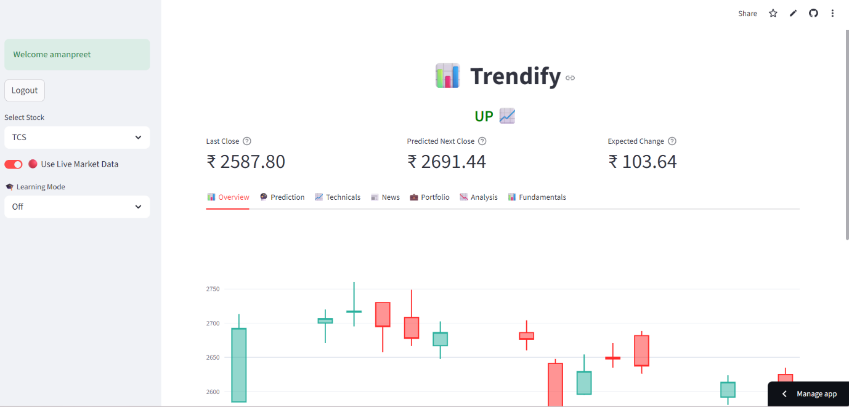

PRICE PREDICTION

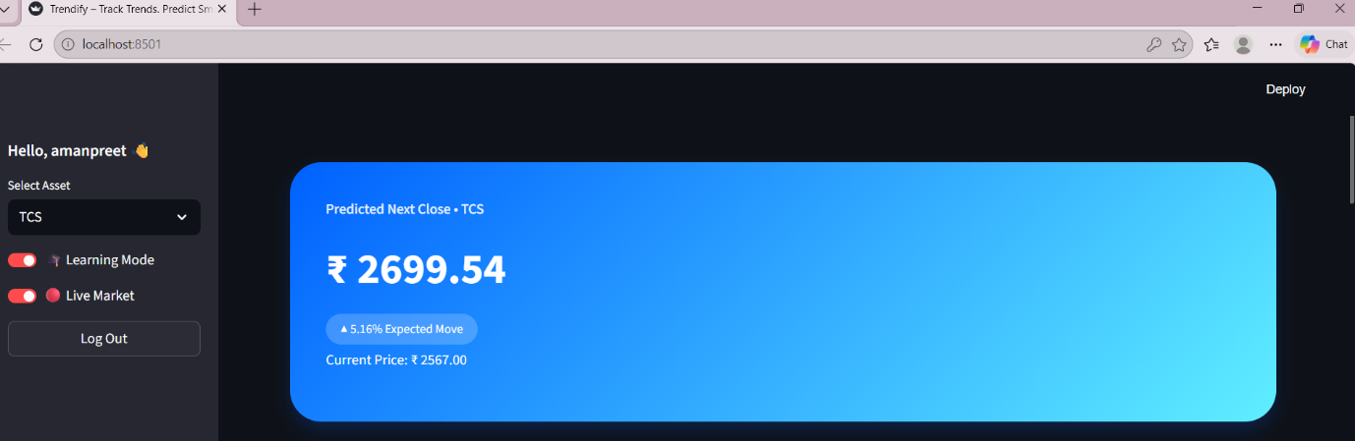

PORTFOLIO

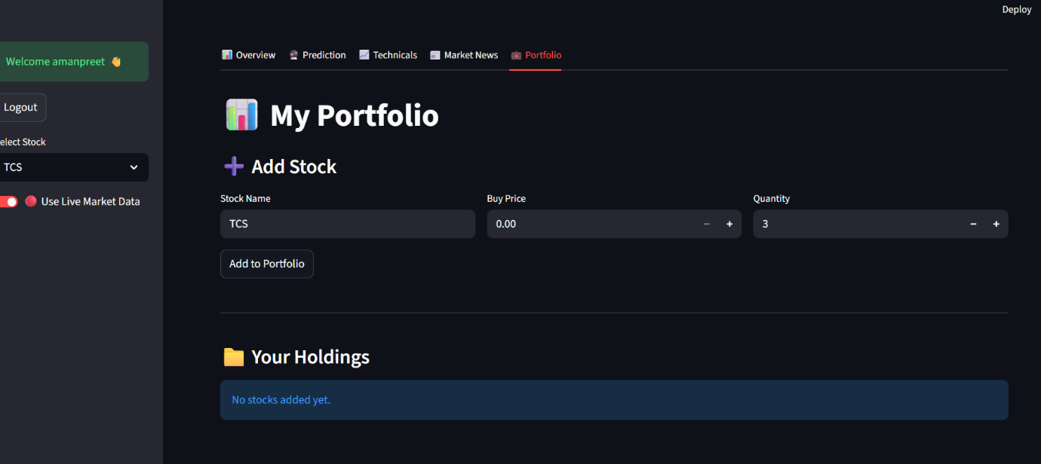

HISTORICAL ANALYSIS
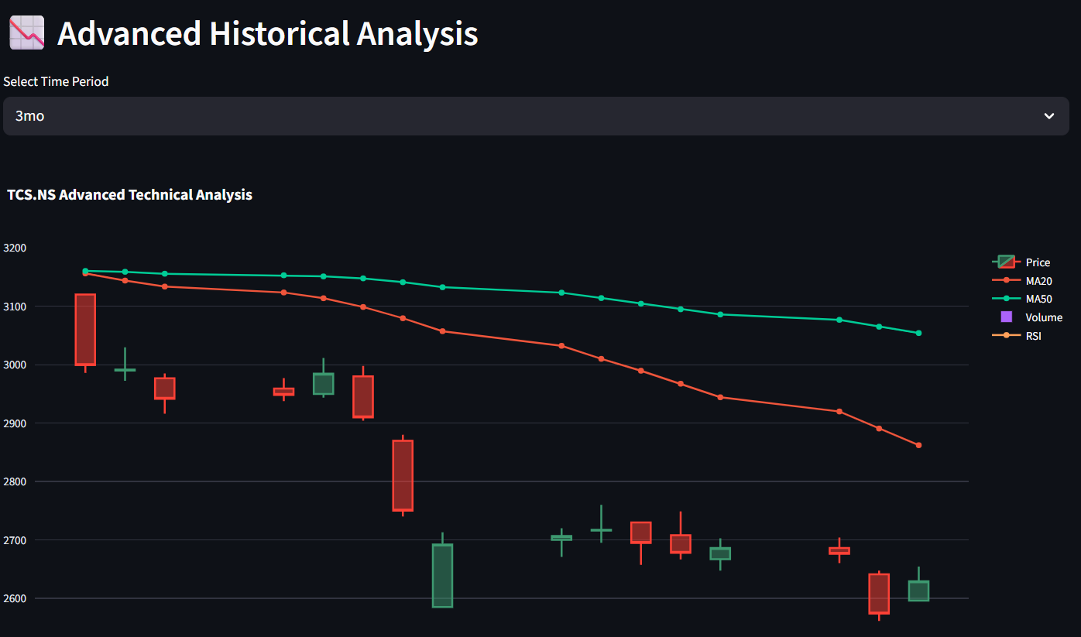

RSI INDICATOR
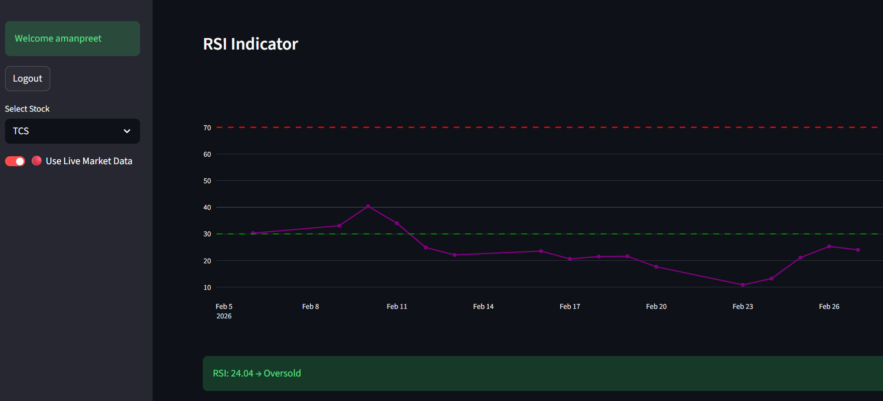

5.3 ERROR HANDLING

Error Handling
Error handling is an important aspect of the Trendify system to ensure smooth operation and prevent system crashes during unexpected situations. The application includes mechanisms to detect, manage, and respond to errors that may occur during execution.
1. Input Validation
The system validates user inputs to ensure that correct and meaningful data is entered. For example, the system checks whether required fields such as username, email, and password are filled during registration. Invalid inputs are rejected and appropriate error messages are displayed.
2. Login Authentication Errors
If a user enters incorrect login credentials, the system displays an error message indicating that the email or password is invalid. This prevents unauthorized access to the dashboard.
3. API Connection Errors
The system retrieves stock data and financial news from external APIs such as Yahoo Finance and Finnhub. If the API connection fails due to network issues or unavailable services, the system handles the exception and displays a message informing the user that the data could not be retrieved.
4. Database Errors
Database operations such as storing and retrieving user or portfolio data are handled carefully. If any database error occurs, such as missing records or failed queries, the system prevents application crashes and informs the user appropriately.
5. Prediction Model Errors
The machine learning prediction module includes checks to ensure that the required data is available before generating predictions. If insufficient data is present, the system displays a message indicating that prediction cannot be performed.
6. General Exception Handling
The system uses exception handling techniques to manage unexpected runtime errors. This ensures that the application continues functioning and provides informative messages instead of terminating abruptly.

RESULT AND DISCUSSION

6.1 PROJECT OUTPUT SUMMARY

The Trendify system successfully provides a comprehensive platform for stock market analysis, prediction, and portfolio management. The application integrates machine learning, technical analysis, and real-time financial data to assist users in understanding stock market trends and making informed investment decisions.
The system allows users to register and log in securely to access personalized features. After logging in, users can select different stocks to view historical data, technical indicators, and interactive charts. The dashboard displays important stock information such as current price, moving averages, and momentum indicators.
The machine learning module predicts the next day’s stock price using a trained Random Forest Regression model. Based on these predictions and technical indicators, the system generates investment recommendations such as buy or sell signals.
The application also includes a portfolio management feature that enables users to add, update, or remove stocks from their personal portfolio. This allows users to track their investments efficiently.
In addition, the system integrates financial news related to selected stocks using the Finnhub API. This feature helps users stay informed about market events that may affect stock prices.
A special learning mode is included to explain technical indicators and prediction logic, making the system useful for beginners who want to learn about stock market analysis.
Overall, the Trendify project demonstrates how machine learning, financial data analysis, and interactive visualization can be combined to create an intelligent stock market analysis platform. The system provides valuable insights into stock trends while maintaining a user-friendly and educational interface.

6.2 PERFORMANCE ANALYSIS

Performance analysis is conducted to evaluate the efficiency, accuracy, and responsiveness of the Trendify system. The system’s performance is measured based on prediction accuracy, system responsiveness, data processing capability, and user experience.
1. Prediction Accuracy
The machine learning model used in the system is Random Forest Regression. The model is trained using historical stock market data and evaluated using metrics such as Mean Absolute Error (MAE) and Mean Squared Error (MSE). The results indicate that the model provides reasonably accurate short-term stock price predictions.
2. System Response Time
The application is designed using Streamlit, which allows quick rendering of dashboards and charts. The system efficiently retrieves stock data from external APIs and processes it in real time, ensuring minimal delay in displaying results to the user.
3. Data Processing Efficiency
Libraries such as Pandas and NumPy are used for handling and processing large financial datasets. These libraries enable fast calculations of technical indicators like Simple Moving Average (SMA) and Relative Strength Index (RSI), ensuring efficient analysis of stock market data.
4. Visualization Performance
Interactive charts are generated using Plotly, which allows users to explore stock price movements dynamically. The charts load quickly and provide smooth interaction, improving the user’s ability to analyze trends effectively.
5. Database Performance
The system uses a SQL-based database for storing user accounts and portfolio data. SQL ensures structured storage, faster querying, and better data management compared to earlier JSON-based storage.
6. System Reliability
The system includes error handling mechanisms to manage issues such as API failures, invalid inputs, and database errors. These mechanisms improve system stability and ensure continuous operation without unexpected crashes.
Conclusion
The performance evaluation shows that the Trendify system operates efficiently and provides accurate predictions, quick data processing, and responsive user interaction. The integration of machine learning, real-time data retrieval, and interactive visualization ensures that the system performs effectively for stock market analysis and decision support.

CONCLUSION & FUTURE SCOPE

7.1 CONCLUSION

The Trendify project successfully demonstrates the application of data analysis and machine learning techniques in the field of stock market prediction and analysis. The system integrates historical stock data, technical indicators, and machine learning algorithms to provide meaningful insights into stock market trends.
The project provides a user-friendly dashboard where users can view stock prices, analyze technical indicators, and receive predicted stock prices using a trained Random Forest Regression model. The integration of interactive charts and visualization tools helps users better understand stock market behavior and trends.
The system also includes additional features such as portfolio management, financial news integration, and a learning mode for beginners. These features make the platform both analytical and educational, allowing users to gain knowledge about stock market concepts while tracking their investments.
By combining machine learning, financial data analysis, and modern web-based visualization, the Trendify system serves as an intelligent decision-support tool for stock market analysis. The project highlights the potential of data-driven approaches in financial forecasting and demonstrates how technology can assist users in making informed investment decisions.
Overall, the project fulfills its objectives by creating a functional and interactive stock market analysis platform that integrates prediction, visualization, and portfolio management into a single system.

7.2 FUTURE ENHANCEMENTS

1. Advanced Machine Learning Models
The system currently uses a Random Forest Regression model for stock price prediction. In the future, more advanced models such as Long Short-Term Memory (LSTM) networks or other deep learning techniques can be implemented to improve prediction accuracy for time-series financial data.
2. Sentiment Analysis from News
Future versions of the system can include sentiment analysis of financial news and social media data. By analyzing whether news articles are positive, negative, or neutral, the system can better predict the possible impact of news on stock prices.
3. More Technical Indicators
Additional technical indicators such as MACD, Bollinger Bands, and Moving Average Convergence Divergence can be integrated to provide deeper insights into stock trends and improve the recommendation system.
4. Risk Analysis Module
A risk analysis module can be added to evaluate the risk associated with different investments. This feature would help users understand the volatility of stocks and make more balanced investment decisions.
5. Mobile Application
The system can be extended into a mobile application so that users can easily access stock analysis, predictions, and portfolio information from their smartphones.
6. Real-Time Notifications
Future improvements can include notification systems that alert users about significant stock price changes, prediction updates, or important financial news.
7. Expanded Stock Coverage
Currently, the system focuses on selected stocks. In the future, the system can support a larger number of companies and global stock markets.
8. Cloud-Based Database
The database can be migrated to a cloud-based system to support a larger number of users and provide better scalability and performance.

REFERENCES / BIBLIOGRAPHY

8.REFERENCES / BIBLIOGRAPHY

- Hands-On Machine Learning with Scikit-Learn, Keras,and TensorFlow, Aurélien Géron, O’Reilly Media, 2019.
- Python for Data Analysis, Wes McKinney, O’Reilly Media, 2017.
- Yahoo Finance API – Stock market data used for historical and live price information.
- Finnhub API – Financial news data used for stock-related news integration.
- Streamlit – Framework used for building the web dashboard.
- Scikit-learn – Machine learning library used for implementing the Random Forest Regression model.
- Pandas – Data manipulation and analysis library used for processing stock datasets.
- NumPy – Library used for numerical computations.
- Plotly – Used for creating interactive financial charts and visualizations.

APPENDIX

9.APPENDIX

Appendix A: Sample Code
The following sample code demonstrates how the machine learning model is trained and used for stock price prediction in the Trendify system.
import pandas as pd
from sklearn.model_selection import train_test_split
from sklearn.ensemble import RandomForestRegressor
# Load dataset
data = pd.read_csv("stock_data.csv")
# Select features and target
X = data[['Open', 'High', 'Low', 'Close', 'Volume']]
y = data['Close']
# Split dataset
X_train, X_test, y_train, y_test = train_test_split(X, y, test_size=0.2)
# Train model
model = RandomForestRegressor()
model.fit(X_train, y_train)
# Predict stock prices
predictions = model.predict(X_test)
This code shows how the system processes stock data, trains a machine learning model, and generates predictions.

Appendix B: Alerts
The Trendify system provides alerts and messages to inform users about important system events.
Examples of alerts include:
- Login Alert: Displays an error message if incorrect login credentials are entered.
- Prediction Alert: Displays predicted stock price and expected trend direction.
- Portfolio Alert: Confirms when a stock is successfully added or removed from the portfolio.
- API Alert: Notifies users if stock data or news cannot be fetched due to API connection issues.
These alerts help improve user interaction and ensure that users are informed about system activities.

Appendix C: Testing Tools
Several tools and libraries were used to test and verify the performance of the Trendify system.
Tool | Purpose
Python | Core programming language used to develop and test the system
Streamlit | Used to test and run the web application dashboard
Scikit-learn | Used for training and testing machine learning models
Pandas | Used for data preprocessing and testing data manipulation
Plotly | Used to test visualization and chart rendering
These tools helped ensure that the system performs efficiently and produces accurate outputs.

Appendix D: Glossary
Term | Description
Stock Market | A marketplace where shares of companies are bought and sold.
Machine Learning | A branch of artificial intelligence that allows systems to learn from data and make predictions.
Random Forest | A machine learning algorithm used for prediction by combining multiple decision trees.
Technical Indicators | Mathematical calculations used to analyze stock price trends.
SMA (Simple Moving Average) | Indicator that calculates the average price over a specific period.
RSI (Relative Strength Index) | Indicator used to measure stock momentum and identify overbought or oversold conditions.
API | Application Programming Interface used to fetch data from external services.
Portfolio | A collection of financial investments owned by a user.

