**Topics: Descriptive Statistics and Probability**

1. Look at the data given below. Plot the data, find the outliers and find out $μ, σ, σ^{2}$

|  |  |
| --- | --- |
| **Name of company** | **Measure X** |
| Allied Signal | 24.23% |
| Bankers Trust | 25.53% |
| General Mills | 25.41% |
| ITT Industries | 24.14% |
| J.P.Morgan & Co. | 29.62% |
| Lehman Brothers | 28.25% |
| Marriott | 25.81% |
| MCI | 24.39% |
| Merrill Lynch | 40.26% |
| Microsoft | 32.95% |
| Morgan Stanley | 91.36% |
| Sun Microsystems | 25.99% |
| Travelers | 39.42% |
| US Airways | 26.71% |
| Warner-Lambert | 35.00% |

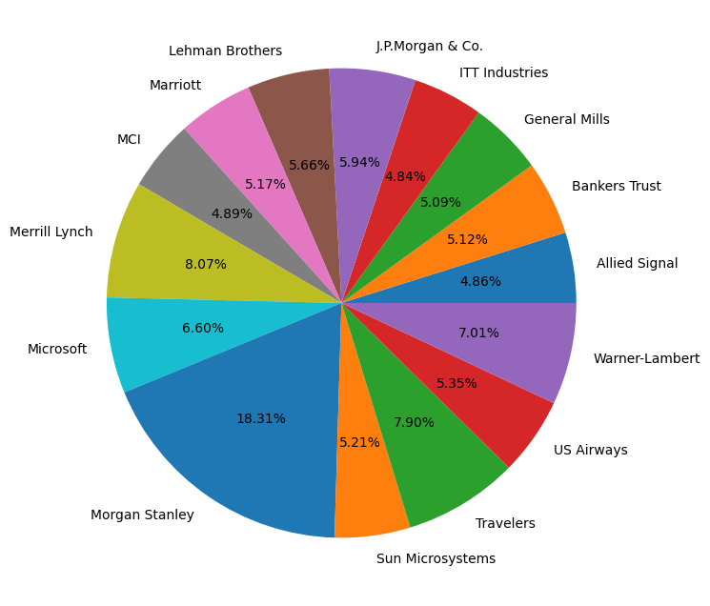

**MORGAN STANLEY HAS LARGER PORTION**

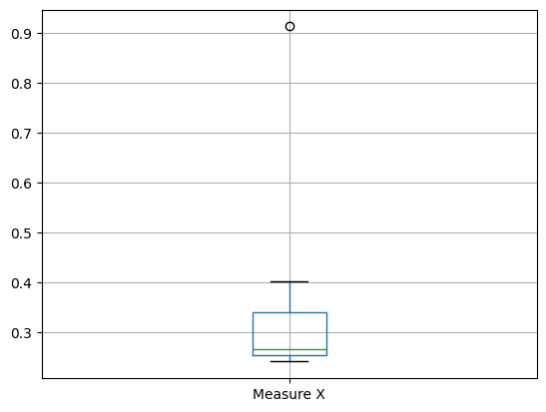

**THIS IS RIGHT SKEWED AND HAVE OUTLIER ON UPPER SIDE**



Answer the following three questions based on the box-plot above.

1. What is inter-quartile range of this dataset? (please approximate the numbers) In one line, explain what this value implies.

**SOL:- Here, Q1=5, Q3=12,Median=7**

**SO, IQR=Q3-Q1=12-5=7**

1. What can we say about the skewness of this dataset?

**SOL:- This is Positive Skewed as the gap between the median to the right side is more than**

**the other side.**

1. If it was found that the data point with the value 25 is actually 2.5, how would the new box-plot be affected?

**SOL:- There is as huge difference between 25 and 2.5 so the median will decrease and the IQR may also differ and outliers would be changed.**

1. 

Answer the following three questions based on the histogram above.

1. Where would the mode of this dataset lie?

**SOL:- As we can see the above graph,here the two bars between 4 and 10 is longest as compare to others,so the mode would lie between of them.**

1. Comment on the skewness of the dataset.

**SOL:- This is the right skewed data**

1. Suppose that the above histogram and the box-plot in question 2 are plotted for the same dataset. Explain how these graphs complement each other in providing information about any dataset.

**SOL:- After seen both the graphs we found that there is outliers in boxplot and histogram at point of 25 and maybe median is nearly same.**

1. AT&T was running commercials in 1990 aimed at luring back customers who had switched to one of the other long-distance phone service providers. One such commercial shows a businessman trying to reach Phoenix and mistakenly getting Fiji, where a half-naked native on a beach responds incomprehensibly in Polynesian. When asked about this advertisement, AT&T admitted that the portrayed incident did not actually take place but added that this was an enactment of something that “could happen.” Suppose that one in 200 long-distance telephone calls is misdirected. What is the probability that at least one in five attempted telephone calls reaches the wrong number? (Assume independence of attempts.)

**SOL:- P(all calls misdirected)=1/200**

**P(one call correctly directed)=1-1/200**

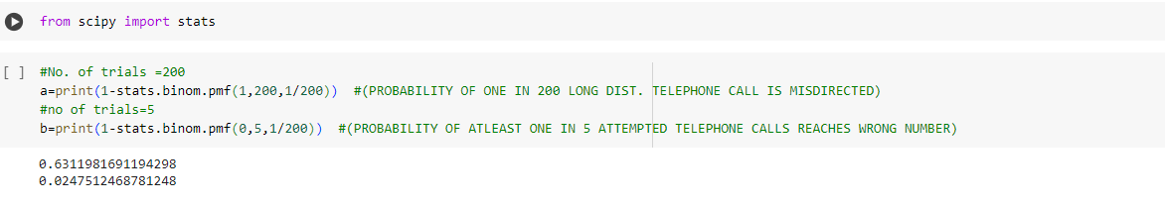

**P(atleast one in five attempted calls reaches wrong number)=0.02475**

1. Returns on a certain business venture, to the nearest $1,000, are known to follow the following probability distribution

|  |  |
| --- | --- |
| x | P(x) |
| -2,000 | 0.1 |
| -1,000 | 0.1 |
| 0 | 0.2 |
| 1000 | 0.2 |
| 2000 | 0.3 |
| 3000 | 0.1 |

|  |  |
| --- | --- |
| E(X)=(X.P(X) | E(X^2)=X^2.P(X) |
| -200 | 400000 |
| -100 | 100000 |
| 0 | 0 |
| 200 | 200000 |
| 600 | 1200000 |
| 300 | 900000 |
| TOTAL=800 | 2800000 |

1. What is the most likely monetary outcome of the business venture?

**SOL:- 2000 WOULD BE THE MOST LIKELY MONETARY OUTCOME AS IT IS HIGHEST AS COMPARED TO OTHERS**

1. Is the venture likely to be successful? Explain

**SOL:- P(0 TO 3000) IS 0.8 WHICH MEANS 80% SO THERE IS GOOD CHANCE FOR MAKING PROFIT**

1. What is the long-term average earning of business ventures of this kind? Explain

**SOL:- THE AVERAGE EARNING IS $800.**

**E(X)=SUM(X.P(X))**

1. What is the good measure of the risk involved in a venture of this kind? Compute this measure

**SOL:- RISK INVOLVED IN VENTURE DEPENDS UPON VARIANCE, HIGHER VARIANCE MEANS**

**MORE CHANCE OF RISK.**

**VAR(X)=E(X^2)-(E(X))^2=2800000-800^2=2160000**