1. **letter based on thank you author of his book on depression.**

Dear Anurag Raichand

Reading is something that I run to whenever life gets hard or I face dejections from everywhere. This time my situation was worst and I ended up in depression. I was alone since a week and then through a social site, I encountered with your esteemed book - "Tackle Depression with Fighting Spirit". The name of the book equally complimented with its content.

I would like to thank you for teaching me the real meaning of fighting. I truly adhered that the fight is within us and not with the people around. The key to success is hope, patience and perseverance along with hard work and this precept comprehended from your book. The way you articulated about various characters make the readers feel very much connected to those

The credit of making me a competitive person goes to your book and I have already suggested the book to all my near and dear ones. And I would like to add that if somebody says that they only have one life to live must not have read a book

Thanking you again and hoping to read such encouraging books from you more.

Yours faithfully

ABCD

**From:**  
Aman

**Dear Akash,**

I hope this message finds you well. Reading has always been my refuge, especially during challenging times when I need motivation and perspective. Last month, I went through a difficult period, facing setbacks in both my health and work. At that time, I discovered your book, The Real Motivation is Inside You, through social media, and I felt compelled to read it.

Your book has been transformative for me. It helped me understand that true motivation is within us, waiting to be unlocked. The insights I gained have shifted my outlook, helping me to appreciate life and be grateful for all that we have, even during tough times.

I’ve recommended your book to friends and family, and they, too, have found great value in its message. Your work is truly impactful, and I appreciate the way you’re inspiring countless readers through your words.

Thank you for creating something so meaningful. I look forward to exploring more of your work in the future.

Warm regards,  
Aman

Here’s a simpler version of your letter:

**From:**  
Aman

**Dear Akash,**

I hope you’re doing well. I like to read whenever I feel down or need some motivation. Last month, I was going through a tough time with my health and work, and that’s when I came across your book, *The Real Motivation is Inside You*, on social media. I decided to read it, and it changed my mindset completely.

Your book helped me realize that real motivation comes from within. It taught me to appreciate life and be thankful for what we have, even when things get hard. I’ve shared your book with my friends and family, and they’ve enjoyed it too. You’re doing amazing work by inspiring so many people through your writing.

Thank you for creating something so impactful. I look forward to reading more of your books in the future.

Best regards,  
Aman

1. **Wriet a latter to your bank maneger regarding some fraudent transtion happend in your account.**

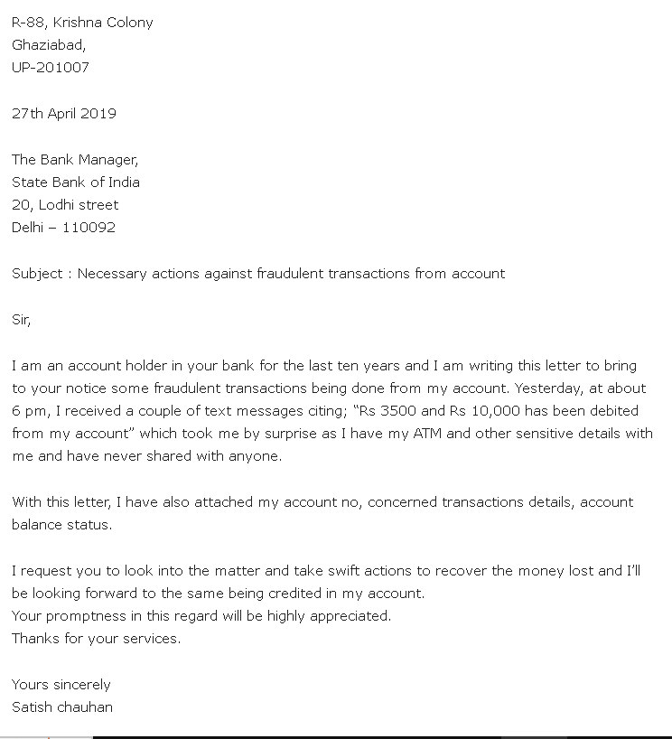

[Your Address]  
[City, Zip Code]  
[Date]

The Manager  
[Bank Name]  
[Branch Address]  
[City, Zip Code]

Subject: Report of Fraudulent Transactions in My Bank Account

Dear Sir/Madam,

I am writing to bring to your notice certain unauthorized transactions in my bank account ([Account Number]). Recently, I noticed that on [Date(s)], several transactions totaling Rs. [Amount] were made from my account, which I did not authorize.

Upon noticing these unusual activities, I immediately secured my account by changing my login credentials. However, I request that you take urgent action to investigate these transactions, and if possible, stop any further unauthorized access to my account. Additionally, please assist me with any further steps to secure my account and initiate the necessary procedures for reimbursement.

Enclosed are transaction details for your reference. Your prompt action in resolving this matter would be greatly appreciated.

Thank you for your assistance.

Sincerely,  
[Your Full Name]  
[Contact Number]  
[Email Address]

**## Write a latter to insurance company for the claim of damage to your car.**

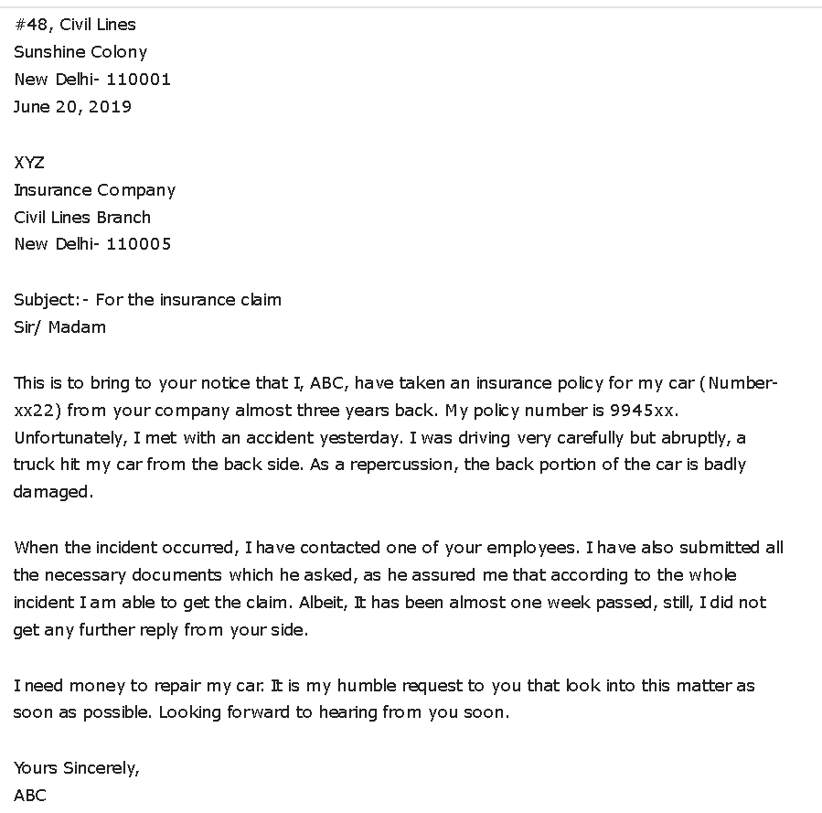

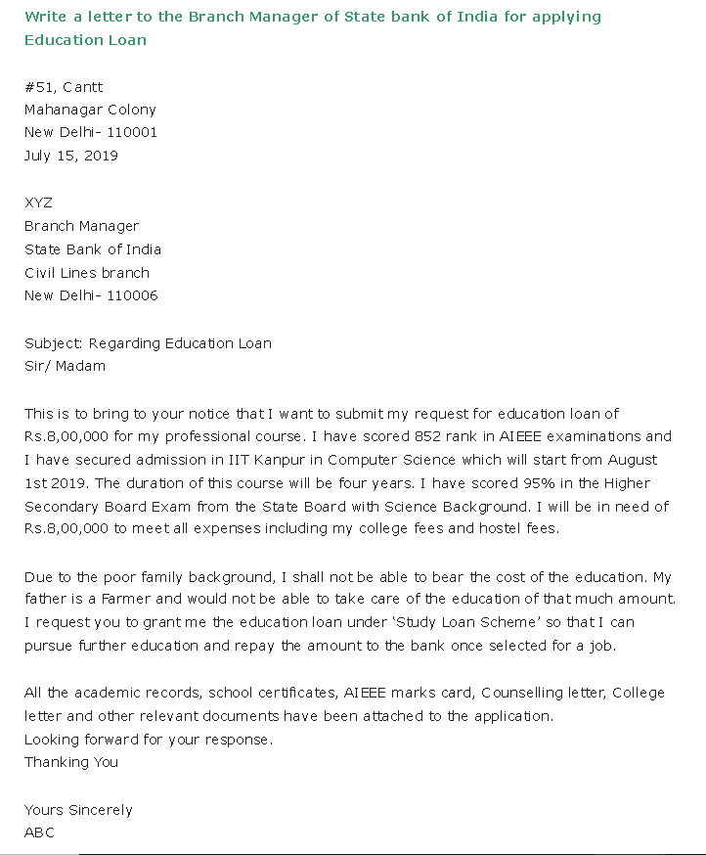

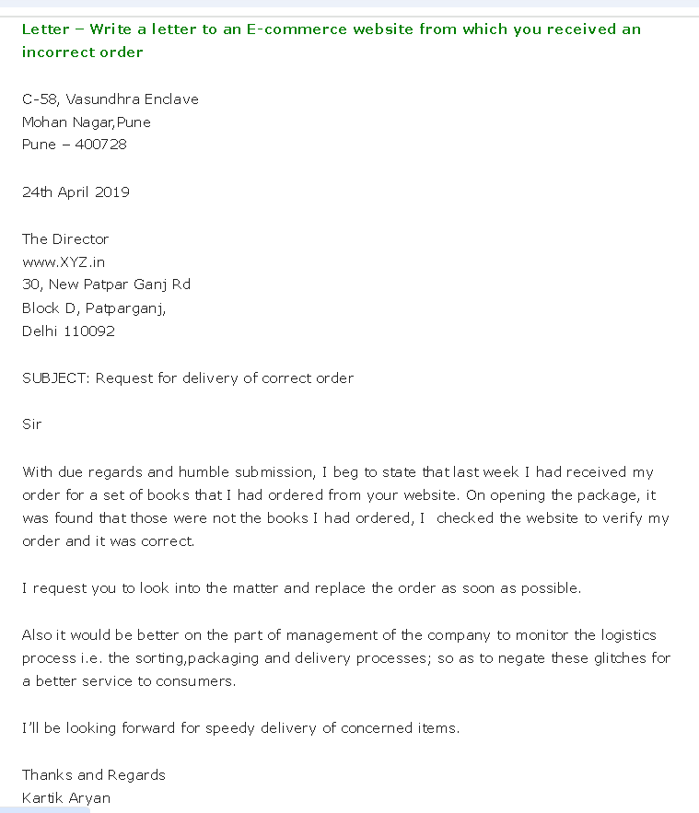

[Your Name]

[Your Address]

[City, State, Zip Code]

[Date]

Customer Service Department

[Company Name]

[Website Address]

[City, State, Zip Code]

Subject: Incorrect Order Received – Order #[Order Number]

Dear Customer Service Team,

I am writing to bring to your attention an issue with an order I recently placed on your website. On [Order Date], I ordered [Description of the Item(s) Ordered] from your website under order number [Order Number]. However, upon receiving the delivery on [Delivery Date], I found that the items delivered did not match the items I had ordered.

The items received were [Description of Incorrect Items Received]. This is not what I expected based on my original order. I kindly request that you look into this matter and advise on the process for returning the incorrect items. Additionally, please let me know when I can expect the correct order to be shipped.

Please feel free to reach me at [Your Contact Number] or [Your Email Address] if you require any further information to resolve this issue. I would appreciate your prompt response and assistance in this matter.

Thank you for your attention to this.

Sincerely,

[Your Name]

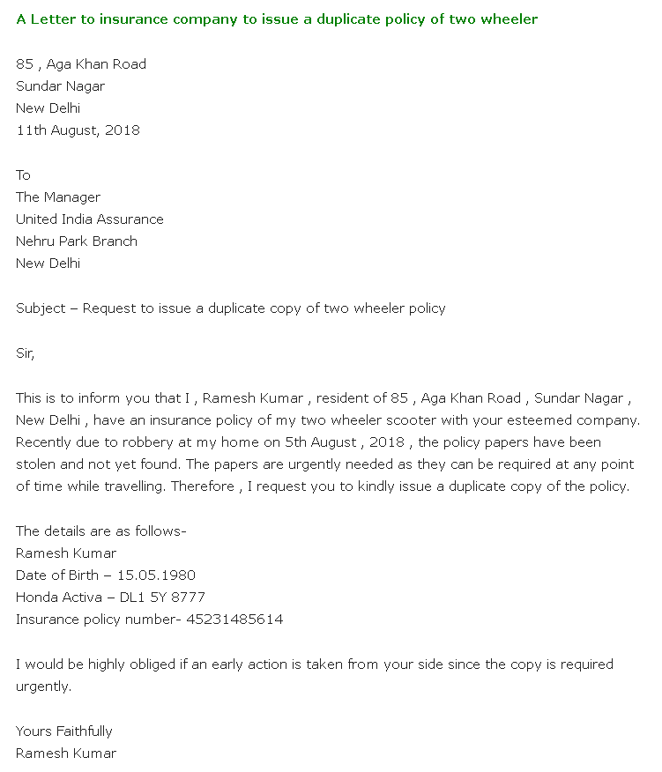

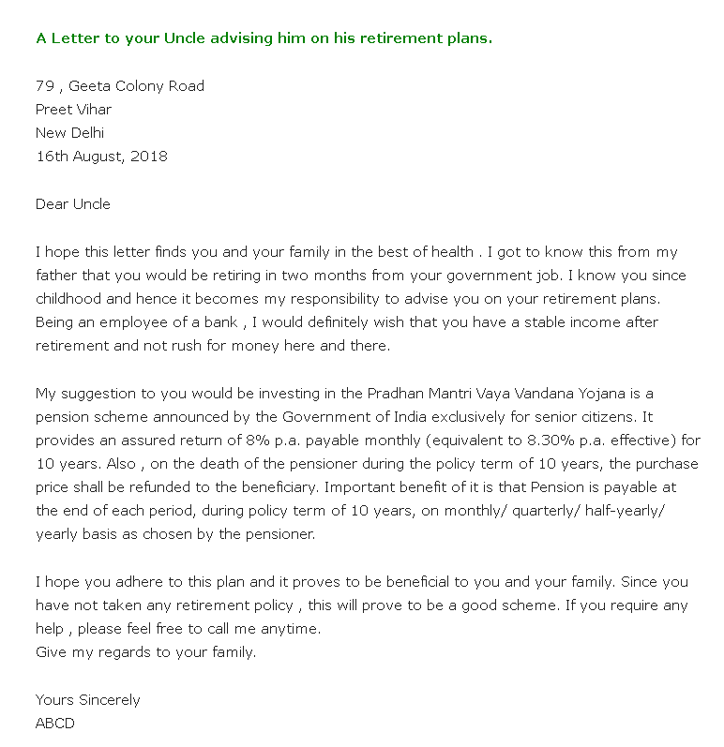

**##### Write a letter to the editor of a newspaper expressing your concerns about environmental pollution in your city and suggesting solutions.**

**[Your Address]**  
[City, Postal Code]  
[Date]

The Editor,  
[Newspaper Name],  
[Newspaper Address],  
[City]

**Subject: Concern Regarding Environmental Pollution in Our City**

Dear Sir/Madam,

I am writing to express my deep concern about the increasing environmental pollution in our city. Pollution levels are rising rapidly, affecting both our health and the environment. The air quality has worsened, water bodies are contaminated, and garbage is piling up in many areas.

One of the main causes is the increasing number of vehicles, which release harmful gases into the air. Industrial emissions also add to the air pollution problem. Meanwhile, plastic waste and other non-biodegradable materials are clogging drains and polluting water sources.

I believe a few steps could help improve the situation. Firstly, authorities should promote public transportation and cycling to reduce vehicle emissions. Additionally, industries should be encouraged to adopt cleaner practices and limit waste. Regular cleaning of water bodies and setting up proper waste disposal systems would also make a positive impact. Moreover, awareness campaigns about reducing plastic use and recycling could involve citizens in keeping the city clean.

"I hope sharing this concern will encourage people and authorities to take quick action for a cleaner, healthier city."Thank you for considering this concern.

Sincerely,  
[Your Name]

**##### write a formal letter complain about facility and faculty in an institution**

**Subject:** Complaint Regarding Facilities and Faculty at the Institution

Dear [Principal/Director's Name],

I am writing to bring to your attention some issues related to the facilities and faculty at [Institution Name]. While I appreciate the efforts of the institution in providing education, there are certain areas that require immediate attention for the benefit of students and staff.

Firstly, the infrastructure in classrooms and common areas needs significant improvement. The seating arrangements in many classrooms are uncomfortable, and some rooms lack proper ventilation, making it difficult for students to focus. Additionally, the cleanliness of washrooms and other facilities is often inadequate, which is concerning for health and hygiene.

Secondly, there have been instances where some faculty members are either absent frequently or do not effectively address students' academic concerns. This not only hampers the learning experience but also demotivates students from fully participating in their education.

I kindly request the administration to take appropriate measures to address these issues. Improving facilities and ensuring accountability among faculty members will greatly enhance the learning environment and overall reputation of the institution.

Thank you for considering this matter. I hope for a prompt response and effective action.

Yours sincerely,  
[Your Full Name]

**#### Write a letter to the editor of a newspaper regarding noise pollution in festive season.**

572 Sector G,

Ashiyana, Lucknow,

U.P

23rd May 2017

The Editor,

The Times of India,

Milap Bhawan, Delhi

**Subject: Concern About Noise Pollution and Its Impact on Health**

Sir,

I would like to draw the kind attention of the concerned authorities towards increasing problem of noise pollution. It has become a serious threat to people’s health. If not controlled, it may lead to hearing loss and other health problems.

The main causes of this problem are the increasing number of vehicles, the rise in factories near residential areas, and the excessive use of loudspeakers. These noises disturb daily life and harm our well-being.

I urge the authorities to take strict action to control noise pollution. Factories in residential areas should be relocated to distant places. Also, the use of loudspeakers should be limited to specific hours to reduce unnecessary noise.

I hope this issue will be highlighted in your newspaper, prompting the concerned authorities to take the necessary steps to protect people from the harmful effects of noise pollution.

Yours sincerely,  
[Your Name]

**#### 2**

Subject: Concern About Noise Pollution During Festive Season

Sir,

I am writing to share my concerns about the problem of noise pollution during the festive season. While festivals are a time of joy and celebration, the excessive use of loudspeakers, firecrackers, and other noise-making activities creates a lot of disturbance.

The loud noises not only disturb students, elderly people, and patients but also harm animals. Many times, these activities go on till late at night, causing inconvenience to everyone in the neighborhood.

I kindly request the authorities to strictly enforce noise pollution rules during festivals. Public awareness campaigns can also help people celebrate in a peaceful and respectful manner. Reducing the use of loudspeakers and banning firecrackers in residential areas can make a big difference.

I hope this issue will be highlighted in your newspaper so that necessary actions are taken to ensure celebrations are enjoyable for everyone without harming the environment or public health.

Yours sincerely,  
[Your Name]

**Letter to the Editor: Concern Over Stray Animals on Roads**

**21-B, Aishbagh,**  
Lucknow, U.P - 226004  
23rd May 2017

**The Editor,**  
The Hindu,  
Hazratganj, Lucknow

**Subject: Stray Animals on Roads Causing Traffic Problems**

Sir,

Through the columns of your esteemed newspaper, I wish to raise concern about the increasing number of stray animals on the roads in Aishbagh area. These animals freely roam on busy roads during peak hours, causing traffic jams and, at times, accidents.

Despite repeatedly reporting the issue to the concerned authorities, no effective action has been taken. This situation not only creates inconvenience for commuters but also poses a serious risk to public safety.

I urge the civic authorities to take immediate steps to address this issue. Catching the stray animals and ensuring their proper rehabilitation is essential. A systematic approach is needed to make our roads safer for everyone.

I hope this letter will draw the attention of the concerned authorities and lead to effective action soon.

Thanking you,  
Yours faithfully,  
**Dheeraj**

**#### The opportunity at XYZ Company interests me due to the organization's commitment to innovation and professional growth.**

Dear Hiring Manager,

I am writing to apply for the position of Assistant Manager, as advertised in The Times of India on 05-Nov-2024. I hold a Master's degree in Business Administration and have over three years of experience in management roles, where I developed skills in team leadership, project management, and client relations. I am interested in the opportunity at XYZ Company because of its focus on innovation and helping employees grow professionally. I believe my qualifications and experience align well with the job requirements, and I am eager to contribute positively to your team.

Attached is my resume for your reference. Look forward to the possibility of contributing to XYZ Company’s success.

**##### Write a letter to the local municipality demanding that a damaged road in your area be repaired. Provide information about the specific difficulties with the road and how they affect the people.**

[Your Address]  
[City, State, PIN Code]  
[Date]

To  
The Commissioner  
[Local Municipality Name]  
[City, State]

Subject: Request to repair the damaged road in [Your Area]

Dear Sir/Madam,

I am writing to inform you about the poor condition of the road in [specific location/area]. The road has severely damaged for a long time and is causing many problems for the people living in and traveling through the area.

The road is full of potholes, making it difficult for vehicles to move smoothly. During rainy days, water collects in these holes, making it dangerous for drivers, especially for two-wheelers and pedestrians. This has led to accidents and traffic jams, which affect everyone in the neighborhood.

Additionally, the dust from the broken road is causing health issues, especially for children and elderly people. Emergency services like ambulances also face delays because of the bad road conditions.

I kindly request you to arrange for the repair of the road as soon as possible. Fixing the road will make travel safer and more comfortable for everyone and will improve the quality of life in the area.

Thank you for your attention to this issue. I hope you will take quick action to resolve this matter.

Dear Sir/Madam,

I am writing to bring to your attention the critical condition of [Road Name] in our neighborhood. The road has been severely damaged for several months, with numerous potholes and uneven surfaces that pose a significant problems to drivers and pedestrians alike.

Residents, including myself, have witnessed an increase in accidents and vehicle damage due to these road conditions. Moreover, emergency vehicles face delays, and local businesses are suffering from reduced foot traffic as a result of the road's poor state.

We urgently request that the municipality prioritize repairs to ensure the safety and well-being of our community. Timely action will greatly alleviate the difficulties we are currently facing.

Thank you for your prompt attention to this matter.

**#### Write a letter to the editor of a local newspaper highlighting the issue of rising food prices and its impact on the common man. Suggest some measures that can be taken to alleviate the situation.**

**[Your Address]**  
[City, State, PIN Code]  
[Date]

The Editor,  
[Newspaper Name],  
[City]

**Subject: Rising Food Prices and Their Impact on the Common Man**

Dear Sir/Madam,

I am writing to express my concern about the rising food prices, which have become a major burden for the common people. The increasing cost of essential items like vegetables, grains, and cooking oil is making it difficult for families to manage their daily expenses, especially for those with limited incomes.

This situation has led (made people ) to reduced purchasing power, forcing many households to compromise on nutritional needs. Middle-class families are finding it hard to save, and the poor are struggling to afford even basic meals.

To address this problem, the government can take steps such as providing subsidies to farmers to boost production, controlling hoarding, improving distribution through public systems, and monitoring exports to ensure domestic availability. These measures will help stabilize prices and bring relief to the public.

I urge you to publish this issue in your esteemed newspaper to draw attention from the authorities and encourage action. Your support can help make food more affordable for everyone.

**#### Draft a letter to your bank requesting an extension for the repayment of a personal loan. Provide reasons for the delay, your current financial situation, and a revised repayment plan.**

Dear [Bank Manager's Name],

I am writing to request an extension on the repayment of my personal loan (Account Number: [Your Loan Account Number]). Due to unexpected financial difficulties, I am unable to make the payments as per the current schedule.

In recent months, my financial situation has been impacted by [briefly explain the reason, e.g., a job loss, medical expenses, or reduced income]. While I am actively working to improve my situation, including [mention any steps you’re taking, e.g., seeking new employment, cutting expenses, or pursuing additional income]. I need some extra time to stabilize my finances.

Given these circumstances, I kindly request an extension of six months. I propose a revised repayment plan where I will make monthly payments of [Proposed Amount] starting from [Proposed Start Date]. This adjustment will help me manage my finances more effectively while ensuring that I can fulfill my loan obligations.

Thank you for understanding my situation. Please let me know if additional documentation or information is required.

**#### Write a formal letter to the editor of a local newspaper expressing your views regarding importance of blood donation**

**[Your Address]**  
[City, State, Pin Code]  
[Date]

**The Editor**  
[Name of the Newspaper]  
[Address]

**Subject:** Importance of Blood Donation

**Sir/Madam,**

I am writing to highlight the importance of blood donation and its role in saving lives. Blood donation is a simple act that can make a huge difference to individuals in medical emergencies, surgeries, or those suffering from chronic illnesses like cancer and anemia. Despite its importance, there is often a shortage of blood in hospitals and blood banks.

Donating blood not only helps save lives but also promotes a sense of social responsibility. It is a safe and painless process that takes only a few minutes but can give someone the gift of life. Awareness campaigns and regular blood donation drives can motivate more people to contribute.

I urge you to use your platform to spread awareness about this noble cause and encourage readers to participate in blood donation programs.

Thank you.

**#### Write a letter to your friend sharing your experience of selection in the IBPS RRB Clerk Exam. in simple words**

**Dear [Friend's Name],**

I hope you are doing well. I am writing to share some great news with you—I have cleared the IBPS RRB Clerk Exam! This is such a happy moment for me, and I wanted to tell you all about it.

Preparing for the exam was not easy. I spent a lot of time studying and solving practice papers. Staying consistent and focused really helped me improve day by day. On the day of the exam, I was nervous but determined to do my best. When the results came out and I saw my name on the list, I felt so proud and relieved.

This selection means a lot to me because it’s a big step toward my career goals. I am looking forward to learning and growing in this new journey.

Thank you for always motivating me. Let’s meet soon to celebrate together!

Take care and stay in touch.

**Your friend,**  
[Your Name]

**#### Write a letter to your younger brother expressing your concern regarding the recent outbreak of WannaCry Ransomware and telling him to be wary of his online presence and the precautions he can take to stay protected.**

**[Your Address]**  
[City]  
[Date]

Dear [Younger Brother's Name],

I hope this letter finds you well. I am writing to share my concerns about a recent cyber threat called WannaCry Ransomware that has been affecting systems worldwide. It encrypts files on a victim's computer and demands a ransom for their release. Since you frequently use the internet for studies and entertainment, I want to ensure you’re cautious about your online presence.

Here are a few simple precautions you can take to stay safe:

1. **Keep Your Software Updated**: Regularly update your operating system and software to patch any security vulnerabilities.
2. **Use a Reliable Antivirus**: Install and maintain a trusted antivirus program to detect and block malware.
3. **Avoid Suspicious Links and Emails**: Don’t click on unknown links or download attachments from unfamiliar sources.
4. **Backup Your Data**: Maintain regular backups of important files on external drives or secure cloud storage.
5. **Use Strong Passwords**: Create unique passwords for your accounts and enable two-factor authentication where possible.

Cybersecurity is crucial in today’s digital age. By following these steps, you can reduce the risk of falling victim to such attacks.

Take care and stay safe online. Let me know if you need help setting up any of these precautions.

With love,  
[Your Name]

**#### Write a letter to your sister persuading her to study hard and to appear for SBI PO examination.**

Dear [Sister’s Name],

I hope this letter finds you in great health and high spirits. I wanted to talk to you about an exciting opportunity that can shape your career and future—appearing for the SBI PO (Probationary Officer) examination.

The SBI PO exam is one of the most prestigious banking exams in India. Clearing it can open doors to a stable and rewarding career in the banking sector. Not only will it provide you with financial independence, but it will also give you a platform to learn and grow professionally. A job like this comes with respect, job security, and opportunities to serve the public.

I know how talented and hardworking you are, and I truly believe that with the right focus and dedication, you can crack this exam. It will require consistent study and practice, but trust me, the effort will be worth it. You can start by following a structured preparation plan, solving mock tests, and staying updated with current affairs.

Remember, challenges may seem daunting, but determination can turn them into achievements. I am here to support you in every way, whether it’s guiding you with study material or motivating you through difficult times.

I believe in you, and I know you can do this. Take this step seriously, and you will see how fulfilling it is to achieve your dreams.

With lots of love and encouragement.

**#### Write a letter to a local government official, requesting improvements to public transportation in your area. in simple words and vocabulary.**

**[Your Address]**  
[City], [State]  
[Date]

**To**  
The Local Government Official  
[Department Name]  
[City], [State]

**Subject:** Request for Improvements to Public Transportation

Dear Sir/Madam,

I am writing to bring to your attention the challenges faced by residents in our area due to inadequate public transportation facilities. Many commuters, including students, office-goers, and elderly citizens, find it difficult to travel conveniently because of the limited number of buses, irregular schedules, and overcrowding.

The lack of proper transportation not only causes inconvenience but also leads to increased reliance on private vehicles, contributing to traffic congestion and pollution. Improved public transport can significantly enhance mobility, reduce travel costs for residents, and promote eco-friendly commuting.

I kindly request you to consider adding more buses to busy routes, ensuring better maintenance of existing vehicles, and implementing punctual schedules. Introducing affordable passes for frequent commuters could also encourage more people to use public transport.

I trust that you will take necessary steps to address this matter for the betterment of our community.

Thank you for your attention.

Yours sincerely,  
[Your Name]

**Write a formal letter to the manager of a telecom provider, complaining about frequent service outages in your mobile network. Describe how the service issues have impacted you and request a quick resolution to the matter.**

**Write a formal letter to the CEO of a company, praising their corporate social responsibility efforts and suggesting areas for improvement.**

**Write a letter to the local health department addressing concerns about the cleanliness of a public park and suggesting improvements.**