NODE-JS

1. Initial step to start wok –

First step to make folders and write server start program -

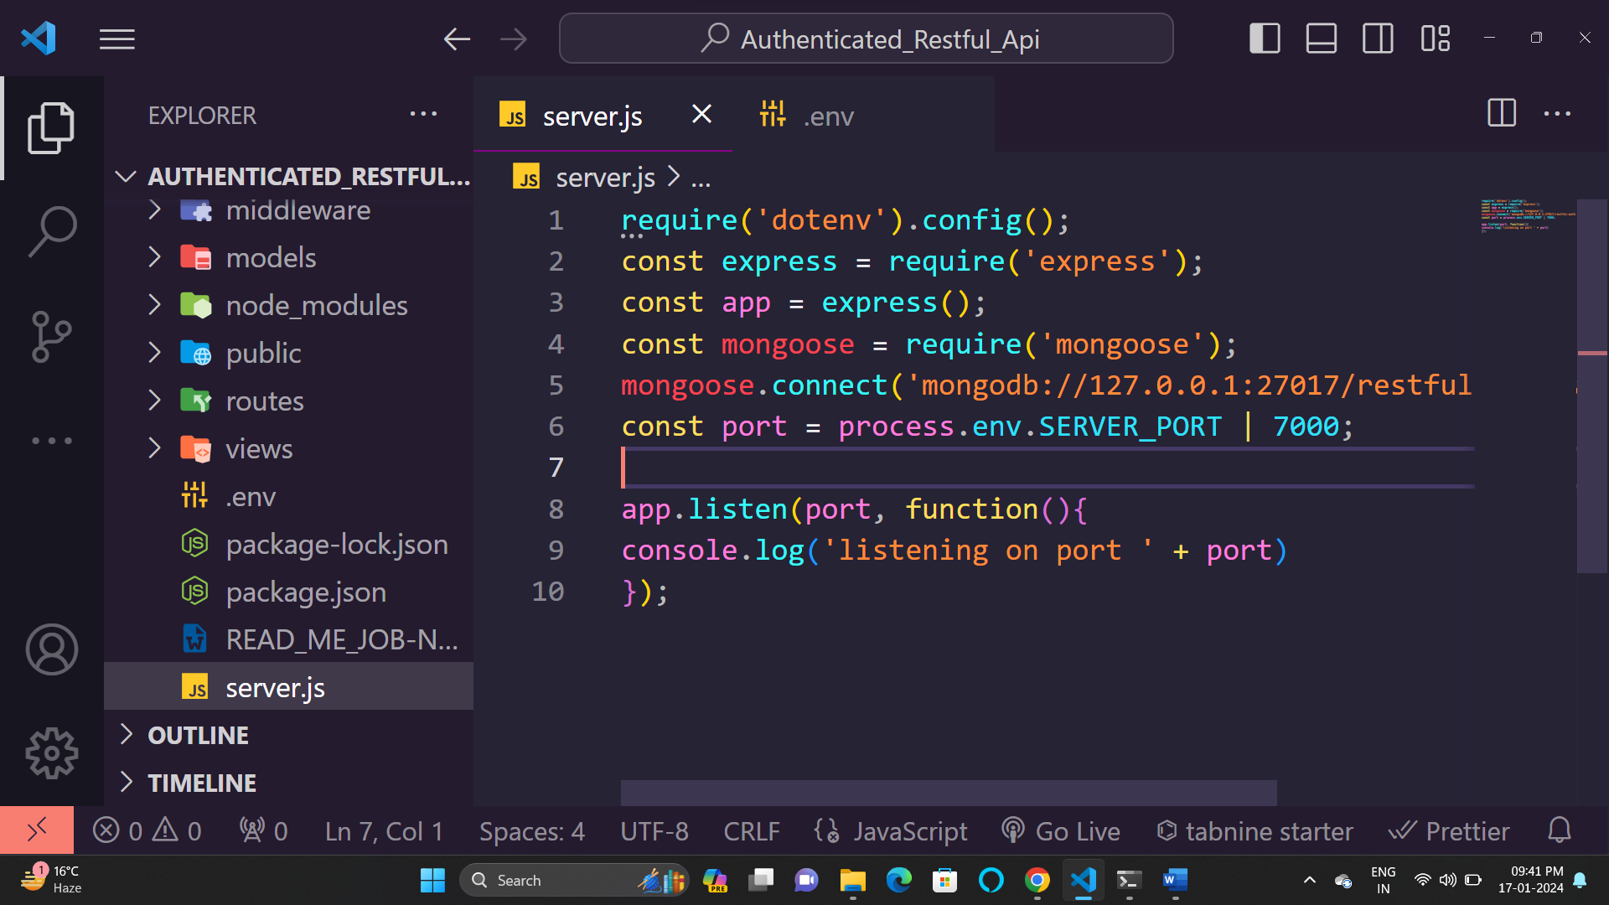

Then install dependencies - 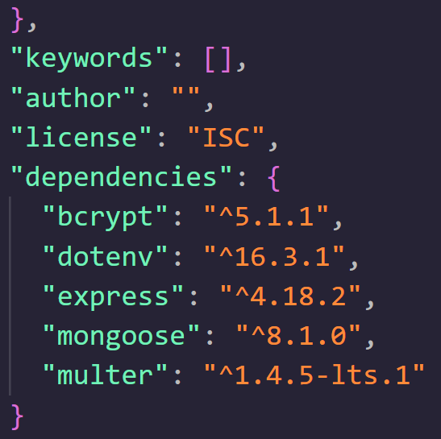

Take input of this –

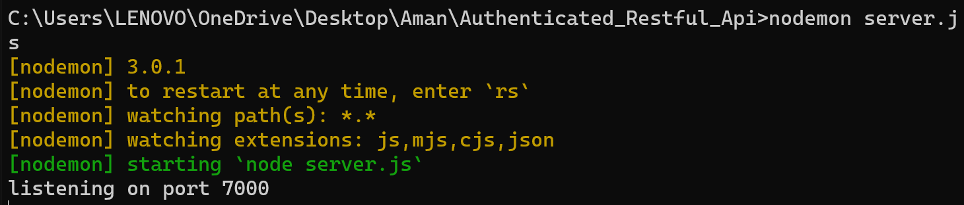

*// Requirements*

*// require("dotenv").config();*

const http = require('http');

const app = require('./app');

const server = http.createdServer(app);

const express = require("express");

*// const app = express();*

const studentRoute = require('./routes/student');

*// For connection of DB with MongoDB*

const mongoose = require("mongoose");

mongoose.connect("mongodb://127.0.0.1:27017/restful-auth-apis");

*// Take port number from external dot(.)env file*

const port = process.env.SERVER_PORT | 9000;

*// Middleware-Plugin*

app.use(express.urlencoded({ extended: false }));

app.use('/student', studentRoute);

*// Use external file with external folder*

const userRouter = require('./routes/user');

const router = require("./routes/student");

*// which place and file are use for file routing*

app.use("/", userRouter);

*// listen on PORT*

app.listen(port, function () {

  console.log("listening on port " + port);

});