Week-06 HandsOn Solution

- ReactJS-HOL

Question 1: Introduction to React & Creating First App

- Code:

import logo from './logo.svg';
import './App.css';

function App() {
return (
<h1>Welcome the First Session of React</h1>
);
}
export default App;

- Output:

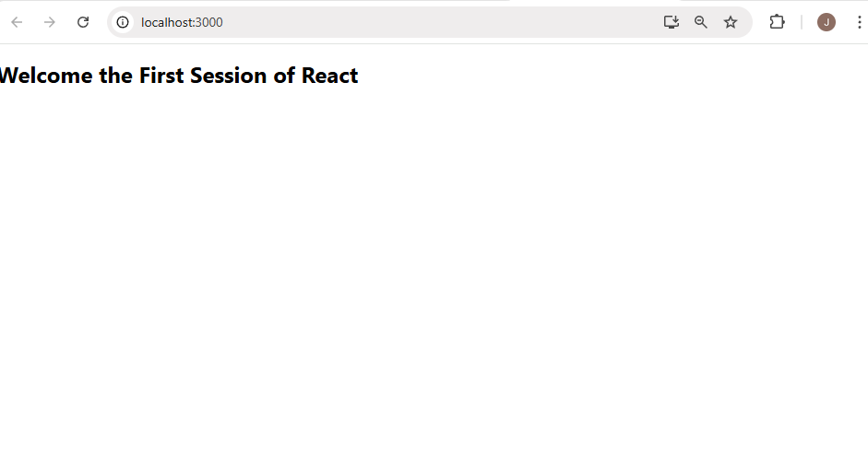

Question 2: Class Components in React

- Code:

//About.js

import React, { Component } from 'react';
class About extends Component {
render() {
return (
<div>
<h3>Welcome to the About page of Student Mangement Portal </h3>
</div>
);
}
}
export default About;

//Contact.js

import React, { Component } from 'react';
class Contact extends Component {
render() {
return (
<div>
<h3>Welcome to Contact page of Student Mangement Portal</h3>
</div>
);
}
}export default Contact;
//Home.js

import React, { Component } from 'react';
class Home extends Component {
render() {
return (
<div>
<h3>Welcome to the Home Page of Student Management Portal </h3>
</div>
);
}
}
export default Home;

- Output:

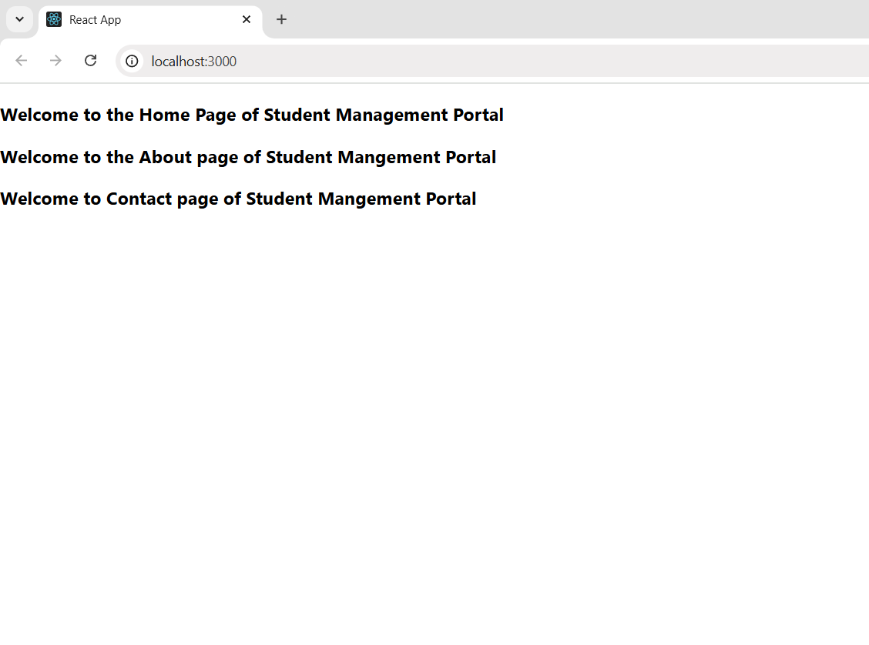

Question 3: Functional Components & Styling

- Code:

import './Stylesheets/mystyle.css'

const percentToDecimal = (decimal) => {
return (decimal.toFixed(2) + '%')
}

const calcScore = (total, goal) => {
return percentToDecimal(total / goal)
}

export const CalculateScore = ({ Name, School, total, goal }) => (
<div className='formalstyle'>
<h1><font color="Brown">Student Details : </font></h1>
<div className='Name'>
<b> <span>Name : </span></b>
<span>{Name}</span>
</div>
<div className='School'>
<b><span>School : </span></b>
<span>{School}</span>
</div>
<div className='Total'>
<b><span>Total : </span></b>
<span>{total}</span>
<span>Marks</span>
</div>
<div className='Score'>
<b>Score : </b>
<span>{calcScore(total, goal)}</span>
</div>
</div>)

- Output:

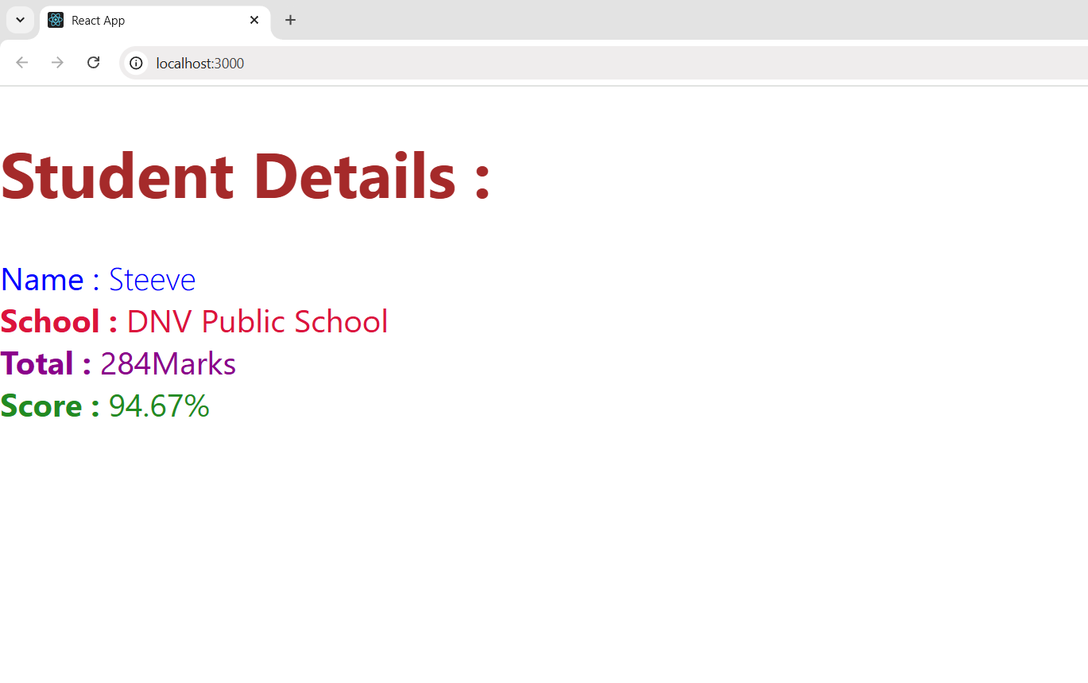

Question 4: React Component Lifecycle Methods

- Code:

import Post from "./Post";
import React from "react";
class Posts extends React.Component {
constructor(props) {
super(props);
this.state = {
posts: []
};
}
loadPosts() {
fetch('https://jsonplaceholder.typicode.com/posts')
.then((response) => response.json())
.then((data) => {
const obj = data.map(value => new Post(value.id, value.title, value.body));
this.setState({ posts: obj });
})
.catch((error) => {
console.error("Error in Fetching : ", error);
});
}
componentDidMount() {
this.loadPosts();
}
render() {
const { posts } = this.state;

return (
<>
<ul>
{posts.map(post => (
<li key={post.id}>
<h1>{post.title}</h1>
<p>{post.body}</p>
</li>
))
}
</ul>
</>
);
}
componentDidCatch(error, info) {
console.error("Error in Posts Component: ", error);
}

}
export default Posts;

- Output:

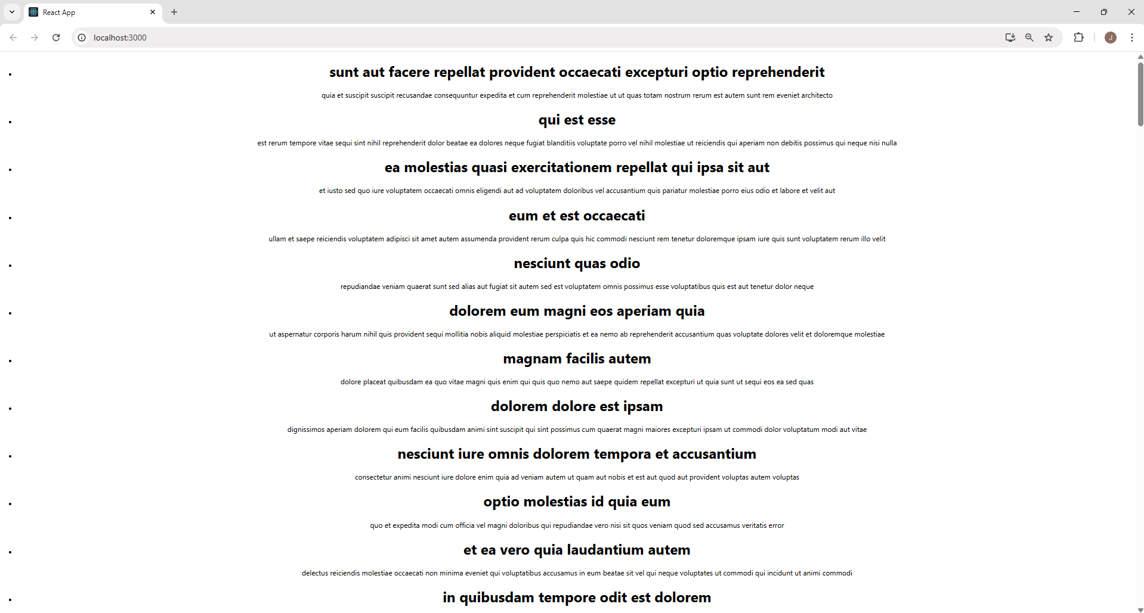

Question 5: Styling React Components with CSS Modules

- Code:

//App.js

import logo from './logo.svg';
import './App.css';
import { CohortsData} from './Cohort'
import CohortDetails from './CohortDetails';

function App() {

return (
<div>
<h1>Cohorts Details</h1>
{CohortsData.map(cohort => <CohortDetails cohort={cohort}/>)}
</div>
);
}

export default App;

//Cohort.js

class Cohort {
constructor(cohortCode,
startDate,
technology,
trainerName,
coachName,
currentStatus) {
this.cohortCode = cohortCode;
this.coachName = coachName;
this.trainerName = trainerName;
this.technology = technology;
this.startDate = startDate;
this.currentStatus = currentStatus;
}
}
const CohortsData = [
new Cohort('INTADMDF10', '22-Feb-2022', '.NET FSD', 'Jojo Jose', 'Aathma', 'Scheduled'),
new Cohort('ADM21JF014', '10-Sep-2021', 'Java FSD', 'Elisa Smith', 'Apoorv', 'Ongoing'),
new Cohort('CDBJF21025', '24-Dec-2021', 'Java FSD', 'John Doe', 'Aathma', 'Ongoing'),
new Cohort('INTADMJF12', '22-Feb-2022', 'Java FSD', 'To Be Assigned', 'Ibrahim', 'Scheduled'),
new Cohort('CDE22JF011', '24-Dec-2021', 'Java FSD', 'Emma Swan', 'Apoorv', 'Ongoing'),
new Cohort('INTADMDF09', '22-Feb-2022', 'Dataware Housing', 'Babjee Rao', 'Aathma', 'Scheduled'),
new Cohort('ADM22DF001', '10-Sep-2021', '.NET FSD', 'Marie Curie', 'Ibrahim', 'Ongoing'),
];
export { Cohort, CohortsData };

- Output:

