HIVE STREAMING
Data Engineer Assignment

High Level Design Document | v1.0 | May 2026

Primary Goal  Data Processing & Analytics Pipeline | Secondary Goal  Video Player Telemetry Collection Plugin

1. Overview
Hive Streaming delivers a video experience platform that helps large enterprises run and monitor live webcasts. The challenge is detecting quality issues in real time across millions of concurrent viewers.

This document covers the end-to-end system design — from data collection in the viewer's browser, through ingestion and processing, to a live QoS dashboard.

1.1 The Problem
When a viewer's video buffers or drops quality, Hive Streaming needs to know immediately. The system must handle:

- Continuous telemetry from millions of concurrent viewers.
- Real-time detection of buffering events and quality degradation.
- Aggregated analytics per viewer and per event.
- A dashboard that operations teams can monitor live.

1.2 Assignment Goals

Goal | Type | Scope
Goal 1 — Pipeline & Dashboard | Primary | PySpark pipeline on Databricks. Bronze, Silver and Gold layers. Databricks SQL dashboard showing QoS metrics.
Goal 2 — Collection Plugin | Secondary | TelemetryCollector.js plugin that runs in the viewer's browser. Captures quality changes and buffering events from hls.js.

2. System Architecture
The architecture has five layers. Data flows from the viewer's browser through ingestion, stream processing and storage before reaching the Databricks pipeline and dashboard.
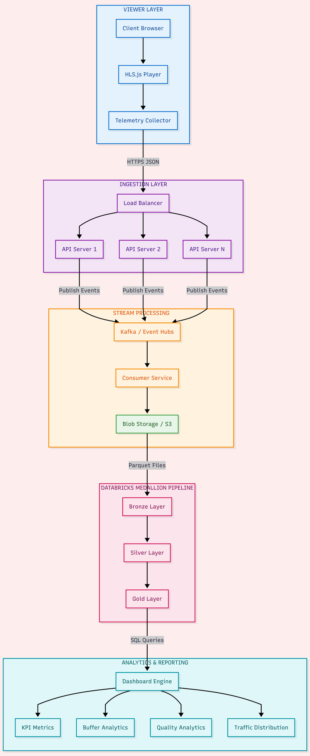

3. Layer Breakdown

Layer 1 — Viewer Layer
Runs inside the viewer's browser

Every viewer has TelemetryCollector.js loaded alongside hls.js. The plugin runs entirely in the browser and silently captures two things:

- Quality changes — when the stream switches from one resolution to another
- Buffering events — when the video freezes and when it resumes, including how long it lasted

Events are batched and sent every 5 events via HTTPS POST. If a send fails, the plugin retries up to 3 times with 1s, 2s and 3s delays — exponential backoff.

Component | Description
hls.js Player | Open-source HLS player used by Hive. Fires events when quality switches or when the manifest loads.
TelemetryCollector.js | Our plugin. Listens to hls.js and native video events. Packages events as JSON and sends to the backend.
HTTPS POST | Encrypted transport. Events sent in batches of 5 per request.
Retry logic | 1s → 2s → 3s backoff. After 3 failed attempts, events are logged and dropped.

Layer 2 — Ingestion Layer
Receives and routes telemetry at scale

The ingestion layer accepts requests from millions of viewers simultaneously. Its job is to be fast and never drop data, regardless of what happens downstream.

Component | Description
Load Balancer | Azure Front Door or AWS ALB. Distributes incoming requests across API servers. Provides automatic failover if any server goes down.
API Servers | Multiple FastAPI instances running in parallel. Each validates the payload, adds a server timestamp and pushes to Kafka. Stateless — scales horizontally.
Kafka / Event Hubs | Message queue that buffers events between the API and the consumer service. Can hold millions of events. If the consumer is slow, events wait safely — nothing is lost.

Kafka is the most critical component in this layer. Without it, slowness in downstream processing would back up into the API and affect the viewer's browser experience.

Layer 3 — Stream Processing
Aggregates events and writes parquet files

The consumer service reads from Kafka and converts raw individual events into structured rows — the format the Databricks pipeline reads.

Component | Description
Consumer Service | Reads batches from Kafka. Groups by clientId. Counts BUFFER_END events for bufferings. Sums durationMs for bufferingTime. Groups by quality for qualityDistribution.
Blob Storage / S3 | Azure Blob or AWS S3. Consumer writes snappy-compressed parquet files partitioned by eventDate. Partitioning means Databricks only reads relevant date folders.

The output matches the exact schema in the provided dataset — player.bufferings, player.bufferingTime, qualityDistribution and totalDistribution fields.

Layer 4 — Databricks Medallion Pipeline
Bronze, Silver and Gold processing

The pipeline runs on Databricks using PySpark. It follows the Medallion Architecture — three progressive layers each adding more structure and value.

Layer | Write mode | What it does
Bronze | Append | Reads new parquet files since last checkpoint. Stores raw data exactly as received. Nothing is transformed here.
Silver | Append | Flattens nested structs. Converts bufferingTime from ms to seconds. Explodes qualityDistribution into one row per quality level.
Gold | MERGE | Three tables: viewer buffering metrics, quality distribution per viewer, and overall event summary. MERGE updates existing viewer rows.

The pipeline runs incrementally. A checkpoint table stores the last processed eventDate. Each run reads only new data, appends to Bronze and Silver, and merges updated totals into Gold.

Layer 5 — Analytics & Reporting
Databricks SQL Dashboard

The dashboard queries the Gold tables using Databricks SQL. Five widgets give the operations team a full picture of viewer QoS.

Widget | Chart type | What it shows
Overall Event KPIs | Counter cards | Total viewers, buffering events, avg buffer time, P2P traffic %
Buffering Time Per Viewer | Bar chart | Total seconds each viewer spent buffering — sorted worst to best
Quality Distribution | Pie chart | Data consumed at each quality level across all viewers
P2P vs CDN Traffic Per Viewer | Stacked bar | Split of traffic from CDN vs peer-to-peer delivery per viewer
Top 10 Worst Performing Viewers | Table | Ranked by buffering time with events, avg, worst and P2P columns

4. Dashboard Screenshot
The dashboard below was built on Databricks SQL against the Gold layer.

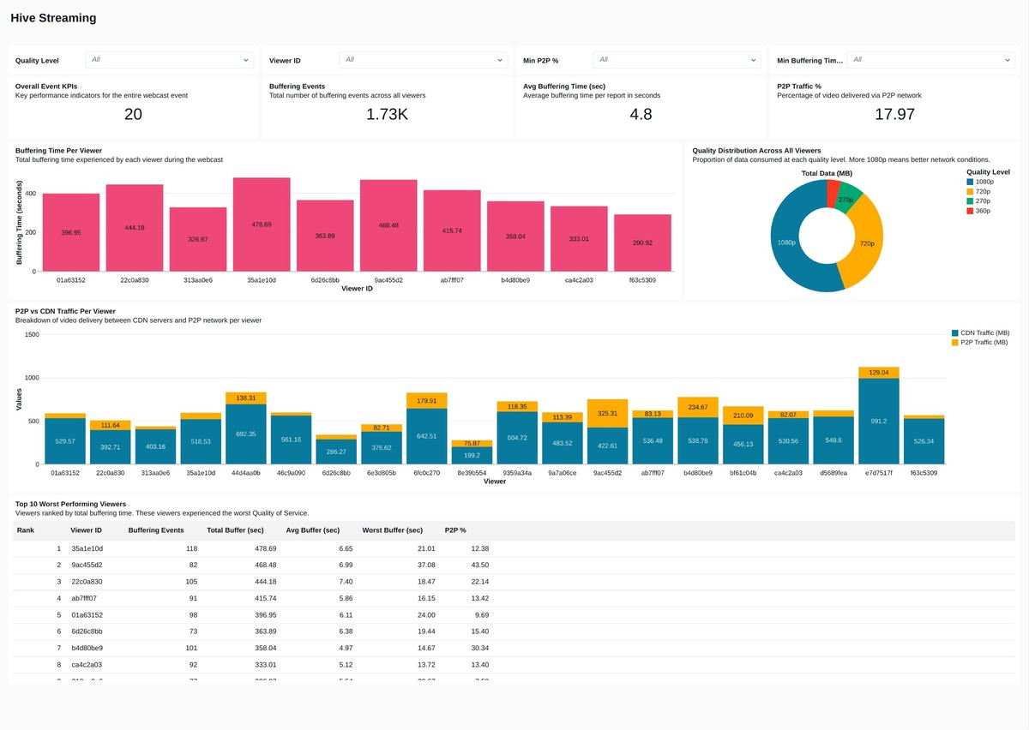

Key observations from the data:

- Viewer 35a1e10d had the worst experience — 118 buffering events and 478 seconds of total buffer time
- 1080p was the dominant quality, meaning most viewers had good network conditions
- P2P delivered 17.97% of total traffic, reducing CDN costs
- Average buffering time of 4.8 seconds per report indicates moderate QoS overall

5. Data Collection Plugin (Goal 2)
TelemetryCollector.js is the starting point of the entire data flow. It attaches to the hls.js player and captures quality and buffering telemetry from inside the viewer's browser.

5.1 What it collects

Event | Trigger | Fields captured
QUALITY_CHANGE | hls.js LEVEL_SWITCHED fires | fromQuality, toQuality, bitrate, height, timestamp
BUFFER_START | Native video 'waiting' event | quality at time of stall, timestamp
BUFFER_END | Native video 'playing' event | quality, durationMs, timestamp
PLAYER_ERROR | hls.js ERROR with fatal=true | errorType, errorDetail, timestamp

5.2 Telemetry payload format

{
"clientId" : "viewer-abc123",
"contentId" : "hive-webcast",
"customerId" : "enterprise-xyz",
"sentAt" : 1763032024137,
"events": [
{ "type": "QUALITY_CHANGE", "fromQuality": "360p", "toQuality": "1080p", "bitrate": 4500000, "timestamp": 1763032024137 },
{ "type": "BUFFER_START", "quality": "1080p", "timestamp": 1763032025000 },
{ "type": "BUFFER_END", "quality": "1080p", "durationMs": 3500, "timestamp": 1763032028500 }
]
}

5.3 How to plug into the test page

Drop the script tag in after hls.js and initialise with the existing hls instance:

const collector = new TelemetryCollector(hls, video, {
clientId : "viewer-001",
contentId : "hive-webcast",
customerId : "enterprise-abc",
backendUrl : "https://api.hivestreaming.com/telemetry",
batchSize : 5,
debug : true
});
collector.start();

5.4 Live testing results

The plugin was tested on the Hive Streaming test page. Session summary after the test:

Metric | Value | Notes
Current quality | 1080p | Maintained high quality throughout
Total buffering | 5 | Five buffering events captured
Total buffer time | 5,474 ms | 5.4 seconds total across the session
Quality changes | 3 | Including a drop to 240p during network throttle test
Total events sent | 14 | Sent across three batches of 5

6. Incremental Processing
The pipeline tracks where it left off between runs. Rather than re-reading all data from scratch every time, it only processes new records that have arrived since the last run.

6.1 Checkpoint design

- A checkpoint table stores the last successfully processed eventDate
- Each run reads the checkpoint and filters source data to only dates after it
- If no new data exists the pipeline exits immediately — zero wasted compute
- The checkpoint is only updated after all three layers complete — a failure means the next run retries from the same point

6.2 Write strategy per layer

Layer | Mode | Reason
Bronze | Append | New records are unique by timestamp. Safe to append directly.
Silver | Append | Derived from new bronze records. Also unique. Append is correct.
Gold | MERGE | Same viewer appears across multiple reporting intervals. Must update their existing row with recalculated totals — not insert a duplicate.

7. Production Considerations
The current implementation is scoped to the assignment. Moving to production at scale would require the improvements below.

7.1 Plugin

- Replace auto-generated clientId with the authenticated user ID from the login system
- Add a 30-second heartbeat so the backend can detect abnormal session endings
- Compress JSON payloads with gzip before sending — reduces bandwidth by 70-80%
- Add localStorage persistence so clientId survives page refreshes

7.2 Pipeline

- Switch to Spark Structured Streaming reading from Kafka — reduces dashboard latency from minutes to seconds
- Add schema validation at the API level to reject malformed payloads early
- Set up automated Databricks Jobs — every 15 minutes during live events
- Enable Delta OPTIMIZE and ZORDER on Gold tables for faster dashboard queries

7.3 Infrastructure

- Multi-region deployment for global webcasts
- API rate limiting per clientId to prevent a single viewer from flooding the backend
- Multiple Kafka consumer groups for parallel event processing
- DDoS protection at the load balancer level

8. Technology Stack

Component | Technology | Reason
Data collection | JavaScript ES6 | Browser-native, no build step, works directly with hls.js
API servers | FastAPI (Python) | Fast, async, simple to write and scale
Message queue | Kafka / Azure Event Hubs | Handles millions of events/sec. Event Hubs chosen for Azure alignment
File storage | Azure Blob / AWS S3 | Cheap, durable, integrates natively with Databricks
File format | Parquet (Snappy) | Columnar format — fast for analytics, much smaller than JSON
Processing | PySpark on Databricks | Scalable, handles Delta Lake natively, incremental reads built-in
Table format | Delta Lake | ACID transactions, time travel, efficient upserts via MERGE
Dashboard | Databricks SQL | Built-in, connects directly to Gold tables, no extra setup

Hive Streaming | Data Engineer Assignment | High Level Design Document | v1.0 | May 2026

