

INT217: Introduction to Data Science

Project: Excel Dashboard

Lovely School of Computer Science

Lovely Professional University, Phagwara

Under the Guidance of Ms. Veerpal Kaur: 25909

Discipline of CSE/IT

Submitted by

Aman Raj

12101946

Section:- KM100

(Project Semester August-December 2022)





Declaration

I, Aman Raj, student of Computer Science and Engineering under CSE Discipline at, Lovely Professional University, Punjab, hereby declare that all the information furnished in this project report is based on my own intensive work and is genuine.



Date: 4th Nov 2022

Signature

Registration No.

12101946



Name of the student

Aman Raj



ACKNOWLEDGEMENT

We would like to thank Ms. Veerpal Kaur (25909) for their support and guidance in completing our project on the topic “Google Play Store”. It was a great learning experience for me.

-Aman Raj

-12101946



Introduction

This project is developed to keep track of my google play store while I am analysing the data, I used Excel for cleaning the data and analysing the Datasets of “Google Play Store”

Dashboard includes:

* DATA CLEANING
* CATEGORY AND COUNT OF INSTALL
* APPS WITH RESPECT TO RATINGS BETWEEN 4-5
* TOP 5 POPULAR APPS
* COUNT OF APPS W.R.T INSTALLS
* NO. OF APPS ACCORDING TO TYPES

Source of dataset

Link:

https://www.kaggle.com/datasets/lava18/google-play-store-apps



Reference:

https://www.kaggle.com

* Dataset contains:

Number of columns: 13

Number of rows: 10842

* Refined Dataset contains:

Number of columns: 13

Number of rows: 7425

Columns contain:

1. App
2. Category
3. Rating
4. Reviews
5. Size



1. Installs
2. Type
3. Price
4. Content Rating
5. Genres
6. Last Updated
7. Current Ver
8. Android Ver

Specific Requirements:

1. MS Excel
2. we need pivot table.
3. We need slicer to compare.

**Process of creating this table:-**

1. Convert the row table into refined table.
2. Convert the table into pivot table by selecting the cell of the table and click on the pivot table .



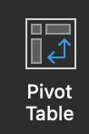

* Select the table range and where to open that table in new worksheet or existing workbook.

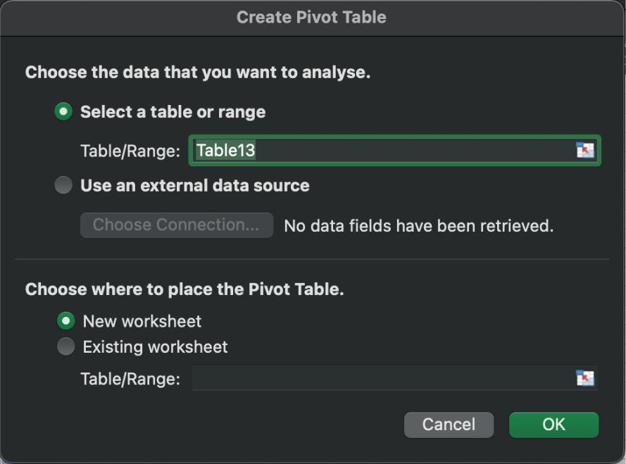

* 1. **CATEGORY AND COUNT OF INSTALL**
* This Table contain total count of apps belongs from the given category
* Process of creating this table:-

1. Convert the row table into refined table.
2. Convert the table into pivot table by selecting the cell of the table and click on the pivot table .



* Select the table range and where to open that table in new worksheet or existing workbook.

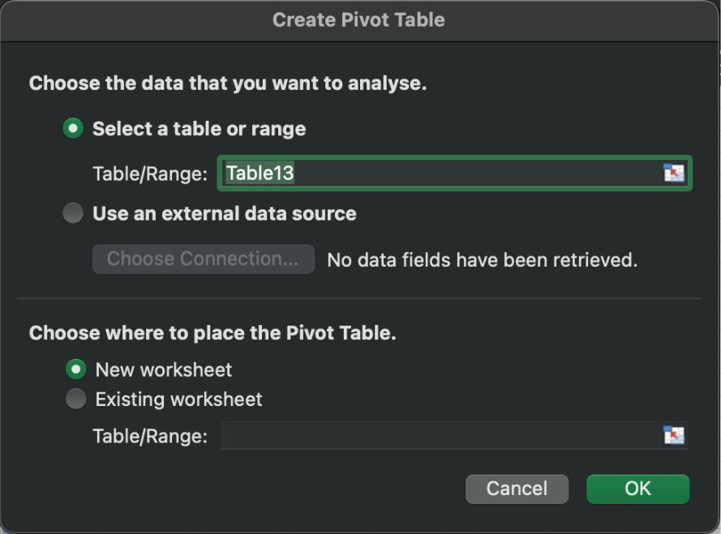

* After click on that go to PivotTable fields and



select the “App” and “Category” for analysing that “how many apps belongs to the category” like Beauty contain 42 apps.

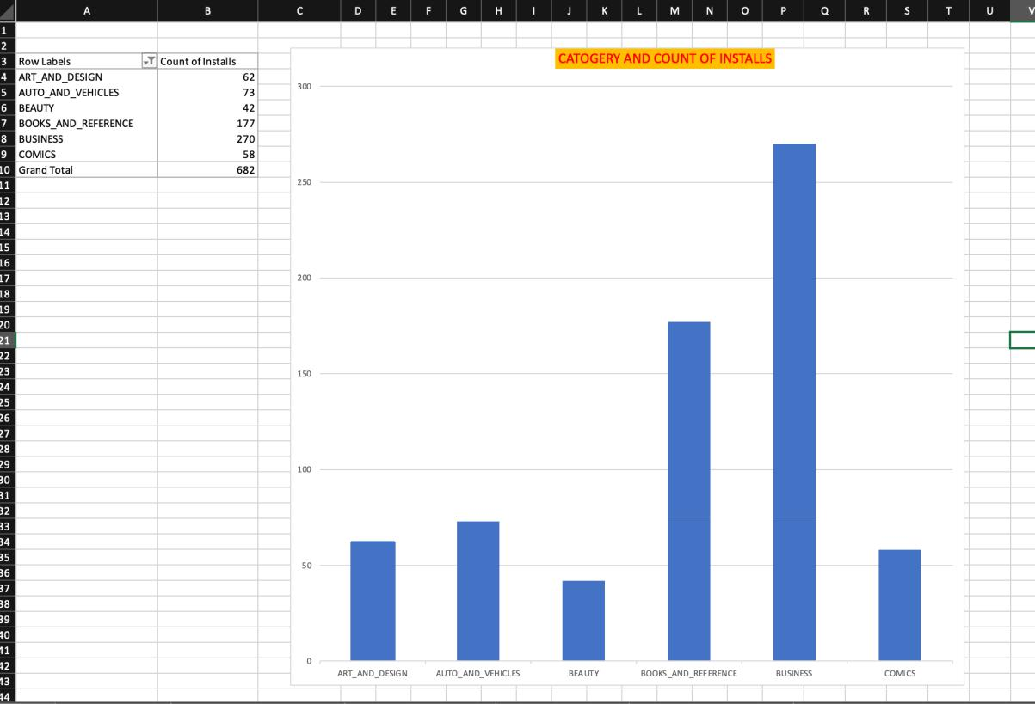

* + 1. **APPS WITH RESPECT TO RATINGS BETWEEN 4-5**
* This Table contain total count of apps belongs from the given ratings
  + After click on that go to PivotTable fields and select the “Ratings” and “Apps” for analysing that “how many apps belongs to the given Ratings” like from rating “1” the total app count is “16”.

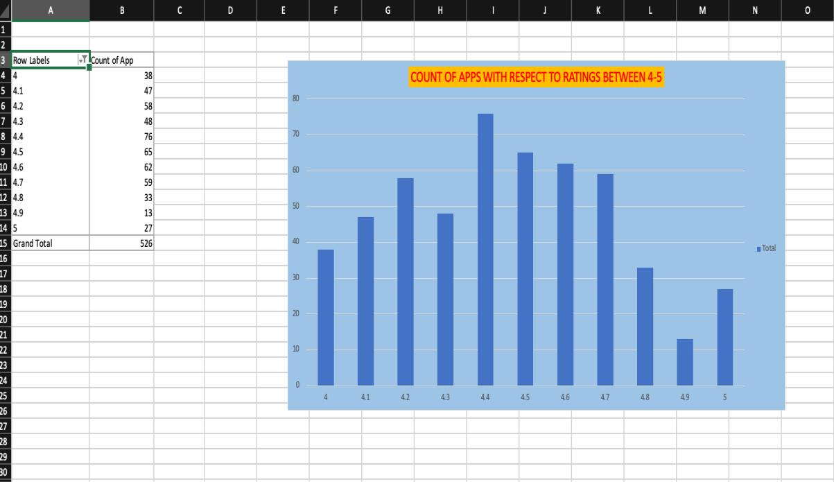

**3. TOP 5 POPULAR APPS**

* This Table contain top 5 popular apps total count of review belongs from the given apps.
  + After click on that go to PivotTable fields and select the “Apps” and “Review” for analysing that “total number of review according to apps” like “Bible” have total “2440695 ” reviews.

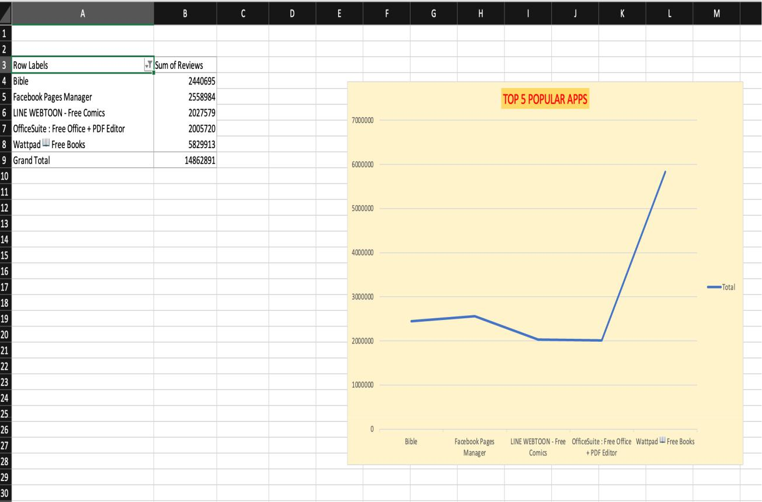

**4. COUNT OF APPS W.R.T INSTALLS**

* This Table contain count of apps with respect to installs

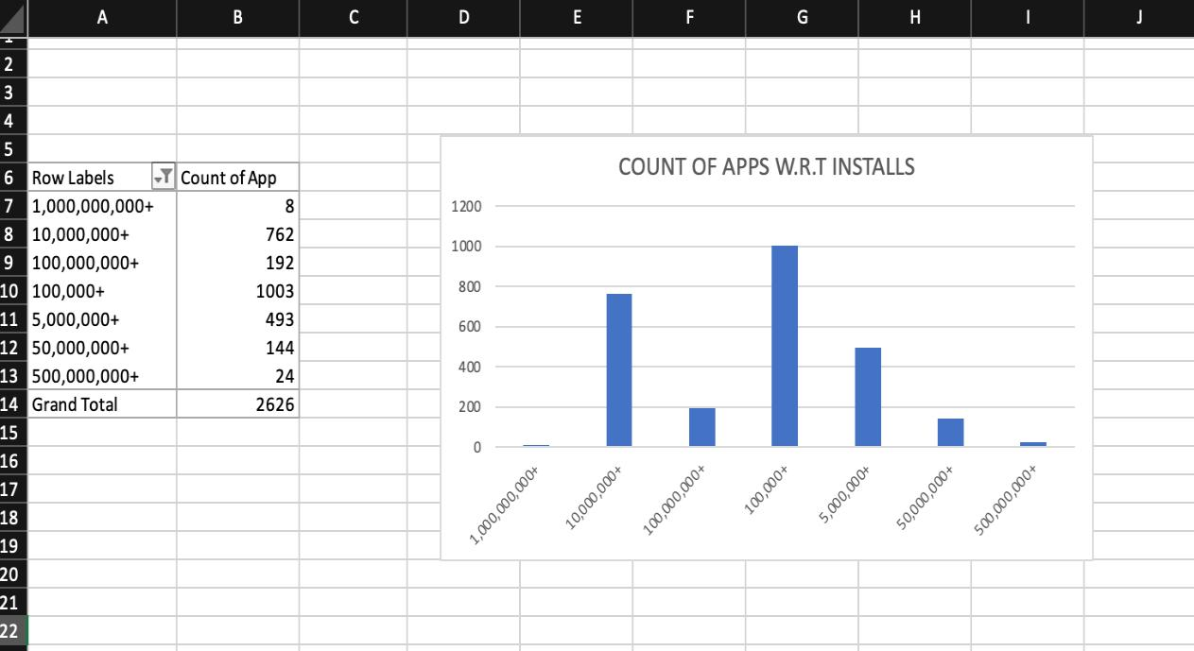

**5. NO. OF APPS ACCORDING TO TYPES**

* Count of apps according to their types

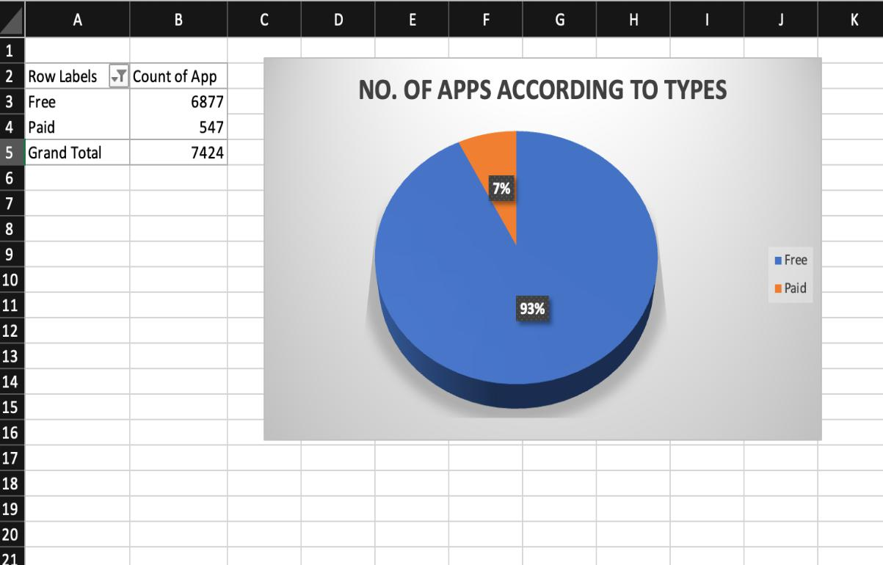

* 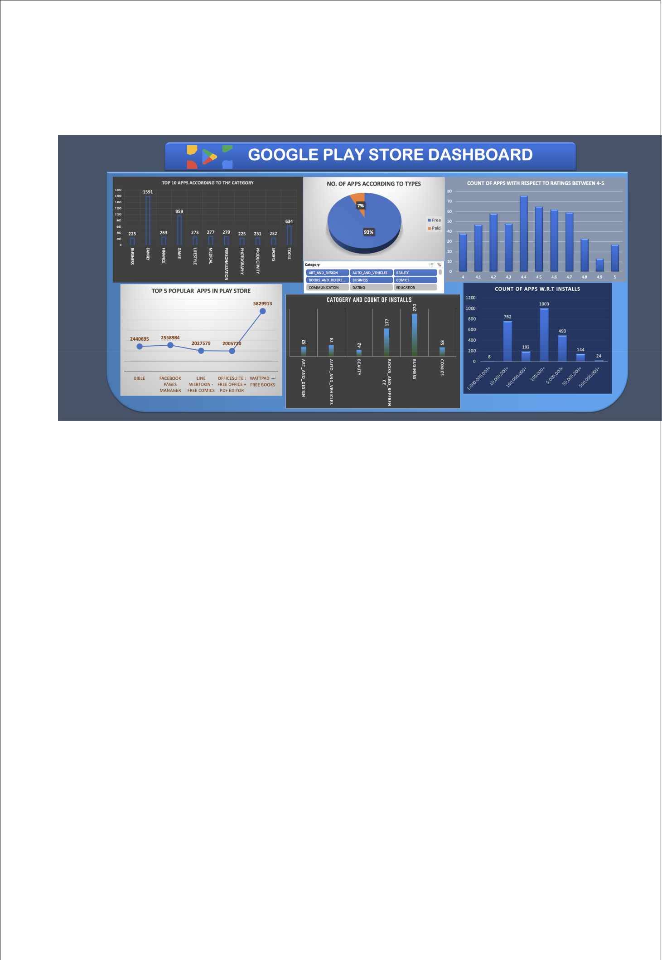**DASHBOARD**

