REPORT
OF
CLOUD COMPUTING INTERNSHIP
Submitted
To
School of Computer Science and Engineering
IILM University, Greater Noida, U.P.
In partial fulfilment of the requirement of degree of
B.Tech CSE

By
Roll Number of Student: 25SCS1003004014
Name of Student: AMAN RAJ
Batch: BTECH 2CSE17

2026–27
CANDIDATE’S DECLARATION
I, AMAN RAJ, do hereby declare that the internship report titled “Cloud Computing Internship” has been completed by me to fulfil the requirement for the award of the degree of Bachelor of Technology in CSE. The work presented in this report describes the learning and practical activities carried out during my internship with Codec Technologies Pvt. Ltd. I affirm that this report has not been submitted to any other institute for any degree or diploma requirement. I shall be responsible for any copyright violation in this regard.
Signature: AMAN RAJ
Student Name: AMAN RAJ
Roll No.: 25SCS1003004014

ACKNOWLEDGEMENT
I am using this opportunity to express my gratitude to everyone who supported me throughout the Internship Program. I am thankful for the guidance, constructive feedback and friendly advice that helped me complete the learning activities and practical work. I would like to thank Codec Technologies Pvt. Ltd. for providing me the opportunity to take part in the Cloud Computing internship program. I am also grateful to the faculty members of IILM University for their academic support and guidance. Finally, I express my gratitude to my parents for their support and blessings.
Signature: AMAN RAJ
Student Name: AMAN RAJ
Roll No.: 25SCS1003004014

INTERNSHIP COMPLETION CERTIFICATE
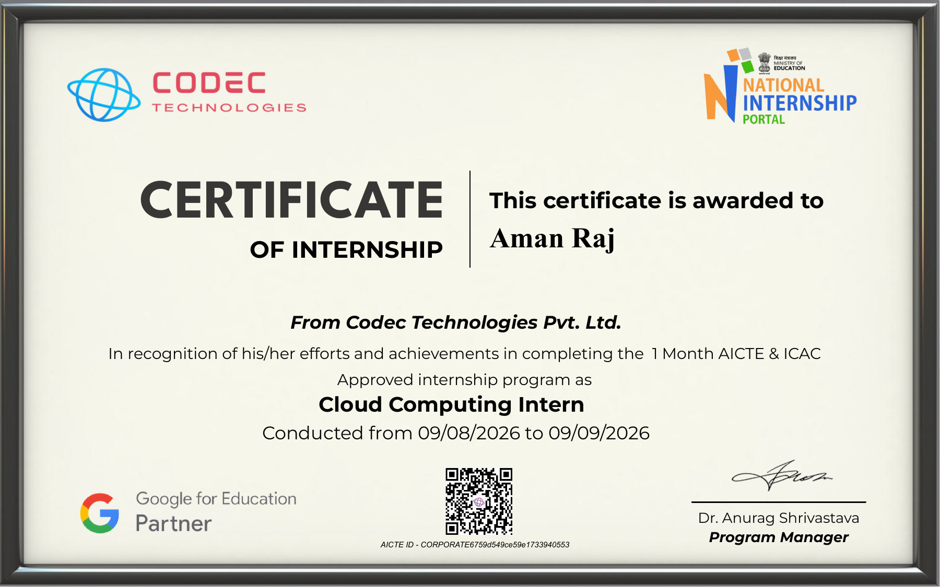

TABLE OF CONTENTS
Chapter No. | Chapter Name | Page Nos.
 | Cover Page | ----
1. | Candidate’s Declaration | i
2. | Acknowledgement | ii
3. | Internship Completion Certificate | iii
4. | Project Description | 1
 | 4.1 Introduction | 1
 | 4.2 Organization Profile | 1
 | 4.3 Problem Statement | 1
 | 4.4 Project Objectives | 1
 | 4.5 Scope of the Project | 2
 | 4.6 Technologies and Tools Used | 2
 | 4.7 System Architecture | 3
 | 4.8 Methodology | 4
 | 4.9 Expected Outcomes | 5
 | 4.10 Certificates of Completion and Other Communication Proof | 5
5. | Bibliography / References | 6
LIST OF TABLES
Table 4.1 Architecture Layers 2
LIST OF FIGURES
Figure 4.1 System Architecture — Multi-Tier Application and Dashboard 3

4. PROJECT DESCRIPTION
4.1 Introduction
The internship was completed in the area of Cloud Computing at Codec Technologies Pvt. Ltd. The internship provided an opportunity to understand basic cloud concepts and apply them through practical, student-level projects. The practical work focused on cloud architecture, application deployment concepts, source-code management and cloud cost awareness. Two projects were selected for the internship work: a Multi-Tier Web Application with CI/CD and a Cloud Cost Optimization Dashboard.
4.2 Organization Profile
Codec Technologies Pvt. Ltd. was the organization where the internship was carried out. The internship certificate identifies the role as Cloud Computing Intern and records the internship period from 09/08/2026 to 09/09/2026. The certificate also states that the program was a one-month AICTE & ICAC approved internship. The internship activities were focused on learning and practical project work related to cloud computing.
4.3 Problem Statement
Cloud platforms provide computing, storage, databases, networking and monitoring services, but understanding how these components work together can be difficult for beginners. The project work was therefore designed to provide simple practical examples of cloud-based application architecture and cost management. The first project demonstrates a multi-tier application structure and the basic idea of CI/CD. The second project presents cloud-cost information through a dashboard and provides simple suggestions for optimization.
4.4 Project Objectives
- Understand the basic concepts and uses of cloud computing.
- Study the structure of a multi-tier web application.
- Understand the role of compute, storage and database services.
- Understand the basic purpose of CI/CD in application development.
- Create a simple dashboard for viewing cloud-cost information.
- Identify basic ways to reduce unnecessary cloud expenditure.
- Improve practical skills in web development, GitHub and documentation.
4.5 Scope of the Project
The projects are academic and demonstration-level implementations. They are intended to explain important concepts in a simple way and can be extended later into fully deployed cloud applications.
- The multi-tier application separates frontend, backend and database responsibilities.
- The CI/CD concept is connected with GitHub-based source-code management.
- The cost dashboard displays sample monthly service costs and budget usage.
- The dashboard provides basic optimization suggestions.
- Live cloud APIs and deployed infrastructure can be added as future improvements.
4.6 Technologies and Tools Used
Technology / Tool | Purpose | Project
HTML | Page structure and interface | Both
CSS | Layout and styling | Both
JavaScript | Client-side functionality | Both
Node.js / Express | Backend and API handling | Multi-Tier App
MySQL | Database layer | Multi-Tier App
GitHub | Source-code hosting and version control | Both
AWS services | Reference cloud deployment architecture | Both
Cloud Cost Explorer | Reference for cloud cost data | Cost Dashboard

4.7 System Architecture
The multi-tier application follows a basic three-layer architecture. The frontend provides the user interface, the backend processes requests and application logic, and the database stores application information. GitHub is used for source-code hosting and version control, and CI/CD is presented as a development practice. For the cost dashboard, sample cost data is processed using JavaScript and displayed through a web dashboard containing total cost, budget usage, service-wise costs and optimization suggestions.
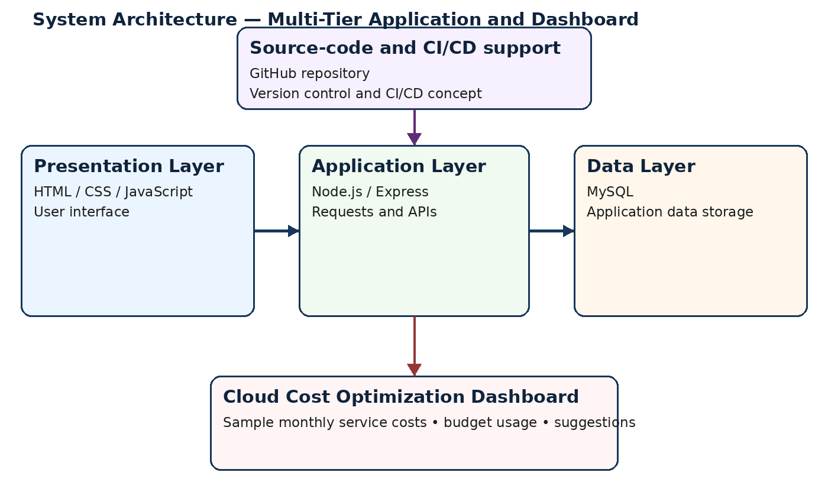
Figure 4.1 System Architecture — Multi-Tier Application and Dashboard
Table 4.1 Architecture Layers
Layer | Main Component | Role
Presentation | HTML / CSS / JavaScript | User interface
Application | Node.js / Express | Requests and APIs
Data | MySQL | Application data storage

4.8 Methodology
1. Understanding requirements: Reviewed the assigned objectives and identified the main functions to demonstrate.
2. Planning: Outlined the application components, data flow and basic interface.
3. Implementation: Developed the web pages and supporting JavaScript/backend components.
4. Testing: Checked the main functions and corrected basic issues.
5. Documentation: Prepared project documentation and organized the work for GitHub submission.
Project 1: Multi-Tier Web Application with CI/CD
The first project is a simple task-management web application. It demonstrates a frontend, backend and database structure. Users can add tasks, view tasks, mark tasks as completed and delete tasks.
- Frontend: HTML, CSS and JavaScript.
- Backend: Node.js with Express.
- Database: MySQL.
- GitHub used for source-code hosting and version control.
Project 2: Cloud Cost Optimization Dashboard
The second project is a simple dashboard that presents cloud-cost information in a readable form. It uses sample monthly data for services such as EC2, S3, RDS and CloudFront.
- Monthly service-wise cost display.
- Total cost and budget usage summary.
- Basic optimization suggestions.
- HTML, CSS and JavaScript used for the interface.
- Sample data can be replaced by live cloud cost data in future.

4.9 Expected Outcomes
The internship and project work were intended to provide a basic practical understanding of cloud computing and related development practices.
- Better understanding of cloud computing fundamentals.
- Understanding of multi-tier application architecture.
- Basic familiarity with compute, storage, database and CDN concepts.
- Understanding of the purpose of CI/CD and source-code management.
- Ability to present cloud-cost information through a simple dashboard.
- Improved confidence in creating and documenting small technical projects.
- Experience in publishing project work on GitHub.
4.10 Certificates of Completion and Other Communication Proof
A copy of the internship completion certificate issued by Codec Technologies Pvt. Ltd. is attached on page iii of this report. The certificate records the role as Cloud Computing Intern and the internship period from 09/08/2026 to 09/09/2026.

5. BIBLIOGRAPHY / REFERENCES
- Amazon Web Services (AWS) — Documentation on cloud computing, compute, storage and cost management.
- GitHub Documentation — Repositories, version control and project hosting.
- Node.js Documentation — Runtime and application development.
- Express.js Documentation — Web applications and APIs.
- MySQL Documentation — Relational databases and SQL.
Appendix: Project Submission Details
Add the final GitHub repository links before submitting the report.
Project 6 GitHub Link: https://github.com/amanraj88/student-task-manager
Project 7 GitHub Link: https://github.com/amanraj88/cloud-cost-optimization-dashboard

