|  |  |  |  |
| --- | --- | --- | --- |
| |  |  |  | | --- | --- | --- | | |  |  | | --- | --- | |  |  | | |   NAME : Akash singh  ROLL NO. : 41  DATABASE MANAGEMENT SYSTEM  ASSIGNMENT 1 |   ANS : -    TABLES |
| TABLE : 1 |

|  |  |  |
| --- | --- | --- |
| |  |  | | --- | --- | | **Table : 2)**  **3)** |  | |

|  |  |  |
| --- | --- | --- |
| |  |  | | --- | --- | | **4)** |  | |

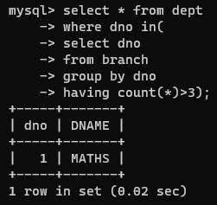

|  |  |  |  |  |
| --- | --- | --- | --- | --- |
| |  |  | | --- | --- | | **5)** |  |   **Ans a)**   |  |  | | --- | --- | |  |  |   **Question (A)**   Develop a SQL query to list details of Departments that offer more than 3 branches. |

**Question (B)**   
Develop a SQL query to list the details of Departments that offer more than 6 courses.

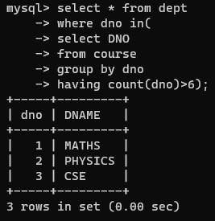

**Question (D)**   
Develop a SQL query to list students who got ‘S’ in more than 2 courses during single enrollment.

