|  |  |  |  |  |  |  |
| --- | --- | --- | --- | --- | --- | --- |
| |  |  |  |  |  |  | | --- | --- | --- | --- | --- | --- | | |  |  |  | | --- | --- | --- | |  | **UTTARANCHAL UNIVERSITY** |  | | **(Established vide Uttaranchal University Act, 2012, Uttarakhand Act No. 11 of 2013)** | | **Premnagar-248007, Dehradun, Uttarakhand, INDIA** | |   NAME : AMAN KUMAR RAJAK  ROLL NO. : 53  DATABASE MANAGEMENT SYSTEM  ASSIGNMENT : 1  **Q1 Attempt any three questions and use relevant output:**  **Question (A)**  Develop a SQL query to list details of Departments that offer more than 3 branches.  **Question (B)**  Develop a SQL query to list the details of Departments that offer more than 6 courses.    **Question (D)**  Develop a SQL query to list students who got ‘S’ in more than 2 courses during single enrollment. |

|  |
| --- |
| **ER model**    **TABLES** |

|  |  |  |
| --- | --- | --- |
| |  |  | | --- | --- | | **Table : 1)**  **2)** |  |   **3)** |

|  |  |  |
| --- | --- | --- |
| |  |  | | --- | --- | | **4)** |  | |

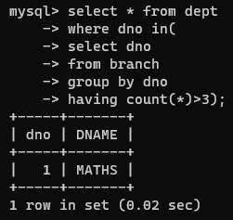

|  |  |  |  |  |
| --- | --- | --- | --- | --- |
| |  |  | | --- | --- | | **5)** |  |   **Ans a) Ans b)**     |  |  | | --- | --- | | **Ans d)** |  | |