***Synopsis***

***On***

**FACE EXPRESSION RECOGNITION WITH SONG RECOMMENDATION SYSTEM USING “OPEN-CV”.**

**Submitted for the requirement of**

**Project course**

BACHELOR OF ENGINEERING

**COMPUTER SCIENCE & ENGINEERING**



**Submitted to Submitted by:**

**SHUBHAM SINGH (16BCS1180)**

**SUVANSH ARORA (16BCS1365)**

**AMAN RAJPUT (16BCS1737)**

**DEPARTMENT OF COMPUTER SCIENCE & ENGINEERING**

**CHANDIGARH UNIVERSITY**

**GHARUAN, MOHALI, PUNJAB, INDIA-140413**

### CERTIFICATE

This is to certify that the work embodied in this synopsis entitled **“FACE EXPRESSION RECOGNITION WITH SONG RECOMMENDATION SYSTEM USING “OPEN-CV””** being submitted by **“ Aman, Shubham,Suvansh” (UID.:16BCS1737,16BCS1180,16BCS1365 )** for partial fulfillment of the requirement for the degree of **“ Bachelor of Engineering in Computer Science & Engineering ”** discipline to “ **Chandigarh University** ” during the academic year 2018-19 is a record of bona fide piece of work, carried out by him under my supervision and guidance in the **“ Department of Computer Science & Engineering ”, Chandigarh University.**

**APPROVED & GUIDED BY:**

(Assistant Professor, Department Of Computer Science and Engineering)

### DECLARATION

### I, student of Bachelor of Engineering in Computer Science & Engineering discipline, session: 2007-2018, Chandigarh University, here by declare that the work presented in this synopsis entitled **“FACE EXPRESSION RECOGNITION WITH SONG RECOMMENDATION SYSTEM USING “OPEN-CV””** is the outcome of our own work, is bona fide and correct to the best of our knowledge and this work has been carried out taking care of Engineering Ethics. The work presented does not infringe any patented work and has not been submitted to any other university or anywhere else for the award of any degree or any professional diploma.

|  |  |  |
| --- | --- | --- |
| **TOPIC NAME** |  | **PAGE NO.** |
| Certificate | ………………… | 2 |
| Declaration | ………………… | 3 |
| Abstract | ………………… | 5 |
| 1.0 INTRODUCTION | ………………… | 6 |
| 2.0 PROPOSED METHODOLOGY | ………………… | 7-8 |
| 3.0 TEAM MEMBER WISE DISTRIBUTION | *…………………* | *9* |
| 4.0 SOFTWARE AND HARDWARE REQUIREMENTS | *…………………* | *9* |
| BIBILIOGRAPHY | ………………… | 10 |

**ABSTRACT**

At one of the most successful application of images analysis and understanding, facerecognition has recently received significant attention, especially during the past few years.Facial recognition technology (FRT) has emerged as an attractive solution to address manycontemporary needs for identification and the verification of identity claims. It bringstogether the promise of other biometric systems, which attempt to tie identity to individuallydistinctive features of the body, and the more familiar functionality of visual surveillancesystems. This report develops a sociopolitical analysis that bridges the technical and socialscientific literatures on FRT and addresses the uni!ue challenges and concerns that attend itsdevelopment, evaluation, and specific operational uses, conte"ts, and goals. It highlights the potential and limitations of the technology, noting those tas#s for which it seems ready for deployment, those areas where performance obstacles may be overcome by futuretechnological developments or sound operating procedures, and still other issues whichappear intractable. Its concern with efficacy e"tends to ethical considerations. Facerecognition technology may solve this problem since a face is undeniably connected to itsowner e"pect in the case of identical twins. It$s nontransferable. The system can thencompare scans to records stored in a central or local database or even on a smart card..

**1.0 INTRODUCTION**

# Introduction to Image Processing

In order to get an enhanced image and to extract some useful information out of it, the method of Image Processing can be used. It is a very efficient way through which an image can be converted into its digital form subsequently performing various operations on it. This is a technique similar to signal processing, in which the input given is a 2D image, which is a collection of numbers ranging from 0 to 255 which denotes the corresponding pixel value. [8]

TABLE 1:This is a 2D array depicting the pixels of a sample image

|  |  |  |
| --- | --- | --- |
| 134 | 21 | 107 |
| 64 | 37 | 78 |
| 42 | 4 | 13 |

The method involves converting an image into a 2D Matrix.

It consists of three basic steps [2]:

1.) **Scanning the image**: a raw image is acquired which has to be processed. It can be expressed in form of pixels as stated above. The aim of this step is to extract information which is suitable for computing.

2.) **Processing and Enhancing it**: -the image is converted into digital form by using a digitizer which samples and quantizes the input signals. The rate of sampling should be high for good resolution and high quantization level for human perception of different shades using different using gray-scale

3.) The obtained result describes the property of the image and further classifies the image.

**Conversion of Color Image to Gray Scale**

There are basically two methods to convert a color image to a gray scale image [8]:

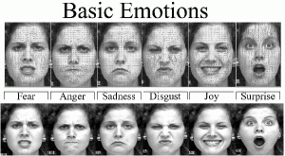

**METHODOLOGY USED:-**

A.) **Average Method**

In Average method, the mean is taken of the three colors i.e. Red, Blue & Green present in a color image. Thus, we get

Grayscale= (R+G+B)/3;

But what happens sometimes is instead of the grayscale image we get the black image. This is because we in the converted image we get 33% each of Red, Blue & Green.

Therefore, to solve this problem we use the second method called Weighted Method or Luminosity Method.

B) **Weighted or Luminosity Method**

To solve the problem in Average Method, we use Luminosity method. In these method, we decrement the presence of Red Color and increment the color of Green Color and the blue color has the percentage in between these two colors.

Thus, by the equation [8],

Grayscale= ((0.3 * R) + (0.59 * G) + (0.11 * B)).

We use this because of the wavelength patterns of these colors. Blue has the least wavelength while Red has the maximum wavelength.

II. Review of Literature

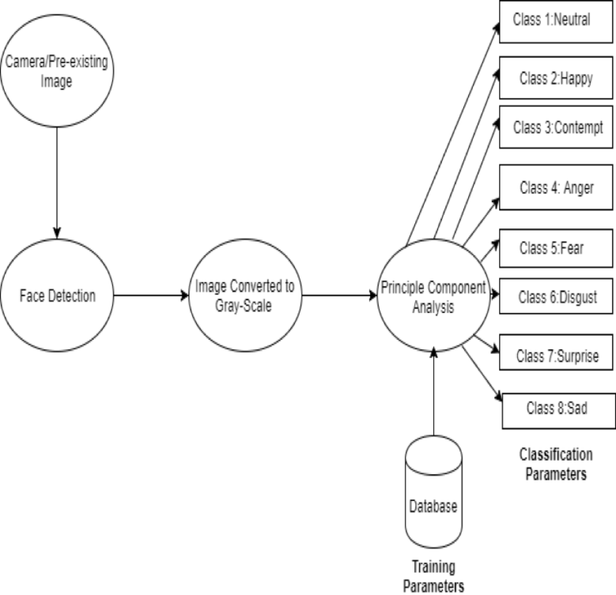1. Different Strengths & Weaknesses were noted in the emotion recognition system by Mr. Ashwini, Mr. Jacob and Dr. Jubilant [14] of St. Joseph’s College of Engineering.

2. Mr. Aruna Chakraborty, Mr. Amit Konar, Mr. Uday Kumar Chakraborty, and Mr. Amita Chatterjee in. Emotion Recognition from Facial Expressions and Its Control Using Fuzzy Logic [15] explained that this fuzzy approach that has accuracy of about 90%.

3. Strengths and weaknesses of facial expression classifiers and acoustic emotion classifiers were analyzed by Carlos Busso, Zhigang Deng, Serdar Yildirim, Murtaza Bulut, Chul Min Lee, Abe Kazemzadeh, Sungbok Lee, Ulrich Neumann and Shrikanth Narayanan. [1].

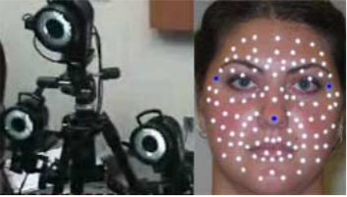

Fig.1Data Recording System [16]

III. **Introduction to OpenCV**

OpenCV is Open Computer Vision Library [4]. It is a free for all extensive library which consists of more than 2500 algorithms specifically designed to carry out Computer Vision and Machine Learning related projects. These algorithms can be put to use to carry out different tasks such as Face Recognition, Object Identification, Camera Movement Tracking, Scenery Recognition etc. It constitutes a large community with an estimate of 47,000 odd people who are active contributors of this library. Its usage extends to various companies both, Private and Public.

A new feature called GPU Acceleration [12] was added among the preexisting libraries. This new feature can handle most of the operations, though it’s not completely advanced yet. The GPU is run by using CUDA and thus takes advantages from various libraries such as NPP i.e. NVIDIA performance primitives. Using GPU is beneficial by the fact that anyone can use the GPU feature without having a strong knowledge on GPU coding. In GPU Module, we cannot change the features of an image directly, rather we have to copy the original image followed by editing it.



**Module & Team Member wise Distribution of work**

This project is developed by 3 members. By the determination of all the members in the group we have achieved our goal. All the members has their own key skills in the specific category because of which it will be much easier to implement this project by the help of the project is created very well with all the client requirements fulfilled.

The key Members and their work Distribution in the Project are

**1. A Member work Description**

**Aman Rajput will be looking after the necessary software requirements and the Code implementation of this project**

Time of completion of his module will be the end of this semester.

**2. B Member work Description**

**Suvansh Arora will be looking after the functioning and application of this project .**

Time of completion of her module will be the end of this semester.

**3. C Member work Description**

**Shubham will be looking after the all the resources that will be needed to full fill this projects and all its Objectives**

Time of completion of his module will be the end of this semester.

**Software and Hardware Requirements**

**HARDWARE REQUIREMENTS**

* Windows Based Platform.
* 4GB of RAM.
* i3 to i7 Intel core processor can be used .
* Web Cam.

**SOFTWARE REQUIREMENTS**

* Operating System: Windows 10
* Programming language: Python and Open CV.
* Libraries required: Numpy,Scikitlearn. Tensorflow,Id3,Panda’s, Matplotlib, Seaborn etc.
* Database: Oracle DB

**Bibliography**

**Websites**

* http://www.Wikipedia.com
* http://www.TutorialsPoint.com
* <http://www.youtube.com>
* http://www.github.com