**PLOT DESCRIPTIONS**

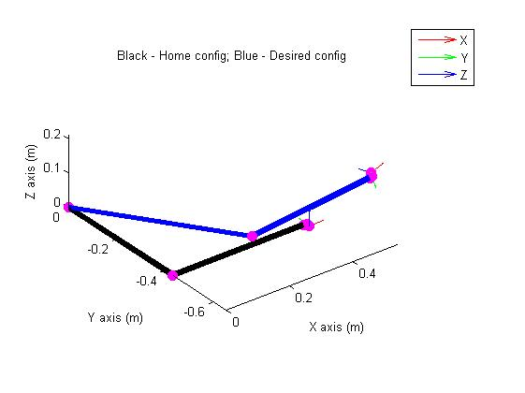

**Figure 1: Plot of the PSM at its initial position (in black) and final position (in blue)**

This plot shows the Patient Side Manipulator (PSM) in its home configuration in black with all its joint values set to 0 i.e. the configuration when there is no actuation. The position of the manipulator in this configuration is found using forward kinematics to be (0.43, -0.44, 0.00) and its Euler angles are found to be (0, 0, 0). The line plot in blue shows the PSM in its final configuration after performing forward kinematics with joint values obtained from the inverse kinematics for a desired position (0.5, -0.6, 0.2) and orientation specified by a set of Euler angles (0, 0, 0). As can be seen, the manipulator has been positioned correctly, while there are some glitches in getting the orientation to work properly. More details about inaccuracies in orientation are given in further plot descriptions.

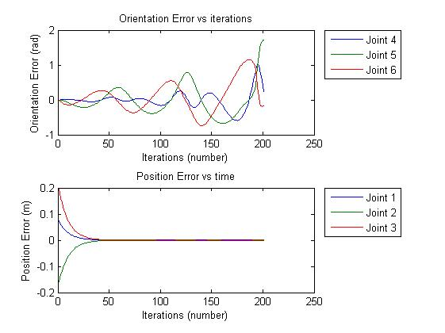

**Figure 2: Plot of the PSM’s orientation and position errors vs. time (iterations)**

The top plot indicates the change in orientation error with iterations. It is evident that the orientation error is an increasing sinusoid. The orientation error does not seem to converge and this again indicates a glitch in the computation. The position error however converges to zero relatively quickly (at the 47th iteration).

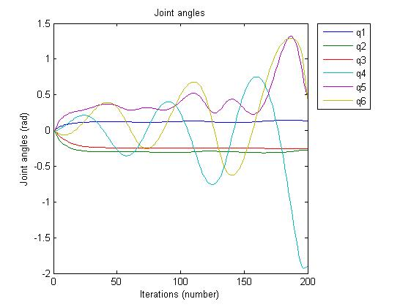

**Figure 3: Plot of the variation in joint angles with iterations**

This plot shows the variation of joint angles with time or iterations. It can be inferred from the plot that joints 1, 2 and 3 converge to a stable value while joints 4, 5 and 5 do not. This again reinforces the fact that the positioning has been done correctly because joints 1, 2 and 3 are responsible for the positioning and joints 4, 5 and 6 are responsible for orienting the end effector. Here again, we see that joint values for joints 4, 5 and 6 is sinusoidal and the trend suggests that it is never converging to a bounded value.

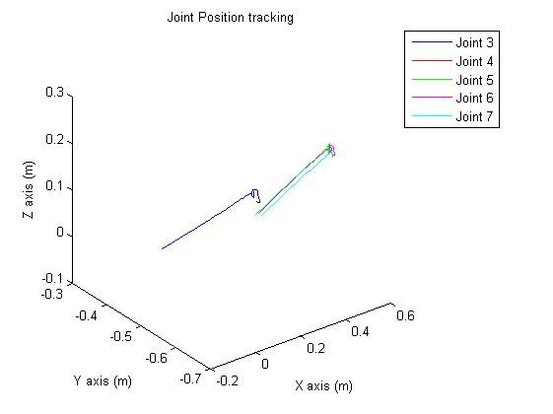

**Figure 4: Plot of joint trajectory tracking**

In this plot, the trajectories of all joints have been tracked in the task (Cartesian) space. Joints 1 and 2 are at the base and do not move and are hence not plotted. Joints 3 through 7 are plotted. It is interesting to observe the unstable behaviour of the system towards the end where the joints 4, 5 and 6 are used to orient the end effector towards the desired orientation. Until the curvy, unstable portion of the plot, the system seems to be stable i.e. when joints 1, 2 and 3 are performing the job of positioning the end effector to the desired position, there seems to be an almost straight line trajectory indicating stability and convergence towards the desired position.