INTRODUCTION TO DATA MANAGEMENT
PROJECT REPORT
(Project Semester January-April 2025)

(Netflix Movies Analysis Dashboard)

Submitted by

(Aman Singh Rawat)

Registration No:12315416

Programme and Section B. TECH CSE(K23EG)
Course Code INT217

Under the Guidance of

Jaffar Amin Chacket (30453)

Discipline of CSE/IT

Lovely School of Computer Science

Lovely Professional University, Phagwara

CERTIFICATE

This is to certify that Aman Singh Rawat bearing Registration no. 12315416 has completed INT217 project titled, “Netflix Movies Analysis Dashboard” under my guidance and supervision. To the best of my knowledge, the present work is the result of his/her original development, effort and study.

Signature and Name of the Supervisor
Designation of the Supervisor
School of Computer Science
Lovely Professional University
Phagwara, Punjab.

Date:

DECLARATION

I, Aman Singh Rawat student of B. Tech CSE under CSE/IT Discipline at, Lovely Professional University, Punjab, hereby declare that all the information furnished in this project report is based on my own intensive work and is genuine.


Date:
Registration No. 12315416 Aman Singh Rawat

1. Introduction
With the rising consumption of digital content, Netflix has emerged as a leading platform offering a wide range of Movies and TV Shows globally. This project aims to explore Netflix's content library through an interactive dashboard created after detailed data preprocessing and analysis. The objective is to uncover meaningful insights into content trends, audience preferences, and production patterns.
2. Source of Dataset
The dataset used in this project was obtained from a public domain source, containing detailed information on Netflix titles including title names, type (Movie/TV Show), release year, genres, countries, directors, cast, ratings, and popularity indicators like vote average and vote count.
3. Dataset Preprocessing
The raw dataset contained inconsistencies, missing values, and formatting issues. Preprocessing steps included:
- Removing duplicates
- Handling missing values using appropriate imputation strategies
- Standardizing text columns (title case, trimming whitespaces)
- Encoding categorical variables where necessary
- Converting date-related columns to datetime format for time-based analysis
4. Analysis on Dataset
Objective 1: Top Performing Directors by Revenue
- General Description: Directors play a key role in the success of content. This analysis identifies the top-grossing directors.
- Specific Requirements: Calculate total revenue (vote_average * vote_count) for each director.
- Analysis Results: Top directors contributing to the highest revenue were highlighted.
- Visualization: A horizontal bar chart showcasing top 10 directors by revenue.
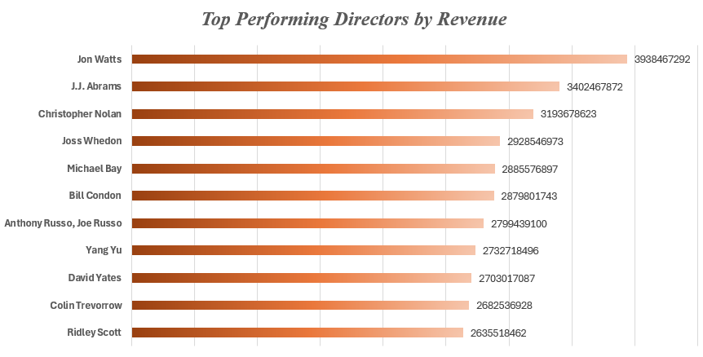

Objective 2: Audience Engagement by Content Type
- General Description: Engagement levels vary between Movies and TV Shows.
- Specific Requirements: Calculate and compare average vote count for each content type.
- Analysis Results: Viewers show different levels of interaction with Movies vs TV Shows.
- Visualization: Bar plot comparing average vote count for Movies and TV Shows.

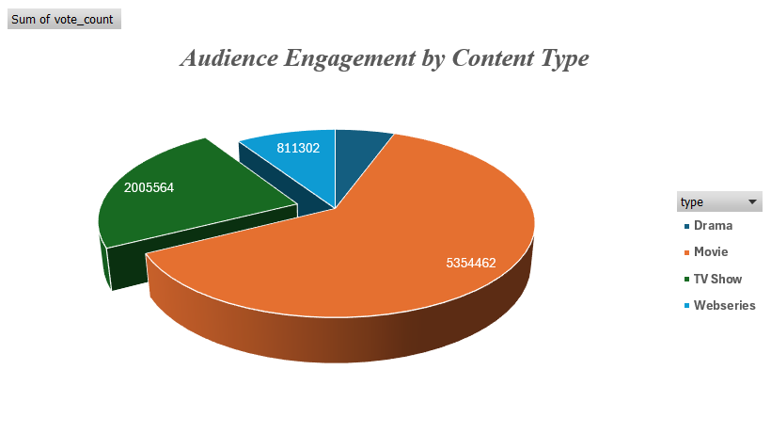
Objective 3: Top 10 Most Popular Netflix Titles
- General Description: Popularity is essential for understanding viewer choices.
- Specific Requirements: Sort titles by vote count and vote average to find the top 10.
- Analysis Results: Most popular titles by user engagement were listed.
- Visualization: A vertical bar chart of top 10 titles based on combined popularity score.
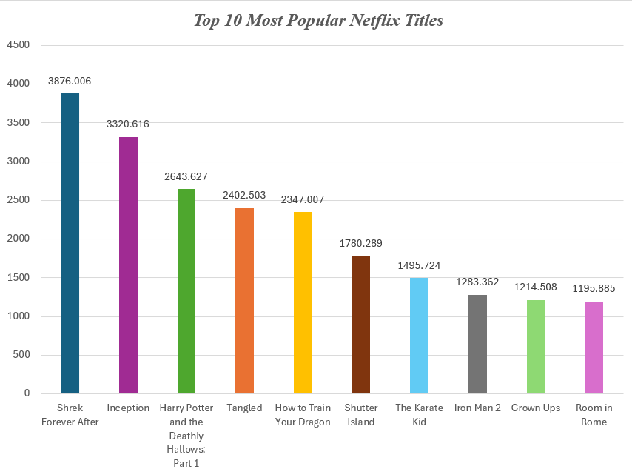
Objective 4: Distribution of Content Types
- General Description: Analyze the ratio of Movies to TV Shows.
- Specific Requirements: Count occurrences of each content type.
- Analysis Results: Movies dominate the platform in quantity.
- Visualization: Pie chart showing the percentage of Movies vs TV Shows.

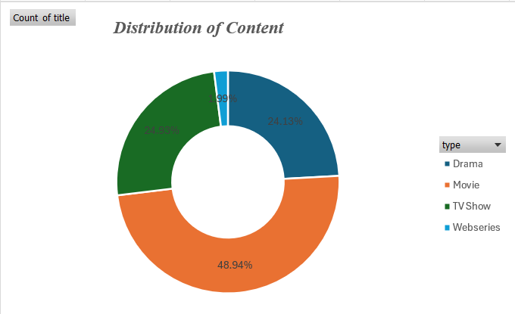
Objective 5: Most Common Genres on Netflix
- General Description: Identify genres frequently featured in Netflix content.
- Specific Requirements: Extract and count genre frequencies from genre column.
- Analysis Results: Drama, Comedy, and Action were the most common.
- Visualization: Bar plot displaying genre frequency.
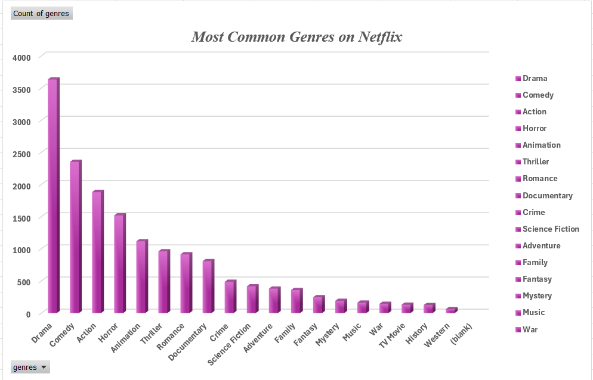
Objective 6: Content Production by Country
- General Description: Determine Netflix’s global production outreach.
- Specific Requirements: Count number of titles produced by each country.
- Analysis Results: The United States leads content production, followed by India and the UK.
- Visualization: Bar plot or map showing country-wise content distribution.
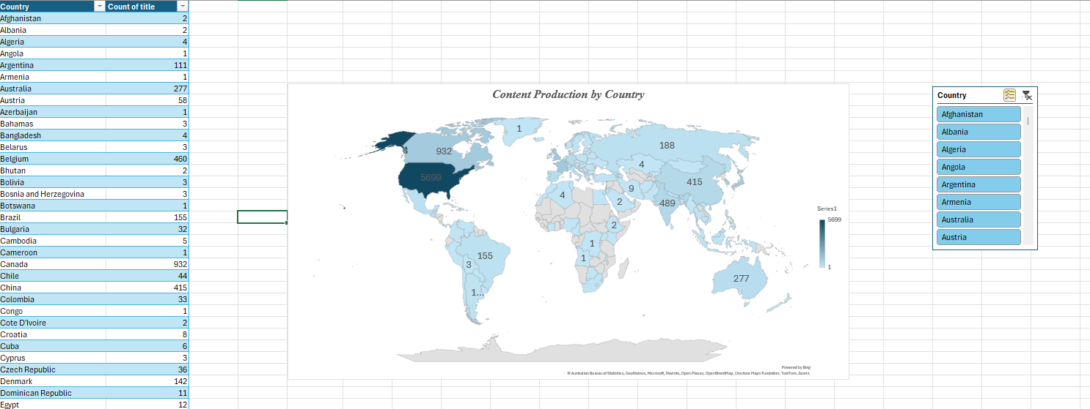
Objective 7: Trend of Releases Over the Year
- General Description: Analyzing how the volume of releases changed over time.
- Specific Requirements: Group titles by release year and count them.
- Analysis Results: There was a significant rise in content release after 2015.
- Visualization: Line chart showing number of releases per year.
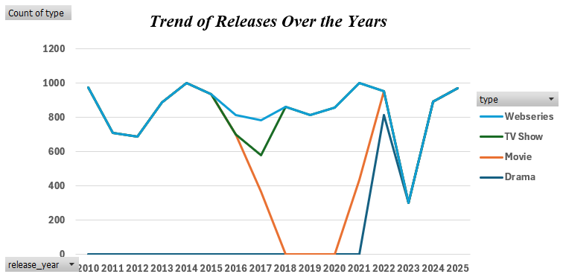
5. Conclusion
The analysis provided valuable insights into the type of content viewers prefer, the countries leading content production, and the evolution of Netflix's content library. The dashboard facilitates quick decision-making and reveals trends that help understand the dynamics of digital content.
6. Future Scope
Future work can include:
- Sentiment analysis on reviews and descriptions
- Predictive modeling to forecast content popularity
- User segmentation based on genre preferences
- Deep dive into regional content trends
7. References
- Netflix Dataset (Kaggle/Public Repository)- https://www.kaggle.com/datasets/bhargavchirumamilla/netflix-movies-and-tv-shows-till-2025
- Python Libraries: pandas, matplotlib, seaborn, numpy
- Online articles and documentation for visualization best practices
- Linkedin Post-https://www.linkedin.com/posts/amansinghrawat040_netflixdata-dashboardproject-datastorytelling-activity-7316755387968278528-gswL?utm_source=social_share_send&utm_medium=member_desktop_web&rcm=ACoAAC4pPjoB6mfWhe3k5pymgFXfEOG9hy4Gxu4

