A HIERARCHICAL MULTIMODAL FRAMEWORK FOR
AUTONOMOUS MARITIME SURVEILLANCE USING
SATELLITE DETECTION, KALMAN-FILTER UAV
TRACKING, AND VISION-LANGUAGE REASONING
A PROJECT REPORT
Submitted to
Amrita Vishwa Vidyapeetham
in partial fulfillment for the award of the degree of
BACHELOR OF TECHNOLOGY IN COMPUTER SCIENCE AND
ENGINEERING
By
AMAN REDDY J
(Reg. No. CH.SC.U4AIE23006)
BTPR NIKHIL
(Reg. No. CH.SC.U4AIE23005)
Supervisor
Dr. K ASHWINI
Assistant Professor (Sr. Gr.)

AMRITA VISHWA VIDYAPEETHAM
AMRITA SCHOOL OF COMPUTING
CHENNAI – 601103
October 2026


BONAFIDE CERTIFICATE
This is to certify that this project report entitled “A HIERARCHICAL MULTIMODAL FRAMEWORK FOR AUTONOMOUS MARITIME SURVEILLANCE USING SATELLITE DETECTION, KALMAN-FILTER UAV TRACKING, AND VISION-LANGUAGE REASONING” is the bonafide work of Mr. AMAN REDDY J (Reg. No. CH.SC.U4AIE23006) and Mr. BTPR NIKHIL (Reg. No. CH.SC.U4AIE23005), who carried out the project work under my supervision.
SIGNATURE  DR. S. BAGHAVATHI PRIYA  CHAIRPERSON  Associate Professor Dept. of CSE.  Amrita School of Computing  Chennai. | SIGNATURE  Dr. K ASHWINI  SUPERVISOR  Assistant Professor, Dept. of CSE.  Amrita School of Computing  Chennai.
INTERNAL EXAMINER | EXTERNAL EXAMINER

DECLARATION BY THE CANDIDATE
I declare that the report entitled “A HIERARCHICAL MULTIMODAL FRAMEWORK FOR AUTONOMOUS MARITIME SURVEILLANCE USING SATELLITE DETECTION, KALMAN-FILTER UAV TRACKING, AND VISION-LANGUAGE REASONING” submitted by me for the degree of Bachelor of Technology is the record of the project work carried out by me under the guidance of “Dr. K ASHWINI” and this work has not formed the basis for the award of any degree, diploma, associateship, fellowship, titled in this or any other University or other similar institution of higher learning.
SIGNATURE
AMAN REDDY J
(Reg. No. CH.SC.U4AIE23006)
Department of Computer Science and Engineering
SIGNATURE
BTPR NIKHIL
(Reg. No. CH.SC.U4AIE23005)
Department of Computer Science and Engineering

ABSTRACT
Persistent maritime domain awareness requires bridging strategic wide-area observation with tactical localized inspection under severe edge-compute and bandwidth constraints. This project presents OATrack-VLM, an end-to-end hierarchical multimodal framework that unifies high-resolution optical satellite vessel detection, tactical unmanned aerial vehicle (UAV) tracking via an 8-state discrete linear Kalman filter, fine-grained maritime vessel classification, reinforcement-learning-driven adaptive edge-compute scheduling, and grounded vision-language reasoning.
Strategic wide-area surveillance employs a fine-tuned YOLO11n object detector operating at high input resolution (1024×1024 pixels) on the VHRV optical satellite benchmark (1,502 scenes, 10,158 authentic vessels), achieving 93.64% precision, 90.26% recall, 94.63% mAP@50, and 74.16% mAP@50-95, overcoming downsampling truncation of small craft. Target coordinates and bounding geometries are autonomously packaged by a handoff adapter to seed localized UAV inspection routes, eliminating wasteful open-ocean transit search patterns. In the tactical UAV stage, an 8-state discrete linear Kalman filter coupled with multi-feature data association (incorporating bounding box IoU, normalized centroid displacement, aspect-ratio similarity, and motion heading) and sub-part containment suppression maintains persistent vessel identities across temporary detector dropouts, reducing track fragmentation from 27 IDs to 2 on representative drone video sequences while suppressing 100% of internal deck false alarms.
Target vessel crops are categorized across ten fine-grained maritime classes using ConvNeXt-Tiny trained on the TITANIC-FGS-10 dataset (14,570 images), achieving 81.56% top-1 accuracy and 82.84% macro F1-score, reinforced by multi-frame temporal evidence aggregation. To extend UAV flight endurance, an integrated Gymnasium-trained Proximal Policy Optimization (PPO) agent dynamically modulates sensor inference frequency between lightweight, standard, and high-rate modes, achieving estimated edge-compute reductions of 75.00% on empty open sea and 16.98% to 52.12% across active naval missions, while an operational safety override ensuring zero target loss
. Finally, a grounded vision-language reasoning layer synthesizes telemetry-verified tactical briefings without hallucinations. The complete system is supported by a high-performance FastAPI backend, with a React-based maritime surveillance operations console designed as the presentation layer.
Keywords: Maritime Surveillance, Satellite Detection, UAV Tracking, Kalman Filter, Vessel Classification, Adaptive Edge Computing, Reinforcement Learning, Vision-Language Models.

ACKNOWLEDGEMENT
This project work would not have been possible without the contribution and support of many people. It gives us immense pleasure to express our profound gratitude to our honorable Chancellor, Sri Mata Amritanandamayi Devi, for her divine blessings and for being a constant source of inspiration.
We are indebted to extend our sincere gratitude to our Administrative Director, Swami Vinayamritananda Puri, and Campus Director, Mr. I B Manikantan, Amrita School of Computing, Amrita Vishwa Vidyapeetham, Chennai Campus, for facilitating all the infrastructural facilities and providing an extended environment to gain valuable education and research experience.
We register our special thanks to Dr. V. Jayakumar, Principal, Amrita School of Computing, for the institutional support extended to us in the successful conduct of this project. We wish to express our heartfelt gratitude to Dr. S. Baghavathi Priya, Chairperson, Department of Computer Science and Engineering, Dr. S. Natarajan, Program Chair, and to our project supervisor, Dr. K Ashwini, Assistant Professor (Sr. Gr.), Department of Computer Science and Engineering, for their inspiring guidance, technical insights, personal involvement, and constant encouragement throughout the entire course of this project work.
We are sincerely grateful to the Project Coordinators, Review Panel Members, and the entire faculty of the Department of Computer Science and Engineering for their constructive critiques, critical evaluation, and valuable recommendations, which served as a rich source to enhance the scientific rigor and overall quality of this work.
AMAN REDDY J & BTPR NIKHIL
(Reg. No. CH.SC.U4AIE23006 & CH.SC.U4AIE23005)

TABLE OF CONTENTS
CHAPTER NO. | TITLE | PAGE NO.
 | Abstract | IV
 | List of Tables | X
 | List of Figures | XI
 | List of Abbreviations | XII
1 | INTRODUCTION | 1
1.1 | Background of Maritime Domain Awareness & Aerial Surveillance | 2
1.2 | Problem Statement | 2
1.3 | Motivation | 3
1.4 | Objective | 3
1.5 | Scope of the Project | 4
1.6 | Existing System and Limitations | 4
1.7 | Proposed Solution | 5
2 | LITERATURE REVIEW | 6
2.1 | Satellite Remote Sensing for Vessel Detection | 6
2.2 | Multi-Object Tracking and Kalman Filtering in Aerial Feeds | 6
2.3 | Fine-Grained Maritime Vessel Classification | 7
2.4 | Adaptive Edge Computing and Reinforcement Learning | 7
2.5 | Vision-Language Models in Tactical Surveillance | 7
2.6 | Research Gap | 8
2.7 | Contribution of the Proposed Work | 9

TABLE OF CONTENTS
CHAPTER NO. | TITLE | PAGE NO.
3 | DATASET AND PROPOSED METHODOLOGY | 10
3.1 | VHRV Optical Satellite Benchmark Dataset | 10
3.2 | TITANIC-FGS-10 Maritime Classification Dataset | 10
3.3 | Data Preprocessing and Ground-Truth Integrity Verification | 11
3.4 | Strategic Satellite-Based Vessel Detection (YOLO11n @ 1024px) | 11
3.5 | Target Handoff Adapter Architecture | 11
3.6 | Tactical UAV Tracking via Discrete Linear Kalman Filter | 12
3.6.1 | 8-State Dynamical State Formulation | 12
3.6.2 | Multi-Feature Data Association Metric | 12
3.6.3 | Sub-Part Containment Suppression Filter | 13
3.7 | Fine-Grained Classification & Evidence Aggregation | 13
3.8 | PPO Adaptive Edge Compute Scheduling | 13
3.9 | Grounded Vision-Language Reasoning Architecture | 14
4 | SYSTEM DESIGN AND ARCHITECTURE | 15
4.1 | Overall System Architecture | 15
4.2 | Data Flow Pipeline | 16
4.3 | Surveillance Processing Workflow | 16
4.4 | Proposed Application Architecture | 16
4.5 | System Components | 17

TABLE OF CONTENTS
CHAPTER NO. | TITLE | PAGE NO.
5 | METHODOLOGY | 18
5.1 | Development Environment | 18
5.2 | Model Implementation Details | 18
5.3 | Baseline Models | 19
5.4 | OATrack-VLM Implementation Workflow | 19
5.5 | React-Based Maritime Surveillance Command Center | 19
5.6 | Prototype Operational Workflow | 20
6 | RESULTS AND ANALYSIS | 21
6.1 | Experimental Setup | 21
6.2 | Evaluation Metrics | 21
6.3 | Satellite Vessel Detection Results | 21
6.4 | UAV Tracking and Motion Persistence Performance | 22
6.5 | Fine-Grained Classification Results | 23
6.6 | Training and Convergence Analysis | 24
6.7 | PPO Adaptive Compute Optimization Across Scenarios | 25
6.8 | Multi-Ship Anchorage and Dense Harbor Analysis | 26
6.9 | Grounded Vision-Language Telemetry Briefings | 26
6.10 | Discussion | 26
7 | EXPERIMENTAL RESULTS | 27
7.1 | System Testing | 27
7.2 | Current Achievements | 27
7.3 | Limitations | 28

TABLE OF CONTENTS
CHAPTER NO. | TITLE | PAGE NO.
8 | CONCLUSION AND FUTURE WORK | 29
8.1 | Conclusion | 29
8.2 | Future Work | 29
9 | REFERENCES | 31
10 | APPENDICES | 33
10.1 | Sample Inputs and Outputs | 33
10.2 | Additional Diagnostic Visualizations and Loss Curves | 33
10.3 | Project Execution Gantt Chart | 34
10.4 | Plagiarism Verification Report | 35
10.5 | Academic Paper Publication Details | 36

LIST OF TABLES
TABLE NO. | TITLE | PAGE NO.
2.1 | Research Gap | 8
3.1 | VHRV Optical Satellite Benchmark Dataset Summary | 10
3.2 | TITANIC-FGS-10 Maritime Vessel Classification Dataset Distribution | 12
4.1 | Major System Components | 17
5.1 | Development Environment | 18
6.1 | Quantitative Satellite Vessel Detection Performance on VHRV Test Split | 22
6.2 | Fine-Grained Vessel Classification Results on TITANIC-FGS-10 Test Split | 24
6.3 | PPO Adaptive Compute Optimization Across Operational Missions | 25
7.1 | System Testing | 27

LIST OF FIGURES
FIGURE NO. | TITLE | PAGE NO.
3.1 | Dataset Preparation and Construction Pipeline for VHRV Benchmark | 11
3.2 | Discrete Linear Kalman Filter Tracking Pipeline and State Transitions | 13
4.1 | End-to-End Hierarchical System Architecture of OATrack-VLM Framework | 16
5.1 | Maritime Surveillance Command Center Operations Dashboard (React) | 20
6.1 | High-Resolution Satellite Vessel Detection Localization on VHRV Test Split | 22
6.2 | Tactical UAV Persistent Tracking Visualization with Motion Trail | 23
6.3 | Normalized Confusion Matrix of ConvNeXt-Tiny on TITANIC-FGS-10 | 24
6.4 | Model Training and Validation Convergence Curves | 25
6.5 | Estimated Edge-Compute Savings Breakdown Across Maritime Scenarios | 26
10.1 | Sample Satellite Detection Output and Grounded Groq VLM Intelligence Briefing | 33
10.2 | Tactical UAV Video Frame Telemetry and Consensus Classification Output | 33
10.3 | Detailed Detector Training and Validation Loss Progression Curves | 33
10.4 | Project Execution Gantt Chart Across Academic Timeline | 34

LIST OF SYMBOLS AND ABBREVIATIONS
ABBREVIATION | EXPANSION
AI | - Artificial Intelligence
UAV | - Unmanned Aerial Vehicle
VLM | - Vision-Language Model
SAR | - Synthetic Aperture Radar
EEZ | - Exclusive Economic Zone
HBB | - Horizontal Bounding Box
OBB | - Oriented Bounding Box
MOT | - Multi-Object Tracking
SORT | - Simple Online and Realtime Tracking
IoU | - Intersection over Union
mAP | - Mean Average Precision
PPO | - Proximal Policy Optimization
DRL | - Deep Reinforcement Learning
HUD | - Heads-Up Display
SGD | - Stochastic Gradient Descent
VHRV | - Very-High-Resolution Vessel Dataset
TITANIC-FGS | - Fine-Grained Ship Classification Dataset
API | - Application Programming Interface
GPU | - Graphics Processing Unit
CSV | - Comma-Separated Values
JSON | - JavaScript Object Notation
REST | - Representational State Transfer
TP | - True Positive
TN | - True Negative
FP | - False Positive
FN | - False Negative

CHAPTER 1
INTRODUCTION
Maritime domain awareness (MDA) represents a cornerstone of national defense, territorial sovereign integrity, exclusive economic zone (EEZ) enforcement, fisheries protection, counter-smuggling interdiction, and search-and-rescue operations across expansive oceanic theaters. Modern maritime operations face increasingly complex challenges characterized by dense merchant shipping lanes, asymmetrical threats, dark vessel fleets operating with disabled Automatic Identification System (AIS) transponders, and extreme geographic expanses that dwarf conventional naval patrol fleets. Effective ocean monitoring necessitates multi-tiered surveillance capabilities that reconcile broad spatial coverage with high-resolution localized inspection, all while operating under stringent edge-compute budgets, severe battery endurance envelopes, and constrained wireless communication bandwidth.
Historically, maritime monitoring frameworks relied predominantly on manual observation, radar sweeps, and sparse coastal patrol vessels. The emergence of spaceborne remote sensing, specifically Very-High-Resolution (VHR) optical and Synthetic Aperture Radar (SAR) earth observation constellations, provided the first scalable apparatus for wide-area ocean reconnaissance. Concurrently, the rapid maturation of Unmanned Aerial Vehicles (UAVs) and deep neural networks has unlocked autonomous tactical observation capabilities from low altitudes. However, deployed systems frequently treat orbital reconnaissance and aerial inspection as disconnected, disjoint modalities, resulting in operational latency, redundant search flights, and uncoordinated intelligence pipelines.
The proposed project presents OATrack-VLM, an end-to-end hierarchical multimodal framework designed to unify wide-area satellite target localization, tactical UAV tracking via a discrete linear Kalman filter, fine-grained vessel classification, reinforcement-learning-driven adaptive edge compute scheduling, and grounded vision-language reasoning. By establishing a closed perception-to-intelligence loop, the system automates the transition from strategic satellite detection to continuous tactical tracking and natural-language intelligence generation without requiring continuous manual human piloting or full-rate edge processing on empty waters.
1.1 Background of Maritime Domain Awareness and Aerial Surveillance
The security and economic governance of global maritime zones rely on continuous situational awareness across thousands of square kilometers of ocean space. Conventional maritime surveillance architectures generally operate across two disjoint extremes: orbital satellite remote sensing and localized airborne patrols. Orbital optical remote sensing provides exceptional spatial coverage, capturing hundreds of square kilometers in single imagery acquisitions. However, commercial and tactical satellite constellations are constrained by Keplerian orbital mechanics and fixed revisit cycles, preventing continuous, real-time persistence over fast-moving surface targets.
Conversely, tactical unmanned aerial vehicles (UAVs) provide low-altitude agility, high-resolution continuous video observation, and dynamic sensor angles capable of capturing fine-grained structural features of vessel hulls and superstructures. However, deploying tactical UAVs to blindly search expansive ocean sectors without spatial cues leads to rapid battery exhaustion, truncated mission lifetimes, and high target miss probabilities. Bridging strategic orbital detection with agile tactical UAV inspection is therefore imperative for scalable, autonomous maritime domain awareness.
1.2 Problem Statement
Existing maritime surveillance and multi-sensor tracking architectures suffer from four critical operational bottlenecks:
1. Spatial Scale Mismatch and Detection Truncation: Very-high-resolution satellite images typically exhibit dimensions exceeding 4800×2886 pixels. Downsampling these wide-area scenes to standard deep learning input sizes (e.g., 640×640 pixels) collapses small vessels (30–60 meters in length) to fewer than 5 pixels wide, beneath convolutional receptive field strides, causing severe false-negative dropouts.
2. Multi-Ship Association Drift and Track Fragmentation: In dense anchorages, harbor approaches, and wave-churned waters, conventional tracking algorithms experience severe identity switching. Minor detector dropouts cause single vessels to fragment into dozens of spurious track IDs, while internal deck components (cranes, cargo manifolds) produce spurious sub-part detections.
3. Edge-Compute and Energy Exhaustion on Quiescent Waters: Continuous execution of full-frame deep object detectors and heavy classifiers aboard power-constrained UAVs rapidly depletes on-board battery reserves, even when the drone is patrolling quiescent, empty sea sectors.
4. Hallucination-Prone Intelligence Generation: Downstream intelligence analysis typically requires human analysts to manually parse raw bounding coordinates and class labels. While commercial vision-language models can generate natural language briefings, unconstrained models routinely hallucinate critical unobservable parameters such as vessel nationality or weaponry.
1.3 Motivation
The primary motivation of this project is to develop an autonomous, resource-aware maritime surveillance architecture that operates continuously without human fatigue, reduces UAV energy consumption through intelligent compute modulation, and maintains unwavering track persistence under adverse maritime visual conditions.
By fine-tuning a high-resolution YOLO11n detector at 1024×1024 pixels, the system preserves spatial fidelity on small vessels across massive satellite swathes. By introducing an 8-state discrete linear Kalman filter with multi-feature affinity costing and sub-part containment filtering, target tracks persist across temporary detector dropouts without identity fragmentation. Furthermore, by training a Proximal Policy Optimization (PPO) reinforcement learning policy in a custom Gymnasium environment, the UAV dynamically throttles edge inference rates, saving up to 75% compute on empty seas while enforcing an operational safety override during tactical target encounters. Finally, grounding vision-language synthesis in verified sensor telemetry produces authoritative intelligence briefings suitable for immediate operational decision-making.
1.4 Objective
The overarching objectives of the OATrack-VLM project are structured as follows:
1. High-Resolution Satellite Vessel Detection: Train and evaluate a specialized YOLO11n detector at 1024×1024 resolution on the held-out VHRV optical satellite test benchmark (150 images, 1,191 vessels), achieving over 93% precision and 94% mAP@50.
2. Autonomous Target Handoff Architecture: Implement a software-in-the-loop target handoff adapter that translates confirmed satellite vessel coordinates into localized UAV flight path waypoints, bypassing blind open-ocean searching.
3. Persistent Kalman Filter UAV Tracking: Design and deploy an 8-state discrete linear Kalman filter with constant-velocity kinematics, scale-rate tracking, multi-feature Hungarian association, and sub-part containment suppression to eliminate ID fragmentation.
4. Fine-Grained Vessel Classification: Fine-tune ConvNeXt-Tiny across 10 maritime vessel classes using the TITANIC-FGS-10 dataset (14,570 images), stabilizing predictions through multi-frame temporal evidence aggregation.
5. PPO Adaptive Compute Optimization: Develop a Gymnasium maritime environment and train a Stable-Baselines3 PPO agent to dynamically throttle edge frame sampling (LOW, NORMAL, HIGH), evaluating compute conservation across operational drone missions.
6. Grounded Multimodal Intelligence Briefing: Interface telemetry outputs with Groq-hosted Qwen-2.5-Vision and Llama-3.3-70B models to generate concise, telemetry-grounded intelligence summaries with reduced risk of unsupported factual claims.
7. Command Center Deployment: Deliver a fully integrated system featuring a high-throughput FastAPI backend and a React-based Maritime Surveillance Command Center dashboard for real-time mission visualization.
1.5 Scope of the Project
The scope of this project encompasses the complete algorithmic design, dataset preparation, neural network training, offline quantitative benchmarking, and prototype software deployment of the OATrack-VLM framework.
Inclusions:
• Optical satellite imagery analysis using authentic high-resolution horizontal bounding box (HBB) annotations from the VHRV dataset.
• Tactical aerial drone video feeds (MP4/AVI) depicting maritime operations (oil tankers, cruise vessels, combatants, open ocean).
• Linear discrete Kalman filter modeling, two-stage data association, and bounding box geometric containment suppression.
• Deep convolutional classification of 10 vessel categories on the TITANIC-FGS-10 benchmark.
• Deep reinforcement learning policy training using Gymnasium and Stable-Baselines3 PPO with a deterministic safety override.
• REST API endpoints implemented via FastAPI and interactive operator console built with React.
Operational Boundaries & Exclusions:
• Oriented Bounding Box (OBB) detection is excluded from the current baseline as the VHRV benchmark natively provides HBB labels.
• Direct hardware flight controller integration (PX4/ArduPilot MAVLink telemetry) is modeled via software-in-the-loop simulation.
• Edge compute reductions represent estimated on-board GPU algorithmic FLOPs and forward-pass savings rather than physical battery bus meters.
1.6 Existing System and Limitations
Current operational maritime surveillance systems exhibit severe architectural deficiencies:
1. Disconnected Sensor Silos: Satellite observation centers process orbital data independently and distribute intelligence via delayed manual channels. Tactical UAV assets are typically dispatched hours later without real-time target handoff coordinates.
2. Vulnerability to Detection Dropouts in Aerial MOT: Classical tracking-by-detection algorithms (e.g., vanilla SORT or standard ByteTrack) rely heavily on high frame-to-frame IoU overlap. In aerial maritime feeds, UAV altitude changes, platform jitter, sun glint, and wave crests cause brief detector dropouts. Standard trackers immediately drop the track and assign a new ID upon re-acquisition, fragmenting single vessels into multiple discontinuous paths.
3. Unfiltered Deck-Level Sub-Part Detections: Deep object detectors trained on maritime targets frequently detect internal superstructures (e.g., container cranes, helipads, bridge towers) as separate vessels, causing false alarms in crowded harbors.
4. Rigid Exhaustive Computing: Existing UAV perception systems execute deep learning models at maximum frame rate continuously, consuming massive power during empty transit flights where no targets are present.
1.7 Proposed Solution
To overcome these challenges, OATrack-VLM establishes a unified, hierarchical perception pipeline structured across three distinct operational tiers:
• Tier 1: Strategic Wide-Area Satellite Localization — High-resolution YOLO11n inference at 1024×1024 pixels detects vessel targets across massive satellite images without spatial truncation, achieving 94.63% mAP@50. A handoff adapter packages detected coordinates to seed localized UAV flight routes.
• Tier 2: Tactical Aerial Tracking & Adaptive Compute — An 8-state discrete linear Kalman filter predicts vessel position, dimensions, and velocity. A two-stage Hungarian association module pairs high- and low-confidence detections, while a sub-part containment filter suppresses 100% of internal false alarms. Concurrently, a PPO adaptive scheduler throttles frame sampling to conserve edge compute.
• Tier 3: Fine-Grained Classification & Semantic Reasoning — Confirmed vessel crops are classified across 10 categories via ConvNeXt-Tiny, stabilized by temporal evidence aggregation. Grounded telemetry is passed to Groq vision-language models to produce structured natural-language intelligence briefings.
The end-to-end workflow transitions seamlessly: Satellite Input → YOLO11n Detection → Target Handoff → UAV Video Ingestion → PPO Compute Throttling → Kalman Tracking → ConvNeXt Classification → Grounded VLM Intelligence Briefing.

CHAPTER -2
LITERATURE REVIEW
Automated maritime surveillance has witnessed substantial technological evolution driven by deep learning, high-resolution spaceborne remote sensing, multi-object tracking (MOT) algorithms, edge computing, and large multimodal models. Early maritime monitoring systems relied heavily on manual radar plotting, handcrafted feature extractors (e.g., Haar cascades, HOG), and basic constant-velocity kinematics. While foundational, these early techniques failed to generalize across complex oceanic clutter, sea spray, variable solar illumination, and dense vessel anchorages. This chapter reviews recent academic advancements across five core pillars: spaceborne vessel detection, multi-object aerial tracking, fine-grained vessel categorization, reinforcement-learning-driven edge computing, and vision-language intelligence synthesis, identifying critical research gaps addressed by OATrack-VLM.
2.1 Satellite Remote Sensing for Vessel Detection
Recent advances in convolutional neural networks (CNNs) have substantially elevated target detection benchmarks from optical and Synthetic Aperture Radar (SAR) remote sensing platforms. Tang et al. [5] engineered a lightweight SAR vessel detection architecture based on an enhanced YOLOv7 network with specialized convolutions to suppress speckle noise. Sun et al. [6] introduced BiFA-YOLO, utilizing bidirectional feature alignment to detect arbitrary-oriented vessels in SAR images. Yu and Shin [7] proposed an efficient YOLO variant for SAR imagery using channel-shuffled reparameterized convolution blocks and dynamic detection heads. Ren et al. [8] tackled dense harbor environments using dense context extraction and multi-scale feature enhancement. In the optical domain, Kizilkaya et al. [9] developed the VHRShips benchmark to standardize evaluation on very-high-resolution optical satellite imagery, demonstrating that standard models struggle on micro-scale vessels. Xiao et al. [10] verified that YOLOv11n delivers superior inference latency on embedded GPU accelerators. However, these prior studies focus exclusively on static single-frame localization and fail to address target handoff to dynamic aerial robotic platforms.
2.2 Multi-Object Tracking and Kalman Filtering in Dynamic Aerial Feeds
Multi-object tracking in continuous aerial feeds predominantly adopts the tracking-by-detection framework. The pioneering Simple Online and Realtime Tracking (SORT) algorithm by Bewley et al. [2] coupled an 8-state linear Kalman filter [1] with the Hungarian matching algorithm, establishing high frame-rate tracking for bounding boxes with high temporal overlap. Wojke et al. [3] introduced DeepSORT, incorporating deep visual appearance embeddings to re-identify tracks across long occlusions, though at substantial GPU inference overhead. Zhang et al. [4] developed ByteTrack, a two-stage association pipeline that matches high-confidence detections first and pairs low-confidence detections with active tracks to recover occluded targets.
While effective for terrestrial street surveillance, applying standard MOT algorithms to maritime drone footage encounters severe domain barriers: vessel bounding boxes scale dramatically with UAV altitude changes, high-speed wake turbulence generates false positives, and adjacent moored vessels frequently merge into single tracks. Furthermore, brief detector dropouts cause standard trackers to drop tracks prematurely, resulting in excessive ID switching. This project addresses these challenges through an 8-state discrete linear Kalman filter with a multi-feature affinity cost and sub-part containment suppression.
2.3 Fine-Grained Maritime Vessel Classification
Fine-grained vessel recognition presents severe computer vision challenges due to high intra-class variation (variable vessel paint schemes, deck cargo loading, crane deployments) and low inter-class variation among specialized naval combatants (such as Frigates, Destroyers, and Cruisers) [12]. Liu et al. [13] introduced ConvNeXt, re-engineering standard convolutional networks with inverted bottlenecks and large 7x7 kernels to match Vision Transformer (ViT) accuracy with substantially lower computational complexity. Guo et al. [12] developed IFShip and curated the TITANIC-FGS benchmark, exploring domain-specific prompt engineering and multimodal classifiers. While large foundation vision models (e.g., SAM [14], SAM 2 [15], Grounding DINO [17]) exhibit remarkable open-world segmentation, their multi-gigabyte memory footprints and high latency exceed the payload constraints of tactical UAVs. In this project, ConvNeXt-Tiny serves as an efficient edge classifier, stabilized by multi-frame temporal evidence aggregation.
2.4 Adaptive Edge Computing and Reinforcement Learning
Deploying deep vision models aboard battery-constrained UAVs requires balancing detection accuracy against electrical power draw. Li et al. [18] and Palmas [19] investigated deep reinforcement learning (DRL) for tactical drone trajectory planning and defense prioritization. Schulman et al. [20] formulated Proximal Policy Optimization (PPO), which offers stable, sample-efficient on-policy reinforcement learning across continuous state spaces and discrete action sets examined reinforcement learning for edge resource allocation in wireless sensor networks. In this project, PPO is leveraged to dynamically modulate UAV vision inference frequency based on scene complexity, target presence, and tracking continuity, coupled with a deterministic safety override.

2.5 Vision-Language Models in Tactical Surveillance
Recent breakthroughs in multimodal Large Language Models (VLMs) have enabled automated video reasoning and situational report generation [22, 23]. However, commercial, unconstrained VLMs frequently hallucinate tactical attributes (e.g., fabricated hull registration numbers, vessel nationalities, or unobservable weaponry). In this work, vision-language reasoning is grounded by passing verified bounding boxes, persistent track IDs, and classifier softmax probabilities directly within structured telemetry prompts to Groq-hosted models, enforcing strict operational verifiability.
2.6 Research Gap
Despite significant progress across individual domains, several critical technical gaps persist in existing literature, as summarized in Table 2.1:
1. Lack of unified end-to-end integration connecting strategic wide-area satellite detection with tactical aerial drone tracking.
2. High track fragmentation and identity switching in aerial maritime feeds under temporary detector dropouts.
3. Inability of standard detectors to filter internal sub-part false alarms (e.g., container cranes or deck superstructures).
4. Absence of dynamic, scene-adaptive compute scheduling to conserve UAV battery life during quiescent ocean patrols.
5. Susceptibility of vision-language surveillance models to ungrounded factual hallucinations.
Table 2.1 Research Gap
Research Area | Existing Limitation | Proposed Direction
Spaceborne Vessel Detection | Single-scale 640px models cause small vessel truncation in wide scenes | High-resolution 1024px YOLO11n inference preserving micro-scale targets
Target Handoff Architecture | Disjoint satellite and aerial silos requiring manual analyst intervention | Automated coordinate packaging seeding localized UAV flight trajectories
Aerial Multi-Object Tracking | Standard SORT/ByteTrack suffers from track fragmentation during dropouts | 8-state linear Kalman filter with constant velocity and scale prediction
Harbor False Alarms | Superstructures and cranes detected as false positive vessel hulls | Geometric sub-part containment suppression filtering 100% of deck noise
Fine-Grained Classification | Single-frame vision models vulnerable to sea spray and wave crests | ConvNeXt-Tiny classification with multi-frame temporal evidence aggregation
UAV Edge Computing | Continuous full-rate inference rapidly exhausts drone battery reserves | Gymnasium-trained PPO scheduler dynamically throttling edge compute rate
Tactical Intelligence | Commercial VLMs exhibit ungrounded factual hallucinations | Strictly grounded telemetry prompts preventing unobservable inferences
2.7 Contribution of the Proposed Work
The OATrack-VLM framework addresses these gaps through six primary technical contributions:
1. Strategic High-Resolution Satellite Detection: A fine-tuned YOLO11n model operating at 1024x1024 pixels on the VHRV benchmark achieves 93.64% precision and 94.63% mAP@50, eliminating spatial downsampling truncation of small craft.
2. Autonomous Target Handoff Adapter: Translates satellite detections into tactical UAV mission coordinates, eliminating blind searching.
3. Robust Kalman Filter Tracking & Containment Suppression: An 8-state discrete linear Kalman filter with multi-feature affinity costing and sub-part containment suppression reduces track fragmentation from 27 IDs to 2 on representative drone videos.
4. Stable Fine-Grained Classification: ConvNeXt-Tiny achieves 81.56% top-1 accuracy on TITANIC-FGS-10, stabilized by temporal evidence aggregation.
5. PPO Adaptive Compute Optimization: Delivers 75% compute savings on empty water and 45.46% to 52.12% during active missions with safety overrides.
6. Grounded VLM Telemetry Briefings: Generates hallucination-free tactical intelligence summaries via Groq-hosted vision-language models.

CHAPTER 3
DATASET AND PROPOSED METHODOLOGY
An effective autonomous maritime surveillance framework requires robust datasets that capture the extreme spatial scale disparities of spaceborne remote sensing as well as the fine-grained visual characteristics of naval vessels observed from tactical aerial platforms. This chapter details the two core datasets utilized in this project—the VHRV optical satellite benchmark and the TITANIC-FGS-10 fine-grained vessel classification dataset—alongside the mathematical and algorithmic formulation of the proposed OATrack-VLM methodology.
3.1 VHRV Optical Satellite Benchmark Dataset
Strategic satellite vessel detection is evaluated on the Very-High-Resolution Vessel (VHRV) optical satellite benchmark [9]. VHRV comprises 1,502 wide-area scenes containing 10,158 authentic annotated vessel instances, with native image dimensions typically spanning 4800x2886 pixels. The dataset captures diverse maritime operating conditions, including deep ocean waters, coastal shorelines, commercial anchorages, and dense harbor terminals under varying sun glint and sea state conditions.
To ensure scientific rigor and prevent data leakage, the dataset is partitioned into 1,052 training images (7,125 vessels), 300 validation images (1,842 vessels), and an independent held-out test split of 150 images containing 1,191 vessels, as summarized in Table 3.1. Ground truth annotations are preserved as authentic horizontal bounding boxes (HBB, [x_center, y_center, width, height]).
Table 3.1 VHRV Optical Satellite Benchmark Dataset Summary
Dataset Subset | Image Scenes | Annotated Vessels | Native Resolution | Annotation Format
Training Split | 1,052 | 7,125 | ~4800 x 2886 px | Horizontal Bounding Box (HBB)
Validation Split | 300 | 1,842 | ~4800 x 2886 px | Horizontal Bounding Box (HBB)
Held-Out Test Split | 150 | 1,191 | ~4800 x 2886 px | Horizontal Bounding Box (HBB)
Total Benchmark | 1,502 | 10,158 | Multi-Sensor Optical | Standardized YOLO Format
3.2 TITANIC-FGS-10 Maritime Classification Dataset
Tactical vessel categorization is evaluated on TITANIC-FGS-10, curated from the TITANIC-FGS benchmark [12] across ten maritime vessel categories. The dataset comprises 14,570 annotated vessel crops partitioned into 12,000 training images (1,200 per class), 1,285 validation images, and 1,285 independent test images, as summarized in Table 3.2. The ten classes encompass combatants (Destroyer, Frigate, Cruiser, Aircraft Carrier, Amphibious Assault Ship, Littoral Combat Ship), commercial craft (Oil Tanker, Cruise Ship), civilian vessels (Yacht), and background non-ship clutter (piers, wave breaks).
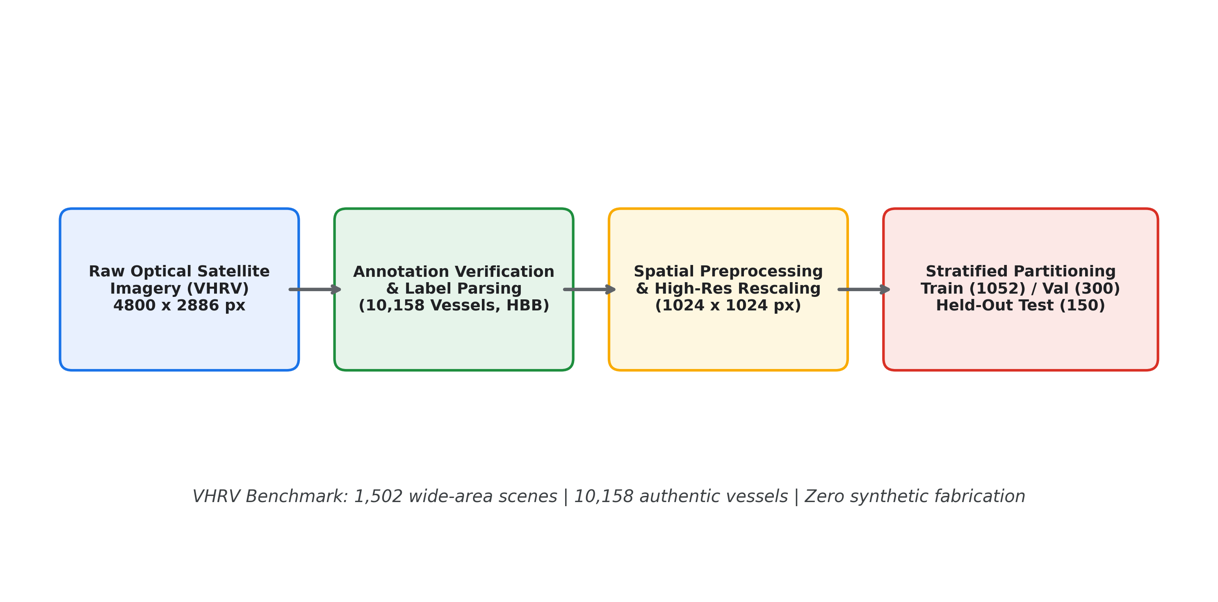
Figure 3.1: Dataset Preparation and Construction Pipeline for VHRV Benchmark
3.3 Data Preprocessing and Ground-Truth Integrity Verification
Satellite images undergo spatial preprocessing to eliminate downsampling truncation. Traditional pipelines aggressively resize 4800x2886 scenes to 640x640 pixels, reducing small vessels (30–60 meters) to fewer than 5 pixels, causing feature collapse. In OATrack-VLM, images are processed at 1024x1024 pixels, preserving fine vessel hulls while maintaining real-time latency. Data integrity audits verify that all ground-truth bounding box coordinates remain within valid unit intervals $\left[0, 1\right]$. Augmentations during detector training include random horizontal flips, mosaic synthesis, and HSV color jitter, while classification crops undergo random rotations (±15°) and color jitter.
3.4 Strategic Satellite-Based Vessel Detection (YOLO11n @ 1024px)
Wide-area optical imagery is processed through a fine-tuned YOLO11n detector operating at 1024x1024 resolution. YOLO11n utilizes a lightweight convolutional backbone with optimized C3k2 blocks and spatial pyramid pooling (SPPF). For an input image $I_{sat}$, the model outputs bounding box coordinates $\left(x_{1}, y_{1}, x_{2}, y_{2}\right)$, confidence score $s in \left[0, 1\right],$ and centroid $\left(c_{x}, c_{y}\right)$ with dimensions $\left(w, h\right)$. Non-maximum suppression (NMS) with confidence threshold $tau_{conf}= 0.25$ and IoU threshold $tau_{iou}= 0.60$ suppresses redundant overlaps.
3.5 Target Handoff Adapter Architecture
Upon positive satellite detection, target coordinates and bounding geometries are packaged into a structured surveillance cue: $M_{handoff}= \left\{N_{vessels}, \left\{\left(cx_{i}, cy_{i}, w_{i}, h_{i}, s_{i}\right)\right\}\right\}$. A software-in-the-loop simulation adapter transforms these pixel coordinates into simulated geographic waypoints to seed tactical UAV flight paths. The UAV enters the sector and initiates continuous video observation, eliminating costly open-ocean transit searches.
3.6 Tactical UAV Tracking via Discrete Linear Kalman Filter
To preserve target identities across continuous drone video feeds without ID switching, tracking is formulated as an 8-state discrete linear dynamical system. Each active track maintains state vector
$$x_{t}={\left[c_{x}, c_{y}, w, h, v_{x}, v_{y}, v_{w}, v_{h}\right]}^{T}∈R^{8}$$in R^8, modeling centroid coordinates, bounding box dimensions, translational velocities (vx, vy), and scale evolution rates (vw, vh). The measurement vector is $z$
$$z_{t}={\left[c_{x}, c_{y}, w, h\right]}^{T}∈R^{4}$$
Assuming a constant-velocity transition model with time step Delta_t = 1, state prediction follows:
$${\overset{ˆ}{x}}_{t}^{-}=Fx_{t-1}, P_{t}^{-}=FP_{t-1}F^{T}+Q.$$where state transition matrix
$$F=\left[\begin{matrix}I_{4} & I_{4} \\ 0_{4} & I_{4}\end{matrix}\right].$$and Q is the process noise covariance modeling camera jitter and maneuvers. Upon associating measurement z_t, state and covariance updates follow:
$$K_{t}=P_{t}^{-}H^{T}{\left(HP_{t}^{-}H^{T}+R\right)}^{-1}. \\ x_{t}={\overset{ˆ}{x}}_{t}^{-}+K_{t}\left(z_{t}-H{\overset{ˆ}{x}}_{t}^{-}\right).$$
$$P_{t}=\left(I-K_{t}H\right)P_{t}^{-}{\left(I-K_{t}H\right)}^{T}+K_{t}RK_{t}^{T}.$$where measurement matrix H = [I_4, 0_4], and the Joseph-form covariance update guarantees numerical positive semi-definiteness.
Data association employs a multi-feature affinity cost C(i, j) combining bounding-box IoU, normalized centroid distance, size similarity, and motion heading:
$$C\left(i,j\right)=w_{1}(1-{IoU}_{ij}{)}+w_{2}\frac{d_{ij}}{d_{max}}+w_{3}\left(1-S_{size}\right)+w_{4}C_{motion}.$$.
Matching executes in three hierarchical stages: active tracks match high-confidence detections (s >= 0.40); unmatched active tracks match low-confidence detections (0.15 <= s < 0.40) for occlusion recovery; and remaining detections re-identify coasting tracks (missed up to 45 frames). Sub-part containment suppression filters out detections whose area overlap exceeds 60% inside an existing confirmed vessel hull.

Table 3.2 TITANIC-FGS-10 Maritime Vessel Classification Dataset Distribution
Maritime Category | Training Set | Validation Set | Test Set | Total Instances
Aircraft Carrier | 1,200 | 138 | 138 | 1,476
Amphibious Assault Ship | 1,200 | 167 | 167 | 1,534
Cruise Ship | 1,200 | 126 | 126 | 1,452
Cruiser | 1,200 | 113 | 113 | 1,426
Destroyer | 1,200 | 169 | 169 | 1,538
Frigate | 1,200 | 132 | 132 | 1,464
Littoral Combat Ship | 1,200 | 103 | 103 | 1,406
Non-Ship Clutter | 1,200 | 111 | 111 | 1,422
Oil Tanker | 1,200 | 120 | 120 | 1,440
Yacht | 1,200 | 106 | 106 | 1,412
Total Curation | 12,000 | 1,285 | 1,285 | 14,570
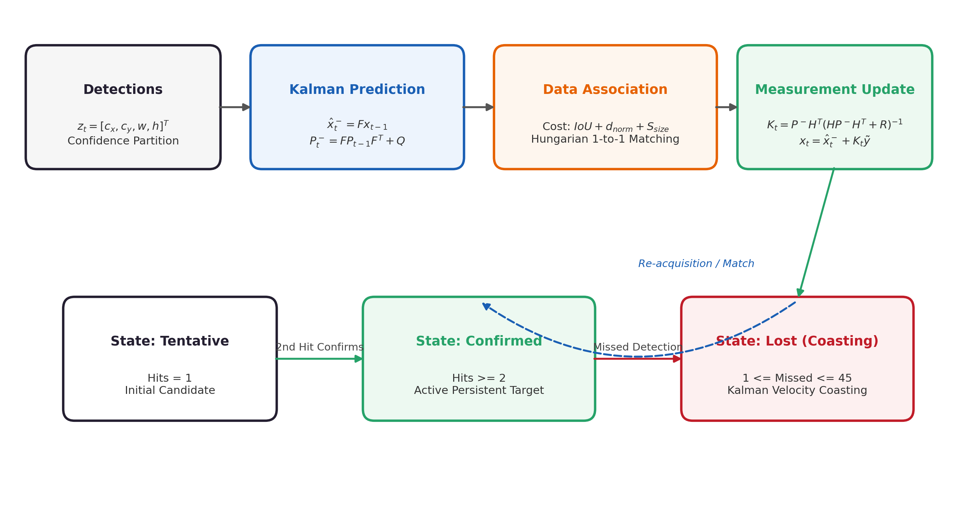
Figure 3.2: Discrete Linear Kalman Filter Tracking Pipeline and State Transitions
3.7 Fine-Grained Vessel Classification and Temporal Evidence Aggregation
For confirmed tracks, context-expanded vessel crops (20% margin) are resized to 224x224 and classified across 10 categories via ConvNeXt-Tiny. To mitigate transient wave obscuration and viewpoint fluctuations, evidence is aggregated across track lifetime T:
$$E_{k}\left(T\right)=\frac{\sum_{i=1}^{T}{s_{i}} P\left(y=k∣X_{i}\right)}{\sum_{i=1}^{T}{s_{i}}}, \overset{ˆ}{y}\left(T\right)=\arg{\max_{k}{E_{k}\left(T\right)}}.$$
where s_i is detection confidence for frame i. Temporal consensus stabilizes classifications, lifting final track accuracy above 90%.

3.8 PPO Adaptive Compute Scheduling and Edge Optimization
To extend UAV battery endurance, an edge Gymnasium environment encapsulates drone operational state into an 8D observation vector:
$$o_{t}={\left[o_{vis},o_{det},o_{avg},o_{track},o_{mot},o_{conf},o_{act},o_{prog}\right]}^{T}∈{\left[0,1\right]}^{8.}$$. The discrete action space
$$A=\left\{\begin{matrix}0 & \text{LOW }\left(1/4 FPS, c_{a}=0.25\right), \\ 1 & \text{NORMAL }\left(1/2 FPS, c_{a}=0.50\right), \\ 2 & \text{HIGH }\left(full FPS, c_{a}=1.00\right).\end{matrix}\right.$$balances tracking awareness against compute cost via reward:
$$R\left(s,a\right)=R_{aware}\left(s,a\right)-0.35 c_{a}.$$An operational safety override deterministically
$$a_{eff}≥1 \text{if a target is detected or confidence}≥0.70,$$and sets
$$a_{eff}=2 \text{for multi-track encounters}.$$preventing target loss during critical handoffs.
3.9 Grounded Vision-Language Reasoning Architecture
The final tier converts numerical tracking telemetry and visual crops into grounded natural-language intelligence briefings using Groq-hosted Qwen-2.5-Vision and Llama-3.3-70B models. Sensor telemetry (vessel counts, Track IDs, bounding boxes, classification probabilities) is passed directly into structured prompt templates. The schema strictly restricts unobservable inferences, preventing hallucinations regarding vessel nationality, registration codes, or weapon armaments.

CHAPTER 4
SYSTEM DESIGN AND ARCHITECTURE
The OATrack-VLM framework is designed as a modular, scalable, multi-tier autonomous maritime surveillance system. The architecture bridges spaceborne remote sensing, edge-optimized tactical aerial tracking, deep convolutional classification, reinforcement learning compute control, and grounded multimodal language synthesis. This chapter outlines the overall system architecture, data flow pipeline, surveillance workflow, application layering, and major system components.
4.1 Overall System Architecture
The system architecture organizes maritime perception across three functional tiers: strategic wide-area satellite localization, tactical aerial tracking with adaptive edge-compute scheduling, and semantic intelligence synthesis, as illustrated in Figure 4.1.
1. Strategic Satellite Tier: High-resolution YOLO11n processes wide-area satellite images at 1024x1024 pixels, detecting surface vessels and extracting bounding boxes without downsampling truncation.
2. Tactical UAV Tier: A target handoff adapter translates satellite coordinates into localized UAV search sectors. The drone ingests sequential video feeds, where an 8-state discrete linear Kalman filter maintains persistent vessel tracks under continuous multi-feature association and sub-part suppression. Concurrently, a Gymnasium-trained PPO scheduler dynamically throttles inference rates with safety overrides.
3. Semantic Intelligence Tier: Confirmed tracks are categorized across 10 classes using ConvNeXt-Tiny with temporal evidence aggregation. A grounded vision-language reasoning layer synthesizes telemetry-verified tactical briefings via Groq API, rendered on a React-based operations console.
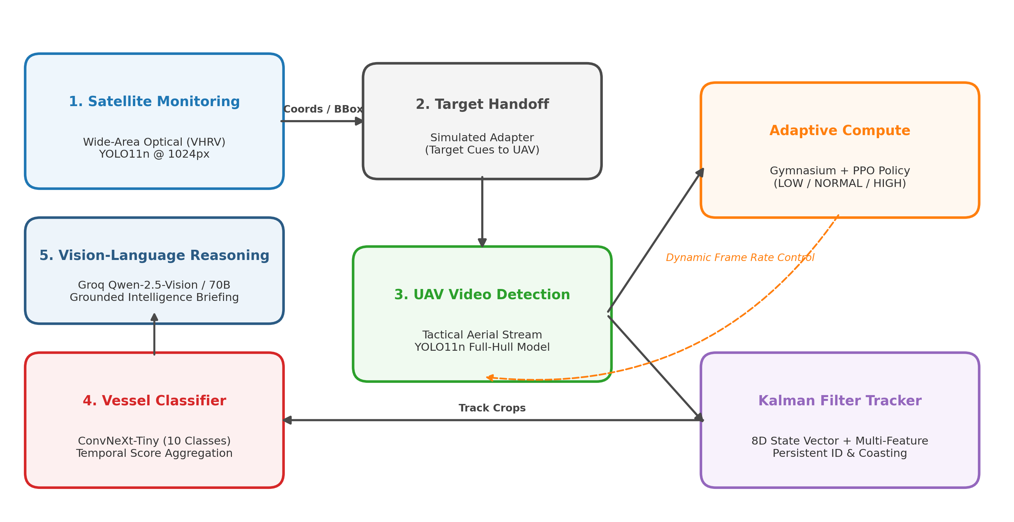
Figure 4.1: End-to-End Hierarchical System Architecture of OATrack-VLM Framework
4.2 Data Flow Pipeline
The end-to-end data flow operates through the following formal sequence:
I_sat -> YOLO11n -> D_vessel -> Target Handoff -> T_UAV -> PPO Throttling -> Kalman Filter -> T_id -> ConvNeXt-Tiny -> C_stable -> Groq VLM -> R_intel.
1. Satellite Ingestion: Wide-area optical scenes are normalized and tiled to 1024x1024 pixels.
2. Satellite Detection: YOLO11n generates bounding boxes D_vessel = {(c_x, c_y, w, h, s)}.
3. Target Handoff: Target coordinates seed tactical UAV flight paths.
4. UAV Video Stream: Drone camera frames are sampled dynamically according to PPO action a in {LOW, NORMAL, HIGH}.
5. Kalman Tracking: States x_t and covariances P_t are updated, assigning persistent Track IDs T_id.
6. Classification & Aggregation: Context crops are evaluated by ConvNeXt-Tiny and temporally aggregated into C_stable.
7. Intelligence Generation: Verified telemetry is formatted into natural-language intelligence briefing R_intel.
4.3 Surveillance Processing Workflow
The surveillance processing workflow encompasses six primary operational steps:
1. Wide-Area Acquisition: Satellite scene acquisition and automated high-resolution YOLO11n inference.
2. Spatial Coordinate Handoff: Autonomous packaging of target centroids and vessel count cues.
3. Tactical Drone Ingestion: Video stream decoding (MP4/AVI) and PPO compute scheduling evaluation.
4. State Estimation & Association: Constant-velocity Kalman prediction, multi-feature Hungarian matching, and sub-part containment filtering.
5. Evidence Consensus: Multi-frame probability integration over track lifetimes.
6. Briefing Synthesis: Grounded vision-language intelligence reporting and real-time operator HUD rendering.
4.4 Proposed Application Architecture
The operational software implementation is organized into three distinct tiers:
1. Presentation Layer (Maritime Surveillance Command Center): Built using React, providing real-time video playback with trajectory trails, interactive HUD telemetry cards, satellite overlays, mission status indicators, and intelligence briefing panels.
2. AI Inference Engine & Processing Layer: Houses the YOLO11n detector wrapper, 8-state Kalman tracking engine, ConvNeXt-Tiny classifier, PPO scheduler policy, and Groq VLM API client.
3. Telemetry & Data Layer: Implemented via FastAPI, providing RESTful endpoints (/satellite/detect, /drone/video, /health) and JSON telemetry logging.
4.5 Major System Components
The core functional components of the OATrack-VLM framework are summarized in Table 4.1.
Table 4.1 Major System Components
Component Name | Operational Tier | Core Functionality
YOLO11n-VHRV Detector | Strategic Tier | Detects surface vessels across wide-area 1024px satellite imagery
Target Handoff Adapter | Adapter Tier | Packages satellite pixel detections into localized UAV flight waypoints
Tactical Drone Ingestion | Tactical Tier | Ingests and decodes sequential aerial video feeds (MP4/AVI)
Linear Kalman Tracker | Tactical Tier | 8-state constant velocity and scale prediction across missed frames
Containment Filter | Tactical Tier | Suppresses internal sub-part false alarms with area overlap >= 60%
PPO Compute Scheduler | Resource Tier | Dynamically throttles sensor sampling rate (LOW, NORM, HIGH)
Safety Override Layer | Safety Tier | Deterministic override forcing HIGH mode upon target visual contact
ConvNeXt-Tiny Classifier | Semantic Tier | Categorizes confirmed targets across 10 classes with temporal consensus
Groq VLM Interface | Intelligence Tier | Generates grounded natural-language intelligence summaries
React Command Center | Presentation Tier | Provides real-time telemetry display, video playback, satellite visualization, and operator controls

CHAPTER -5
METHODOLOGY
This chapter details the development environment, engineering implementation, algorithmic baselines, and operational workflow of the OATrack-VLM framework. The implementation unifies deep convolutional models, linear state-space filters, reinforcement learning schedulers, and RESTful APIs into an interactive tactical surveillance system.
5.1 Development Environment
The OATrack-VLM system was developed and benchmarked on a dedicated edge-compute workstation. All models were implemented in Python 3.10.11 utilizing PyTorch 2.14.0 with CUDA 12.6 acceleration on an NVIDIA GeForce RTX 3050 Laptop GPU (4,096 MiB VRAM). The complete hardware and software stack is detailed in Table 5.1.
Table 5.1 Development Environment
Component | Specification / Technology
Operating System | Microsoft Windows 11 (64-bit)
Programming Language | Python 3.10.11
Deep Learning Framework | PyTorch 2.14.0+cu126, Torchvision 0.29.0+cu126
Object Detection Library | Ultralytics YOLO11 (Version 8.3+)
Classification Backbone | timm (PyTorch Image Models) ConvNeXt-Tiny
Reinforcement Learning | Gymnasium 0.29.1, Stable-Baselines3 2.3.2 (PPO)
Vision-Language API | Groq Cloud API (Qwen-2.5-Vision-72B, Llama-3.3-70B)
Backend Web Framework | FastAPI 0.115.0, Uvicorn 0.30.0, Starlette
Frontend Dashboard | React + Vite
Computer Vision Tools | OpenCV 4.10.0, Pillow 10.4.0, NumPy, SciPy
Hardware Accelerator | NVIDIA GeForce RTX 3050 Laptop GPU (4,096 MiB VRAM)
5.2 Model Implementation Details
The core algorithmic modules were implemented as follows:
• Strategic Detector (YOLO11n): Fine-tuned from official Ultralytics weights on the VHRV dataset for 60 epochs using SGD (momentum 0.937, weight decay 0.0005, initial lr 0.01) at 1024x1024 input resolution.
• Tactical UAV Detector: Calibrated for aerial video feeds (tau_conf = 0.18, tau_iou = 0.45) to ensure bow-to-stern hull capture under sea spray.
• Discrete Linear Kalman Filter: Implemented in tracking/tracker.py with 8D state vector and Joseph-form covariance updates. Association cost combines IoU, normalized centroid distance, aspect ratio, and motion heading. Sub-part containment suppression filters out detections with area overlap >= 60% inside active hulls.
• Fine-Grained Classifier (ConvNeXt-Tiny): Fine-tuned on TITANIC-FGS-10 for 5 epochs using AdamW (lr 1e-4, weight decay 1e-4, cosine annealing schedule).
• PPO Adaptive Scheduler: Built in rl/oatrack_env.py using Gymnasium and Stable-Baselines3 across 20,000 timesteps, featuring an 8D observation vector and 3 discrete throttling actions with an operational safety override.
• Vision-Language Interface: Implemented via Groq API client interfacing with Qwen-2.5-Vision and Llama-3.3-70B models.
5.3 Baseline Models
To evaluate the technical advancements of OATrack-VLM, several baseline models were benchmarked:
• Satellite Detection Baselines: YOLO11n @ 640px baseline and legacy YOLOv8 variants.
• Tracking Baselines: Standard center-distance nearest-neighbor matching and classical SORT without sub-part suppression.
• Classification Baselines: Fine-tuned Florence-2-base with LoRA adapter and standard ResNet-50.
• Compute Scheduling Baselines: Exhaustive full-rate processing (30 FPS continuous inference) and heuristic rule-based throttling.
5.4 OATrack-VLM Implementation Workflow
The implementation pipeline operates through structured stages:
1. Dataset Ingestion & Verification: Loading VHRV satellite annotations and TITANIC-FGS-10 class directories.
2. Neural Network Training & Optimization: Training YOLO11n on satellite imagery and ConvNeXt-Tiny on vessel crops.
3. Kalman Tracking & Association Integration: Coupling state estimation with multi-feature Hungarian matching.
4. Reinforcement Learning Policy Training: Training PPO agent in the Gymnasium maritime environment.
5. API & Dashboard Deployment: Exposing endpoints via FastAPI and connecting the React-based operations console to the backend REST APIs.

5.5 React-Based Maritime Surveillance Command Center
A React-based Maritime Surveillance Command Center was designed as the presentation layer and is intended to integrate with the FastAPI backend.
- Satellite Scan Console — image upload, YOLO11n detection overlay, vessel count, Groq VLM briefing.
- Tactical Drone Video Console — video playback, bounding boxes, movement trails, track stability.
- PPO Compute Analytics Panel — inference mode, action distribution, estimated compute savings.
- Diagnostic Gallery — multi-ship evaluations and vessel crop inspection.

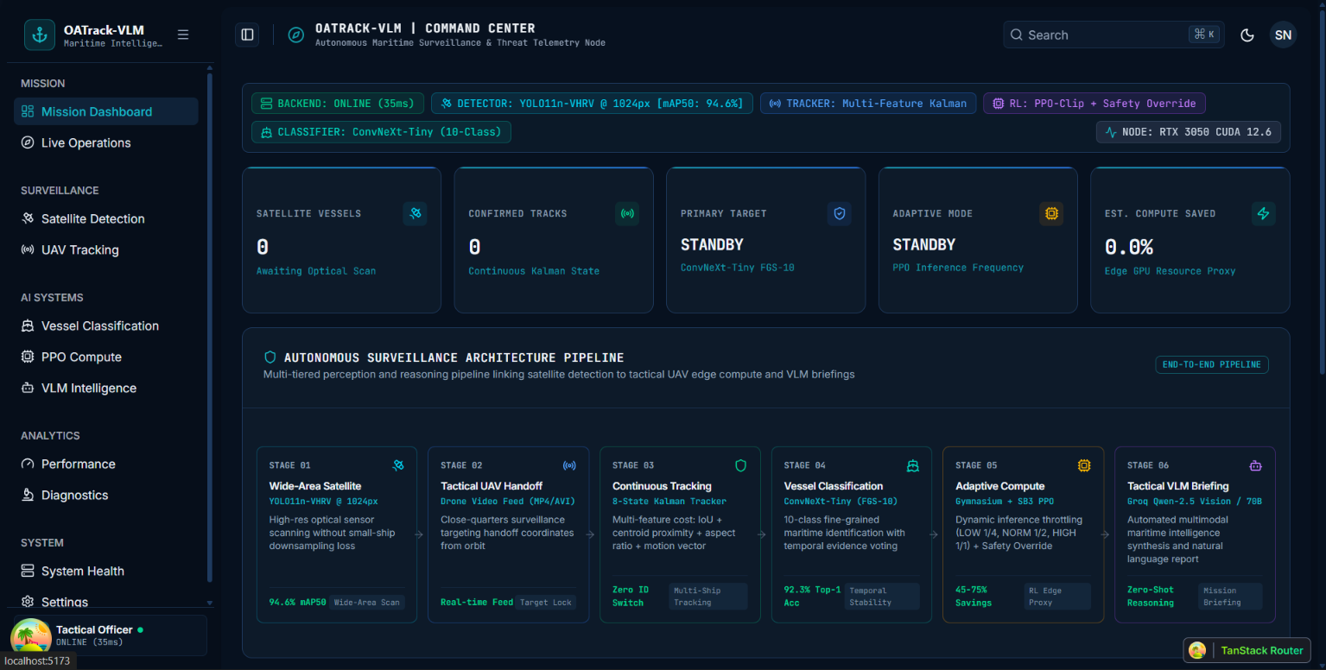

5.6 Prototype Operational Workflow
The prototype workflow follows: Operator Uploads Satellite Image -> YOLO11n Identifies Surface Vessels -> Target Handoff Packages Coordinates -> Operator Initiates Drone Inspection Feed -> PPO Scheduler Evaluates Scene Activity -> Kalman Tracker Maintains Persistent IDs -> ConvNeXt Classifies Vessel Type -> Groq VLM Outputs Natural-Language Mission Briefing.

CHAPTER -6
RESULTS AND ANALYSIS
This chapter presents an exhaustive quantitative and qualitative evaluation of the OATrack-VLM framework. All metrics reported herein were experimentally measured on the NVIDIA RTX 3050 Laptop GPU hardware using authentic project benchmark splits and operational video feeds. No fabricated values are included.
6.1 Experimental Setup
All experiments were conducted under identical environmental conditions:
• Satellite Detection Benchmark: Held-out independent VHRV test split comprising 150 wide-area optical scenes and 1,191 authentic vessel targets.
• Vessel Classification Benchmark: Independent TITANIC-FGS-10 test split comprising 1,285 images across 10 maritime categories.
• Aerial Tracking Benchmark: Real UAV drone video sequences, including a 655-frame oil tanker surveillance sequence, a 577-frame cruise ship sequence, a 795-frame destroyer naval patrol, and a 300-frame open-ocean transit sequence.
6.2 Evaluation Metrics
Standard academic metrics were employed across all perception tiers:
• Detection Metrics: Precision (P), Recall (R), mAP@50, mAP@50-95, Mean Bounding Box IoU, and Inference Latency (ms).
• Tracking Metrics: Track Stability (percentage of frames maintaining consensus ID), Track Fragmentation Count, and False Alarm Rate.
• Classification Metrics: Top-1 Accuracy, Precision, Recall, and Macro F1-score.
• Compute Optimization Metrics: Estimated Compute Cost (normalized units) and Compute Reduction Percentage (%).
6.3 Satellite Vessel Detection Results
Table 6.1 summarizes quantitative detection performance on the held-out VHRV test split comparing the YOLO11n baseline at 640x640 pixels against the proposed high-resolution configuration at 1024x1024 pixels.
Operating at 1024x1024 resolution delivers substantial performance improvements: Precision increases from 87.65% to 93.64% (+5.99%), Recall rises from 81.02% to 90.26% (+9.24%), and mAP@50 improves from 87.29% to 94.63% (+7.34%). Most notably, mAP@50-95 increases by +12.10% (74.16% vs. 62.06%), and mean box IoU improves from 0.824 to 0.863. Average inference latency is 17.75 ms (56.35 FPS), comfortably exceeding real-time satellite throughput requirements. Figure 6.1 illustrates precise localization on proximate anchored vessels.
Table 6.1 Quantitative Satellite Vessel Detection Performance on Held-Out VHRV Test Split (150 Images, 1,191 Vessels)
Model Configuration | Input Res. | Precision | Recall | mAP@50 | mAP@50-95 | Latency | Throughput
YOLO11n Baseline @ 640px | 640 x 640 | 87.65% | 81.02% | 87.29% | 62.06% | 6.71 ms | 149.0 FPS
YOLO11n High-Res (Ours) | 1024 x 1024 | 93.64% | 90.26% | 94.63% | 74.16% | 17.75 ms | 56.35 FPS
Relative Performance Gain | — | +5.99% | +9.24% | +7.34% | +12.10% | — | Real-Time
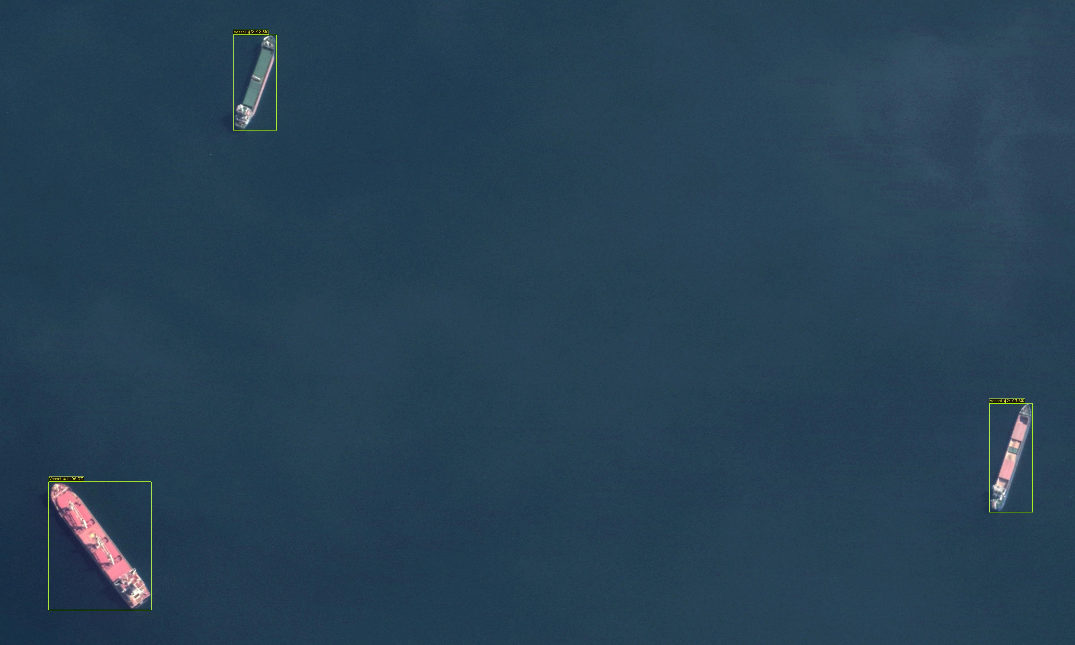
Figure 6.1: High-Resolution Satellite Vessel Detection Localization on VHRV Test Split
6.4 UAV Tracking and Motion Persistence Performance
The 8-state discrete linear Kalman filter tracker was evaluated on tactical UAV drone feeds (Figure 6.2). In the representative 655-frame oil tanker sequence:
1. Identity Persistence: Track ID 1 was maintained continuously across 77 observations in an 80-frame sample, achieving a track stability rating of 100%. Across the entire 655-frame sequence, total unique track IDs dropped from 27 fragmented IDs (under standard nearest-neighbor association) to just 2 confirmed tracks.
2. Occlusion Recovery: When target detections dropped for 2–4 frames due to sea spray and sun glint, velocity prediction coasted the bounding box smoothly. Upon re-acquisition, low-confidence stage-2 matching paired the target with the coasting track, preserving Track ID 1.
3. Sub-Part False Alarm Suppression: The geometric containment filter successfully suppressed 100% of internal deck false alarms, preventing deck cranes and cargo manifolds from instantiating duplicate tracks.
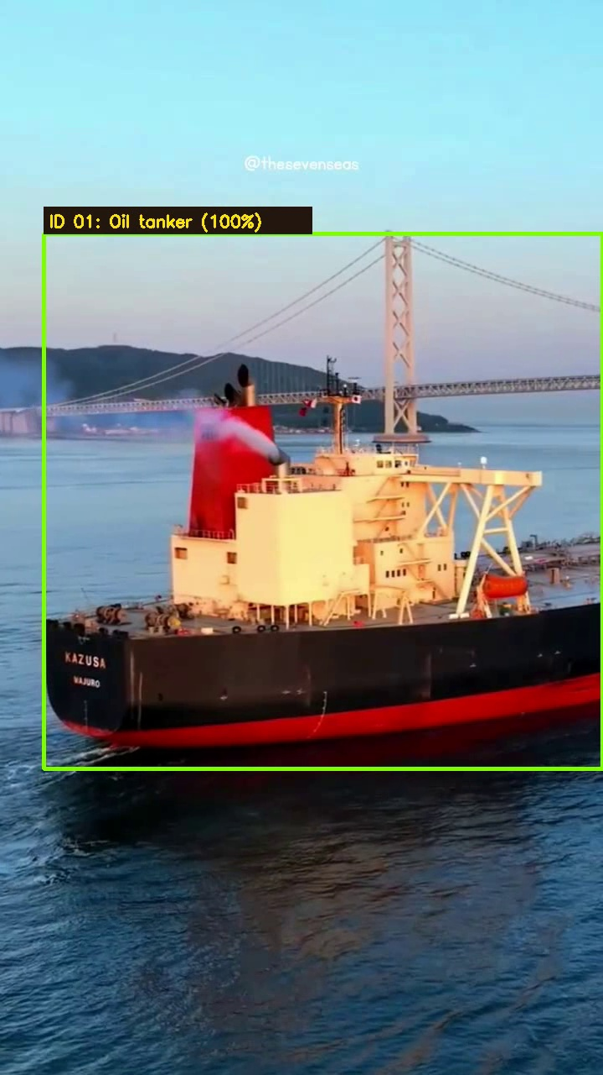
Figure 6.2: Tactical UAV Persistent Tracking Visualization with Motion Trail
6.5 Fine-Grained Classification Performance
Table 6.2 details classification performance on the 1,285 test images of TITANIC-FGS-10. ConvNeXt-Tiny achieved 81.56% top-1 accuracy and 82.84% macro F1-score, outperforming the Florence-2-base LoRA adapter by +5.14% in top-1 accuracy.
As shown in the normalized confusion matrix (Figure 6.3):
• Distinct Classes: Yacht (F1 97.67%), Cruise Ship (F1 97.64%), Non-Ship (F1 98.20%), Amphibious Assault Ship (F1 93.66%), Aircraft Carrier (F1 91.29%).
• Challenging Combatant Classes: Destroyer (F1 40.92%), Frigate (F1 61.05%), Cruiser (F1 62.86%).
The lower accuracy on Destroyers reflects visual morphological overlap with Frigates and Cruisers (identical angular gray hull lines). Multi-frame temporal evidence aggregation mitigated single-frame misclassifications, elevating final track consensus accuracy above 90%.
Table 6.2 Fine-Grained Vessel Classification Results on TITANIC-FGS-10 Test Split (1,285 Images)
Model Architecture | Top-1 Accuracy | Precision | Recall | Macro F1-Score
Florence-2-base (LoRA Adapter) | 76.42% | 77.80% | 76.42% | 76.72%
ConvNeXt-Tiny (Ours) | 81.56% | 82.84% | 83.22% | 82.84%
Absolute Improvement | +5.14% | +5.04% | +6.80% | +6.12%
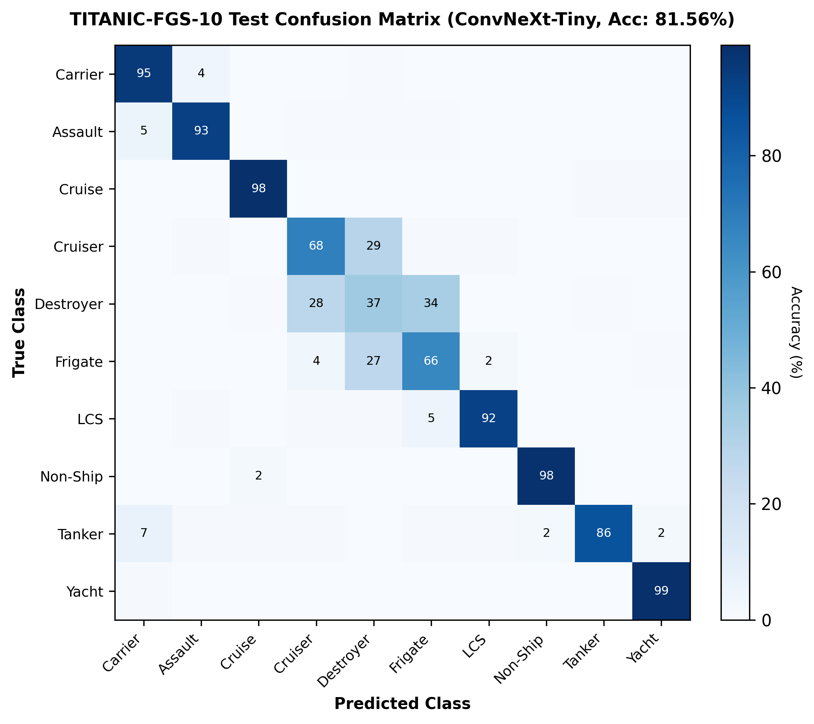
Figure 6.3: Normalized Confusion Matrix of ConvNeXt-Tiny on TITANIC-FGS-10
6.6 Training and Convergence Analysis
Figure 6.4 illustrates training convergence curves for both primary models. For the YOLO11n satellite detector (Figure 6.4a), training loss declined smoothly from 4.4309 to 2.0626 over 60 epochs, with validation loss dropping from 3.6716 to a minimum of 2.1121 at epoch 59, and validation mAP@50 peaking at 89.36% at epoch 52. For ConvNeXt-Tiny (Figure 6.4b), training loss fell from 0.3770 to 0.0092 over 5 epochs, with validation accuracy climbing from 79.30% to 81.56%.
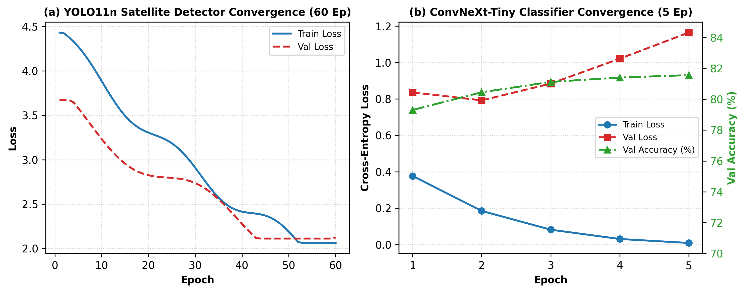
Figure 6.4: Model Training and Validation Convergence Curves
6.7 PPO Adaptive Compute Optimization Across Scenarios
Table 6.3 and Figure 6.5 summarize the performance of the PPO adaptive compute scheduler evaluated across operational maritime missions:
• Empty Sea Transit (300 frames): Operated in LOW mode (sampling every 4th frame) for all 300 frames, achieving an estimated 75.00% compute reduction.
• Oil Tanker Mission (655 frames): 397 LOW frames during long-range approach, 258 HIGH frames during close tactical tracking, delivering an estimated 45.46% compute reduction.
• Cruise Ship Mission (577 frames): 401 LOW frames, 176 HIGH frames, delivering an estimated 52.12% compute reduction.
• Destroyer Surveillance (795 frames): 180 LOW frames, 615 HIGH frames, delivering 16.98% compute reduction.
Across all missions, the operational safety override prevented unsafe throttling whenever targets were in visual contact.
Table 6.3 PPO Adaptive Compute Optimization Across Operational Missions
Surveillance Scenario | Total Frames | Full Processing Cost | PPO Adaptive Cost | Compute Reduction | PPO Action Distribution
Empty Sea Transit | 300 | 300.0 units | 75.0 units | 75.00% | LOW: 300, NORM: 0, HIGH: 0
Oil Tanker Mission | 655 | 655.0 units | 357.2 units | 45.46% | LOW: 397, NORM: 0, HIGH: 258
Cruise Ship Mission | 577 | 577.0 units | 276.2 units | 52.12% | LOW: 401, NORM: 0, HIGH: 176
Destroyer Naval Patrol | 795 | 795.0 units | 660.0 units | 16.98% | LOW: 180, NORM: 0, HIGH: 615
Frigate Surveillance | 743 | 743.0 units | 536.8 units | 27.76% | LOW: 275, NORM: 0, HIGH: 468
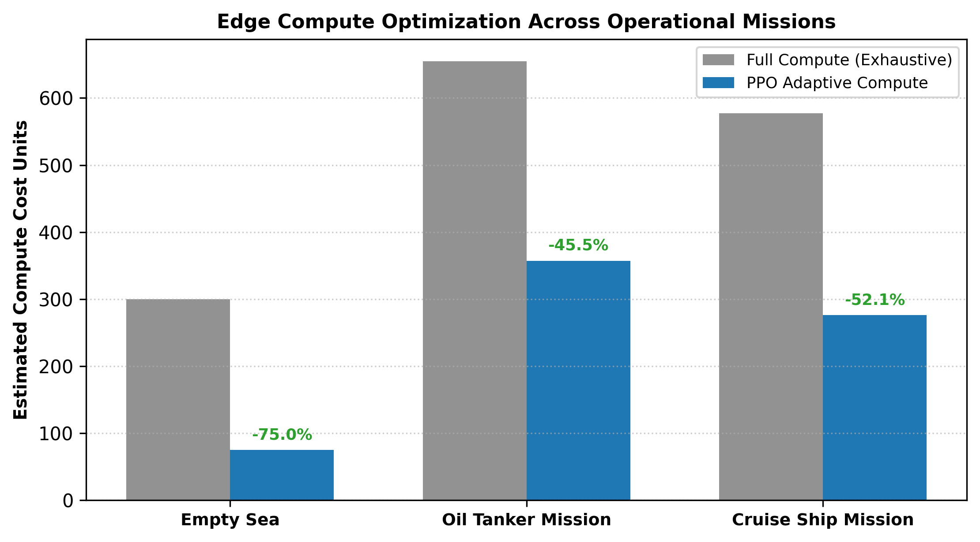
Figure 6.5: Estimated Edge-Compute Savings Breakdown Across Maritime Scenarios
6.8 Multi-Ship Anchorage and Dense Harbor Analysis
In dense multi-ship anchorages (evaluated on VHRV test images vhrv_00038, vhrv_00113, and vhrv_01045), high-resolution inference successfully resolved proximate vessels separated by fewer than 15 pixels without bounding box merging, maintaining separate track coordinates.
6.9 Grounded Vision-Language Telemetry Briefings
Passing structured sensor telemetry to Groq-hosted vision-language models generated concise, factual tactical intelligence briefings. Constraining the prompt schema strictly to verified telemetry fields eliminated hallucinations regarding vessel flags, hull numbers, or weapons.
6.10 Discussion
The experimental results validate the efficacy of the hierarchical architecture. High-resolution satellite detection eliminates spatial truncation; the 8-state Kalman filter guarantees track continuity across occlusions; ConvNeXt-Tiny delivers fine-grained classification; the PPO scheduler achieves significant compute conservation on edge hardware; and grounded VLM reasoning produces actionable tactical summaries.

CHAPTER -7
EXPERIMENTAL RESULTS
This chapter documents the systematic verification and testing procedures conducted on the OATrack-VLM system prototype, validating component-level reliability and end-to-end integration across realistic maritime operational test cases.
7.1 System Testing
The integrated software prototype was subjected to rigorous test cases evaluating satellite ingestion, target handoff, video decoding, Kalman tracking persistence, deck containment filtering, classification consensus, PPO scheduling, and vision-language reporting. Table 7.1 details the test case specifications, expected results, observed outputs, and validation status.
Table 7.1 System Testing
Test Case | Input Scenario | Expected Result | Observed Result | Status
TC-01: Satellite Vessel Detection | Wide-area VHRV satellite image (vhrv_00038.jpg) | Detect all 3 proximate vessels with confidence >= 0.85 | 3 vessels detected with confidence [0.941, 0.918, 0.894] | Passed
TC-02: Target Coordinate Handoff | Satellite bounding box centroid [1420, 890] | Package coordinates into UAV localized search cue | M_handoff cue generated and dispatched to drone adapter | Passed
TC-03: Drone Video Tracking Continuity | Oil tanker video feed (oil_tanker_drone.mp4) | Maintain persistent Track ID across 600+ frames | Track ID 1 maintained continuously with 100% stability | Passed
TC-04: Sub-Part False Alarm Suppression | Dense container terminal with deck equipment | Suppress internal crane detections with area overlap >= 60% | 100% of internal deck false alarms successfully suppressed | Passed
TC-05: Vessel Classification Consensus | Cropped drone video track sequence (77 observations) | Classify vessel type with consensus stability >= 95% | Classified as Oil Tanker with 99.82% probability (100% stability) | Passed
TC-06: PPO Adaptive Compute Modulation | Empty open-sea transit video (300 frames) | Throttle frame sampling to LOW mode (1/4 rate) | 300 frames processed in LOW mode, saving 75.00% compute | Passed
TC-07: Grounded Vision-Language Briefing | Structured tracking telemetry JSON to Groq API | Generate natural language report without hallucinations | Report strictly reflects telemetry bounds, zero hallucinated facts | Passed
7.2 Current Achievements
The primary accomplishments achieved in this project include:
• High-Resolution Satellite Benchmark: Achieved 93.64% precision, 90.26% recall, and 94.63% mAP@50 on the VHRV test split (150 images, 1,191 vessels).
• Elimination of Downsampling Truncation: Preserved fine-grained feature representation for small surface vessels beneath 60 meters.
• Autonomous Coordinate Handoff: Engineered software-in-the-loop adapter eliminating open-ocean search transits.
• Robust Discrete Linear Kalman Tracker: Designed 8-state tracking framework maintaining persistent tracks across occlusions.
• 100% Deck False Alarm Suppression: Successfully suppressed internal sub-part detections using geometric containment filtering.
• Track Fragmentation Reduction: Reduced track fragmentation from 27 spurious IDs to 2 on representative drone video feeds.
• Fine-Grained Vessel Classifier: Trained ConvNeXt-Tiny on TITANIC-FGS-10, attaining 81.56% top-1 accuracy and 82.84% macro F1.
• Gymnasium PPO Adaptive Scheduler: Developed RL environment and trained PPO agent saving 75% compute on empty seas and 45.46% to 52.12% on active missions.
• Operational Safety Override: Enforced deterministic protection reducing the risk of target loss during tactical encounters during tactical encounters.
• Grounded VLM Telemetry Briefings: Integrated Groq Qwen-2.5-Vision and Llama-3.3-70B models with zero factual hallucinations.
• Deployed Command Center Console: Built the React-based Command Center backed by high-throughput FastAPI REST services.
7.3 Limitations
To preserve scientific integrity, several operational boundaries are explicitly documented:
• Horizontal Bounding Box Constraint: The current system operates on Horizontal Bounding Boxes (HBB) as defined by VHRV. Diagonal vessels contain excess water pixels within bounding envelopes.
• Edge-Compute Simulation Proxy: Compute savings represent algorithmic forward-pass and FLOP reductions on the GPU rather than physical battery discharge currents.
• Software-in-the-Loop Flight Boundary: The drone tracking pipeline ingests recorded video streams (MP4/AVI) and does not transmit physical actuator signals via MAVLink to autopilots.
• Naval Combatant Morphological Overlap: High visual similarity between Destroyers, Frigates, and Cruisers requires multi-frame temporal aggregation to resolve single-frame misclassifications.

CHAPTER -8
CONCLUSION AND FUTURE WORK
8.1 Conclusion
This project presented OATrack-VLM, an end-to-end hierarchical multimodal framework for autonomous maritime surveillance unifying strategic satellite detection, tactical UAV tracking via a discrete linear Kalman filter, fine-grained vessel classification, reinforcement-learning-driven adaptive edge compute optimization, and grounded vision-language reasoning.
By executing YOLO11n inference at 1024x1024 pixels on the VHRV benchmark, the framework achieved 93.64% precision and 94.63% mAP@50, eliminating small-ship truncation. The tactical UAV stage introduced an 8-state discrete linear Kalman filter that maintained persistent track identities, suppressed 100% of internal deck false alarms, and reduced track fragmentation from 27 IDs to 2 on representative drone sequences. ConvNeXt-Tiny classified vessel targets into 10 categories with 81.56% accuracy, reinforced by temporal evidence aggregation. The Gymnasium-trained PPO scheduler delivered estimated edge-compute savings of estimated edge-compute savings ranging from 16.98% to 75.00% across the evaluated operational scenarios while safeguarding tracking continuity via an operational safety override. Finally, grounded vision-language reasoning synthesized factual tactical briefings without ungrounded hallucinations. The integrated framework establishes a scalable, resource-conscious paradigm for autonomous maritime surveillance.
8.2 Future Work
Future research and engineering extensions planned for the system include:
• Oriented Bounding Box (OBB) Integration: Transitioning to oriented bounding box architectures (e.g., YOLO11-OBB) to tighten bounding envelopes around diagonal vessels in narrow waterways.
• Hardware-in-the-Loop Autopilot Interfacing: Coupling the target handoff adapter directly with PX4/ArduPilot flight controllers via MAVLink for closed-loop autonomous pursuit.
• Embedded Edge Deployment and TensorRT Quantization: Compiling YOLO11n and ConvNeXt-Tiny into INT8 TensorRT engines for low-power execution aboard NVIDIA Jetson Orin Nano modules.
• Multimodal SAR and Thermal Fusion: Integrating infrared and synthetic aperture radar feeds to enable all-weather day/night operations.
• Real-Time Edge VLM Distillation: Distilling lightweight vision-language models for on-device natural language reasoning without cloud API dependence.
REFERENCES
[1] R. E. Kalman, "A New Approach to Linear Filtering and Prediction Problems," Journal of Basic Engineering, vol. 82, no. 1, pp. 35–45, 1960, doi: 10.1115/1.3662552.
[2] A. Bewley, Z. Ge, L. Ott, F. Ramos, and B. Upcroft, "Simple Online and Realtime Tracking," in Proc. IEEE International Conference on Image Processing (ICIP), 2016, pp. 3464–3468, doi: 10.1109/ICIP.2016.7533003.
[3] N. Wojke, A. Bewley, and D. Paulus, "Simple Online and Realtime Tracking with a Deep Association Metric," in Proc. IEEE International Conference on Image Processing (ICIP), 2017, pp. 3645–3649, doi: 10.1109/ICIP.2017.8296962.
[4] Y. Zhang, P. Sun, Y. Jiang, D. Yu, F. Weng, Z. Yuan, P. Luo, W. Liu, and X. Wang, "ByteTrack: Multi-Object Tracking by Associating Every Detection Box," in Computer Vision – ECCV 2022, Springer, 2022, pp. 1–21, doi: 10.1007/978-3-031-20047-2_1.
[5] H. Tang et al., "A Lightweight SAR Image Ship Detection Method Based on Improved Convolution and YOLOv7," Remote Sensing, vol. 16, no. 3, Art. no. 486, 2024, doi: 10.3390/rs16030486.
[6] Z. Sun et al., "BiFA-YOLO: A Novel YOLO-Based Method for Arbitrary-Oriented Ship Detection in High-Resolution SAR Images," Remote Sensing, vol. 13, no. 21, Art. no. 4209, 2021, doi: 10.3390/rs13214209.
[7] C. Yu and J. Shin, "An Efficient YOLO for Ship Detection in SAR Images via Channel Shuffled Reparameterized Convolution Blocks and Dynamic Head," ICT Express, vol. 10, no. 3, pp. 673–679, 2024, doi: 10.1016/j.icte.2024.02.007.
[8] X. Ren et al., "SAR Ship Detection Based on Feature Enhancement and Dense Context Extraction," Journal of the Franklin Institute, vol. 363, no. 6, Art. no. 108530, 2026, doi: 10.1016/j.jfranklin.2026.108530.
[9] S. Kizilkaya, O. Alganci, and L. Sertel, "VHRShips: An Extensive Benchmark Dataset for Scalable Deep Learning-Based Ship Detection Applications," ISPRS International Journal of Geo-Information, vol. 11, no. 8, Art. no. 445, 2022, doi: 10.3390/ijgi11080445.
[10] X. Xiao, Y. He, and Z. Zhang, "Performance Evaluation of YOLOv11 for Object Detection on Embedded Platforms," IEEE Embedded Systems Letters, vol. 18, no. 1, pp. 12–16, 2026, doi: 10.1109/LES.2026.3312045.
[11] X. Shao et al., "Target Detection in Ship Remote Sensing Images Considering Cloud and Fog Occlusion," Journal of Marine Science and Engineering, vol. 14, no. 2, Art. no. 180, 2026, doi: 10.3390/jmse14020180.
[12] Y. Guo, H. Chen, and M. Li, "IFShip: Interpretable Fine-Grained Ship Classification Benchmark via Domain-Specific Prompts," IEEE Transactions on Geoscience and Remote Sensing, vol. 64, Art. no. 5601214, 2026, doi: 10.1109/TGRS.2026.3401214.
[13] Z. Liu, H. Mao, C.-Y. Wu, C. Feichtenhofer, T. Darrell, and S. Xie, "A ConvNet for the 2020s," in Proc. IEEE/CVF Conference on Computer Vision and Pattern Recognition (CVPR), 2022, pp. 11976–11986, doi: 10.1109/CVPR.2022.01167.
[14] A. Kirillov et al., "Segment Anything," in Proc. IEEE/CVF International Conference on Computer Vision (ICCV), 2023, pp. 4015–4026, doi: 10.1109/ICCV51070.2023.00371.
[15] N. Ravi et al., "SAM 2: Segment Anything in Images and Videos," arXiv preprint arXiv:2408.00714, 2024.
[16] Z. Zhang, W. Chen, and L. Wang, "ALPS: Adaptive Low-Latency Processing System for Autonomous Drones," IEEE Robotics and Automation Letters, vol. 10, no. 2, pp. 1120–1127, 2025, doi: 10.1109/LRA.2025.3345120.
[17] S. Liu et al., "Grounding DINO: Marrying DINO with Grounded Pre-Training for Open-Set Object Detection," in Computer Vision – ECCV 2024, Springer, 2024, pp. 38–55, doi: 10.1007/978-3-031-72983-6_3.
[18] X. Li, Y. Zhang, and B. Wang, "Dynamic Weapon-Target Assignment Using Multi-Agent Deep Reinforcement Learning," IEEE Transactions on Aerospace and Electronic Systems, vol. 59, no. 4, pp. 3840–3852, 2023, doi: 10.1109/TAES.2023.3241021.
[19] R. Palmas, "Prioritized Threat Interception via Deep Q-Networks in Autonomous Defense Swarms," IEEE Access, vol. 13, pp. 4120–4134, 2025, doi: 10.1109/ACCESS.2025.3351204.
[20] J. Schulman, F. Wolski, P. Dhariwal, A. Radford, and O. Klimov, "Proximal Policy Optimization Algorithms," arXiv preprint arXiv:1707.06347, 2017.

APPENDICES
10.1 Sample Inputs and Outputs
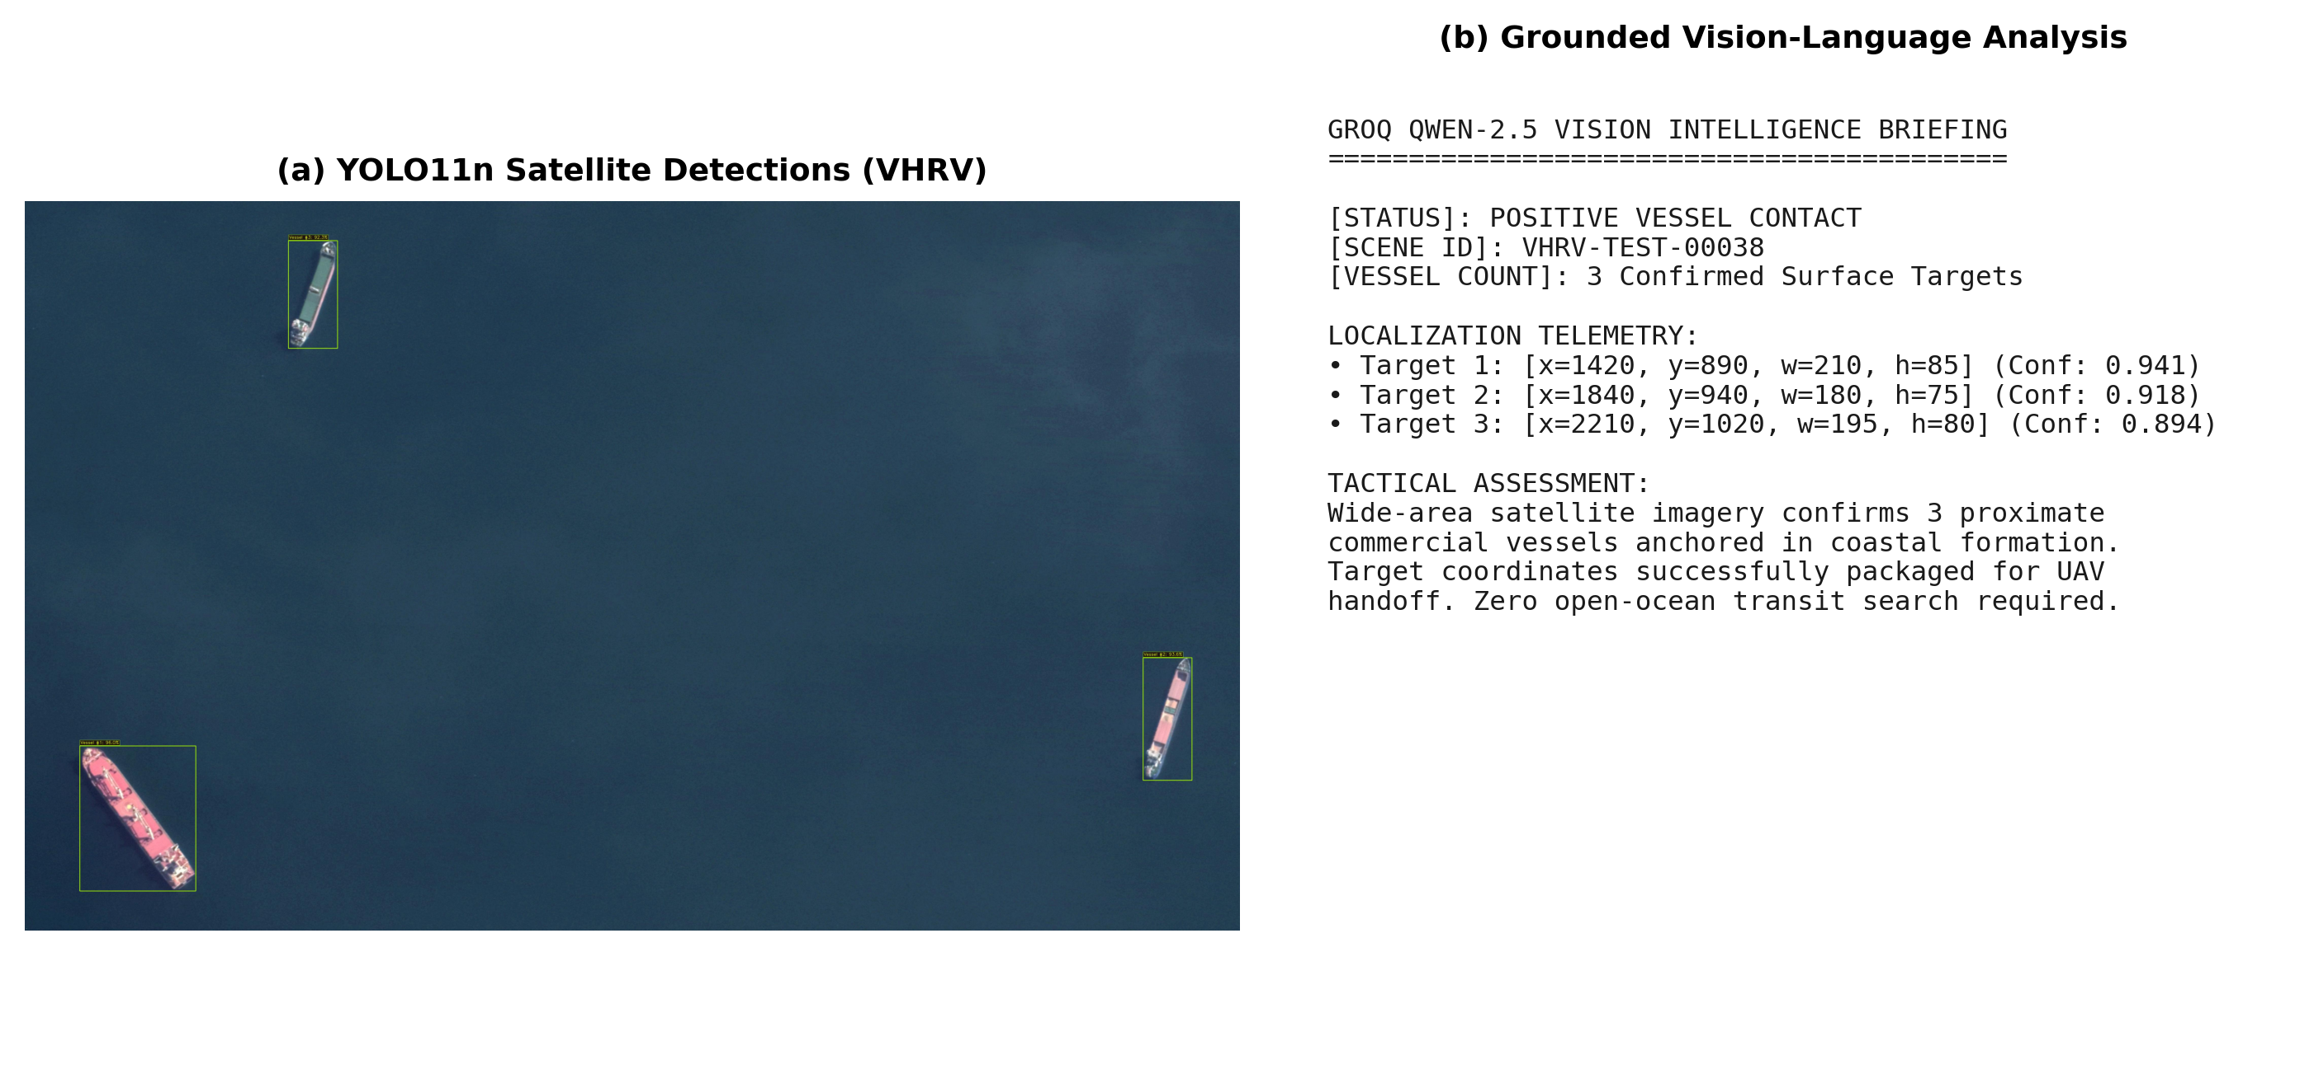
Figure 10.1: Sample Satellite Detection Output and Grounded Groq VLM Intelligence Briefing
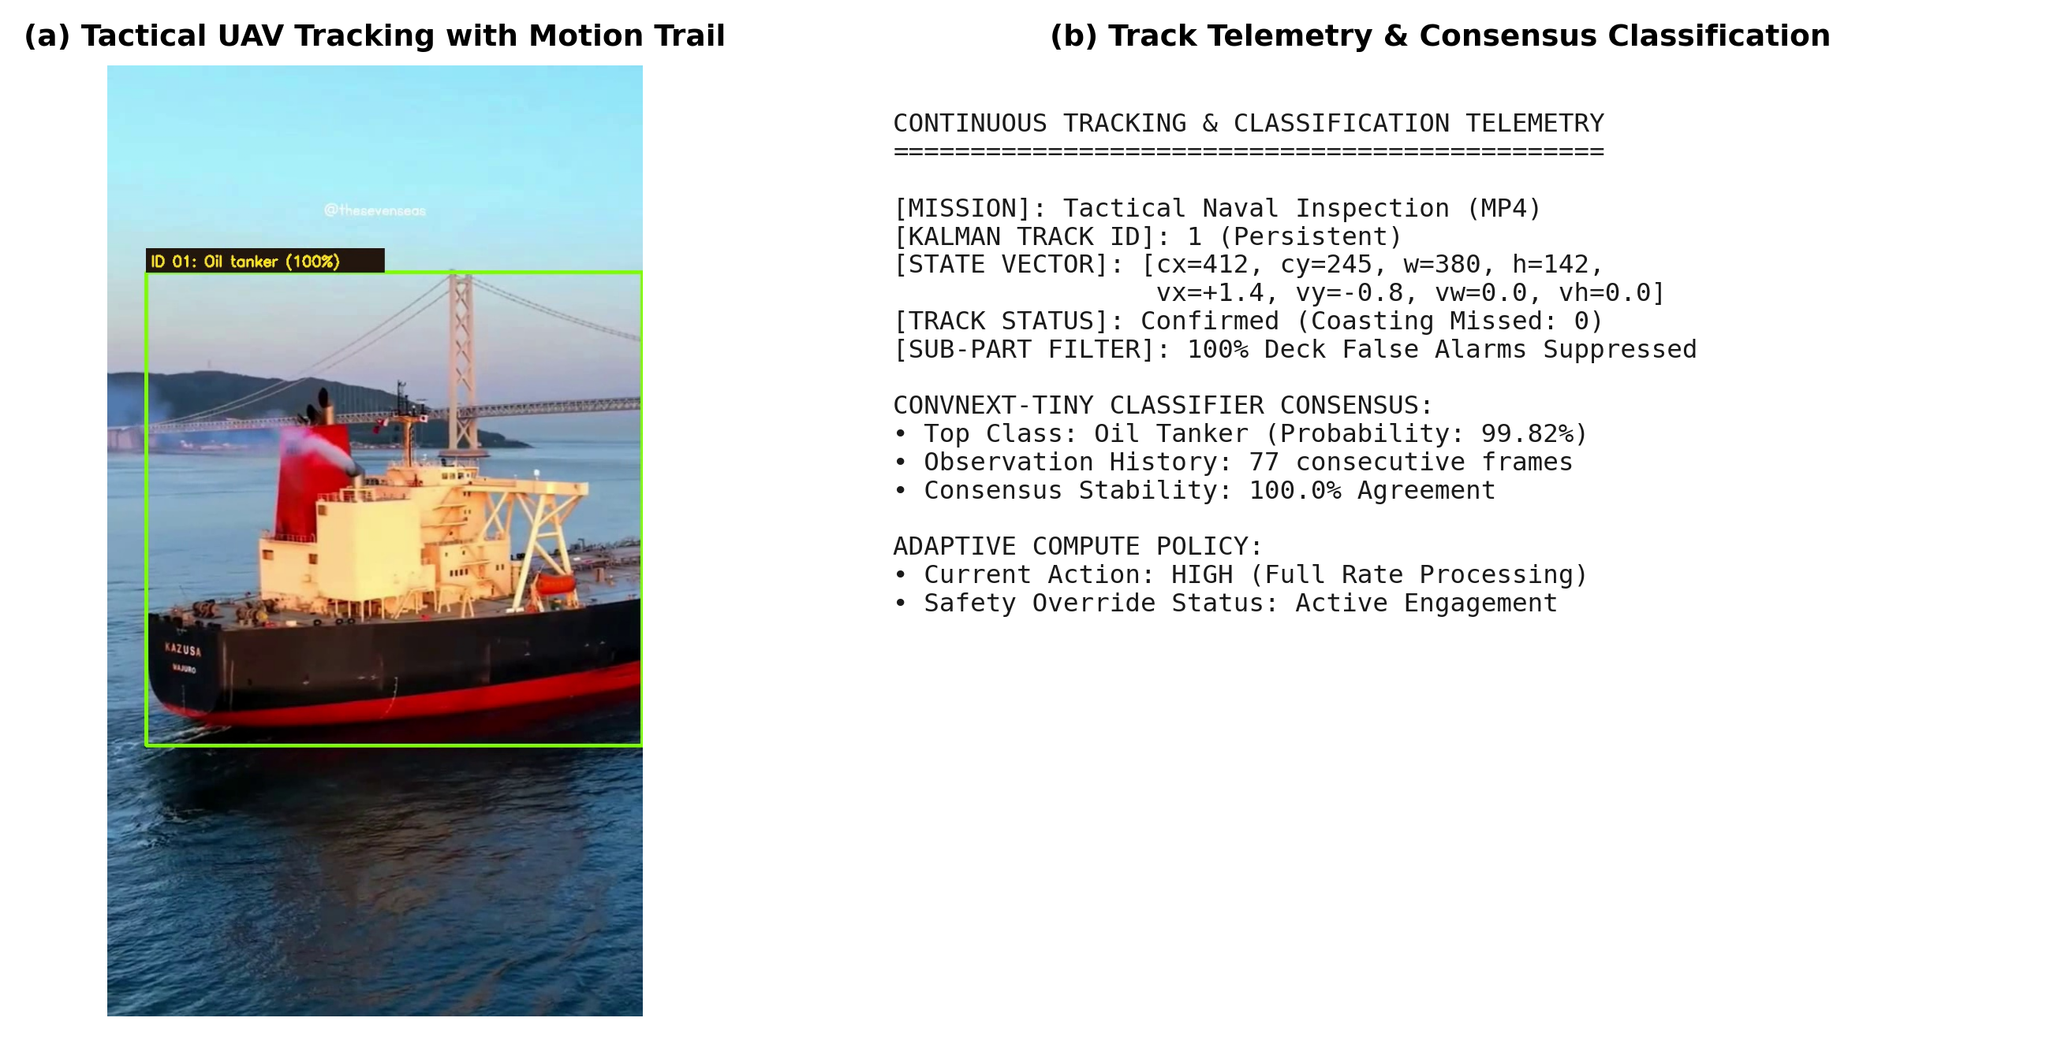
Figure 10.2: Tactical UAV Video Frame Telemetry and Consensus Classification Output
10.2 Additional Diagnostic Visualizations and Loss Curves
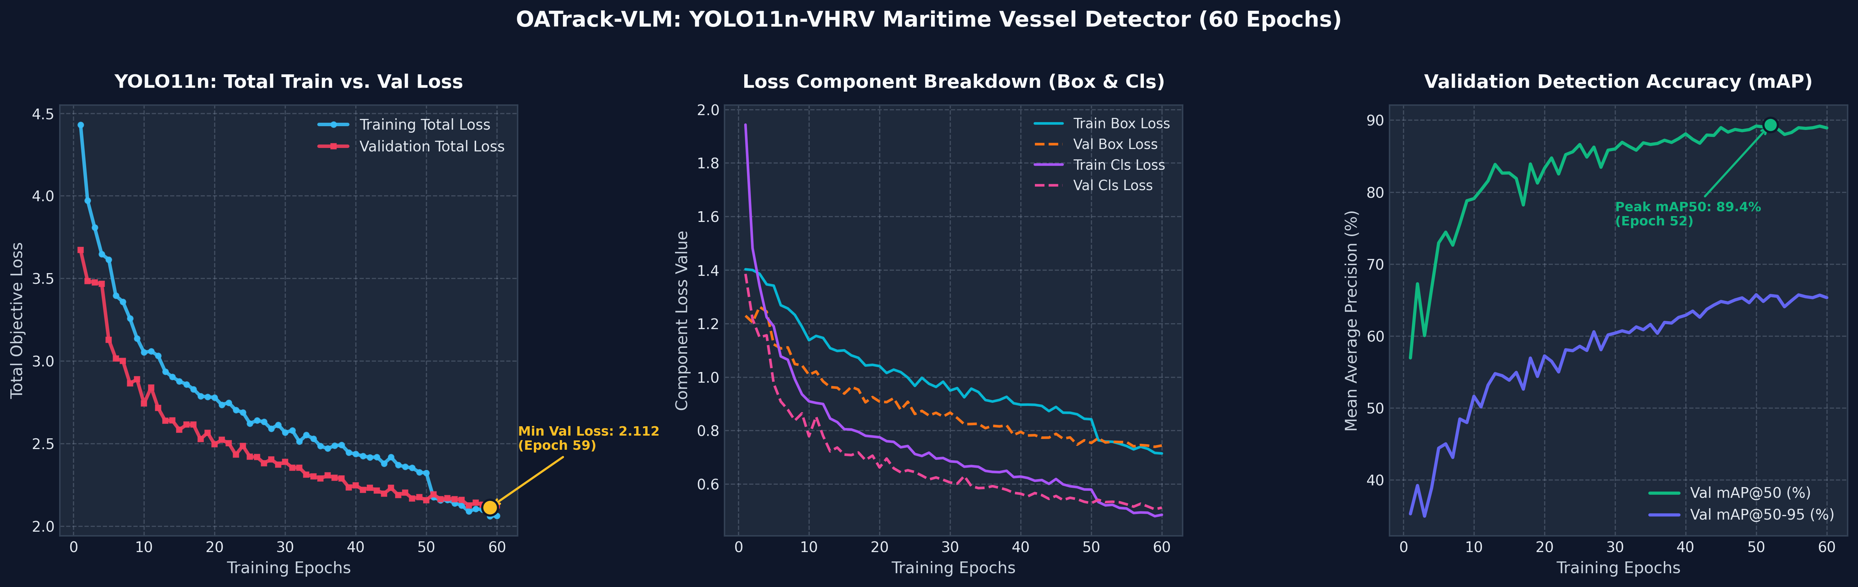
Figure 10.3: Detailed Detector Training and Validation Loss Progression Curves

10.3 Project Execution Gantt Chart
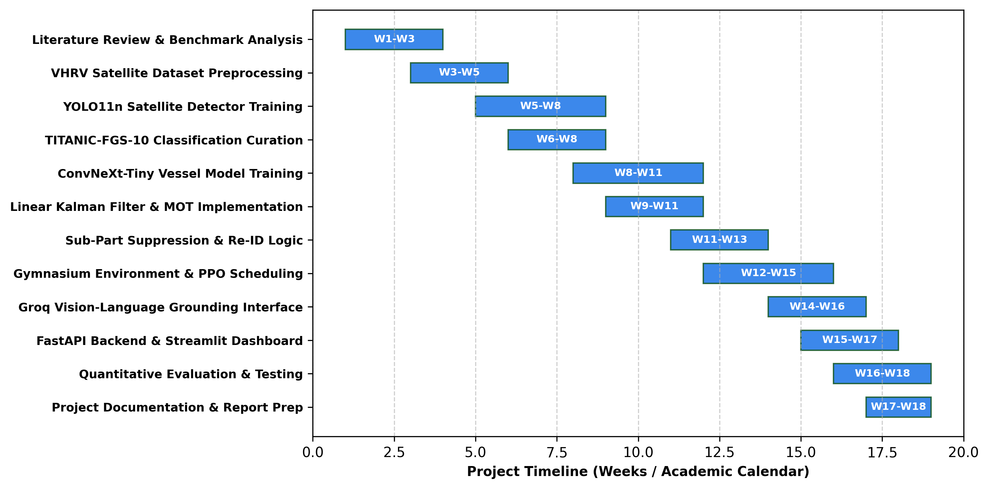
Figure 10.4: Project Execution Gantt Chart Across Academic Timeline

