CIE: Internal Assessment Details

Internal Assessment Question Paper –I

Ramaiah Institute of Technology
(Autonomous Institute, Affiliated to VTU)
Department of Computer Science and Engineering

Programme : B.E Term: Aug-Dec 2017 Date: 27/09/17
Course: CSE02 Course Code: Artificial Intelligence CIE: Test 1
Sem:V Sec: A,B,C Max Marks: 30 Time:2:00-3:00 pm
Portions for Test: (L1-L17)
Instructions to Candidates:
- Question 1 is compulsory. Answer one full Question from 2 or 3.
(Each Full Question carries 15 marks.)
- Mobiles, smart watches or any electronic gadgets are strictly banned.
Sl# | Question | Marks | Bloom’s Level | CO Mapping
1 | - Write the Syntax and Semantics of Propositional Logic.  - Define the task environments and their characteristics for the following games : Chess with a clock, Part picking Robot  - Compare RBFS, SMA* and IDA* algorithms efficiency and pitfalls to search for the shortest route to Bucharest. | 4  4  7 | Under  stand | CO1,CO2,CO3
2 | - Initial State Goal State  B 1 3 1 2 3  4 2 5 4 5 6  7 8 6 7 8 B  Define using the four components the 8 puzzle problem and use h1 as heuristic function to perform DFS to reach the goal state from initial state. Mention in general, the formula to attain solution for this problem. | 8 | Eval  uate | CO2
2 | - Define in simple two steps the process of resolution algorithm for Propositional Logic. Illustrate the procedure of converting the sentence B_{1,1} ⬄(P_{1,2} VP_{2,1}) into Conjunctive Normal form. Mention the necessity of converting a sentence into CNF. | 7 | Analyse | CO2
OR
3 | - Draw the block diagram learning agent and explain it with a real time example. Also state how the performance of such an agent can be improved? | 6 | Remember | CO1
3 | - Consider a state space where the start state is number 1, and the successor function for state n returns two states 2n and 2n+1. Draw the portion of the state space for states 1 to 15. Suppose the goal state is 11. List the order in which nodes will be visited for depth limited search with limit 3 and iterative deepening search and discuss the algorithms performance elements. | 9 | Apply | CO2

Course Outcomes meant to be assessed by the IA Test:
- Identify problems that are amenable to solution by AI methods.

- Identify appropriate AI methods to solve a given problem.
Scheme
Sl# | Question | Marks
1 | Syntax and Semantics of Propositional Logic :- --------------------------- 4 marks  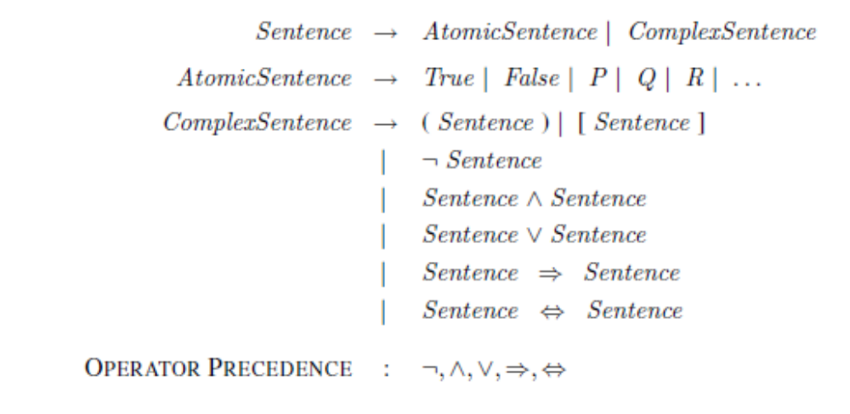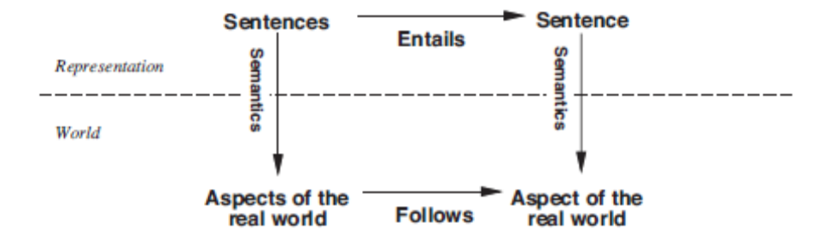  Task environments and their characteristics for the following games : --------------4 marks | 4  4  7
2 | - Initial State Goal State  B 1 3 1 2 3  4 2 5 4 5 6  7 8 6 7 8 B  four components the 8 puzzle problem : -------------------------4 marks  states? locations of tiles, blank in one.  - initial state? given  - actions? move blank left, right, up, down  - Transitional model: ? Given a state and action, this returns the resulting state  - goal test? goal state (given)  - path cost? 1 per move Abstractions?  Mention in general, the formula to attain solution for this problem.  - Note that any given goal can be reached from exactly half of the possible initial states  [Note: optimal solution of n-Puzzle family is NP-hard]  - The 8-puzzle has 9!/2=181, 440 reachable -------------------------- 1 mark  states and is easily solved.  use h1 as heuristic function to perform DFS to reach the goal state from initial state  h1----------→ Misplaced tiles. ----------------------------- 3 marks  - Initial State Goal State  B 1 3 1 2 3  4 2 5 4 5 6  7 8 6 7 8 B  1 B 3 1 2 3 1 2 3 Goal State  4 2 5 4 B 5 4 5 B  7 8 6 7 8 6 7 8 6 | 8
2 | - Define in simple two steps the process of resolution algorithm for Propositional Logic. Illustrate the procedure of converting the sentence B_{1,1} ⬄(P_{1,2} VP_{2,1}) into Conjunctive Normal form.  Mention the necessity of converting a sentence into CNF ---------------------------------- it can be used as input to a resolution procedure. ------------- 1mark  The process continues until one of two things happens: ----------------2 marks  • there are no new clauses that can be added, in which case KB does not entail α; or,  • two clauses resolve to yield the empty clause, in which case KB entails α.  The steps are as follows: ----------------------4 marks  1. Eliminate ⇔, replacing α ⇔ β with (α ⇒ β) ∧ (β ⇒ α).  (B1,1 ⇒ (P1,2 ∨ P2,1)) ∧ ((P1,2 ∨ P2,1) ⇒ B1,1) .  2. Eliminate ⇒, replacing α ⇒ β with ￢α ∨ β:  (￢B1,1 ∨ P1,2 ∨ P2,1) ∧ (￢(P1,2 ∨ P2,1) ∨ B1,1) .  3. CNF requires ￢ to appear only in literals, so we “move ￢ inwards” by repeated application  of the following equivalences .:  ￢(￢α) ≡ α (double-negation elimination)  ￢(α ∧ β) ≡ (￢α ∨ ￢β) (De Morgan)  ￢(α ∨ β) ≡ (￢α ∧ ￢β) (De Morgan)  In the example, we require just one application of the last rule:  (￢B1,1 ∨ P1,2 ∨ P2,1) ∧ ((￢P1,2 ∧ ￢P2,1) ∨ B1,1) .  4. Now we have a sentence containing nested ∧ and ∨ operators applied to literals. We  apply the distributivity law from Figure 7.11, distributing ∨ over ∧ wherever possible.  (￢B1,1 ∨ P1,2 ∨ P2,1) ∧ (￢P1,2 ∨ B1,1) ∧ (￢P2,1 ∨ B1,1) .  The original sentence is now in CNF, as a conjunction of three clauses. | 7
3 | - Draw the block diagram learning agent and explain it with a real time example. Also state how the performance of such an agent can be improved?  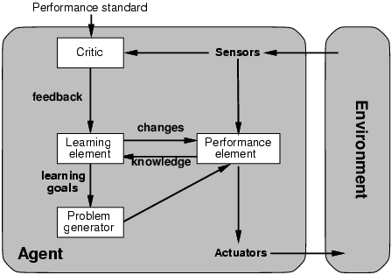 | 6
3 | - Consider a state space where the start state is number 1, and the successor function for state n returns two states 2n and 2n+1. Draw the portion of the state space for states 1 to 15. Suppose the goal state is 11. List the order in which nodes will be visited for depth limited search with limit 3 and iterative deepening search and discuss the algorithms performance elements. | 9

