


Software Requirements Specification
for
Heads Up: TV Series Recommendation System
Version 1.0

Prepared by

SUCHIT MATHUR | 140953312
AMAN SAHAY | 140953368
SEEULEE UPADHAYAYA | 140953422

Instructor: | Mr. RAJESH K
Course: | Rational Unified Process Lab
Lab Section: | A2
Date: | 3 rd October ,2016
Contents
Revisions iii
1 Introduction 3
1.1 Document Purpose 3
1.2 Product Scope 3
1.3 Intended Audience and Document Overview 3
2 Overall Description 4
2.1 Product Perspective 4
2.2 Product Functionality 4
2.3 Users and Characteristics 5
2.4 Operating Environment 5
2.5 Design Constraints …………………………………………………………………5
3 Specific Requirements 6
3.1 External Interface Requirements 6
3.2 Functional Requirements 7
3.3 Behaviour Requirements 7
4 Other Non-functional Requirements 8
4.1 Performance Requirements 8
4.2 Safety and Security Requirements 9
4.3 Software Quality Attributes 9

Revisions
Version | Primary Author(s) | Description of Version | Date Completed
1.0 | Suchit Mathur  Aman Sahay  Seeulee Upadhayaya | First Draft | 03/10/2016

Introduction

Document Purpose
This SRS describes the requirements and specifications of Heads Up, a TV Series Recommendation System. It explains the functional features of the scheduler, along with interface details, design constraints and related considerations such as performance characteristics. The SRS is intended for users and owners of Internet TV Series Database like IMDB and also platforms like Netflix.

Product Scope
This TV series recommender system consists of a large database of various TV

shows available in the market. The system keeps track of all the shows a user has

watched in the past and is currently watching. The system also handles the

Show’s database. The system recommends shows to the users based on the genre

he likes. A user can suggest a show to another user. The system lists and

provides users with date and time of the upcoming shows. The objective of this

product is to make the search for new TV Shows to watch a hassel free affair.The

System uses tools like Text Mining to rate a show through the comments on the

Show’s profile by the users. Additionally, we use an Inversion Algorithm to

judge how similar taste of two different users are and recommend them shows

based on the other user’s Watch list.

Intended Audience and Document Overview
The document is intended for the clients, vendors and for people who want to get familiar with the product .The rest of the SRS is divided into 3 categories namely Overall Description, Specific Requirements and other Non-functional requirements .The Overall Description includes the product perspective , functionality its users and characteristics .This section is meant for vendors i.e the Internet TV series Databases which will be hosting the product on their platform . The Specific Requirements section details the features encapsulated in the product. This section is intended for clients on how to use the product. The Non-functional Requirements section talks about the performance requirements, the safety and software requirements and the software quality requirements.

Overall Description

Product Perspective
As mentioned earlier, Heads Up maintains TV Show’s profile from online databases. It is responsible for recommending the user new TV series based on his watch list. It identifies two users with similar tastes and recommends them shows from each other’s watch list. This is done using an Inversion Algorithm which analyses the data all user’s watch list to come up with the required results. The Inversion Algorithm along with text mining options interacts with the Database. The details of user interfaces have been provided in Section 3.1.
2.2 Product Functionality
The major functionalities Heads Up performs are:

- Profile of each TV Show should be maintained which contains its genre, rating, its Channel host and its actors. Categorize all TV shows according to their genre .Rate the TV Show based on the user comments on the TV Show’s profile. If the comments are positive the TV Show should be given a high rating and vice versa.

- Maintain a watch list which contains the list of shows the user has already watched.

- Recommend the user new shows based on his current watch list.

- Identify users who like similar TV Shows and notify them.

- The identified users with similar tastes should be able to send each other a friend
Request.

- Once two users are friends they can recommend each other TV Shows.

- Any derogatory comment on a TV Show’s profile by a user should be deleted.

- Unregistered users can only view a show’s profile they can’t comment on it.

Users and Characteristics

User: Administrator
The Administrator is the super user and has complete control over all the activities that can be performed. He can update the contents of the database, change its layout, update links, database. He can delete comments posted by users which are in any way derogatory.

User: Unregistered User
Unregistered user can browse the contents like show reviews, trailers, news feeds, celebrity profiles, etc. He can create a login account to avail some other functionalities.

User: Registered User
The features available to a registered user are the same as a external user, with the added functionality mentioned in the product functionalities.

Operating Environment
Since the language used to build this software is Java (JDK 8), this software can be used on any platform in the world – from a Raspberry Pi running Linux to any Windows operated machine.

Design and Implementation Constraint
- No multilingual support.

- Uses limited online databases like IMDB.

- The accuracy of information of users is their sole responsibility.

Specific Requirements

External Interface Requirements

User Interfaces
The GUI is designed on Java Swings.
The user should see the list of all TV Shows categorized by genre. There is a login/Register button which helps the unregistered user to login and unregistered user to register. After successful login the user can go to his watch list and can modify it. He can navigate to different TV Show profiles and can comment on it. The retrieve his recommended friends and recommended TV Shows from his profile

Software Interfaces
Heads Up is built on JAVA and uses Oracle 10g as its database. The database is connected to the software using JDBC. Since the software is built on JAVA it can run on any Windows/Linux/Mac Machine

Functional Requirements
The profile of each TV Show is primarily built from data retrieved from IMDB. The Administrator is the sole user who can modify a TV Show’s profile. The Admin authenticates a registered user and registers an unregistered user. The Admin goes through a user’s watch list and recommends him new TV Shows based on the shows he has watched and determines other users who like similar TV shows as the given user. Such users recommended as friends. The Admin also goes through the comments on a show’s profile and rates the show based on those comments.

A registered user can view and edit his Watch list. He can view the Shows and friends recommended to him by the Software. The user can send his recommended friend a request or accept someone’s request. Once two users are friends then they can recommend each other TV Shows.
An unregistered user can only view a Show’s profile, can’t comment on it and can become a registered user.

Behaviour Requirements

Use Case View
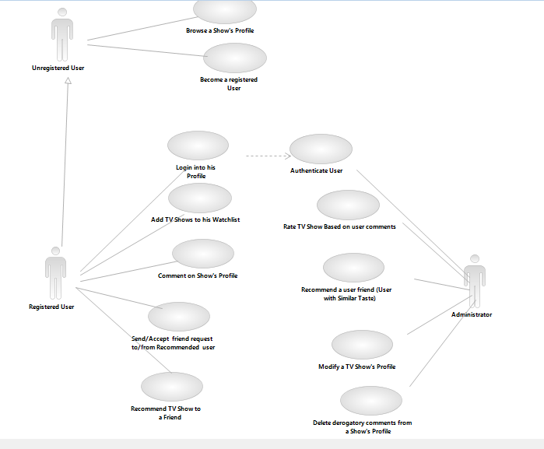

Other Non-functional Requirements

Performance Requirements
- The maximum response time for any functionality will be 1 minute.
- A user can have a maximum of 50 Shows in his watch list.
- Registration of a new user will such that he can’t use an existing username.
- A user’s Password should be minimum 8 characters.
- After 3 unsuccessful login attempts user can only login after 15 mins.

Safety and Security Requirements
- Only the administrator can edit a TV Show’s profile, other users can only view and registered users can comment on it .Derogatory comments if any will be deleted by the administrator.
- A user’s watch list can be viewed by the user and his friends. User is the only person who can edit his watch list.
- After 3 unsuccessful login attempts user can only login after 15 mins.

Software Quality Attributes
Reliability

The Inversion Algorithm gives a user the best recommended shows based on the shows he has already watched. It also recommends him users whose watch list is similar to his.
Text Mining is used to rate Shows based on comments. High rated shows corresponds to very positive feedback from the user and vice versa.

Portability

Due to the robust nature of JAVA this software easily portable across multiple operating Systems like Windows/Linux/Mac.
This software will result in computerization of the various TV Shows available, reduce consumption of time, flexibility, reliability, centralized data management, easy operations by various levels of operators and no need of paperwork.

