import pandas as pd

import numpy as np

import os

import matplotlib.pyplot as plt

import seaborn as sns

data=pd.read_csv("ToyotaCorolla.csv")

data

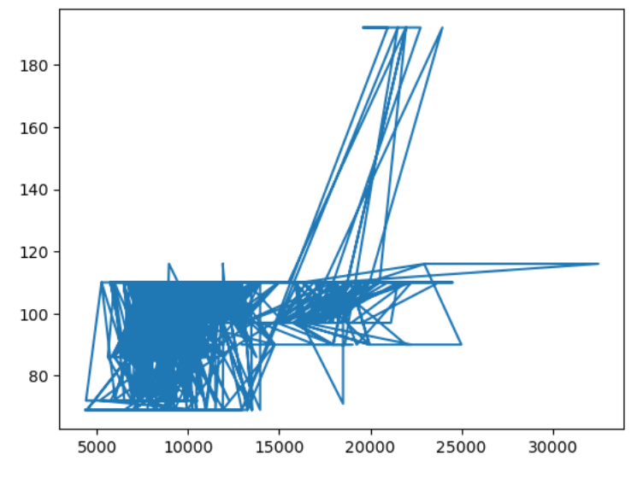

--------------------------------------------------------------------

plt.hist(data['Price'],label='Price')

plt.hist(data['HP'],label='HP')

plt.show()

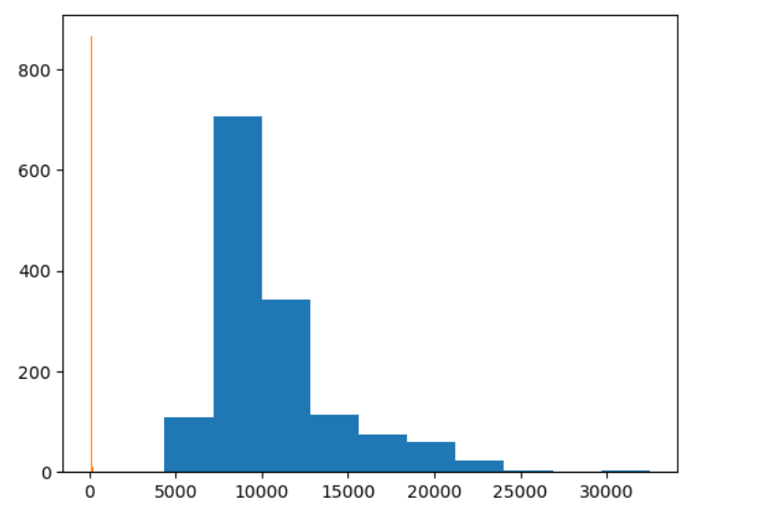

--------------------------------------------------------------------

plt.scatter(data['HP'], data['Price'], label= 'red')

plt.show()

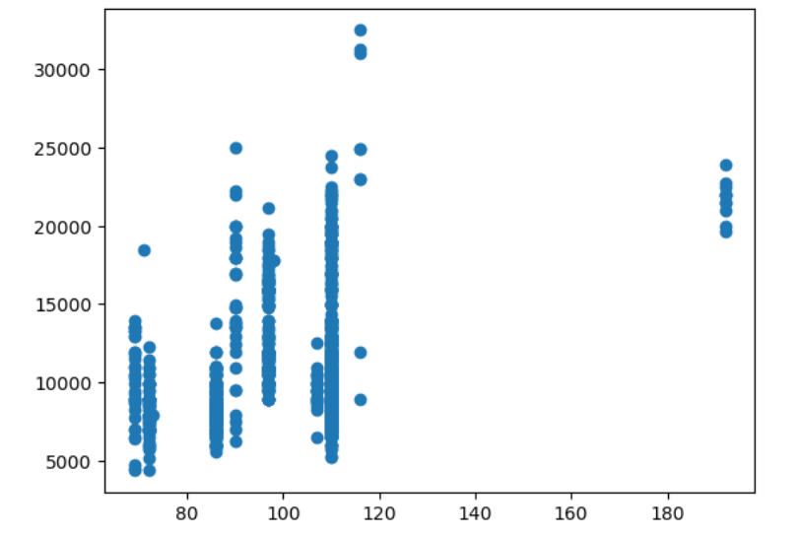

--------------------------------------------------------------------

Out[16]:

<Axes: xlabel='Fuel_Type', ylabel='Price'>



