1. While using forget password system should detect if an email was registered or not. If not, show message “Your email is not registered, Click Here to register”. Done
2. **Registration form**- 2 sections for password

1st is Password, 2nd is confirm password with condition that it should be same as the 1st one **Done**

1. Message for adding less than 10 digits- “Mobile number should be of 10 digits” Done
2. Profile picture is still not loading
3. - should be “Password” and not PassWord. Done

Getting error when trying to reset

1. **Under Profile Settings:** Update for lowercase in letters as “User Category” and GST No. (Optional) and Phone Number Done
2. - update Pic to Picture Done
3. **My Wallet**:
4. Done
5. 
6. 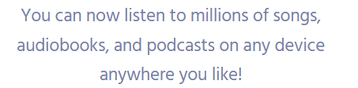- Under Services change this to “Redeem your wallet points while purchasing any of our services” Done
7. 

e. 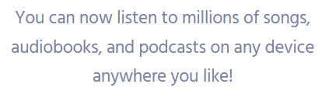- Under Vouchers change this to “Redeem your wallet points against exciting vouchers” Done

f. - “V” should be big **Done**

g. 

h. Different Page or Section for Redeem Now and My Vouchers- Lets discuss how to show this

i. Receiving error will trying to redeem voucher

Be a Affiliate- Write this as “Become an Affiliate”

“PAN Number”

Have Heading

“Bank Account Details”

The sub-sections-

“Bank Name”

“Account Holder Name”

“Account Number”

“IFSC Code”

j. Customize affiliate link- seems very vague as of now- lets discuss this

k. Affiliate User- “Currently, you have no affiliates” Done

l. Affiliate Order- “No order has been placed by any of your affiliate yet” Done

m. Where is the affiliate settlements details? -(like date of payment, amount paid etc)

n. Successfully added to cart – add a popup box that we discussed in call for this message

o. 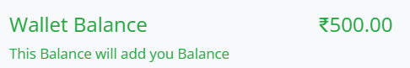- Instead of “Wallet Balance” write “Points Earned”

Correct sentence- “These points will be added to your wallet balance” Done

p. Under add new booking

- should be “Confirm” Done

Keep duration of 30 minutes and 1 hour only

q. On notifications get all the activities as message

- what is this setting and email button for? Done

Under your orders- onboarding call Done

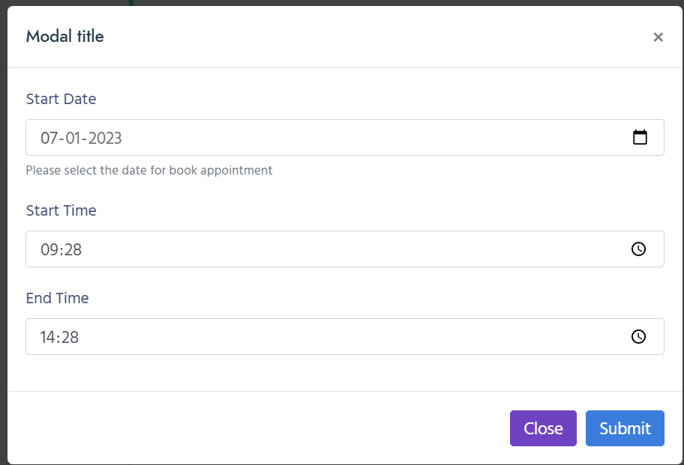

Should be only start date and duration- then automatically calculate end time.

Showing all the times instead of only the time set my manager

Not able to book appointment, getting error

