While resetting password the system should detect if an email was registered or not instead of saying if the email was registered then password for resetting will be sent.

Registration form- It says plain password, should have Net password, confirm password

User Category- write all the categories

Mobile No.- Atleast add a check that the number should be of 10 digits.

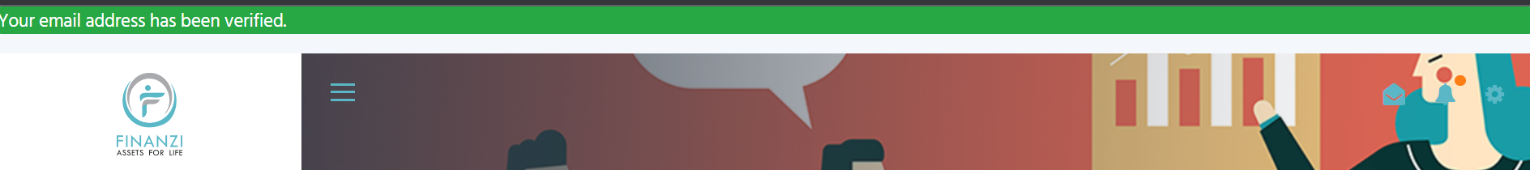

This green banner is not looking good

Profile picture is not loading



***Under Profile Settings:***

Correct spelling- Gender

PAN Number

This should also show GST if added and if not added then option to add whenever someone wants to

Add option to change password

***My Wallet*:**

Spelling- Correct and write “My Wallet Balance”

Service and Voucher is overlapping on pictures

Content below these has to be changed

“Proceed to Services” – “Proceed to Vouchers”

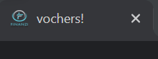

Correct this spelling “Voucher”

Different Page or Section for Redeem Now and My Vouchers

- remove this

Voucher format should be:

Amazon Voucher worth Rs 200/-

You need to use 3000 points from your wallet to redeem this voucher

On redeem now when it is red and someone still clicks it, a message should come as a comment “You don’t have sufficient points in your wallet to redeem this voucher”

Receiving error will trying to redeem voucher

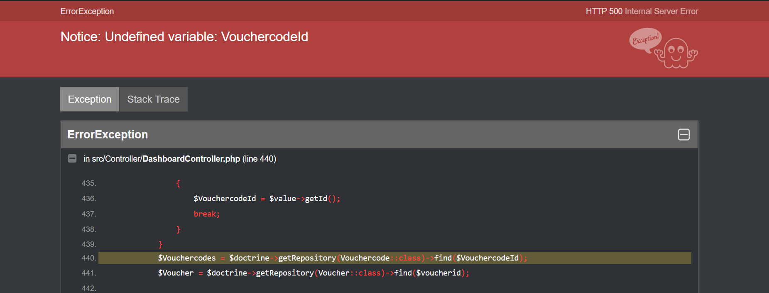

Why Affiliate is coming 2 times?

 - same is happening for other ones as well

Be a Affiliate- Write this as “Become an Affiliate”

“PAN Number”

Have Heading

“Bank Account Details”

The sub-sections-

“Bank Name”

“Account Holder Name”

“Account Number”

“IFSC Code”

- Should be affiliate user

Customize affiliate link- seems very vague as of now

Same thing under affiliate order and user. Under affiliate order and user, once someone becomes an affiliate there should be a message you have no affiliates; no order has been placed by any of your affiliate yet and when any of the thing happens then the table should appear

Where is the affiliate settlements details? -(like date of payment, amount paid etc)

Remove club as of now

When I add service to cart, it should show a message successfully added to cart

And on top in cart it should show 1

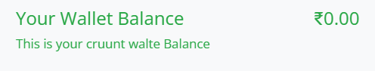- correct spelling- “current wallet balance”

- “your”

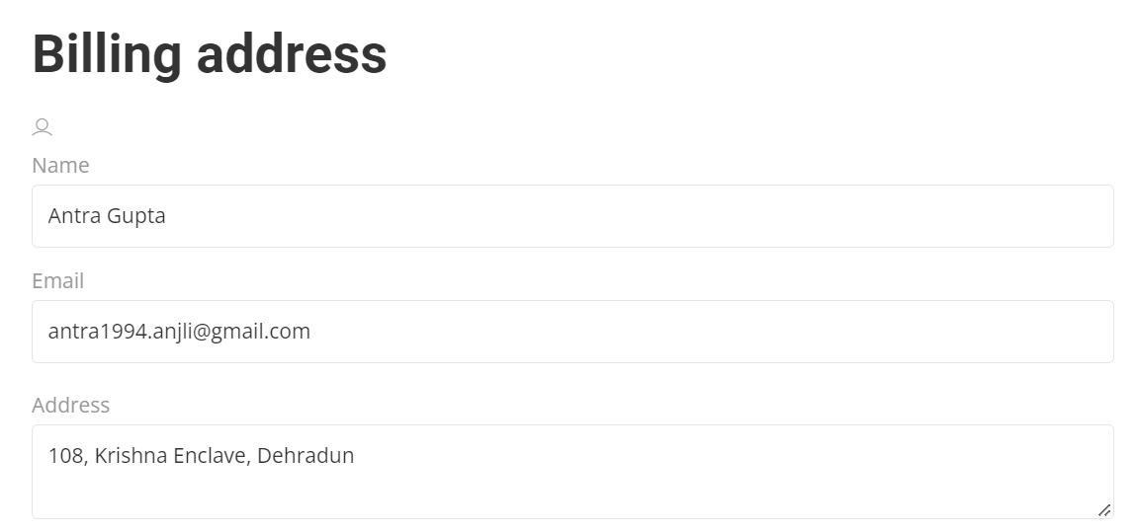

Billing details and not billing address. Add phone number section also

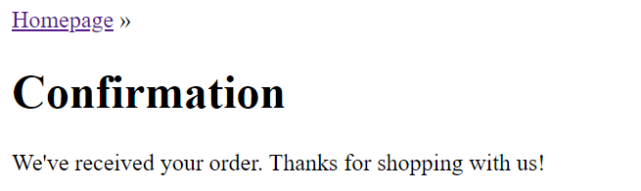- please find a good format and how this as a pop up banner instead of a complete new blank page

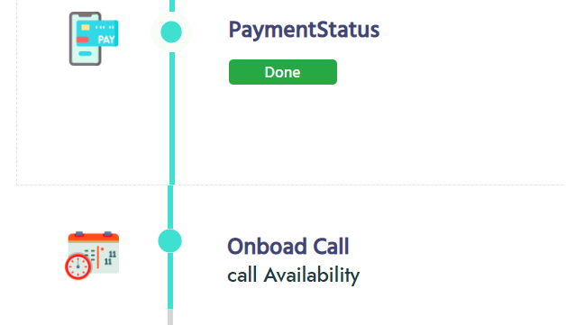- where is professional assigned step?

My Appointment-

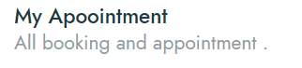- spelling “Appointment”

Remove this “all booking and appointment”

Currently though manager is not assigned but it still shows as timing and dates available, atleast Sunday and time other than 1-5 should be phased out.

- should be “Confirm”

Keep duration of 30 minutes and 1 hour only



Change this

After this message I had to refresh to see the booking on the calendar.

Cannot click on the calendar to see the details of the booking.

Will also need an automated email after the appointment is booked

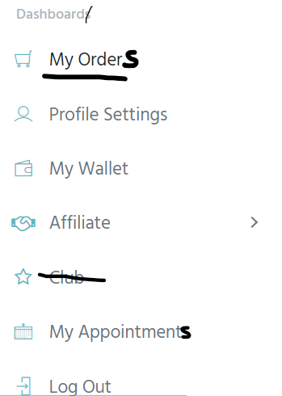

- This is coming for all except vouchers. How is this done?

Nothing happening when clicking on notifications

- all 3 not working

Under your orders- onboarding call

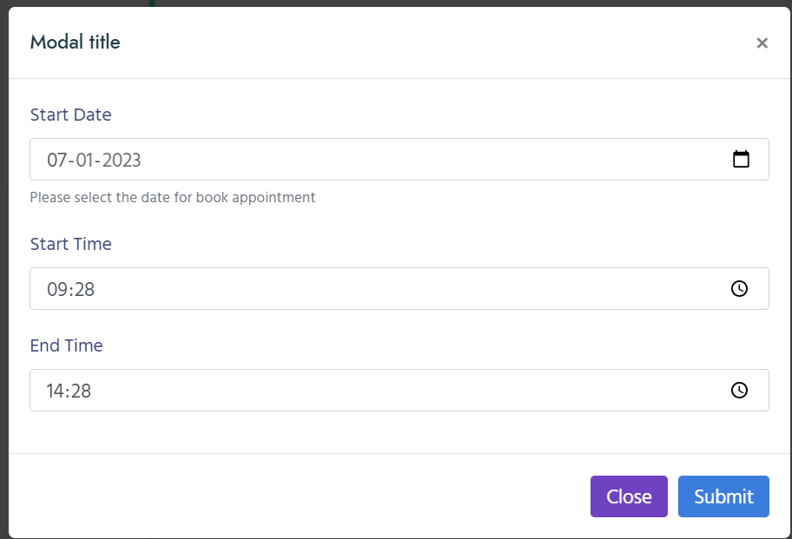

Should be only start date and duration- then automatically calculate end time.

Showing all the times instead of only the time set my manager

Not able to book appointment, getting error

