Project Group : Entity Search (KG01)

Supervisor : Diego Moussallem

#### Submitted to : Prof. Dr. Axel-Cyrille Ngonga Ngomo

Table of Contents

Entity Search 1

Deployment Verification: 3

AGDISTIS Service 4

Deployment Verification: 4

GENESIS 6

Deployment Verification: 6

This document provides the guidelines to deploy Entity Search Project. Entity Search Project depends on two other project modules and it uses the service from these projects-

1. GENESIS
2. AGDISTIS

Deployment Instructions

## Entity Search

**Step 1:**

Entity Search Project is uploaded on Git. Download or clone the project from [here](https://github.com/amansharma30/EntitySearch.git).

**Step 2:**

Import the project as a ‘maven project’.

**Step 3:**

Go to Project Properties to convert the project to Dynamic web project.

Click apply and click save and apply.

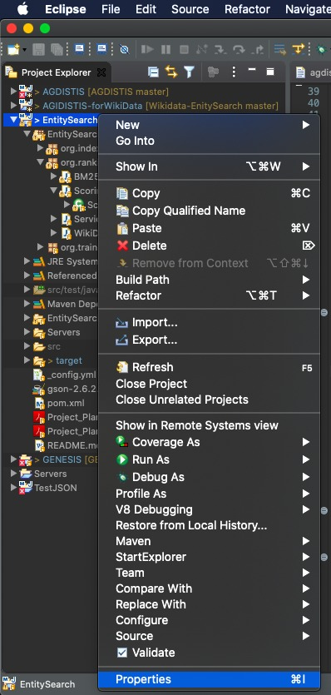

**Step 4:**

Next copy the web.xml under WEB-INF directory.

**Step 5:**

This project needs AGDISTIS project as external library. Download the project source code from [here](https://drive.google.com/file/d/16AuwKzmVcWiLj7Zy_nd8inzggJ4V5xa-/view?usp=sharing). Create the jar with the below command:

>> ***mvn clean compile assembly:single***

**Step 6:**

Go to File-> Project Settings-> Libraries-> add downloaded jar as an external java library-> click apply and ok.

The jar must be kept in the build path of the project.

**Step 7:**

Export the project as a war file. Make sure to export all the dependencies in the web archive file.

**Step 8:**

Copy the war file in tomcat webapps directory located at:

*$TOMCAT_HOME/webapps/*

**Step9:**

Copy the DBPedia index from the below link and extract it under */home*:

<http://hobbitdata.informatik.uni-leipzig.de/agdistis/dbpedia_index_2016-04/en/index_bycontext.zip>

**Step 10:** Set the ENVIRONMENT variable as below:

**AGDISTIS_INDEX_BY_CONTEXT = /home/index_bycontext**

### Deployment Verification:

War is successfully deployed if a new folder with the name ‘Entity Search’ appears in the same directory.

Verify the deployment by hitting the service URL on a web browser.

***$HOSTNAME:$PORTNUMBER/EntitySearch/scoringService/text***

## AGDISTIS Service

**Step 1:**

Download code from Git. This is the repository link: [Wikidata-EnitySearch](https://github.com/Projucti/Wikidata-EnitySearch.git)

**Step 2:**

Step 3:

Import the code and run it by following command:

**>> mvn clean package tomcat:run -DskipTests**

**OR**

**Step 3b:**

Export the project as a war file. Make sure to export all the dependencies in the web archive file.

**Step 4:**

Copy the war file in tomcat webapps directory located at:

*$TOMCAT_HOME/webapps*

**Step 5:**

Set the ENVIRONMENT variable as below:

**AGDISTIS_SERVER_NAME = *HOSTNAME:$PORTNUMBER***

*Example*: AGDISTIS_SERVER_NAME = <http://localhost:8080/>

**Step 6:**

Copy the DBPedia index from the below link and extract it under */home* and rename the file as ‘index’ :

<https://hobbitdata.informatik.uni-leipzig.de/agdistis/wikidata/indexWikidata_en_de_fr.zip>

**Step 7:** Set the ENVIRONMENT variable as below:

**AGDISTIS_INDEX = /home/index**

### Deployment Verification:

War is successfully deployed if a new folder with the same name as that of the war file appears in the same directory.

Verify the deployment by hitting the service URL on a web browser.

***$HOSTNAME:$PORTNUMBER/AGDISTIS?entity=Dresden***

## GENESIS

Step 1:

Download and import the code from the [Git](https://github.com/paarasPB/Genesis.git) and switch to ‘*entity-field-creation’* branch.

Step 2:

Make sure node.js installed on the system. Otherwise, download from the following URL and follow the company guidelines.

<https://nodejs.org/en/>

Step 3:

Go to the project path in your console and run below command for package

Installations:

**>> npm install**

Step 4:

Then run:

**>> npm start**

Step 5:

Go to config.js and select the data source (either DBPedia or WikiData). Make sure to comment the other one.

exports.luceneService = process.env.LUCENE_SERVICE || 'http://localhost:8080/EntitySearch/scoringService/getDocumentsFromDBPedia'; exports.luceneService = ***process***.env.LUCENE_SERVICE || 'http://localhost:8080/EntitySearch/scoringService/getDocumentsFromWikiData';

### Deployment Verification:

Navigate to <http://localhost:3000/> in your browser.