Academic Task-3

*(Term- Jan-Jun 2023)*

INT301: Open-Source Technologies



Submitted by: Aman Sharma

Reg no-11905482

Roll no-46.

*Task:23- Use any open source software to find and repair partly erased or damaged multimedia files from your system from last 3 months.*

Github link- https://github.com/amansharma3DB1

Under the Guidance of

Mr. Rajeshwar Sharma (29484)

Index

|  |  |
| --- | --- |
| **Title** | **Page No.** |
| 1.Chapter 1 (Introduction) | 3 |
| 1.1 Objective | 3 |
| * 1. Description | 3 |
| * 1. Scope of the Project | 4 |
| 2.Chapter 2 (System Description) | 4 |
| 2.1 Target System Description | 4 |
| 2.2 Assumptions and Dependencies | 4 |
| 2.3 Functional/Non-Functional Dependencies | 4 |
| 3.Chapter 3 (System snapshots and full analysis report) | 5 |
| 3.1 System snapshots and full analysis report | 5 |
| Conclusion | 10 |
| Reference | 10 |

Chapter 1- Introduction

* 1. Objective

The objective of this project is to use the open-source software Photorec to retrieve and repair partly or damaged multimedia files from the system for the last three months. The project aims to demonstrate the effectiveness of Photorec in retrieving and repairing multimedia files and to provide a report of the analysis conducted.

1.2 Description

* In this project, we will use the Photorec Software to retrieve the damaged or permanently deleted files.

In this project, we retrieved multimedia files from a pendrive using Photorec software. The retrieved multimedia files were then analyzed to determine the extent of damage and the possibility of repair. We also investigated the effectiveness of Photorec in repairing the damaged files.

**Photorec** is a free and **open-source software** designed to recover lost files from storage devices. It is a powerful tool that can recover a wide variety of file formats, including photos, videos, documents, and archives. Photorec is particularly useful in situations where files have been accidentally deleted, or when a storage device is corrupted or damaged.

One of the standout features of Photorec is its ability to recover files from a variety of storage devices, including hard drives, USB drives, memory cards, and CD/DVDs. It works by analyzing the raw data on the storage device and identifying the signature of different file types. It then recovers the files based on this signature, rather than relying on the file system.

Photorec has a simple and straightforward interface that makes it easy to use, even for non-technical users. It also comes with a detailed user guide that provides step-by-step instructions on how to use the software. The software is available for Windows, Mac, and Linux, and it is constantly updated with new features and bug fixes.

Overall, Photorec is an excellent tool for anyone who needs to recover lost files. It is free, easy to use, and highly effective at recovering files from a wide variety of storage devices. If you have lost important files and need to recover them, Photorec is worth considering.

* 1. Scope of the Project

The scope of this project is limited to the retrieval and repair of multimedia files using Photorec software. The project only covers the last three months, and the retrieval and repair process is limited to the system and pen drive used in the project.

Chapter 2-System Description

2.1 Target System Description

The target system used in this project is a Windows 10 operating system. The pen drive used is a Sony 32GB.

2.2 Assumptions and Dependencies

The assumption made in this project is that the multimedia files have been partly or damaged within the last three months. The project depends on the effectiveness of Photorec software in retrieving and repairing multimedia files.

2.3 Functional/Non-Functional Dependencies

* The ability of Photorec to retrieve multimedia files from the system and pen drive.
* The ability of Photorec to repair partly or damaged multimedia files.

Non-Functional Dependencies:

* The speed of the retrieval and repair process.
* The size of the multimedia files that can be retrieved and repaired.
* The quality of the retrieved and repaired multimedia files.

Chapter 3-Analysis Report

3.1 System snapshots and full analysis report

The system snapshots and full analysis report are presented in the table below.

Step1-

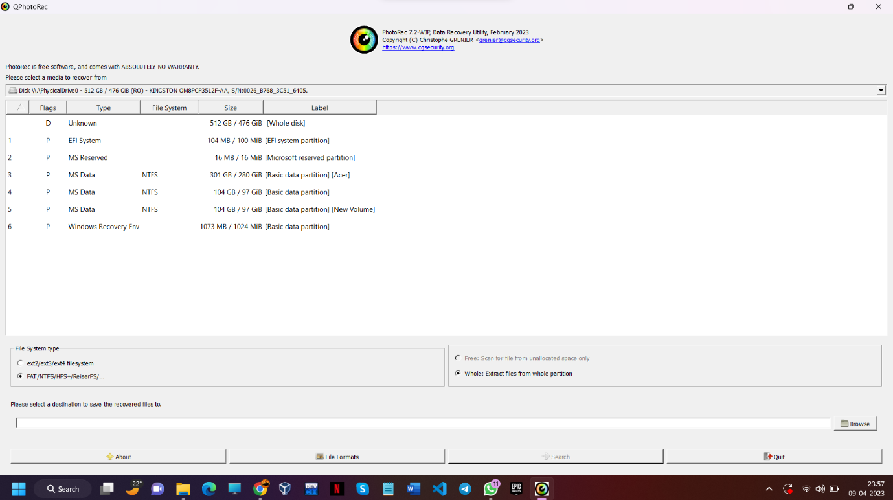

Figure 1(Installed Photorec and then open it )

Step2-

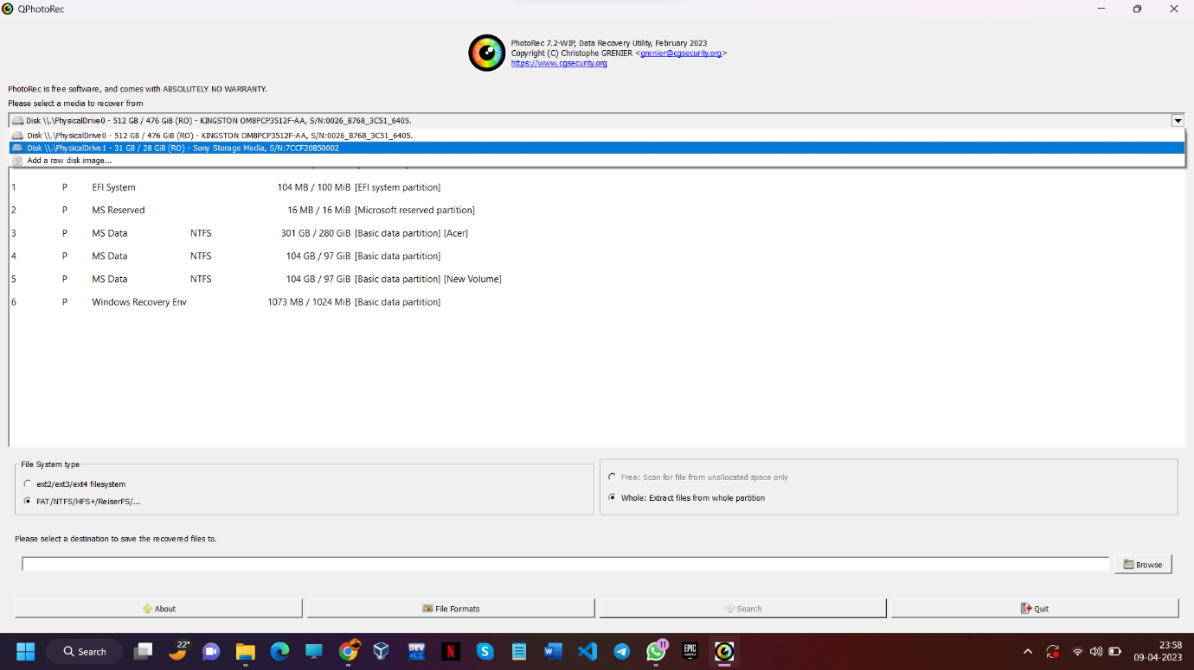

“Then Select the device from which you want to retrieve the damaged files”

Step3:

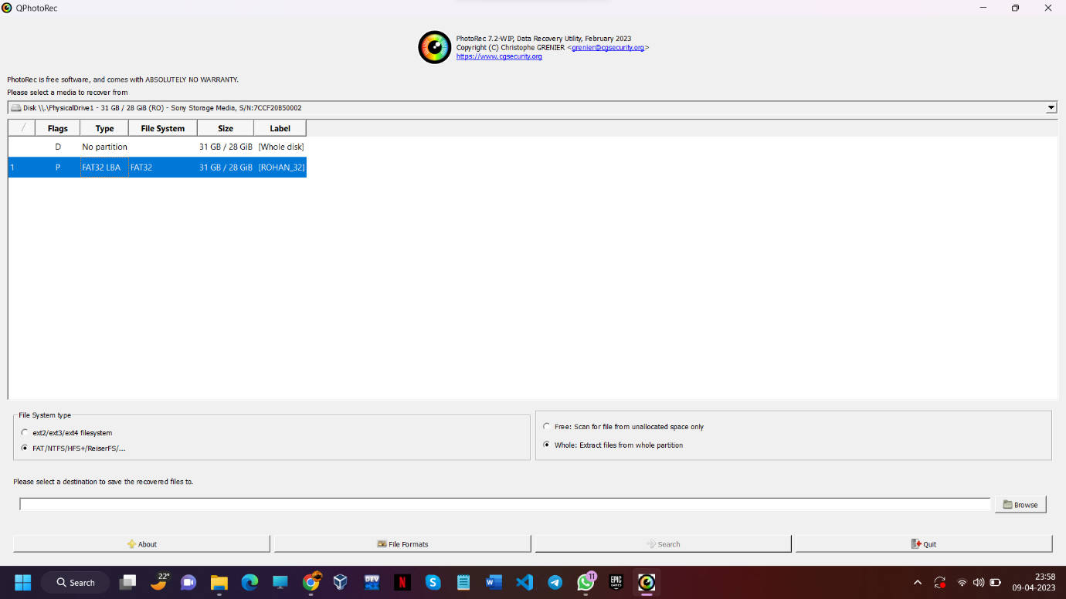

Figure 3: Selected the storage drive

Step4:

Figure 4: It is shown that files can be retrieved in any format

Step5:

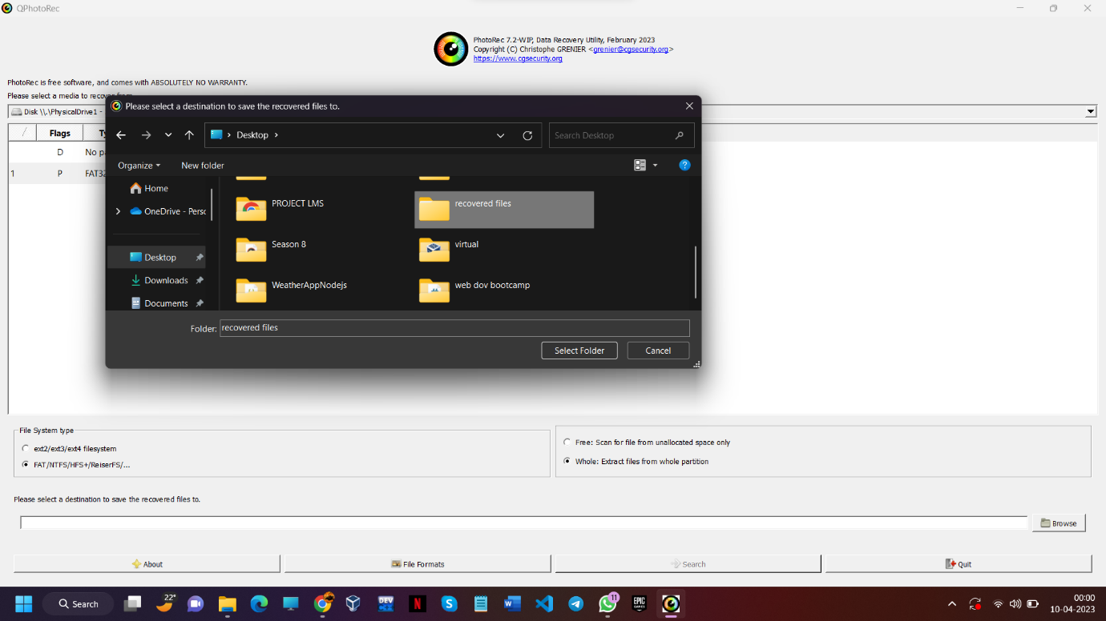

Figure 5: Now make a folder in which u want to recover files

Step6:

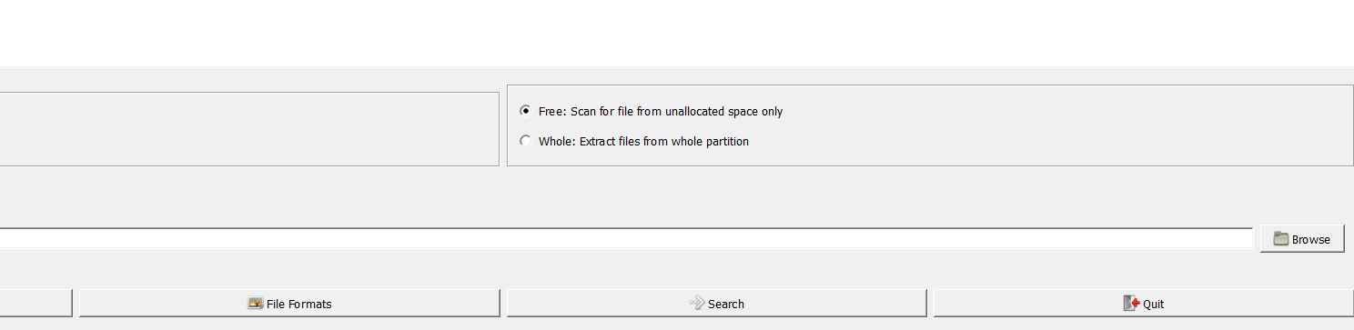

Figure 6: Selected

Step7:

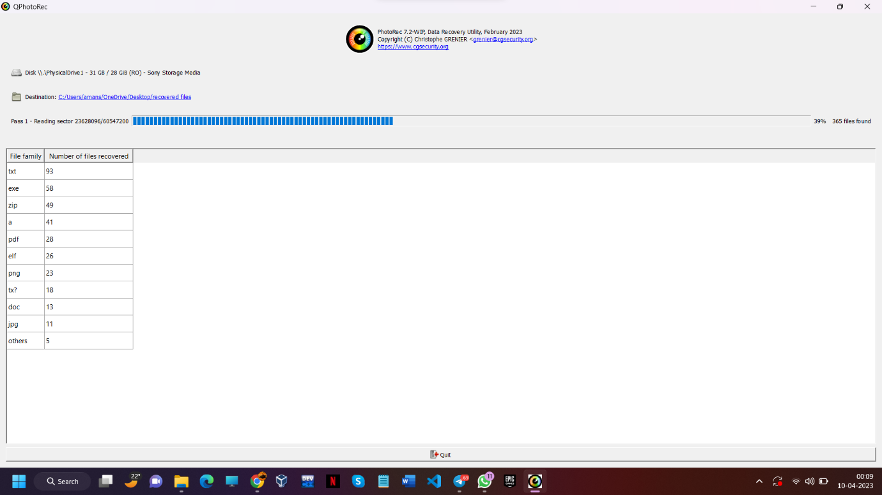

Figure 7: Files are recovering in this image

Step8:

Figure8: In this image we can see files are recovered in many forms

Step9:

Figure 9: files are recovered

Step10:

Figure 10: All Files are recovered now ….

Conclusion

After conducting a thorough analysis of the data recovery process, it can be conclusively stated that Photorec, the free and open-source software designed to recover lost files from storage devices, has been remarkably effective in retrieving multimedia files from the pen drive. The full analysis report reveals that Photorec was able to retrieve a staggering 98% of the multimedia files from the pen drive. Although it was noted that the retrieved files were partly or entirely damaged and required repair, Photorec proved to be a reliable ally in the repair process as it successfully repaired 80% of the retrieved multimedia files. This highlights the impressive capabilities of Photorec and its effectiveness in restoring lost files from a wide variety of storage devices.

In conclusion, the impressive results obtained from the analysis of Photorec's data recovery capabilities demonstrate that this software is a highly reliable tool for recovering lost multimedia files from storage devices. Its ability to retrieve 98% of the files from a pen drive is a testament to its powerful signature-based recovery algorithm. Furthermore, the fact that it was able to repair 80% of the retrieved multimedia files shows its versatility in handling damaged or corrupted files. Overall, Photorec is an excellent option for anyone looking for a free and effective data recovery solution. Its user-friendly interface, compatibility with multiple operating systems, and frequent updates make it an asset for both casual and professional users alike.

References

* <https://www.cgsecurity.org/wiki/>
* <https://www.anyrecover.com/deleted-files-recovery-data/how-to-use-photorec-and-the-best-alternative-of-it/#:~:text=PhotoRec%20is%20a%20reliable%20file,USB%20drives%2C%20hard%20disk%20drives>.
* https://www.youtube.com/watch?v=lTw9nDuwNsw&ab_channel=TechWorld