**Assingment-Of-JavaScript**

Ques 1:Prompt for amount, interest rate and no. of years and calculate simple interest.

Ans:

HTML code:

<!DOCTYPE **html**>

<**html**>

<**head**>

<**meta charset="utf-8"**>

<**title**>Question-1</**title**>

</**head**>

<**body**>

<**script src="./Q1.js" charset="utf-8"**></**script**>

<**script**>*sayhello*()</**script**>

</**body**>

</**html**>

JAVASCRIPT code:

**function** *sayhello*(){

**var** amount=*prompt*(**"Enter the amount"**);

**var** intrest=*prompt*(**"Enter the intrest rate"**);

**var** year=*prompt*(**"Enter the number of year"**);

**var** months=*prompt*(**"Enter the number of months"**);

**var** days=*prompt*(**"Enter number of days"**);

**var** S_I=((amount*intrest*year)+(amount*intrest*months%12)+(amount*intrest*days%365))/100;

***document***.write(S_I);

}

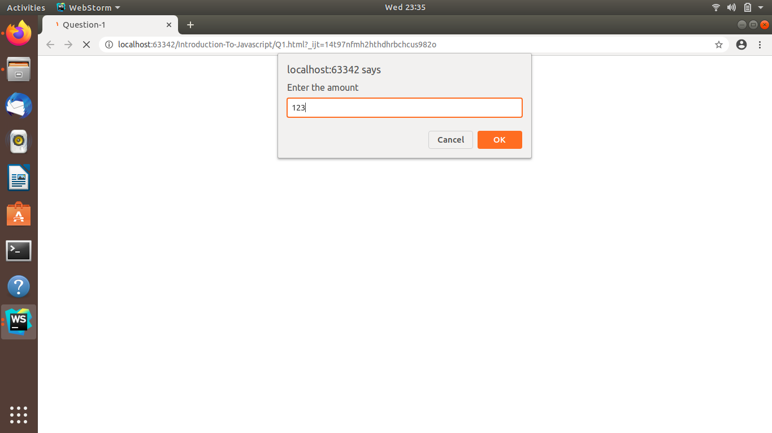

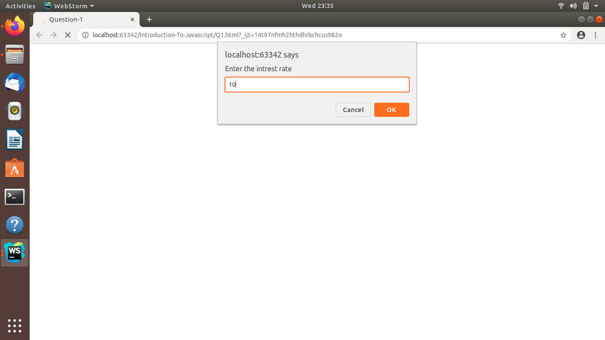

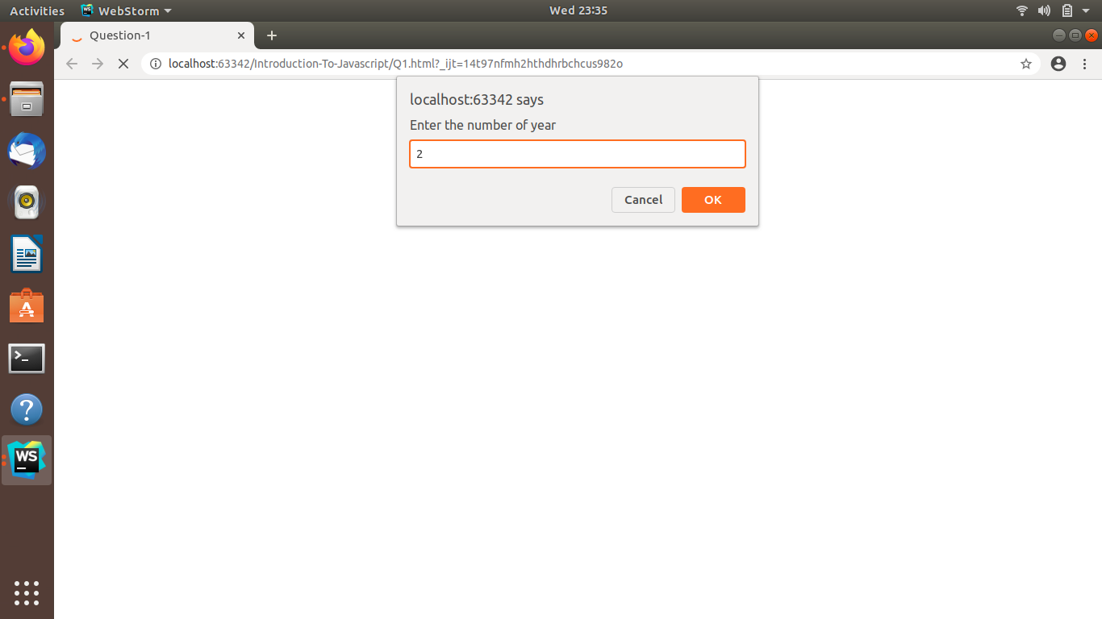

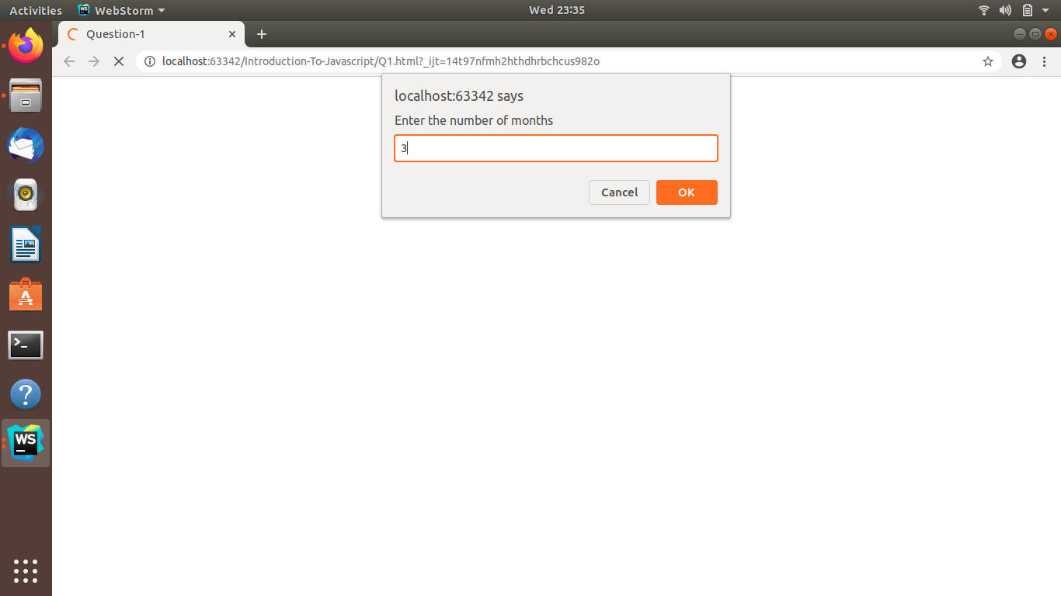

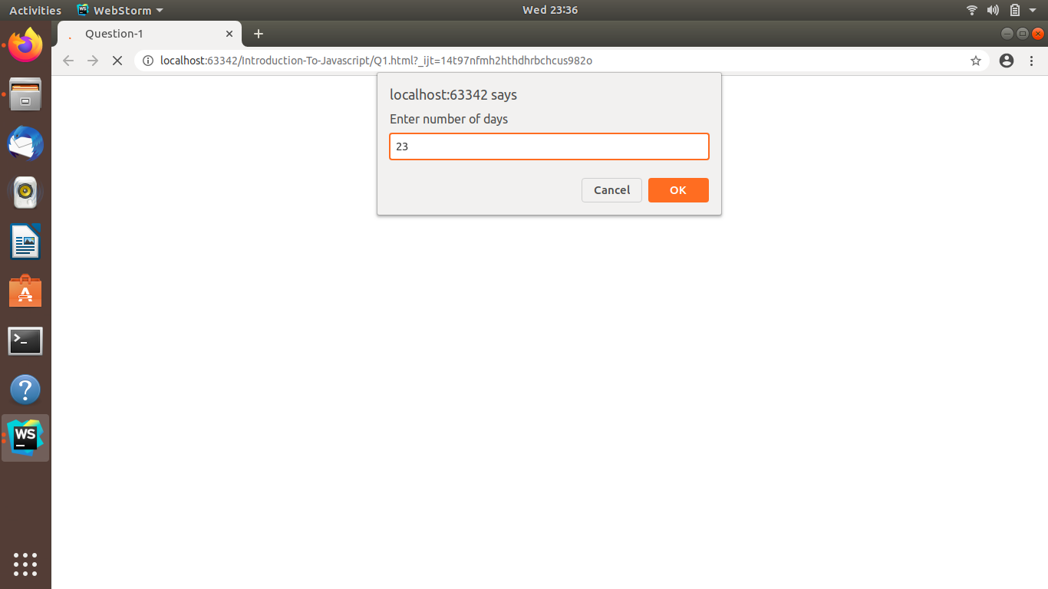

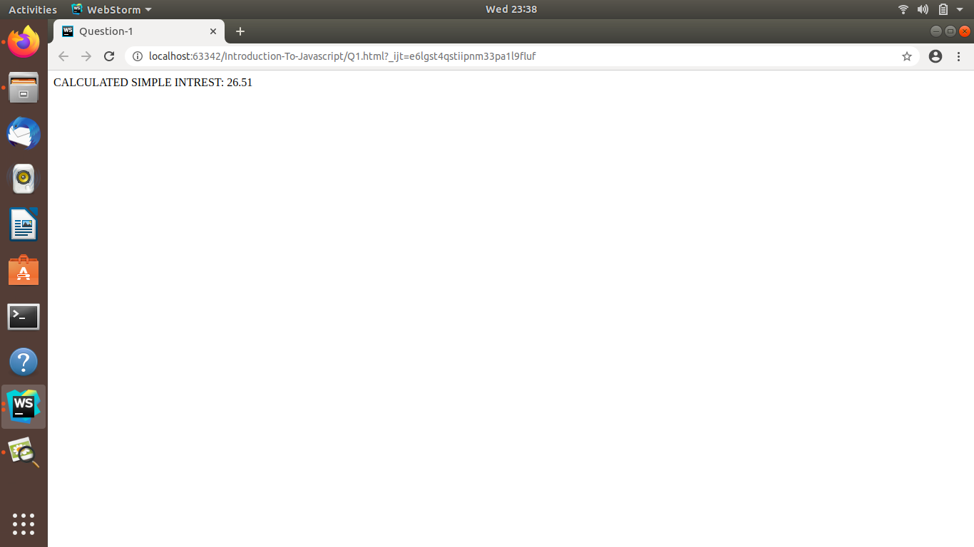

Ques 2:Javascript program to check palindrome string

Ans:

HTML code:

<!DOCTYPE **html**>

<**html lang="en"**>

<**head**>

<**meta charset="UTF-8"**>

<**title**>QUESTION-2</**title**>

</**head**>

<**body**>

<**script src="./Q2.js" charset="UTF-8"**></**script**>

<**form**>Enter a String/Number:

str1 : <**input type="text" id ="str" name="String"**>

<**input type="submit" value="Check" onclick="***ispalindrome*(str)**"**/>

</**form**>

<**br**/>

</**body**>

</**body**>

</**html**>

JAVAscript code:

**function** *ispalindrome*(str){

**var** str1=**""**;

**var** str=***document***.getElementById(**"str"**).**value**;

**var** i =str.**length**;

**for**(**var** j=i; j>=0; j--){

str1 =str1+str.charAt(j);

}

**if**(str1 == str){

***document***.write(**"Palindrone String"**);

}

**else**{

***document***.write(**"Not palindrone String"**);

}

}

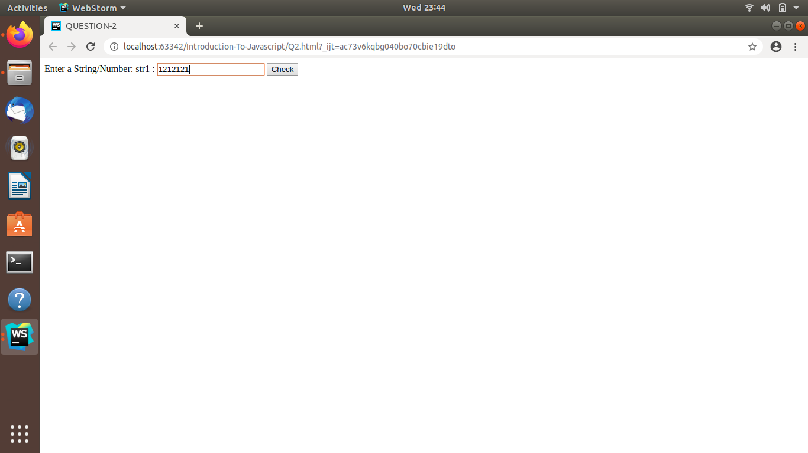

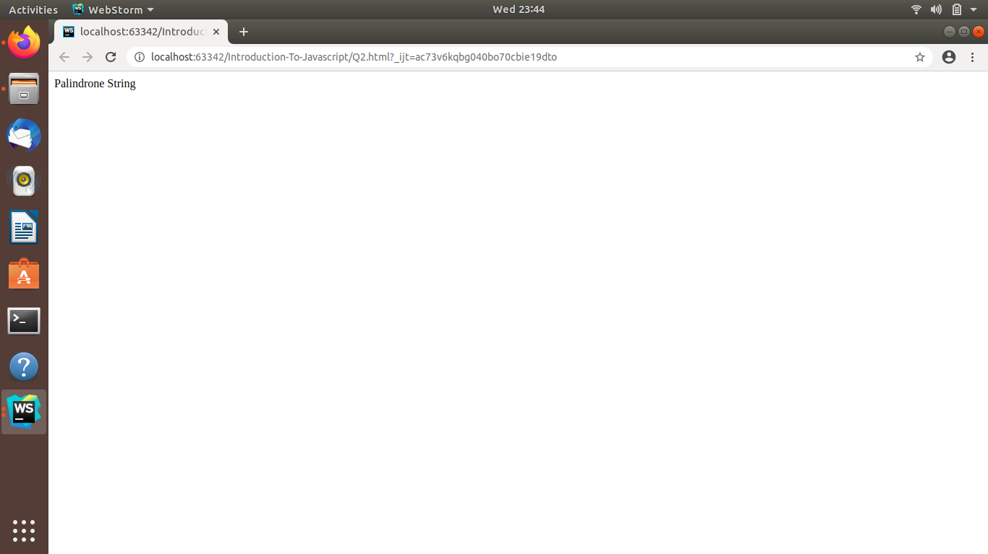

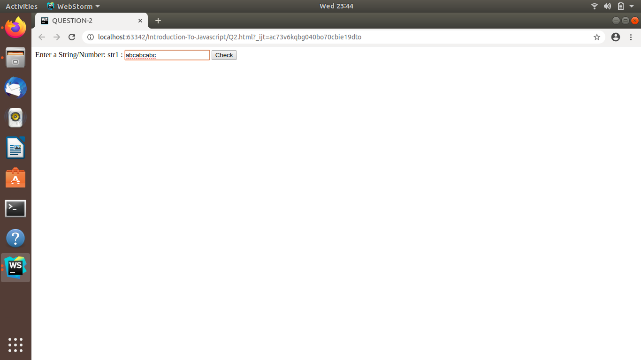

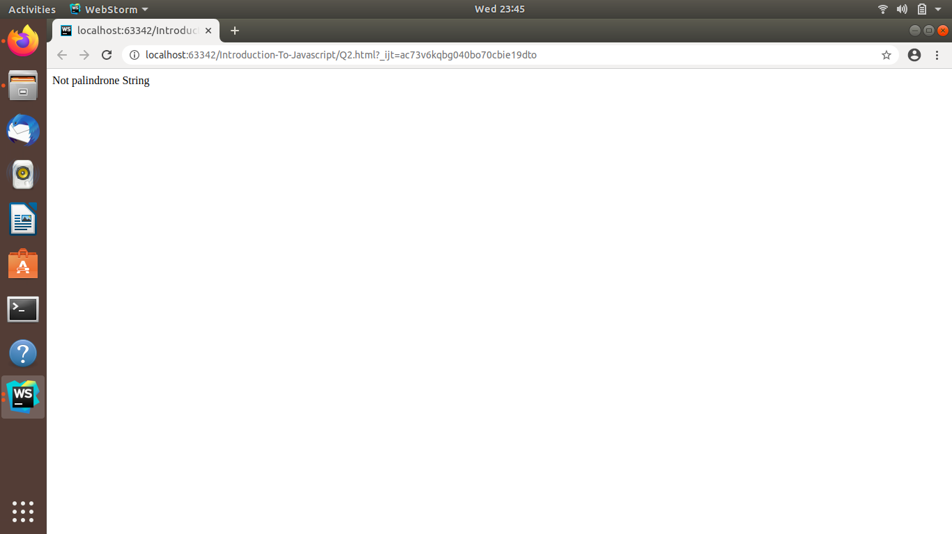

Ques 3:JAVAscript program to calculate area of circle

Ans:

HTML CODE:

<!DOCTYPE **html**>

<**html lang="en"**>

<**head**>

<**meta charset="UTF-8"**>

<**title**>QUESTION-3</**title**>

</**head**>

<**body**>

<**script src="./Q3.js" charset="UTF-8"**></**script**>

<**form**>Enter radius of circle:

radius : <**input type="text" id ="int" name="radius"**>

<**input type="submit" value="calculate" onclick="***area_of_circle*(int)**"**/>

</**form**>

<**br**/>

</**body**>

</**body**>

</**html**>

Javascript Code:

**function** *area_of_circle*(int){

**var** radius=***document***.getElementById(**"int"**).**value**;

**var** area =((3.14)*radius*radius);

***document***.write(**"Area of Circle is"**+area);

}

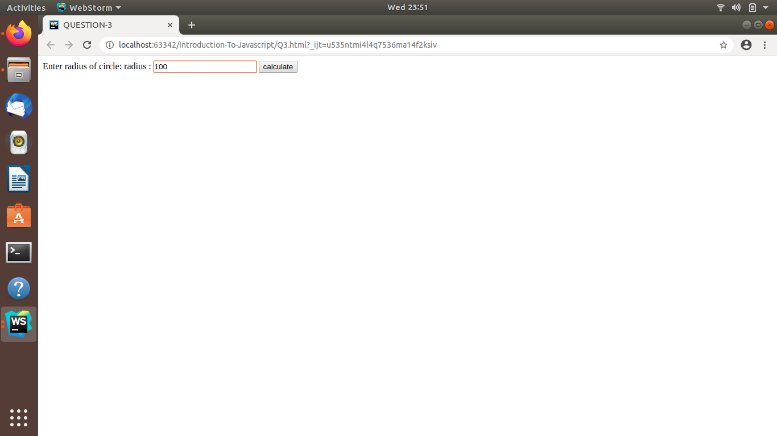

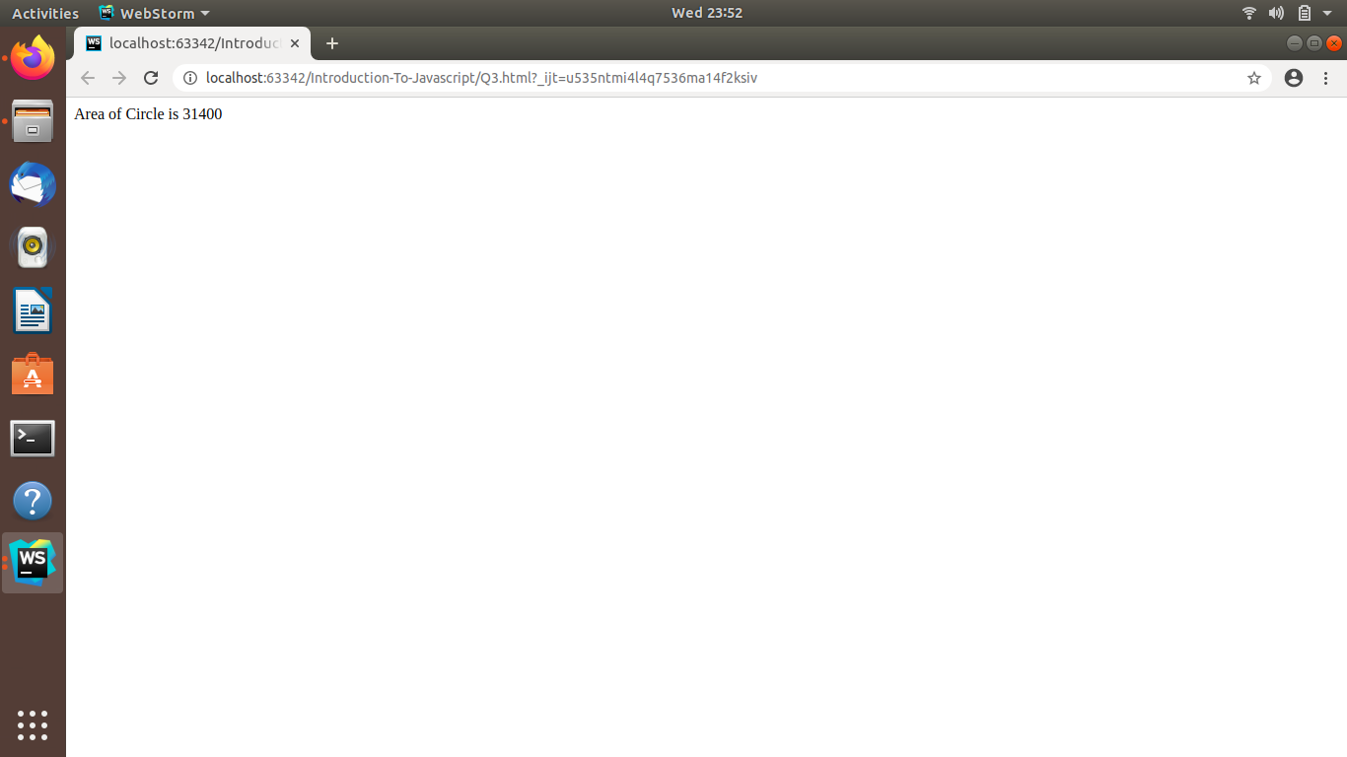

Ques 4:Copy information of one object to another and log it to console.

Ans:

HTML CODE:

<!DOCTYPE **html**>

<**html**>

<**head**>

<**meta charset="utf-8"**>

<**title**>Question-4</**title**>

</**head**>

<**body**>

<**script src="./Q4.js" charset="utf-8"**></**script**>

</**body**>

</**html**>

JAVASCRIPT CODE:

**const *square***={

**side**: 1,

area(){

***console***.log(**'area'**);

}

};

***console***.log(***square***);

**const *clonesquare*** = ***Object***.assign({},***square***);

***console***.log(***clonesquare***);

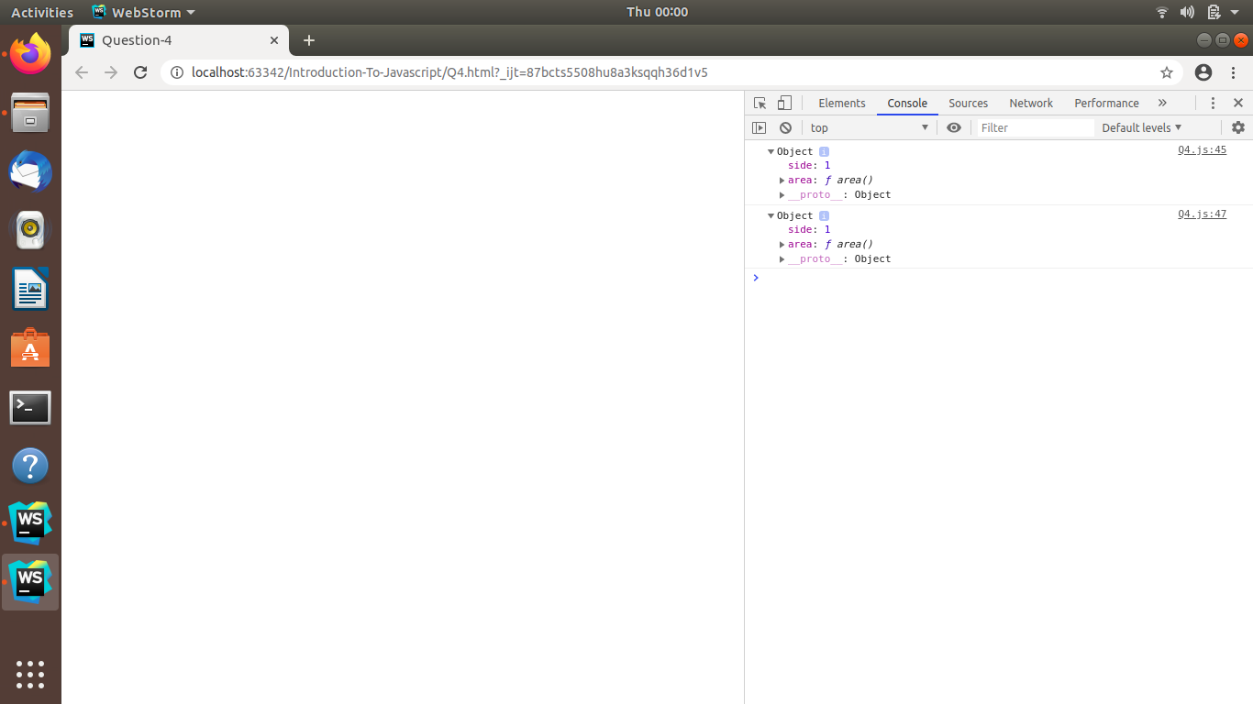

Ques 5:create a list of objects of Employee with info as follow :

Ans:

HTML CODE

<!DOCTYPE **html**>

<**html**>

<**head**>

<**meta charset="utf-8"**>

<**title**>Question-5</**title**>

</**head**>

<**body**>

<**script src="./Q5.js" charset="utf-8"**></**script**>

</**body**>

</**html**>

1. Name, age, salary ,DOB

Javascript code:

**var *list*** =[];

**for**(**let *i***=0; ***i***<=2; ***i***++) {

**var *employee*** ={};

***employee***[**'name'**]=*prompt*(**"Enter the name"**);

***employee***[**'age'**]=*prompt*(**"Enter age"**);

***employee***[**'salary'**]=*prompt*(**"Enter Salary"**);

***employee***[**'DOB'**]=*prompt*(**"Enter DOB"**);

***list***.push(***employee***);

}

***console***.log(***list***);

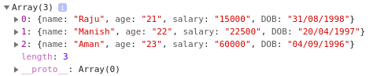

b.filter all employees with salary greater than 5000

**var *list*** =[{**Name**:**"Raju"**,**Age**:21,**salary**:15000,**DOB**:**"31/08/1998"**},

{**Name**:**"Manish"**,**Age**:22,**salary**:22500,**DOB**:**"20/04/1997"**},

{**Name**:**"Aman"**,**Age**:23,**salary**:60000,**DOB**:**"04/09/1996"**},]

**for**(**let *i***=0; ***i***<3; ***i***++)

{

**if**(***list***[***i***].**salary** > 5000)

{

***console***.log(***list***[***i***].**Name**);

}

}

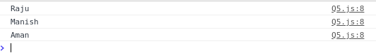

c.group employee on the basis of their age

Javascript Code:

**var *list*** =[{**Name**:**"Raju"**,**Age**:21,**salary**:15000,**DOB**:**"31/08/1998"**},

{**Name**:**"Manish"**,**Age**:22,**salary**:22500,**DOB**:**"20/04/1997"**},

{**Name**:**"Aman"**,**Age**:23,**salary**:60000,**DOB**:**"04/09/1996"**},]

**var *group***=[];

**for**(**let *i***=0; ***i***<3; ***i***++)

{

**if**(***list***[***i***].**salary** < 60000)

{

***group***.push(***list***[***i***]);

}

}

***console***.log(***group***);

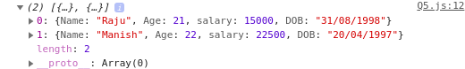

d.fetch employees with salary less than 1000 and age greater than 20. Then give them an increment 5 times their salary

JAVAscript code:.

**var *list*** =[{**Name**:**"Raju"**,**Age**:21,**salary**:800,**DOB**:**"31/08/1998"**},

{**Name**:**"Manish"**,**Age**:22,**salary**:22500,**DOB**:**"20/04/1997"**},

{**Name**:**"Aman"**,**Age**:23,**salary**:900,**DOB**:**"04/09/1996"**},]

**var *group***=[];

**for**(**let *i***=0; ***i***<3; ***i***++)

{

**if**(***list***[***i***].**salary**<1000 && ***list***[***i***].**Age** >20)

{

**var *new_salary***=5\****list***[***i***].**salary**;

***list***[***i***].**salary**=***new_salary***;

}

}

***console***.log(**"new incremented salary"**);

***console***.log(***list***);

