Blockchain Development Challange @ HackerEarth 2019 Sumission

Submitted by Aman Singh
Contact 8743040743
amanggnlps@gmail.com
github.com/amansheaven

Deployment Instructions:

- Copy the Smart Contract in registry.sol file and head over to remix.ethereum.org
- Create a new file by clicking + icon on top left most collumn
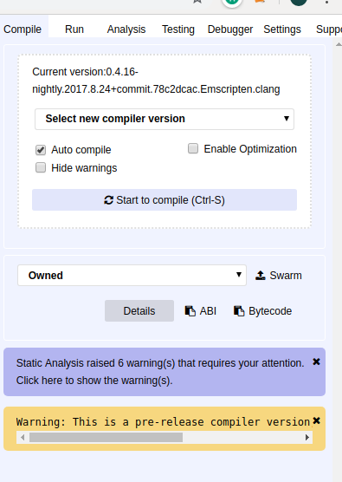
- Paste the code in the editor
- Select the comiler version 0.4.16 and turn on auto comile and click Start to comile.
- After this move to the Run tab and select and deploy both Owned and registry contacts if its successful who new instances would pop below the deployment button.
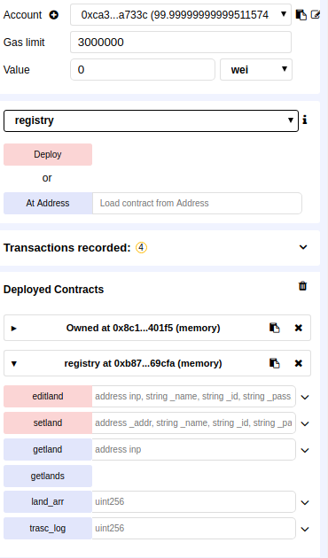

Account- variuos accounts with 100 ethers to process
editland-edit land registry details
setland- create registry
getland – get land details from the account hash
getlands – array of adresses alloacted with the account
land_arr, trans_log – should be used to manage transaction (currently non fucntional)

ShortComings:

- No proper functional front end yet due to the tremendous changes in solidity 5.0.
- No implementation of the transaction module.

Features:

- The Blockchain is functional and records variuos data appropriatively
- The Blockchain have a immunity against tamering of data from another account ie: alex created the block, so only alex account can use editland()
- The Blockchain have a seperate and cummilative information API.

ScreenShots

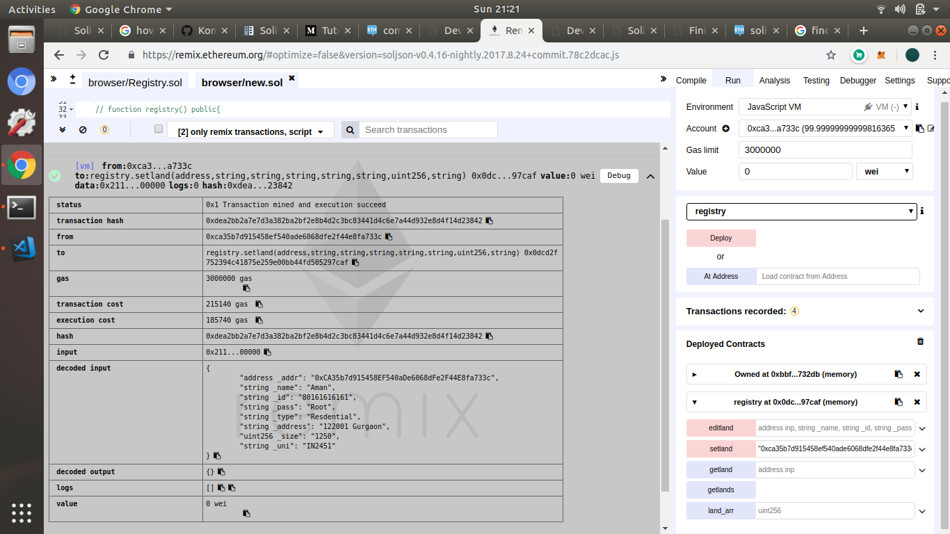
Adding Record

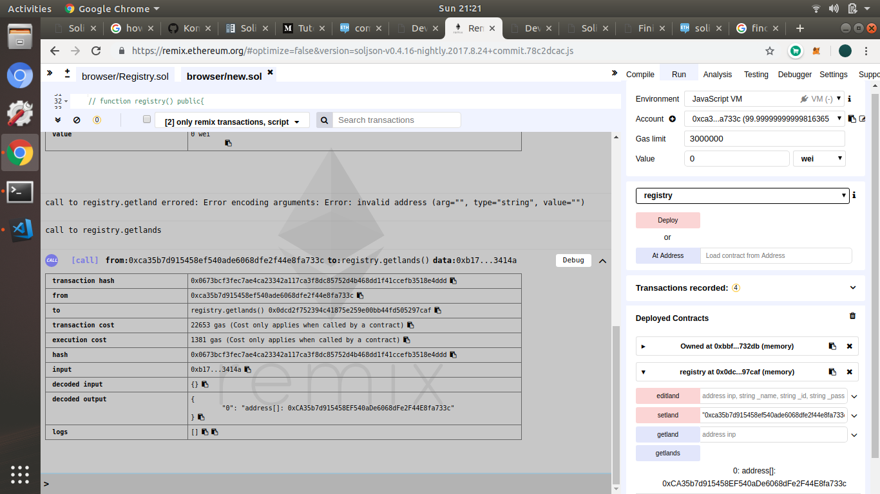
Total Adresses

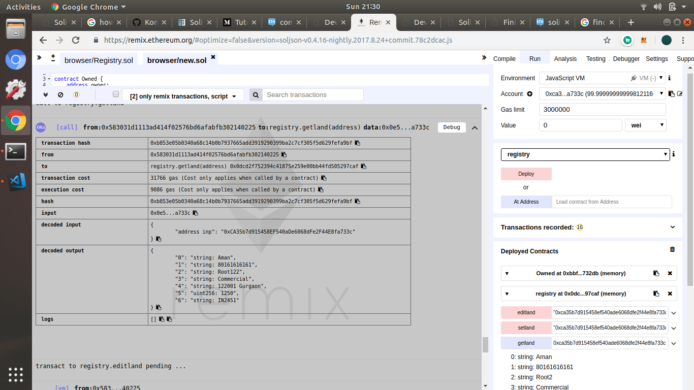
A purticular address info

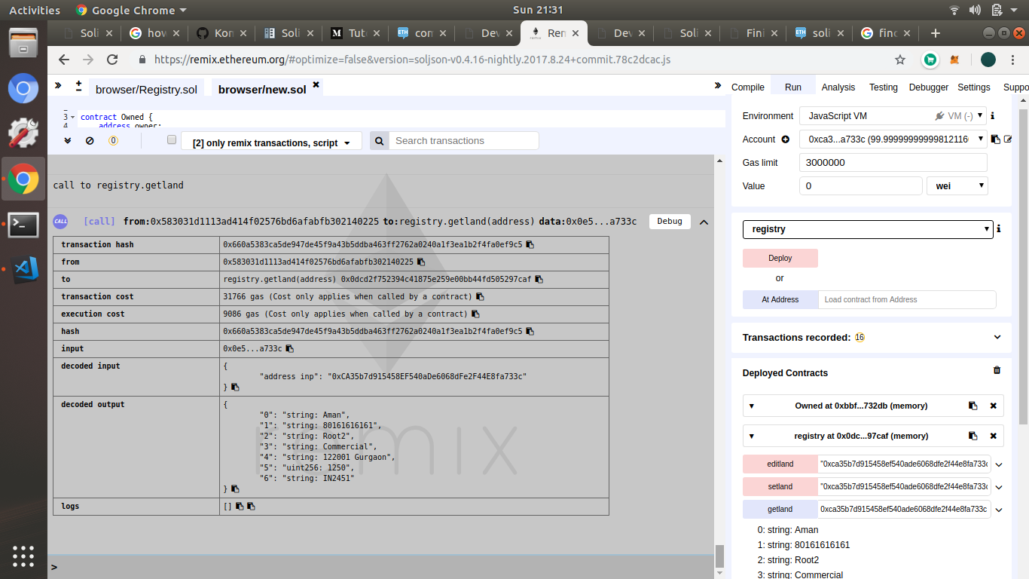
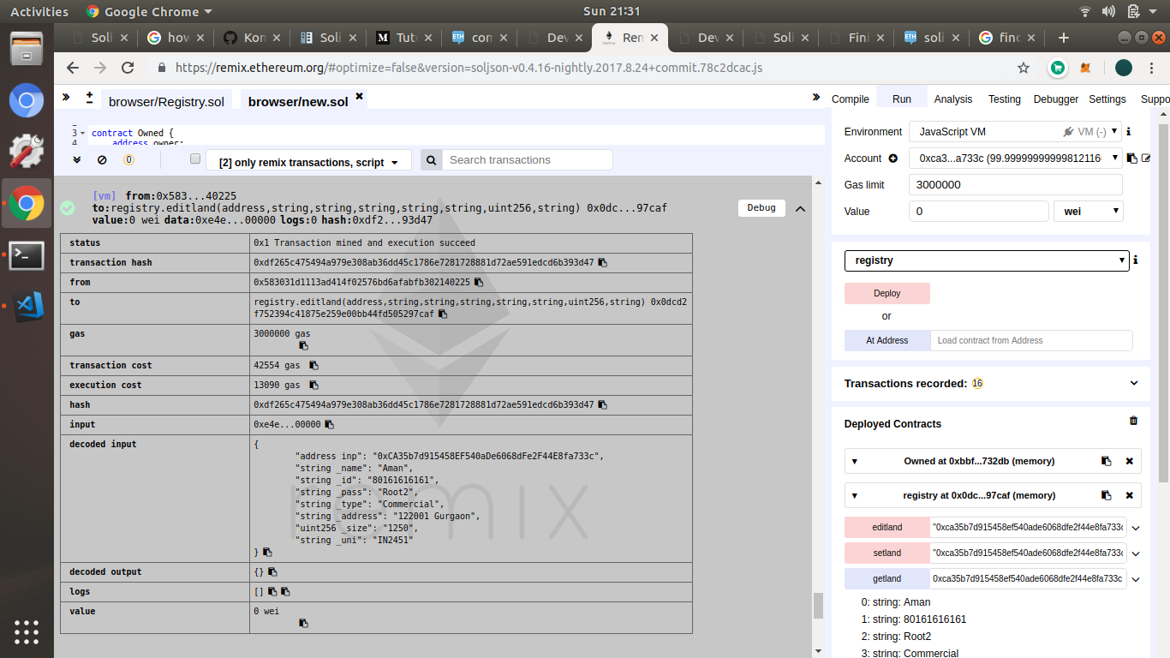

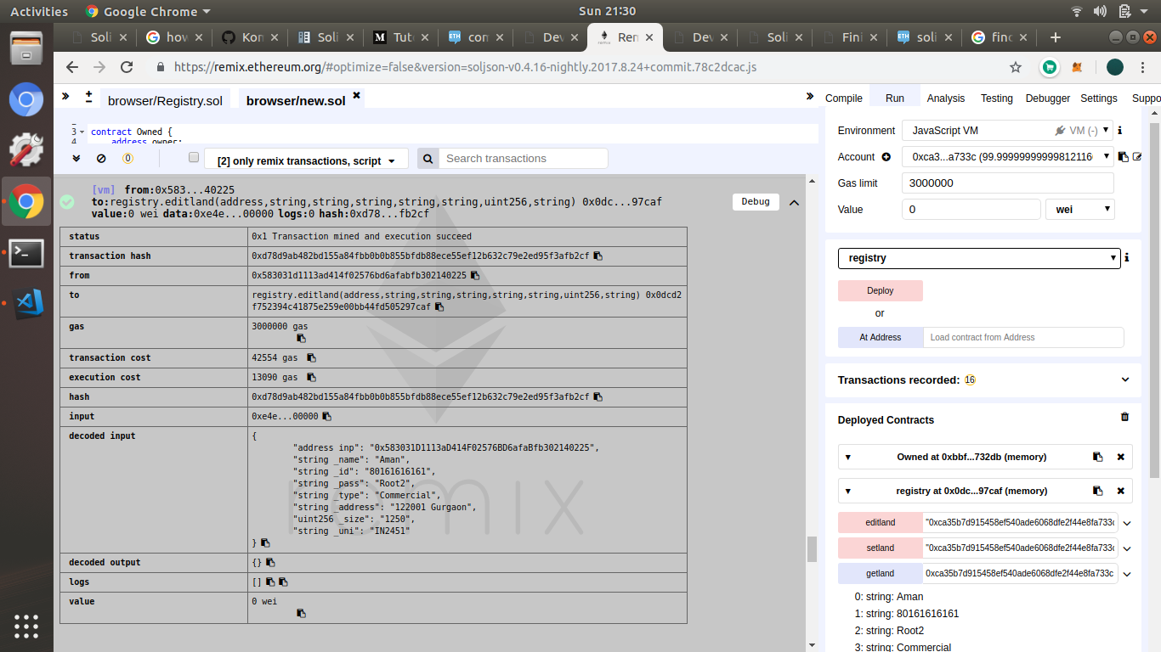

Demonstration of immunity against editing registry by some other accounts

