**NAME – Aman Singh**

**SAP ID- 500075455**

**ROLL NO. – 09(iot)**

**COURSE- BCA-IOT-B1**

**Front-End Web Application Development**

**Q1- Write a javascript code that has a button for performing the following operations:**

**1. Display**

**2. Delete a value (index is to be asked from the**

**user)**

**3. Add a value (index is to be asked from the user)**

**4. Sort**

**5. Reverse**

<html>

<head>

<script lang="javascript">

var array = [];

function displayF(){

document.getElementById("value").innerHTML = array;

}

function addF(){

var string = prompt("Enter value to add to array");

var index = prompt("Enter index of array");

array.splice(index, 0, string);

}

function delF() {

var index = prompt("Enter index of array");

array.splice(index, 1);

}

function sortF() {

array.sort();

document.getElementById("value").innerHTML = array;

}

function reverseF() {

array.reverse();

document.getElementById("value").innerHTML = array;

}

</script>

</head>

<body>

<h1>DISPLAY DELETE ADD SORT REVERSE ARRAY</h1>

<br>

<form>

<input type="button" id="display" value="DISPLAY" onclick="displayF()">

<input type="button" id="delete" value="DELETE" onclick="delF()">

<input type="button" id="add" value="ADD" onclick="addF()">

<input type="button" id="sort" value="SORT" onclick="sortF()">

<input type="button" id="reverse" value="REVERSE" onclick="reverseF()">

</form>

<h3 id="value"></h3>

</body>

</html>

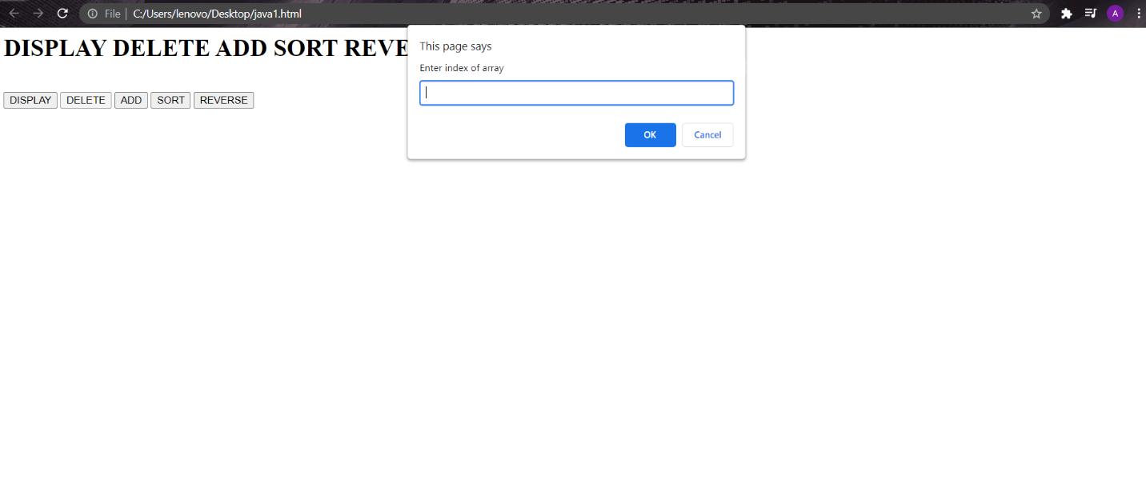

**2. Write a function that accepts an array of strings. Return the longest string.**

<html>

<head>

<link rel="stylesheet" href="style.css">

<script lang="javascript">

var strings = [];

function addToArray() {

var string = document.getElementById("string").value;

strings.push(string);

console.log(strings);

document.getElementById("string").value = "";

document.getElementById("arrayStrings").innerHTML = strings;

}

function checkLongest() {

var longest = strings.reduce(

function (a, b) {

return a.length > b.length ? a : b;

}

);

alert(longest);

document.getElementById("longestVal").innerHTML = longest+ " is the longest string";

}

</script>

</head>

<body>

<h1>LONGEST STRING FROM ARRAY</h1>

<br>

<form>

<input type="text" id="string">

<input type="button" id="add" value="ADD" onclick="addToArray()">

<input type="button" id="check" value="CHECK" onclick="checkLongest()">

</form>

<h3 id="arrayStrings"></h3>

<h3 id="longestVal"></h3>

</body>

</html>

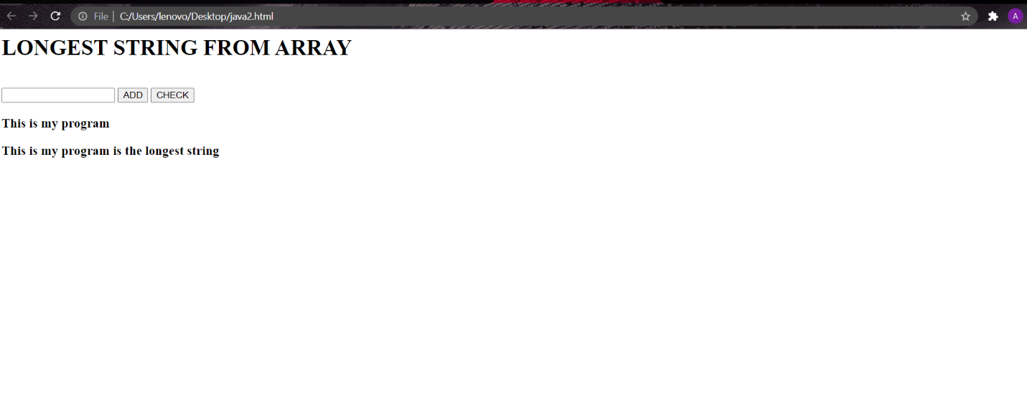

**3. Write a JavaScript function to print an integer with commas as thousands separators.**

<html>

<head>

<link rel="stylesheet" href="style.css">

<script lang="javascript">

function comma() {

var string = document.getElementById("string").value;

document.getElementById("value").innerHTML = string.toString().replace(/\B(?=(\d{3})+(?!\d))/g, ",");

}

</script>

</head>

<body>

<h1>INTEGER WITH COMMA AS THOUSAND SEPERATOR</h1>

<br>

<form>

<input type="text" id="string">

<input type="button" id="check" value="CHECK" onclick="comma()">

</form>

<h3 id="value"></h3>

</body>

</html>

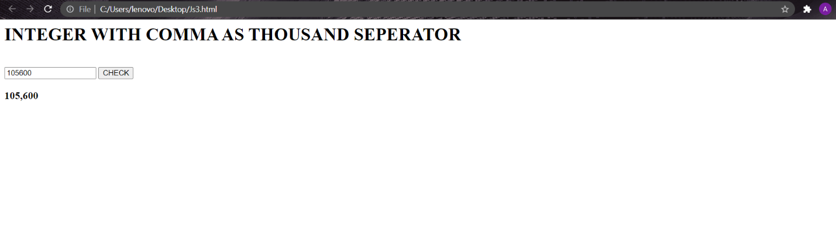

**4. Write a JavaScript function to check whether given value types are same or not.**

<html>

<head>

<script lang="javascript">

function checkType(value1, value2) {

if(is_nan(value1) || is_nan(value2)) {

return is_nan(value1) === is_nan(value2);

}

return toString.call(value1) === toString.call(value2);

}

function is_nan(val)

{

return val !== val;

}

console.log(checkType('69', true));

console.log(checkType('1300135', '1029'));

console.log(checkType("sapnu puas", 100));

</script>

</head>

<body>

<h1>CHECK IF VALUE TYPES ARE SAME, SEE LOGS</h1>

</body>

</html>

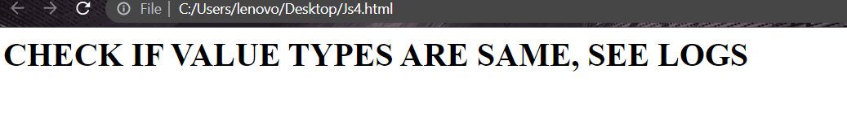

**5. Determine if the input number is an Armstrong number. Return either true or false.**

const number = prompt("Enter a positive integer");

const numberOfDigits = number.length;

let sum = 0;

let temp = number;

while (temp > 0) {

let remainder = temp % 10;

sum += remainder ** numberOfDigits;

temp = parseInt(temp / 10);

}

if (sum == number) {

console.log(`${number} is an Armstrong number`);

}

else {

console.log(`${number} is not an Armstrong number.`);

}

**6. Given an array of objects, sort the objects by population size. Return the entire object.**

let orders = [

{

order: 'order 1', date: '2020/04/01_11:09:05'

},

{

order: 'order 2', date: '2020/04/01_10:29:35'

},

{

order: 'order 3', date: '2020/04/01_10:28:44'

}

];

console.log(orders);

orders.sort(function(a, b){

let dateA = a.date.toLowerCase();

let dateB = b.date.toLowerCase();

if (dateA < dateB)

{

return -1;

}

else if (dateA > dateB)

{

return 1;

}

return 0;

});

console.log(orders);

**7. Given a string, write a function that will return whether or not that string is a palindrome.**

function checkPalindrome(str) {

const len = string.length;

for (let i = 0; i < len / 2; i++) {

if (string[i] !== string[len - 1 - i]) {

return 'It is not a palindrome';

}

}

return 'It is a palindrome';

}

const string = prompt('Enter a string: ');

const value = checkPalindrome(string);

console.log(value);

**8. Write a function that takes a string, and returns the character that is most commonly used in the string.**

<html>

<head>

<link rel="stylesheet" href="style.css">

<script lang="javascript">

function getChar() {

var str = document.getElementById("string").value;

var max = 0,maxChar = '';

str.split('').forEach(function(char){

if(str.split(char).length > max) {

max = str.split(char).length;

maxChar = char;

}

});

document.getElementById("value").innerHTML = maxChar + " is the most commonly used character";

};

</script>

</head>

<body>

<h1>COMMONLY USED STRING</h1>

<br>

<form>

<input type="text" id="string">

<input type="button" id="check" value="PUT COMMA" onclick="getChar()">

</form>

<h3 id="value"></h3>

</body>

</html>

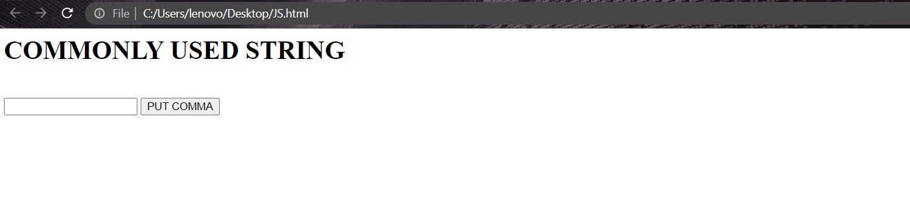

**9. Create a function that takes in two strings as two parameters and returns a boolean that indicates whether or not the first string is an anagram of the second string.**

<script>

function areAnagram(str1,str2)

{

let n1 = str1.length;

let n2 = str2.length;

if (n1 != n2)

return false;

str1.sort();

str2.sort()

for (let i = 0; i < n1; i++)

if (str1[i] != str2[i])

return false;

return true;

}

let str1=['t', 'e', 's', 't' ];

let str2=['t', 't', 'e', 'w' ];

if (areAnagram(str1, str2))

document.write("The two strings are"

+ " anagram of each other<br>");

else

document.write("The two strings are not"

+ " anagram of each other<br>");

</script>

