Project 3 Wrapper

**Name(s):** Aman Singh

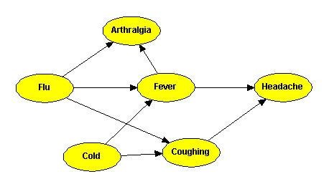

*Figure 1: Example Bayesian network for medical diagnosis. Source*[*: http://song.bayesian.net/index.php/Bayesian_net*](http://song.bayesian.net/index.php/Bayesian_net)

Probabilistic inference over Bayesian networks is a standard AI technique for medical diagnosis. Bayesian networks represent complex causal relationships between patient information, medical conditions, and symptoms. Probabilistic inference allows us to compute diagnostic queries, determining the likelihood of medical conditions given observed symptoms as evidence. Use the example Bayes net above as a prompt for the following questions.

**Question 1:** Recall that the naïve Bayes assumption is that no effects of a cause are also causes of each other. If two effects are correlated it is because they are related to the same, underlying cause. The naïve Bayes model provides an alternative representation for diagnostic inference. Draw a Bayes net representing the naïve Bayes model for diagnosing *Flu* given its symptoms (assume the symptoms of *Flu* are every successor of *Flu* in the Bayes net in Figure 1). Which model (the Bayes net in Figure 1 or the naïve Bayes model that you’ve constructed) is a richer representation? That is to say, is there anything we can represent with one model that we cannot represent with the other model?

Both models accomplish the same thing, with the one exception that the model in Figure 1 can also differentiate whether a sickness is the flu or simply a cold.

**Question 2:** The traditional Dynamic Bayes Net has an unobservable random variable Xt that has a single parent of the value of Xt-1, which is the value of X at the previous time step. For example, SICKt is conditioned on SICKt-1. This can capture a relationship such as “when one is sick, the probability is high that one is still sick at the next time step, and when one is not sick, one can become sick or stay well with equal probability”. See the image for an example. However, if one were to use this Bayes network to predict the future, the model may conclude that people become sick randomly and then stay sick.

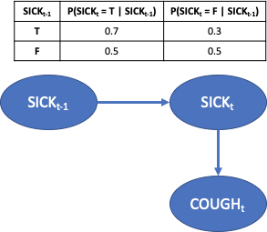This setup does not account for second-order effects, such as:” after one is sick for a while, the probability is high that one stops being sick”. A 2-Markov assumption states that an unobservable random variable Xt is conditioned on Xt-1 and Xt-2. Using a timestep equal to a week, draw a 2-Markov Dynamic Bayes Network that captures the intuition that one can become sick at any time. When one is sick one is likely to remain sick unless they have been sick for two weeks, at which time they are likely to cease being sick. When one is sick, the probability of cough is high and when one is not sick, the probability of cough is low. Show all the conditional probability tables; make up

reasonable numbers to express the relationships described above.

|  |  |  |  |
| --- | --- | --- | --- |
| **SICKt-1** | **SICKt-2** | **P(SICKt = T | SICKt-1, SICKt-2)** | **P(SICKt = F | SICKt-1, SICKt-2)** |
| T | T | 0.3 | 0.6 |
| T | F | 0.7 | 0.3 |
| F | T | 0.2 | 0.8 |
| F | F | 0.5 | 0.5 |

**Question 3:** Medical diagnosis with Bayesian networks are currently used as a *decision support* *systems* by healthcare professionals. An expert can input patient information and observed symptoms, and the decision support system outputs a set of possible diagnoses with associated likelihoods, but the final diagnosis decision is up to the medical professional. Why should we require a human supervisor to accept or override the decision of the AI diagnosis system? Name two (2) potential sources of error or unaccounted for situations for these Bayes net diagnosis models that are mitigated by having a trained healthcare professional make the final diagnosis decision.

One big unaccounted for situation might be when new, experimental drugs are being tested on patients. Usually, around half of the patients are put into the control group and given a placebo. However, they still report symptoms as if they took the actual drug. Trained experts may be able to discern what is real and what is simply placebo, even if the model cannot. Also, if the right doctor is seeing a special patient with a rare condition, he might be more inclined to make the correct diagnosis than the computer as the Bayesian network simply calculates what is more likely.

**Question 4:** Publicly accessible online services often use databases and symptom matching to inform users of possible medical conditions given a list of symptoms. These services *do not* provide diagnosis likelihoods. Could providing a free online service with Bayes-net-based medical diagnosis have negative impacts on human behavior? Could they have positive impacts? If you answered yes to either question, give one example. If you answered no, explain why not.

Free online medical diagnoses would be a Pandora’s box of lots of unintended consequences. On one hand, it can allow people to get immediate diagnoses on conditions without going to the doctor or ER, which could save time and money. However, in my opinion, its negative consequences are worse. People tend to exaggerate symptoms, report non-existent symptoms, or have little understanding of what symptoms they are reporting actually mean, as they are not trained in the field. Especially if something like this is implemented in the psychological field, it would be a disaster for many people attempting to self-diagnose and subsequently explaining away all their mistakes as a mental disorder that they put in themselves into the website, most likely with a lot of confirmation bias. Confirmation bias is probably the biggest problem of sites like this; if someone things he or she has a condition, he or she will be more likely to enter symptoms that more closely align to those conditions, even if he or she is not actually experiencing it to the extent that he or she says.