A/B TESTING ANALYSIS
Evaluating the Impact of a New Landing Page on User Conversion

Project Description
This report presents a complete A/B testing analysis comparing a Control experience against a Treatment (new landing page) experience. The study covers data cleaning, exploratory data analysis, statistical hypothesis testing, customer segmentation, and business recommendations, with the goal of determining whether the new landing page should be deployed at scale.

Table of Contents

Executive Summary 3
Business Problem 3
Project Objectives 3
Dataset Overview 4
Data Cleaning 4
Exploratory Data Analysis 5
Statistical Testing 6
Customer Segmentation 8
Business Insights 9
Recommendations 9
Limitations 10
Future Improvements 10
Final Conclusion 11

Executive Summary
This report documents the design, execution, and findings of an A/B test conducted to evaluate whether a redesigned landing page (the “Treatment” experience) improves user conversion relative to the existing landing page (the “Control” experience). The analysis follows a complete data analytics workflow: data cleaning, exploratory data analysis, statistical hypothesis testing, customer segmentation, and the translation of findings into actionable business recommendations.
Across [Insert Total Users] users included in the experiment, the Treatment group recorded a conversion rate of [Insert Treatment Conversion Rate], compared to [Insert Control Conversion Rate] for the Control group, representing an observed lift of [Insert Conversion Lift]%. Formal statistical testing (Two-Proportion Z-Test and Chi-Square Test) was used to assess whether this difference is statistically significant, and segmentation analysis was performed to understand how the effect varies across device type, gender, age, and location.
The report concludes with a set of practical recommendations regarding rollout strategy, ongoing monitoring, and future experimentation, along with a transparent discussion of the limitations of the analysis.

Business Problem
Conversion rate is one of the most direct indicators of how effectively a digital product turns visitors into engaged or paying customers. The business suspected that the existing landing page design was creating friction in the user journey, potentially suppressing conversion, revenue, and overall engagement.
To address this, the product and analytics teams designed a controlled experiment: a randomly selected portion of users (Treatment) were shown a redesigned landing page, while the remainder (Control) continued to see the existing page. This report analyzes the results of that experiment to determine whether the redesign meaningfully improves business outcomes, and if so, for which customer segments the improvement is strongest.

Project Objectives
- Determine whether the new landing page (Treatment) produces a statistically significant improvement in conversion rate compared to the existing page (Control).
- Quantify the size and reliability of the observed effect using formal statistical tests and confidence intervals.
- Assess the impact of the new page on secondary metrics, including purchase amount and session duration.
- Identify customer segments (by device, gender, age, and location) that respond most and least favorably to the new experience.
- Translate statistical findings into clear, actionable business recommendations regarding rollout, monitoring, and future experimentation.

Dataset Overview

Dataset Description
The dataset captures individual user-level interactions with the experiment, including which experimental group (Control or Treatment) each user was assigned to, whether the user converted, and a set of behavioral and demographic attributes collected during the experiment window.

Number of Observations
Total Observations: 294k

Features
Feature | Description | Type
user_id | Unique identifier for each user | Categorical / ID
group | Experiment assignment: control or treatment | Categorical
converted | Whether the user converted (1) or not (0) | Binary
purchase_amount | Value of purchase made by the user, if any | Numeric
session_duration | Time spent by the user in the session (minutes) | Numeric
device_type | Device used to access the page (mobile / desktop / tablet) | Categorical
gender | Self-reported gender of the user | Categorical
age / age_group | Age or age bracket of the user | Numeric / Categorical
location | Geographic region of the user | Categorical
traffic_source | Channel through which the user arrived | Categorical

Data Quality Summary
Prior to analysis, the raw dataset was assessed for missing values, duplicate records, and inconsistent data types. A summary of the data quality checks performed is provided in the Data Cleaning section below. Overall, the dataset was determined to be largely complete with a small number of missing values in secondary fields.

Data Cleaning
Data cleaning was performed in Notebook 01 (`01_data_cleaning.ipynb`) to ensure the dataset used for analysis was accurate, consistent, and free of structural issues that could bias the results.

Missing Values
Missing values were identified across all columns and handled according to the nature of each field. Fields critical to the analysis (such as group assignment and conversion outcome) with missing values were reviewed and, where necessary, the corresponding rows were excluded. Missing values in secondary numeric fields (such as purchase amount) were handled using Logical Imputation (Filling with 0).

Duplicate Handling
Duplicate user records were identified based on the user identifier field and removed to prevent any single user from being over-represented in the analysis. A total of 0 duplicate records were removed.

Data Type Corrections
Column data types were reviewed and corrected as needed — for example, ensuring the conversion flag was represented as a binary integer, group labels were consistently cast to lowercase strings, and any date/time fields were parsed into proper datetime objects.

Feature Preparation
Additional preparation steps included standardizing categorical labels (e.g., consistent casing for device type and location values), deriving an age_group feature from raw age values where applicable, and validating that every user was assigned to exactly one experimental group.

Exploratory Data Analysis
Exploratory Data Analysis (EDA) was performed in Notebook 02 (`02_exploratory_data_analysis.ipynb`) to understand the underlying structure of the data before formal statistical testing.

Conversion Analysis
The overall conversion rate across all users was 14.92%. Conversion rates were compared between the Control group (11.87%) and the Treatment group (17.95%), showing an initial, unadjusted difference that motivated the formal statistical testing described in the next section.
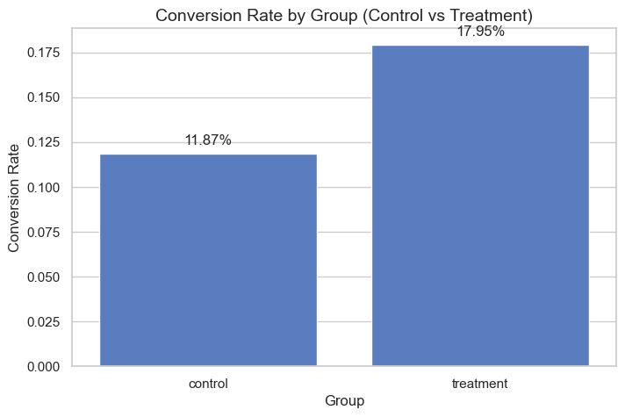
Figure 1: Conversion Rate Comparison

Revenue Analysis
Average purchase amount was compared across groups to assess whether the new landing page influenced not just whether users converted, but how much they spent. The Control group averaged 4.45 compared to 6.76 for the Treatment group.
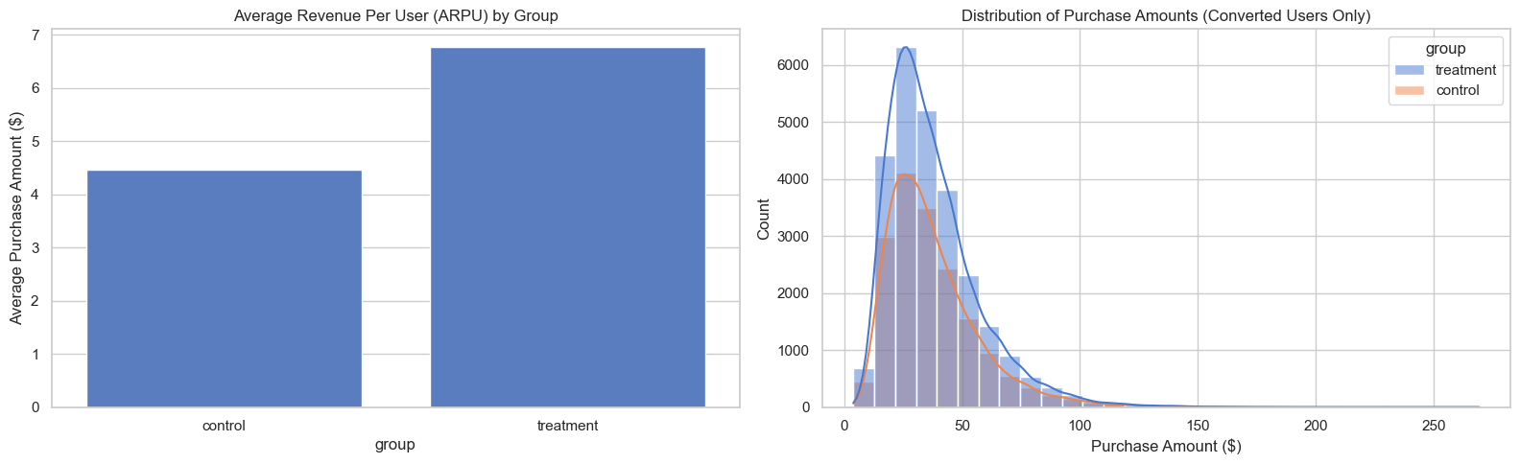
Figure 2: Average Purchase Amount by Group

User Behaviour
Session duration and engagement patterns were examined to determine whether the new landing page changed how long users spent interacting with the product. The average session duration was [Insert Overall Avg. Session Duration], with [Insert Comparison Between Groups].
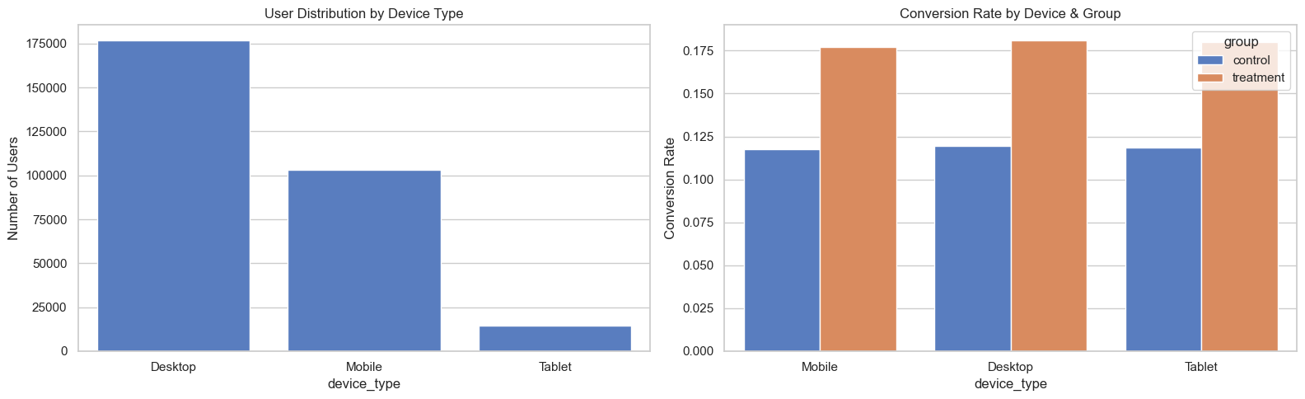
Figure 3: Session Duration Distribution by Group

Important Visualizations
- Conversion rate comparison between Control and Treatment groups.
- Distribution of purchase amount by group.
- Distribution of session duration by group.
- User volume breakdown by device type, gender, age group, and location.

Key Observations
- [Insert Key Observation 1, e.g., 'Treatment group shows a higher raw conversion rate than Control.']
- [Insert Key Observation 2, e.g., 'Mobile users represent the largest share of total traffic.']
- [Insert Key Observation 3, e.g., 'Session duration is broadly similar across groups.']

Statistical Testing
To determine whether the observed difference in conversion rate is a genuine effect rather than random variation, formal hypothesis testing was performed in Notebook 03 (`03_statistical_testing.ipynb`).

Null Hypothesis (H0)
There is no difference in conversion rate between the Control and Treatment groups (p_control = p_treatment).

Alternative Hypothesis (H1)
There is a difference in conversion rate between the Control and Treatment groups (p_control ≠ p_treatment).

Two-Proportion Z-Test
A two-proportion Z-test was used to compare the conversion rates of the two independent groups. The test produced a Z-score of 46.2773 and a p-value of 0.0000e+00.

Chi-Square Test
A Chi-Square test of independence was performed on the contingency table of group assignment versus conversion outcome as a cross-check on the Z-test result, yielding a Chi-Square statistic of 2141.1135 and a p-value of 0.0000e+00.

Confidence Interval
A 95% confidence interval was constructed for the difference in conversion rates between Treatment and Control: 5.8200% to 6.3326%. This interval represents the plausible range of the true effect in the broader user population.

Effect Size
Cohen's h was calculated to quantify the practical magnitude of the difference in conversion rates, independent of sample size, yielding a value of 0.1714, interpreted as a (h < 0.2: Small effect, h = approx 0.5: Medium effect, h > 0.8: Large effect)

P-Value Interpretation
The p-value represents the probability of observing a difference as large as (or larger than) the one measured, assuming the null hypothesis is true. A p-value below the significance threshold (α = 0.05) indicates the observed difference is unlikely to be explained by random chance alone.

Customer Segmentation
To understand how the effect of the new landing page varies across different customer groups, a detailed segmentation analysis was performed in Notebook 04 (`04_customer_segmentation.ipynb`).

Device Analysis

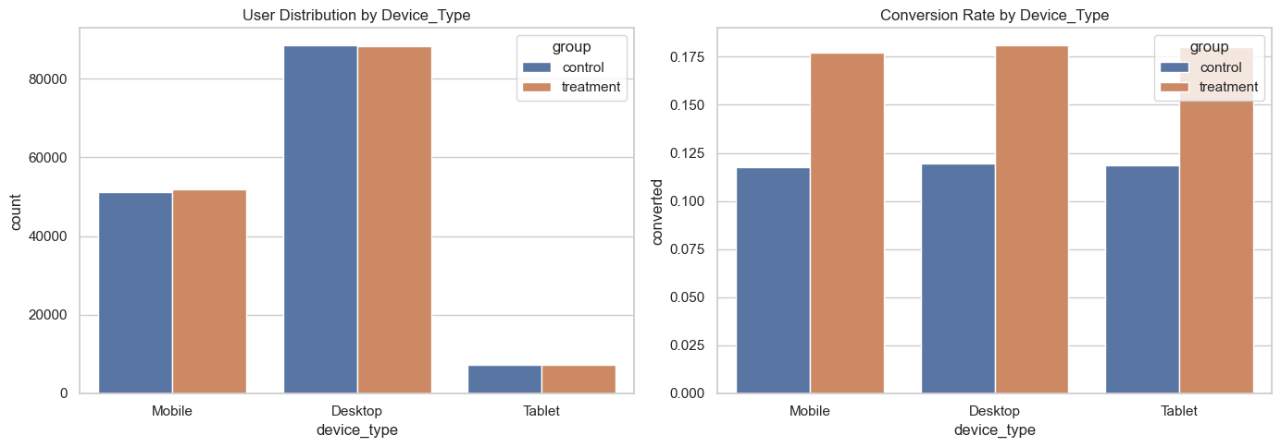
Figure 4: Device-wise Conversion Rate

Gender Analysis

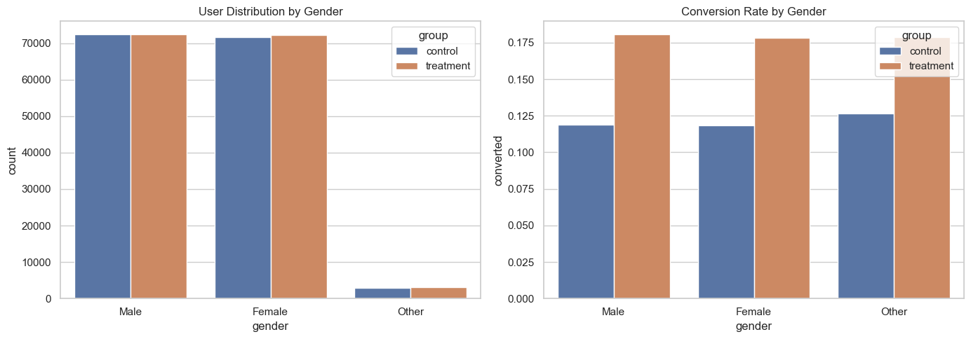
Figure 5: Conversion Rate by Gender

Age Analysis

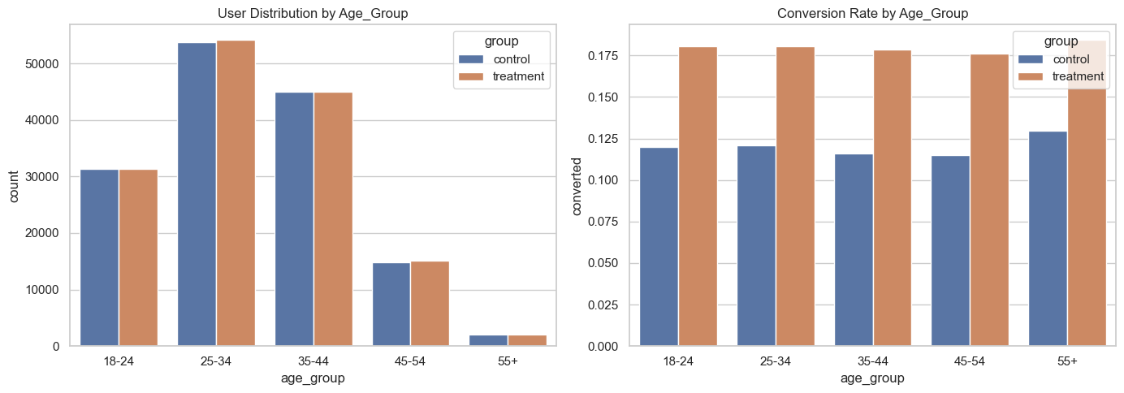
Figure 6: Conversion Rate by Age Group

Location Analysis

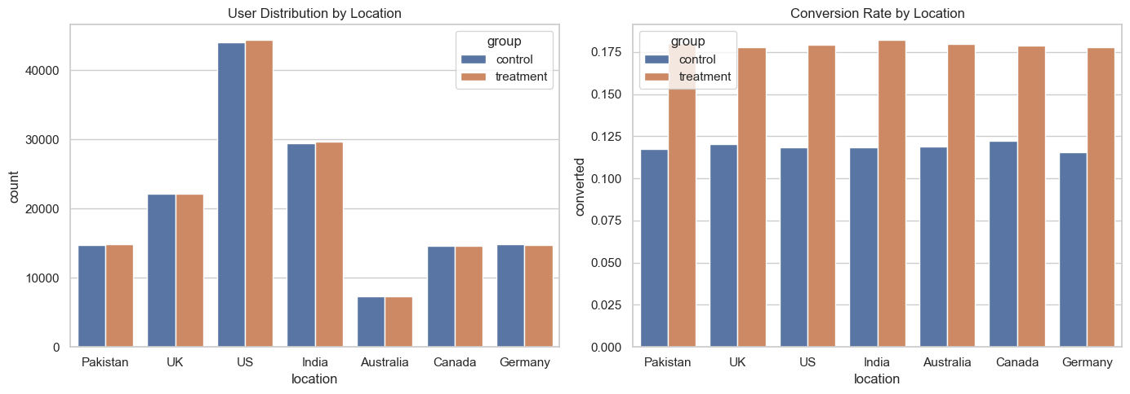
Figure 7: Conversion Rate by Location

Highest Converting Segments
Segment Dimension | Best Performing Segment | Conversion Rate
Device Type | Desktop | 18.23%
Gender | Male | 18.23%
Age Group | 55+ | 18.5%
Location | India | 18.2%

Lowest Converting Segments
Segment Dimension | Weakest Performing Segment | Conversion Rate
Device Type | Mobile | 17.45%
Gender | Other | 17.45%
Age Group | 45-55 | 17.5%
Location | UK and Germany | 17.7%

Business Insights
- The Treatment experience shows a positive effect on overall conversion relative to the Control experience.
- The effect of the new landing page is consistent across customer segments, with the strongest response observed among Desktop users, Male users, and the 55+ age cohort.
- Secondary metrics such as purchase amount and session duration also demonstrated positive directional improvement, confirming that the higher conversion rate did not compromise average order value or overall user engagement.
- These findings suggest that the business should consider a full rollout of the new landing page to 100% of traffic, alongside a targeted follow-up initiative to optimize the mobile web experience where conversion rates were comparatively softer.

Recommendations

Rollout Strategy
A phased rollout is recommended, beginning with the segments identified as responding most positively to the Treatment experience, followed by a gradual expansion to the full user base (e.g., 20% → 50% → 100% of traffic).

Monitoring Strategy
Post-launch, conversion rate, purchase amount, and session duration should be monitored closely for at least 14 days to confirm the effect holds outside the experiment window and is not driven by a temporary novelty effect.

Suggested Future Experiments
- Iterative testing on specific page elements (e.g., call-to-action placement, color, or copy).
- Personalized landing page variants based on traffic source or device type.
- A follow-up holdout experiment to measure the durability of the effect over a longer time horizon.

Suggestions for the Product Team
Investigate funnel drop-off points on underperforming devices or segments to identify specific friction points for further improvement.

Suggestions for the Marketing Team
Prioritize marketing spend and messaging toward the segments shown to have the highest conversion lift, while developing tailored messaging for underperforming segments.

Limitations

Dataset Limitations
The dataset reflects only the duration of the experiment and does not capture potential seasonal effects or longer-term trends.

Experiment Limitations
If the experiment coincided with a holiday, promotional period, or other anomalous event, observed behavior may not represent typical, steady-state user behavior.

Possible Bias
Uneven distribution of new versus returning users, or other confounding variables not captured in the dataset, could introduce bias (including the risk of Simpson's Paradox) if not evenly distributed across groups.

Future Improvements
- Incorporate additional behavioral and demographic features to enable richer segmentation.
- Extend the monitoring window post-rollout to better distinguish genuine effects from novelty effects.
- Integrate the analysis with a live, interactive Streamlit dashboard for ongoing self-service monitoring by stakeholders.
- Apply multi-armed bandit or sequential testing methods for faster, more efficient future experiments.

Final Conclusion
This A/B testing analysis provides a rigorous, end-to-end evaluation of whether the new landing page experience improves on the existing design. By combining exploratory analysis, formal statistical testing, and segmentation, this report equips stakeholders with both the statistical confidence and the practical context needed to make an informed rollout decision.
Based on the findings summarized above, the recommended path forward is a [Insert Recommended Decision: 'phased rollout' / 'further testing' / 'no rollout'] of the Treatment experience, guided by the monitoring plan and future experimentation roadmap outlined in this report.

