A
Practical Assignment
On
“ New Age Life Skills ”
Master in Computer Application
Ist - Sem


RUNGTA INTERNATIONAL SKILLS UNIVERSITY

SESSION: 2025-26

Submitted To:- Submitted By:-
Ms. Priya Das Name : aman Sinha
ERP. No. : 10156

RUNGATA INTERNATIONAL SKILLS
UNIVERSITY CG
SCHOOL OF INFORMATION TECHNOLOGY

INDEX
S.NO. | NAME OF PRACTICAL | SUBMISSION  DATE | REMARK
1 | Design a Professional Resume Using Tamplates. | 22-09-2025
2 | Create a Career Oriented Presentation With 7 Slide Using Transition And Animation. | 29-09-2025
3 | Create a Social Media Poster For DIGITAL AWARENESS WEEK Using Canva. | 01-10-2025
4 | Compose & Send a Professional Email with an attachment as “ you are applying for an Internship, Send Email to your HR With your Resume Atteched. | 06-10-2025
5 | Design a Google Form To Servey and Analyze Response.  - Create a Google Form titled “Student Attendence Report”.  - Include the following question types:  - 5 MCQs  - 1 Rating scale (1–5)  - 1 Short answer  - 1 Checkbox question  - Customize the theme (header image + color).  - Share the form link with 5 friends and collect responses.  Generate charts from responses and take screenshots of the analysis page. | 11-10-2025
6 | Demonstrate the Creation and Management of your digital identify.  - Create a social media profile (LinkedIn preferred).  - Add a profile photo, short bio, skills, and education details.  - Create a simple post about “My Learning Journey in Digital Literacy.”  - Change your privacy settings to:  - Who can see your posts.  Who can message you | 31-10-2025
7 | Using Google Drive Or One Drive.  - Create a new folder named “Unit 3 Practical Work”.  - Upload 3 different files (PDF, image, document).  - Organize them in subfolders: Notes, Images, Assignments.  Share the main folder with your teacher with View Only permission. | 13-11-2025
8 | Identify One Real Phishing Email: A Final Year Student Aman Receives a LinkdeIn Massge Saying:  “You are shortlisted for a Remote Software Developer role at Google. Salary: ₹18 LPA. Pay ₹2,499 as verification fee.Limited seats. Pay now to confirm.”  ANSWER THE QUESTIONS :-  - What type of cybercrime is happening here?  - List 3 red flags that show it is a scam?  What should he do to verify if a job offer is real? | 19-11-2025
9 | Create a Google Form Quiz with the following requirements:  - Convert the form into a Quiz mode with automatic grading.  - Add 5 MCQ questions, each carrying 2 marks.  - Add 1 short answer question that requires manual evaluation.  - Turn ON the setting:  - Limit to 1 response  - Shuffle question order  - Release marks after manual review  - Add a timer add-on (like form presenter) and set up a 10-minute time limit.  - Finally, send the quiz link and view the response summary. | 24-11-2025
10 | Ask ChatGPT Or Google Gemini To Generate a 100-120 Word Paragraph.  “Is online learning better than offline learning for college students?”  - Run the AI-generated text through Grammarly and any plagiarism-check tool.  - Now manually search online to check if similar sentences exist on blogs or articles.  - Identify 2–3 biased statements in the AI answer, such as:  - Over-generalizations  - One-sided opinions  - Unproven claims  - Rewrite the entire paragraph in a neutral and balanced way, using AI only for grammar suggestions.  - Submit 3 screenshots:  - Plagiarism check result  - Grammarly suggestion page  Original AI paragraph vs your rewritten unbiased version | 29-11-2025
11 | To Compare AI Generated Content With Student-Created Content And Undestand Limitation Of AI.  - Write a 100–150 word paragraph on the topic:  “Will AI replace jobs or change them?”  (This must be written by the student.)  - Ask any AI tool (ChatGPT/Gemini/Copilot) to write the same topic.  - In your practical copy, create a Comparison Table with the headings:  - Human-Generated Content  - AI-Generated Content | 03-12-2025
12 | Create a New NotebookLM Project Titled: “ My Chapter Revision Notes ”.  - Upload multiple sources (any 2) such as:  - PDF notes  - Web articles  - Text copied into NotebookLM  - Ask NotebookLM to:  - Create a combined study guide using all sources.  - Generate flashcards for quick revision.  - Create a concept map or explanation of the topic.  - Manually check for:  - Any incorrect facts  - Repeated information  - Missing important points  - Attach 3 screenshots from NotebookLM:  - Combined study guide  - Flashcards  - Concept map / explanation | 10-12-2025
13 | Create A Complete Student Result Management Workbook.  - Create a new workbook with 3 sheets renamed as:  - Student_Data  - Marks_Analysis  - Charts  - In Student_Data, enter a list of 15 students with:  Name, Roll No, Class, City, Subject1, Subject2, Subject3.  - Use Flash Fill to split “Full Name” into “First Name” and “Last Name”.  - Use Find & Replace to replace city name “Delhii” with correct “Delhi”.  - Use IF function to calculate Pass/Fail (Pass = total ≥ 120).  - Use COUNTIF to find how many students belong to “Delhi”.  - Use AVERAGE, MAX, MIN to analyze marks in the Marks_Analysis sheet.  - On the Charts sheet, create:  - A Bar Chart showing marks of any one subject.  - A Pie Chart showing percentage of pass vs fail.  - Apply Conditional Formatting to highlight marks < 40 in red.  Convert the table into a formatted Excel Table. | 19-12-2025
14 | Build a Workbook For Managing And Analyzing Sales Data Of a Small Store.  - Create a workbook with sheets:  - Store_Sales  - Summary  - Charts  - Import a CSV sales file (or create a sample table) containing:  Date, Product, Category, Quantity, Price, Total Sales.  - Use Sort (A→Z, Z→A) to organize products by name and category.  - Apply Filter to view only “Electronics” category.  - Use SUMIF to find total sales for a selected product (e.g., “Headphones”).  - Use LEFT, RIGHT, MID to extract:  - First 3 letters of the product name  - Last 2 letters of the category  - Find the highest and lowest sales value using MAX/MIN.  - Prepare a monthly sales summary in the Summary sheet using AVERAGE & SUM.  - Create a Line Chart of month-wise total sales in the Charts sheet.  Apply sheet protection so data cannot be edited accidentally. | 24-12-2025
15 | Create a complete personal financial planner workbook.  - Create and rename sheets as:  - Expenses  - Budget  - Charts  - Enter at least 20 rows of expense data:  Date, Category, Expense Detail, Amount, Payment Method.  - Use Data Validation dropdown to create a category list (Food, Travel, Fees, Shopping, Other).  - Use Remove Duplicates on the Category column if repeated incorrectly.  - Use SUMIF to calculate total spending for each category.  - In the Budget sheet, create the monthly budget and compare with actual expenses using:  Difference = Budget – Actual (formula required)  - Highlight expenses above ₹2000 using Conditional Formatting.  - Create:  - A Pie Chart showing category-wise spending  - A Bar Chart comparing Budget vs Actual  - Use Flash Fill to separate date into Day / Month / Year if needed. Also explain its detail  Save worksheet in Page Layout view and adjust print area. | 29-12-2025

ASSIGNMENT-1

AIM:- Design a professional resume using templates.

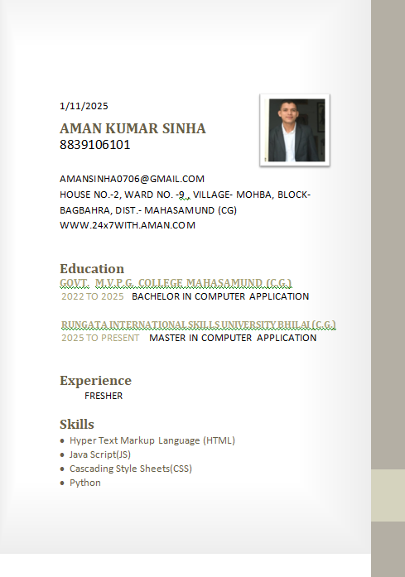

ASSIGNMENT-2

AIM :- Create a Career Oriented Presentation with 7 slides using transitions and animations.



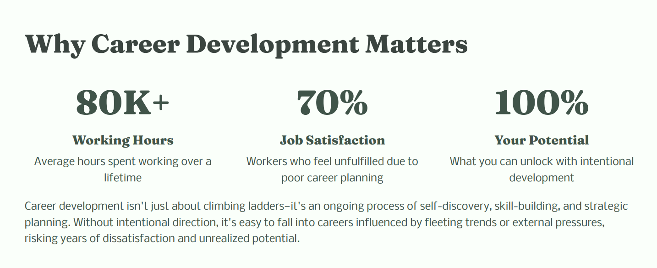

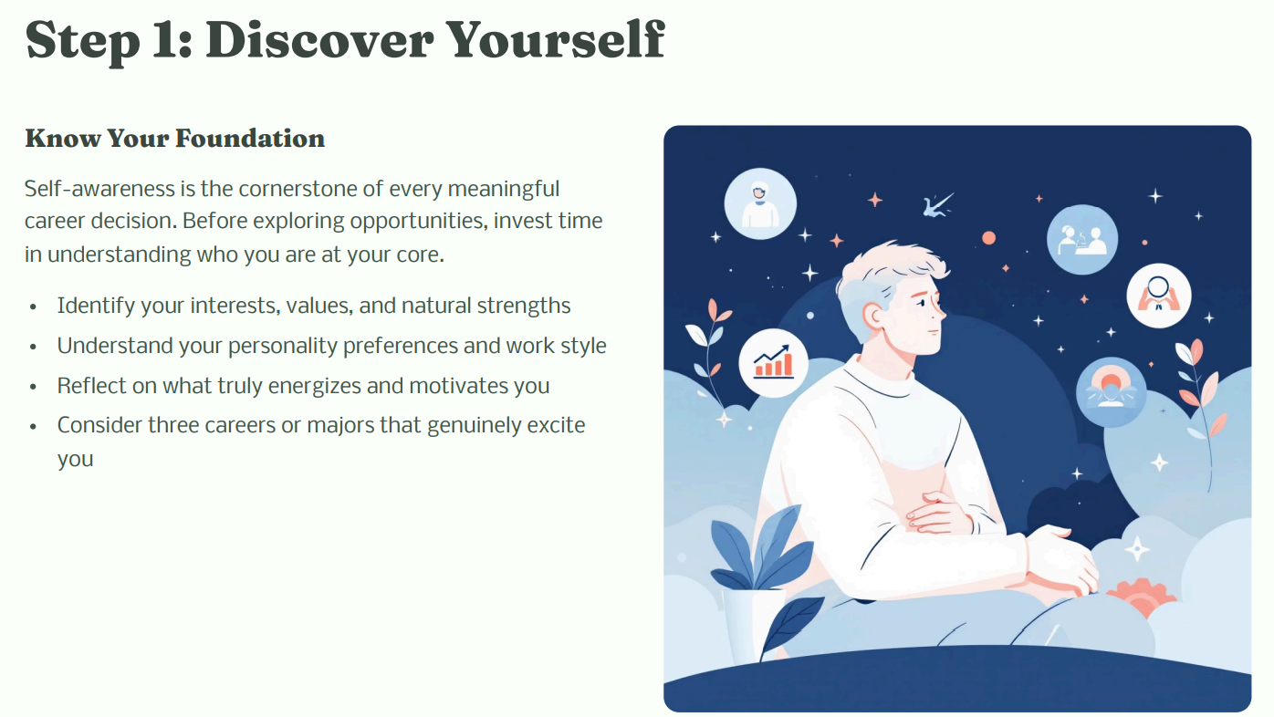

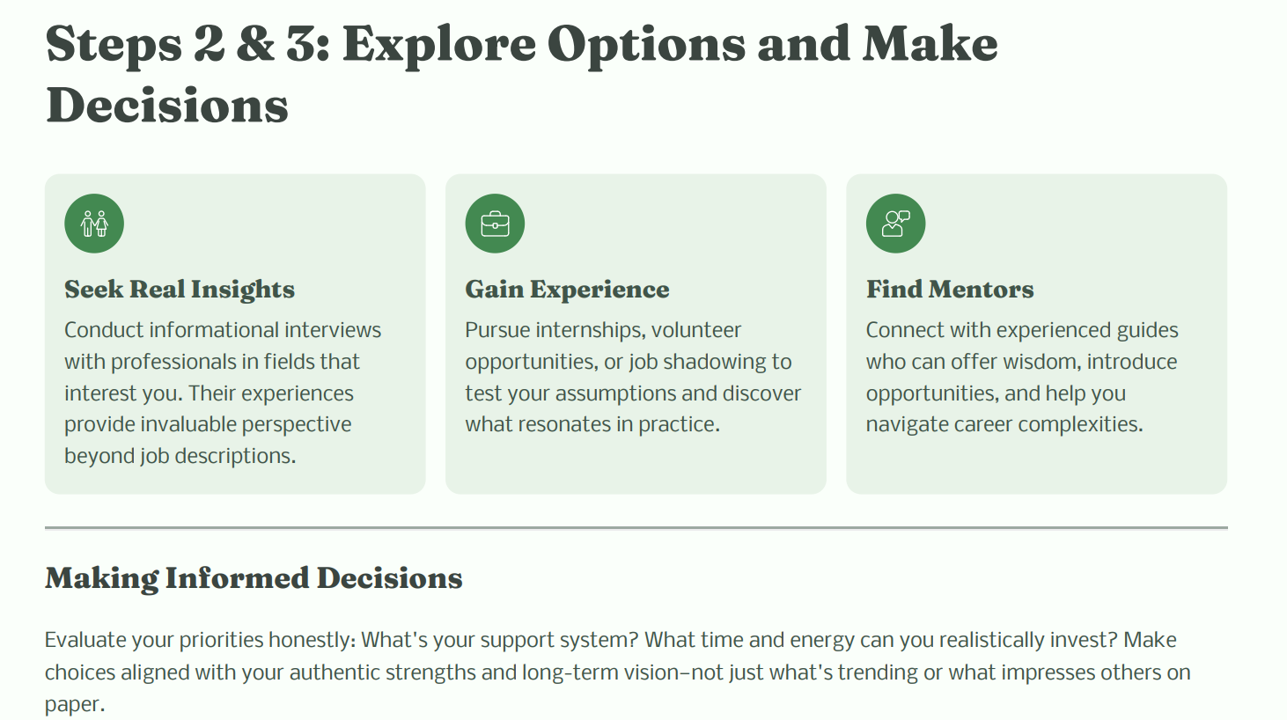

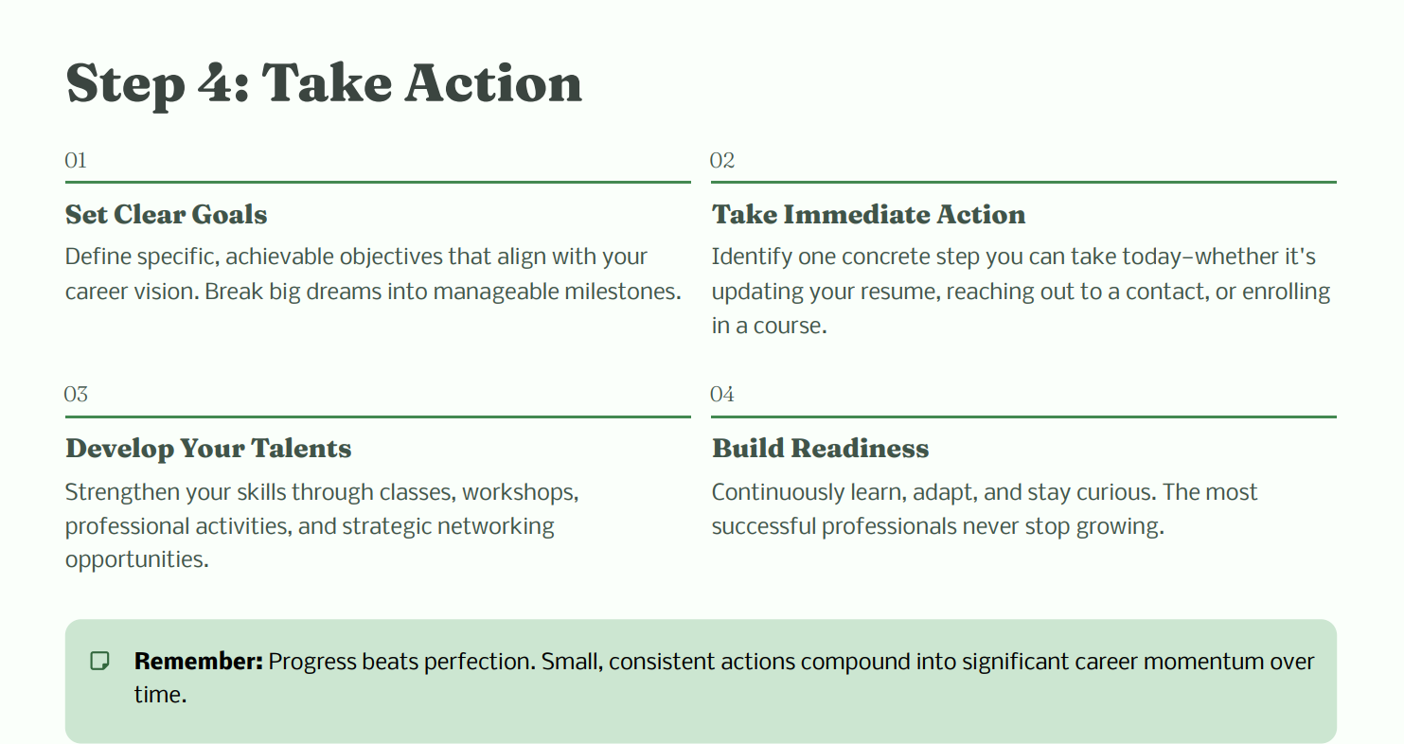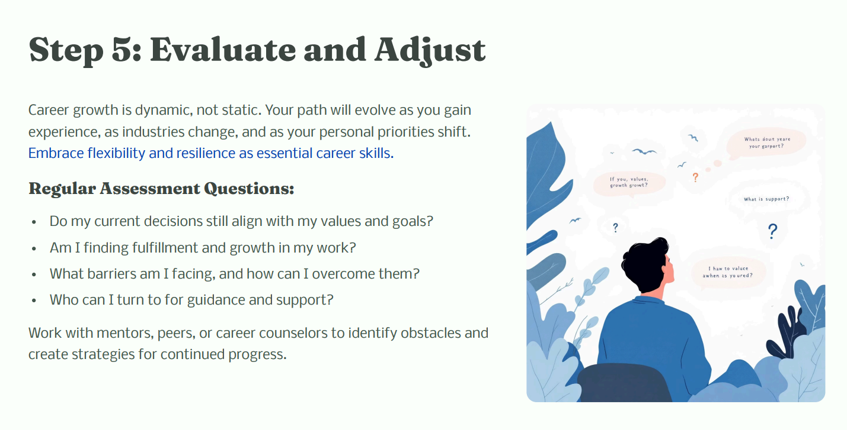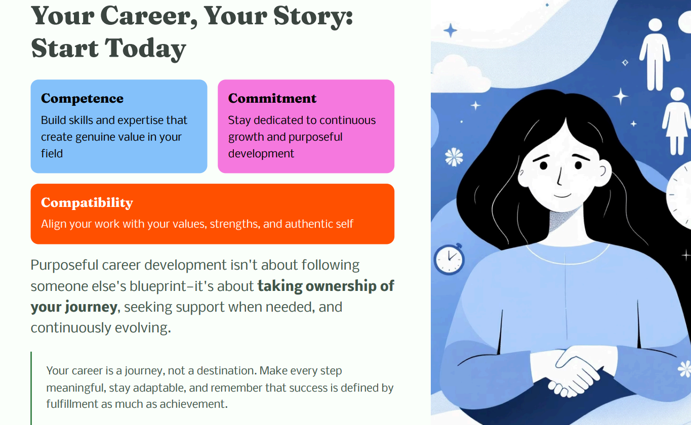

ASSIGNMENT-3

AIM:- Create a social media poster for "DIGITAL AWARENESS WEEK"using canva.

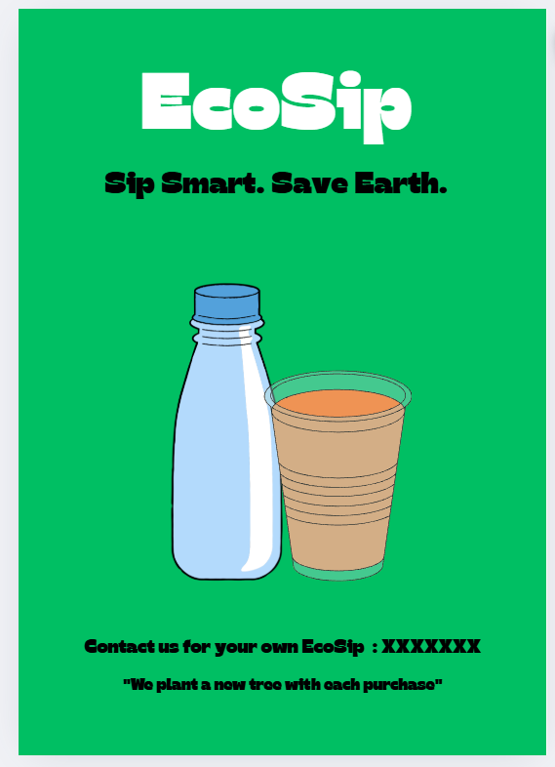

ASSIGNMENT-4

AIM:- Compose & send a professional email with an attachment as "you are applying for an internship, send email to HR with you resume attached”.

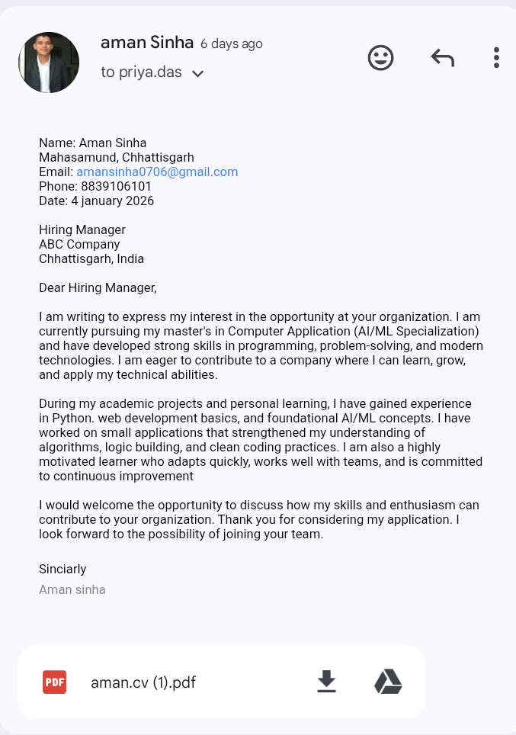

ASSIGNMENT-5

AIM:- Design a complete Google Form survey and analyze responses.
a) Create a Google Form titled "Student Attendance
Report".
b) Include the following question types:
  - 5 MCQs
  - 1 Rating scale (1-5)
  - 1 Short answer
1 Checkbox question:-
c) Customize the theme (headerimage + color).
d) Share the form link with 5 friends and collect
responses,
e) Generate charts from responses and take screenshots of the analysis page.

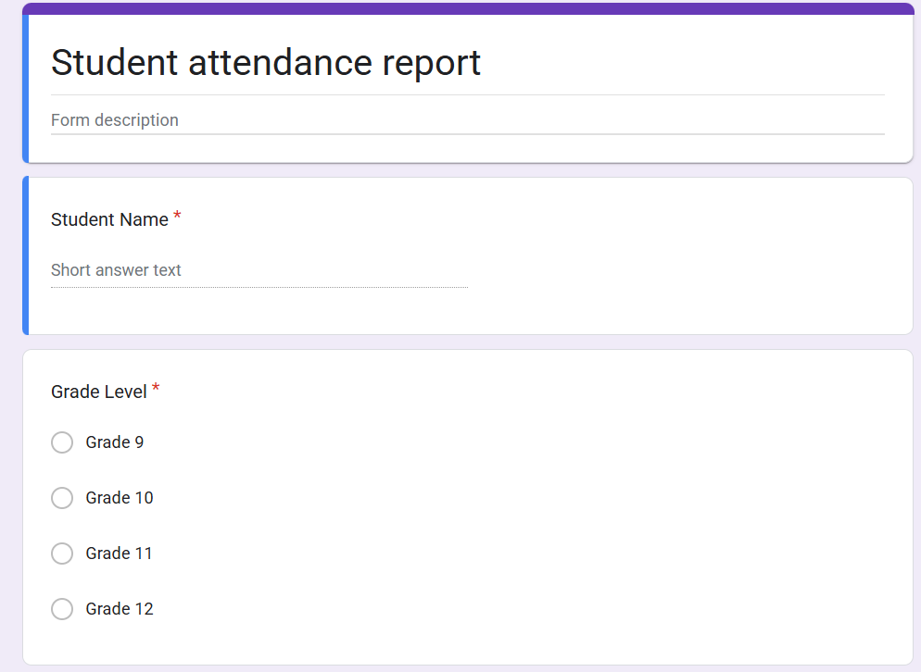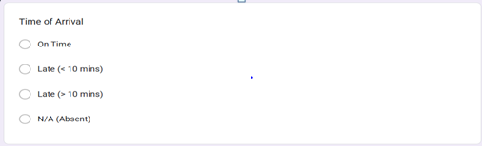
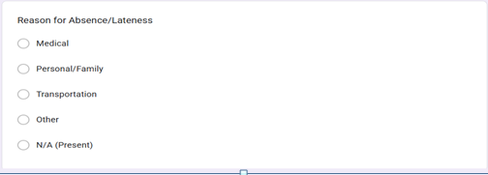
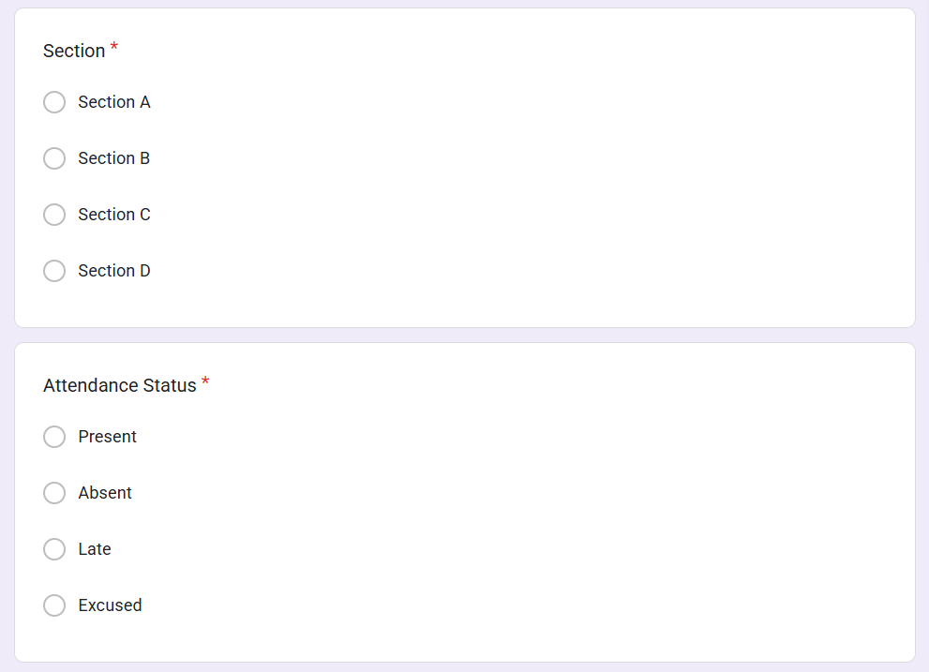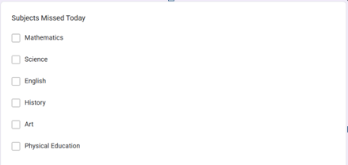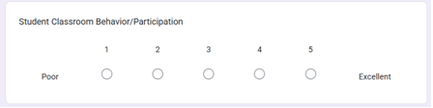

ASSIGNMENT-6

AIM:- Demonstrate the creation and management of vour dieita identity.
a) Create a social media profile (Linkedin preferred).
b) Add a profile photo, short bio, sklls, and education details.
c) Create a simple post about “My Learning
Journey in Digital Literacy."
d) Change your privacy settings to:
a, Who can see your posts.
b. Who can message you

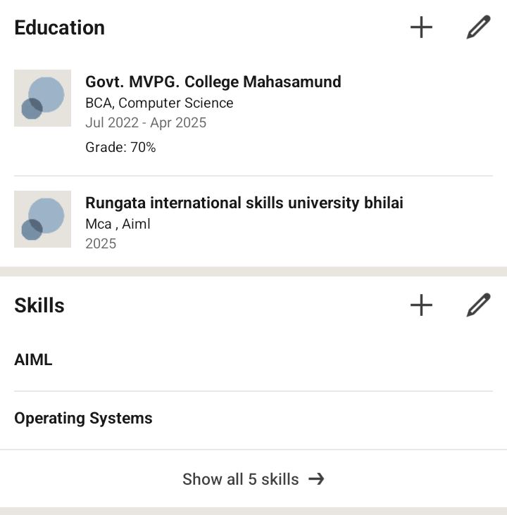
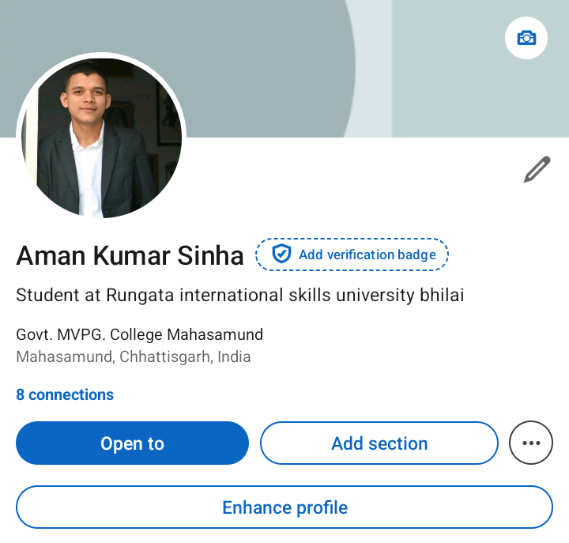

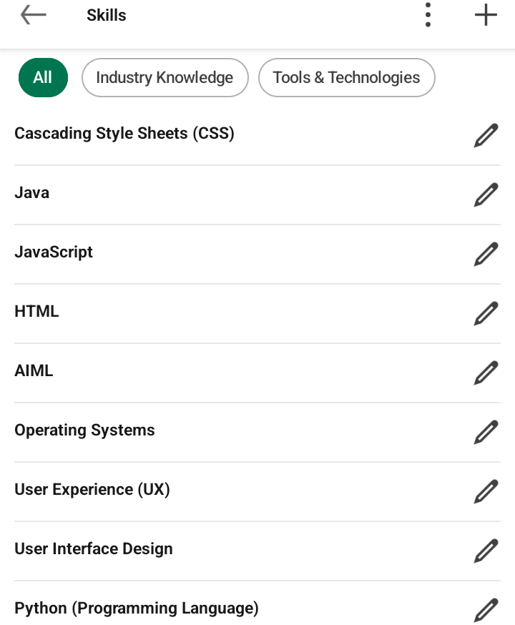

ASSIGNMENT-7

AIM:- Using Google Drive or One Drive:
a) Create a new folder named "Unit 3 Practical Work”.
b) Upload 3 different files (PDF, image, document),.
c) Organize them in subfolders: Notes, Images, Assignments,
d) Share the main folder with your teacher with View Only permission.

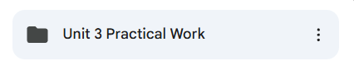

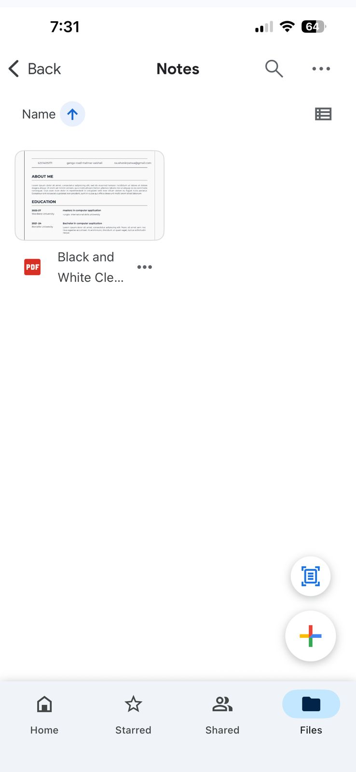
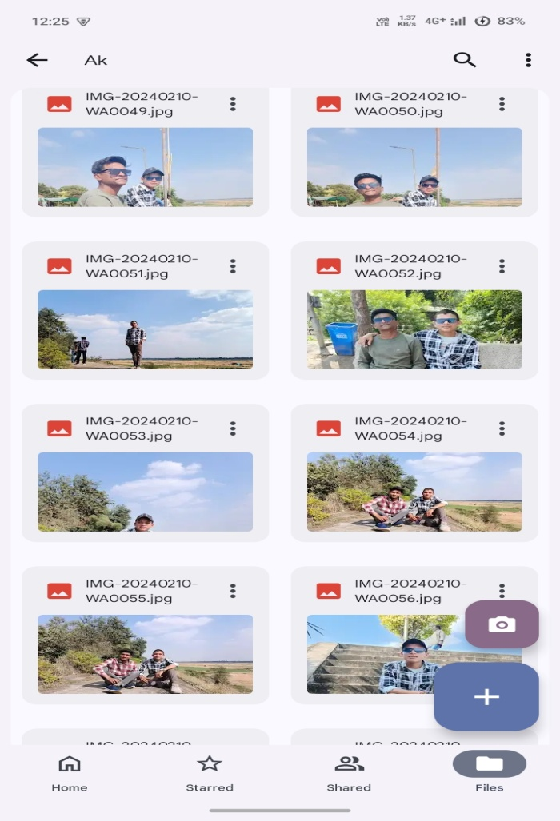
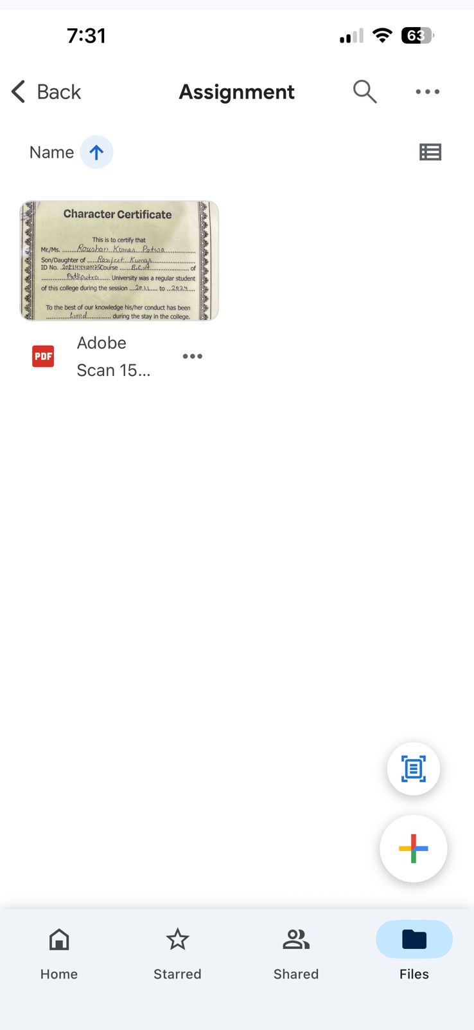

ASSIGNMENT-8

AIM:- Identify one real phishing email : A final-year student, Aman, receives a linkedin message saying:
"you are shortlisted for a Remote Software Developer role at Google.
Salary: @18 LPA
Pay @2, 499 as verification fee.
uimited seats, Pay now to confirm."
ANSWER THE QUESTIONS:-
a) What type of cybercrime is happening here?
b) List 3 red flags that show it is a scam?
c) What should he do to verify if a job offer is real?

a) Type of cybercrime:
This is Phishing + Job/Recruitment Fraud (a form of financial cybercrime and social engineering).
b) 3 Red flags:
- Big brand (Google) + unrealistic claim via a random LinkedIn message, not official hiring process.
- Asking to pay a “verification fee” (legit companies never charge for job offers).
- Urgency/pressure tactic — “Limited seats, pay now to confirm”.
c) Steps to verify the offer is real:
- Check Google Careers portal for the same role or job ID.
- Verify sender’s LinkedIn profile (official Google employee badge, company email domain, activity history).
- Avoid paying anything — instead, ask for official documentation and recruiter’s @google.com email.
- Contact Google support or employees through trusted channels to confirm.
Bottom line: No fee. No rush. Always cross-check on the company’s official platform.

ASSIGNMENT-9

AIM:- Create a Google Form Quiz with the following requirements:
a) Convert the form into a Quiz mode with automatic grading.
b) Add 5 MCQ questions, each carrying 2 marks.
c)Add 1 short answer question that requlres manual
evaluation.
d) Turn ON the setting:
a, Limit to 1 response
b. Shuffle question order
C. Release marks after manual review
e) Add a timer add-on (like form presenter) and set up a 10-minute time limit.
f) Finally, send the quiz link and view the response summary.
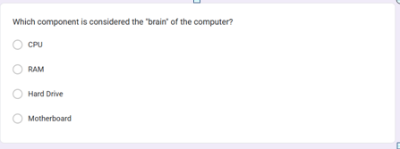
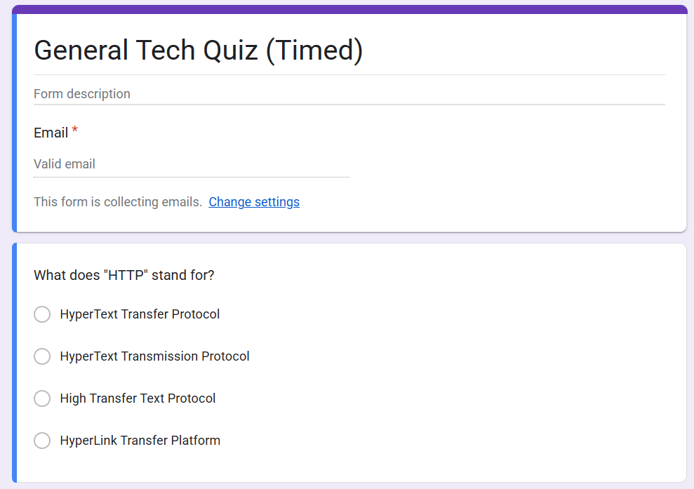
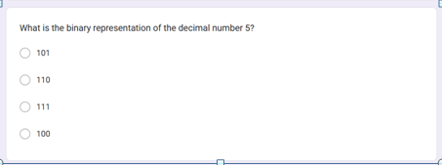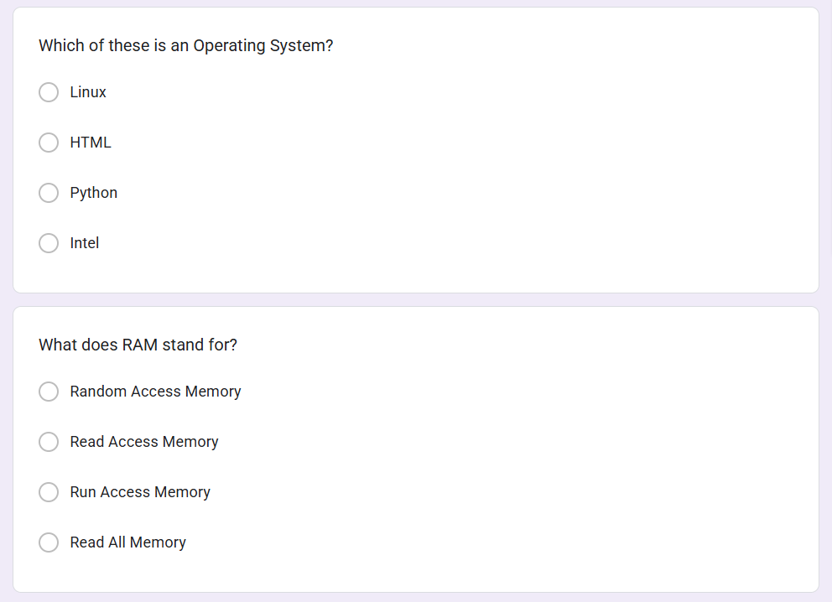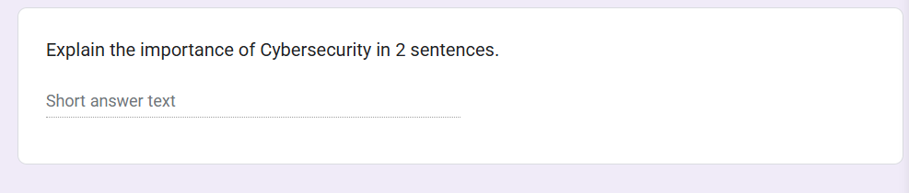

ASSIGNMENT-10

AIM:- Ask ChatGPT OR Google Gemini to generate a 100-120 word paragraph on:
I"Is online learning better than ofline learning for college
students?"
a) Run the Al-generated text through Grammarly and any plagiarism-check tool.
b) Now manually search online to check if similar sentences exist on blogs or articles.
c)Identify 2-3 biased statements in the Al answer, such as:
Over-generalizations
ii.One-sided opinions
ii.Unproven claims
d) Rewrite the entire paragraph in a neutral and
balanced way, using Al only for grammar suggestions.
e) Submit 3 screenshots:
i.
ii.
Plagiarism check result
Grammarly suggestion page
iii.Original Al paragraph vs your rewritten unbiased version

While both online and offline learning have special benefits for college students, neither is always "better." Online learning is perfect for self-paced study and skill-based courses because it offers flexibility, affordability, and access to a wide range of global resources. However, it might not have the same advantages as offline learning, such as direct interaction, structured discipline, and practical experience. Through labs, seminars, and mentorship, traditional classrooms promote peer collaboration, real-time discussions, and practical exposure, all of which foster social and professional development. However, strict schedules, travel, and increased expenses may limit offline learning. The ideal strategy is a hybrid model that relies on offline settings for networking, experiential learning, and guided academic support while utilizing online platforms for theory, revisions, and upskilling. By combining the two, students can learn effectively while remaining interested and prepared for the workforce.
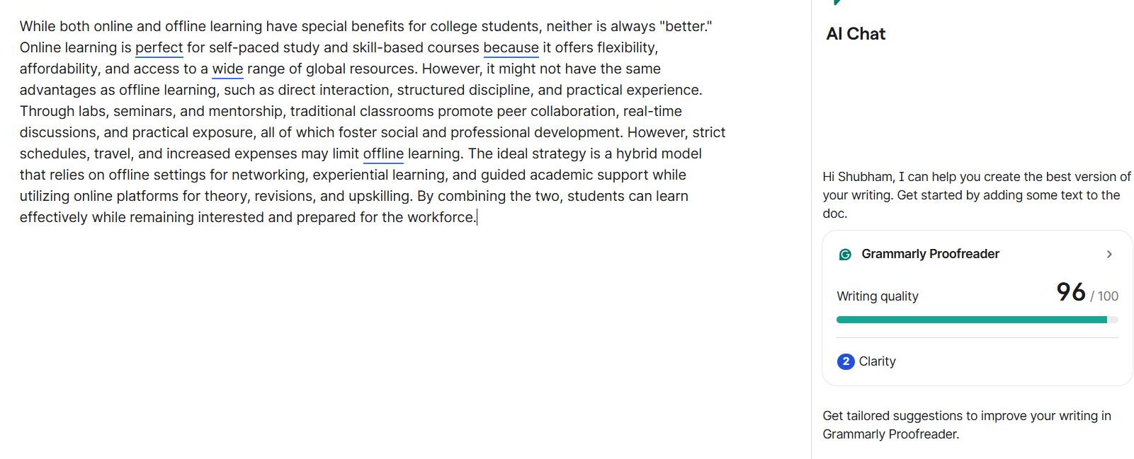
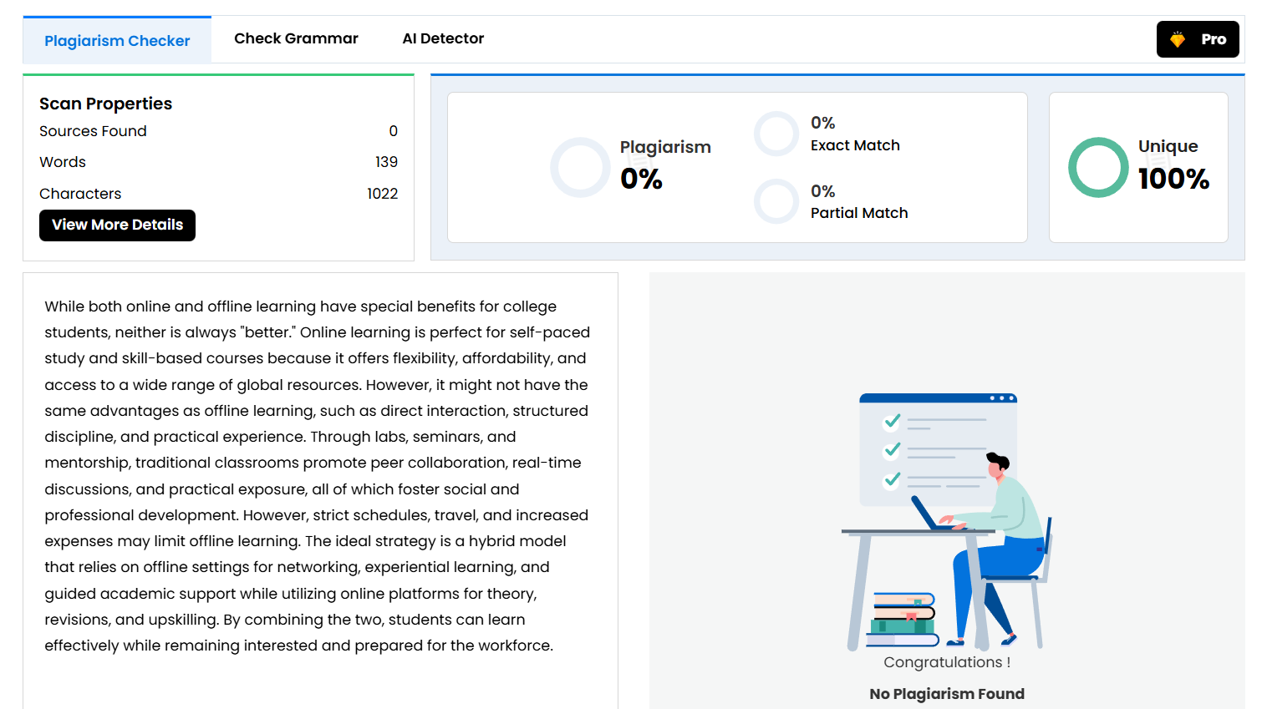

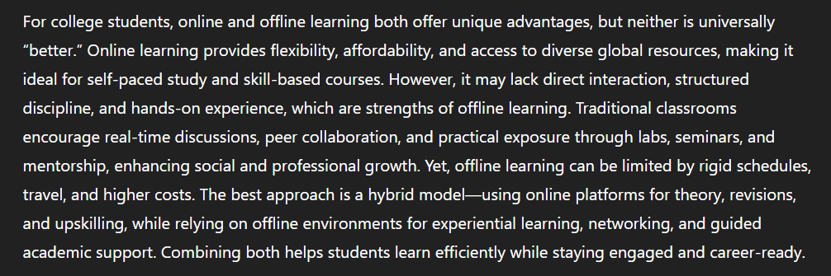

ASSIGNMENT-11

AIM:- To compare Al-generated content with student-created content and understand limitations of AI.
a) Write a 100-150 word paragraph on the topic:
"Will Al replace jobs or change them?"(This must be written by the student.)
b) Ask any Al tool (ChatGPT/Gemini/Copilot) to write the same topic.
c) In your practical copy, create a Comparison Table with the headings:
1. Human-Generated Content
11. Al-Generated Content

- Artificial Intelligence is not only a job destroyer but a paradigm shift that reshapes the very fabric of employment. Although the overall impact of AI-driven automation could be job replacement, primarily because of tasks being very repetitive and predictable, its overall application is in jobs being transformed rather than being replaced. AI increases human efficiency through intelligent process automation, analytics, and generative capabilities. The overall function of jobs, right from software development to healthcare, finance, to education, is being transformed into AI-enabled platforms, which overall require human oversight, human optimization, and human decision-making. At the same time, new jobs are being added to AI as a governing structure, AI optimization, human AI interaction, and AI ethics. The overall job market favors a blended skill set, where technical savvy meets human adaptability, human judgment, and human creativity. In other words, AI is less of a replacement of jobs and more of a complementary function to human employment, which requires human strategic thought to make innovations viable.

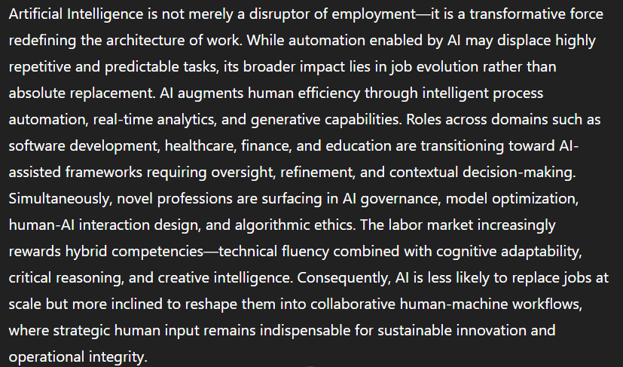

Human-Generated Content | AI-Generated Content
Written in simple, natural student language | Uses formal, analytical, machine-like vocabulary
Focuses on emotions, adaptability, and career advice | Focuses on automation, frameworks, and scalability
Less technical, more opinion-based | More structured, data-driven, and concept heavy
May include personal motivation and direct suggestions. | Gives generalized insights, lacks personal voice
Highlights skill-building from a learner perspective | Highlights industry transformations perspective
Limited use of complex terminology | Includes advanced AI-related terminology

ASSIGNMENT-12

AIM:- Create a new NotebookLM project titled: “My Chapter Revision
Notes, "
a) Upload multiple sources (any 2) such as:
i. PDF notes
ii. Web articles
ii. Text copied into NotebookLM
b) Ask NotebookLM to:
i. Create a combined study guide using all
sources,
ii. Generate flashcards for quick revision.ii. Create a concept map or explanation of
the topic.
c) Manually check for:
i. Any incorrect facts
ii. Repeated information
ii. Missing important points
d) Attach 3 screenshots from NotebookIM:
i. Combined study guide
ii. Flashcards
iii. Concept map / explanation
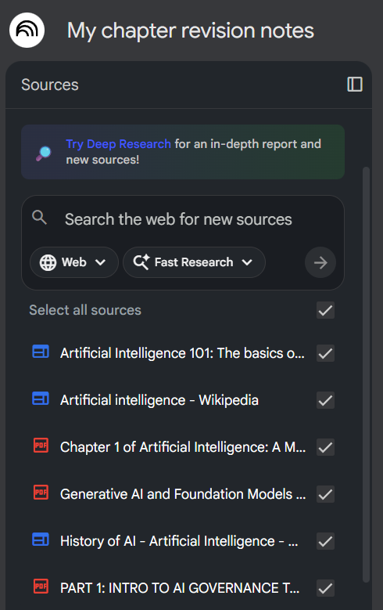
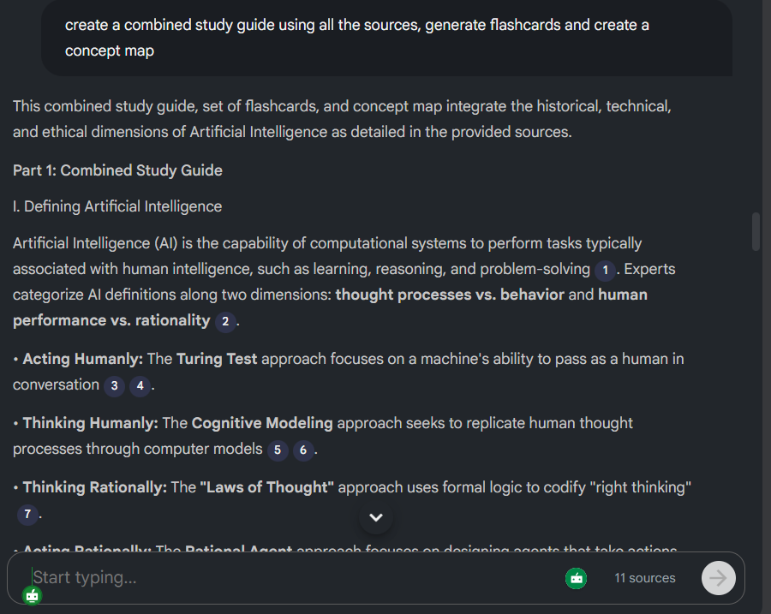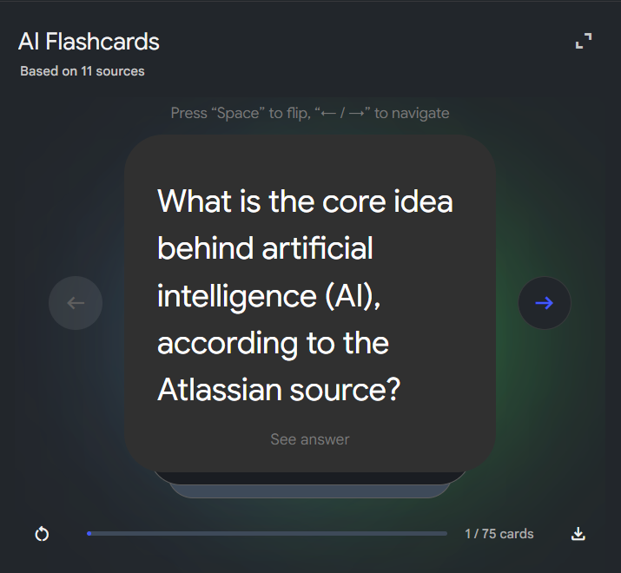
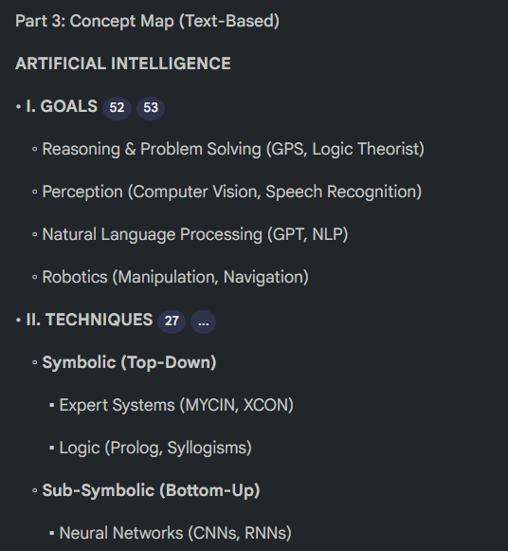

ASSIGNMENT-13

AIM:- Create a complete Student Result Management workbook.
a) Create a new workbook with 3 sheets renamed as:
a, Student_Data
b. Marks Analysis
C. Charts
b) In Student Data, enter a list of 15 students with:Name, Roll No, Class, City, Subject1, Subject2, Subject3.
c) Use Flash Fill to split "Ful Name" Into “First Name"
and “Last Name"
d) Use Find & Replace to replace city name "Delhi"with correct “Delhi”.
e) Use lf function to calculate Pass/Fall (Pass = total2120).
f)Use COUNTIF to find how many students belong to “Delhi"”.
B) Use AVERAGE, MAX, MIN to analye marks in the Marks Analysis sheet.
h) On the Charts sheet, create:
i. A Bar Chart showing marks of any one subject.
ii. A Pie Chart showing percentage of pass vs fail.
i)Apply Conditional Formatting to highlight marks<40 in red.
ji) Convert the table into a formatted Excel Table.

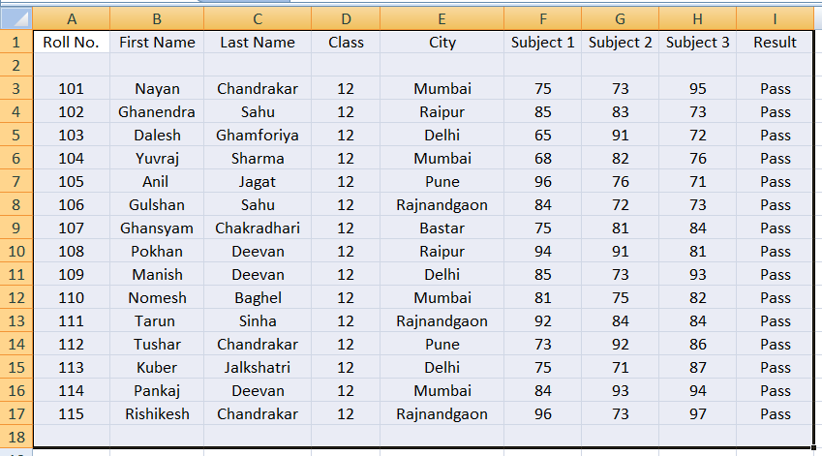

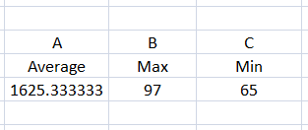

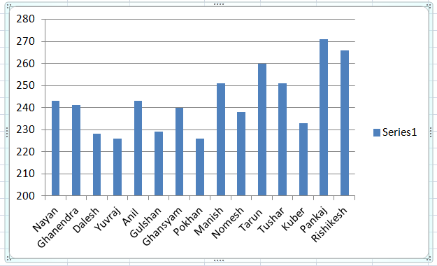

ASSIGNMENT-14

AIM:- Build a workbook for managing and analyzing sales data of a small store.
a) Create a workbook with sheets:
Store_Sales
Il.Summary
Ill. Charts
b) Import a CSV sales file (or create a sample table)containing:
Date, Product, Category, Quantity, Price, Total Sales
c) Use Sort (A-Z, 2 -A) to organize products by nam and category.
d) Apply Filter to view only “Electronics" category.
e) Use SUMIF to find total sales for a selected product(e.8, “Headphones").
f) Use LEFT, RIGHT, MID to extract:
a. First 3 letters of the product name
b. Last 2 letters of the category
8) Find the highest and lowest sales value using MAX/MIN.
a) Prepare a monthly sales summary in the Summary sheet using AVERAGE & SUM.
b) Create a Line Chart of month-wise total sales in the Charts sheet.
c) Apply sheet protection so data cannot be edited accidentally.

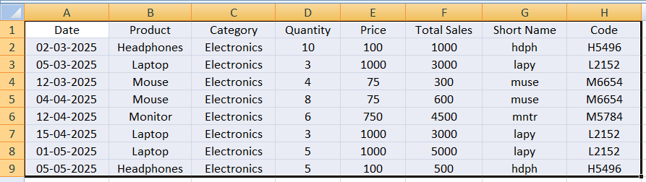

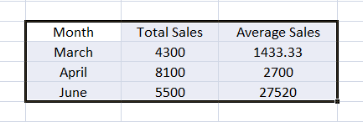

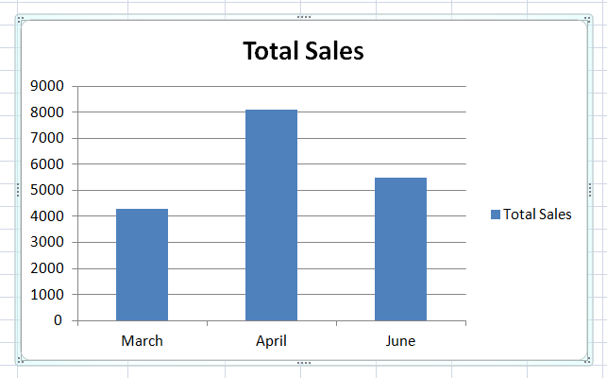

ASSIGNMENT-15
AIM:- Create a complete personal financial planner workbook.
a) Create and rename sheets as:
a, Expenses
b. Budget
C. Charts
b) Enter at least 20 rows of expense data:
Date, Category, Expense Detall, Amount, Payment Method.
c) Use Data Validation dropdown to create a category list (Food, Travel, Fees, Shopping, Other).
d) Use Remove Duplicates on the Category column if repeated incorrectly.
e) Use SUMIF to calculate total spending for each category.
f) In the Budget sheet, create the monthly budget and compare with actual expenses using:
Difference = Budget - Actual (formula required)
g) Highlight expenses above ℃2000 using Conditional Formatting.
h) Create:
A Pie Chart showing category-wise spending ii.
ii.
A Bar Chart comparing Budget vs Actual Use Flash Fill to separate date into Day /Month / Year if needed. Also explain its detail
iv Save worksheet in Page layout view and
adjust print area.

