A
Practical Record
On
“ Pyhon Programming And Problem Solving Lab ”
Master in Computer Application Ist - Sem


RUNGTA INTERNATIONAL SKILLS UNIVERSITY

SESSION: 2025-26

Submitted To:- Submitted By:-
Miss. Kavita Kanvar Name : aman Sinha
(Assistant Professor) ERP. No. :- RU-25-10156

RUNGATA INTERNATIONAL SKILLS
UNIVERSITY CG

SCHOOL OF INFORMATION TECHNOLOGY
INDEX

S.NO. | NAME OF PRACTICAL RECORD | SUBMISSION  DATE | REMARK
1 | Write a program to check whether the year is leap year or not ( Take User Input).
2 | Write a program to count no. of values in a string (Take User Input).
3 | Write a program to reverse a Number Ex:- ( 123456 -654321 ).
4 | Write a program to find Mean, Median, & Mode of given no. (Take User Input).
5 | Write a python program to reverse only the vowels in a given string, keeping other characters in their original positions.
6 | Create a script that takes an integer and display it’s binary, octal, and hexadecimal representations neatly formatted.
7 | Given a list of items (possibly with duplicates), write a program that removes duplicates and displays the sorted lists.
8 | Accept a list of students and their marks as tuples, Display the name of the student with the highest marks.
9 | Read data from a CSV file containing employee details (name, department, salary) display the average salary by department.
10 | Write a Python Program Using Math Module to Calculate:  - Square Root of a Number  - Factorial of a Number  - Power of a Number (Take Input From User)
11 | Write a python program to find the area and circumference of a circle using math module, take input from the user.
12 | Create a list of student and select CR randomly, then shuffle the list and print it.
13 | Write a python program to generate a random password of 12 characters using UPPERCASE, lowercase, digits and special symbols(!, @, #, $, *). Password should start with Capital letter or digits.
14 | Create a package named shapes that contains two modules: circle.py and rectangle.py. Each module should compute area and perimeter of the shape. Write the complete directory structure and sample code.
15 | Write a program that asks the user for an index and prints the element at that index from a predefined list. Handle:  - IndexError (index out of range)  - TypeError (if user enters a non-integer index)  - Print the specific exception message using except Exception as e.
16 | Implement a supervised learning model to classify flowers in the Iris dataset using decision tree classifier. Print the accuracy of the model.
17 | Use Support Vector Machine (SVM) on the breast cancer datasets to classify malignant vs benign tumors.
18 | Perform Principal Component Analysis (PCA) on the digits dataset and reduce the dimension to 2. Print the explained variance ratio.
19 | Apply K-Means clustering on the Iris Dataset and print cluster labels.
20 | Write a Python program to perform basic EDA on a student performance dataset to understand its structure and summary statistics. (dataset attached along with filename – sample_dataset)  - Load the dataset into Python  - Display the first five records  - Display the shape of the dataset  - Show column names and data types  - Check for missing values  - Display basic statistical summary
21 | Write a Python program using pandas to analyze a sales dataset and extract meaningful insights.  - Load the dataset into a pandas DataFrame  - Create a new column Total_Revenue by multiplying Units_Sold and Price_Per_Unit  - Find the total revenue generated for each product  - Find the total units sold for each category  - Calculate the average price per unit for each category  - Find the product with maximum units sold  - Group the data by Month and calculate the total revenue for each month  - Filter and display products where Units_Sold is greater than 40  - Sort the dataset by Total_Revenue in descending order
22 | Write a Python program to visualize an employee dataset using matplotlib and seaborn to understand data distribution and relationships.  - Plot a histogram for Salary  - Draw a box plot for Age  - Create a bar chart showing department-wise employee count  - Plot a scatter plot between Experience and Salary  - Display a correlation heatmap

RECORD NO. :-01

AIM :- Write a program to check whether the year is leap year or not ( Take User Input).

CODE :-

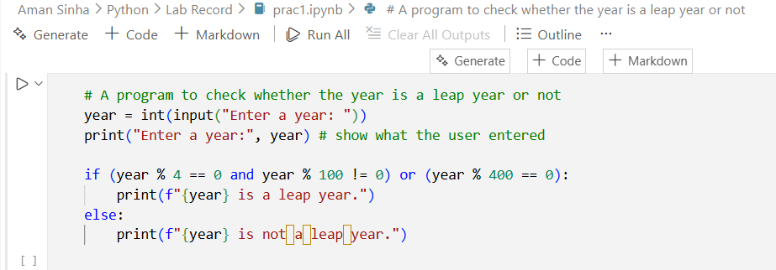

OUTPUT :-

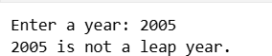

RECORD NO. :-02

AIM :- Write a program to count no. of vowels in a string (Take User Input).

CODE :-

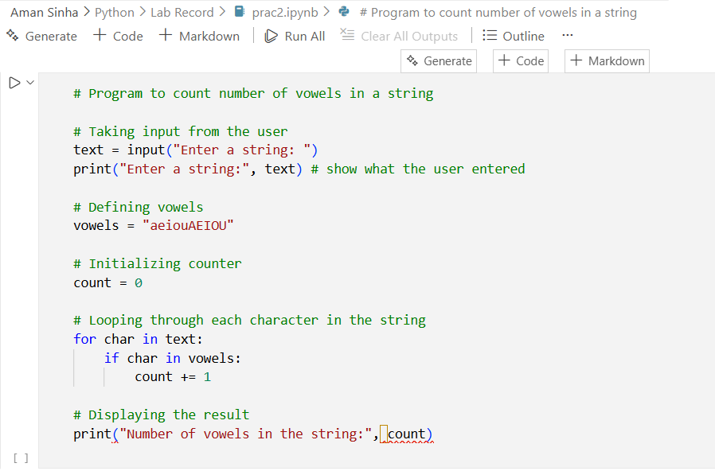

OUTPUT :-

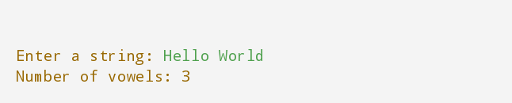

RECORD NO. :-03

AIM :- Write a program to reverse a Number Ex:- ( 123456 -654321 ).

CODE :-

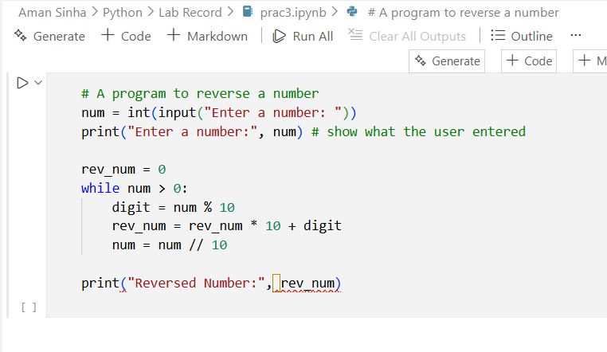

OUTPUT :-

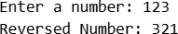
RECORD NO. :-04

AIM :- Write a program to find Mean, Median, & Mode of given no. (Take User Input).
CODE :-

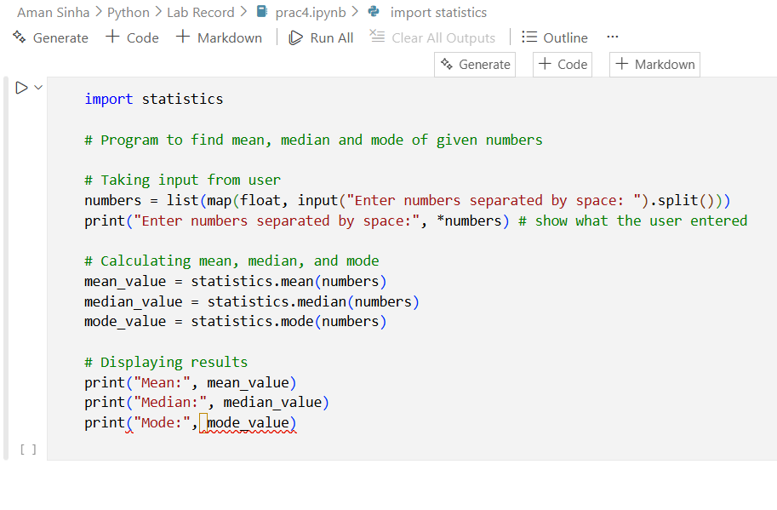
OUTPUT :-

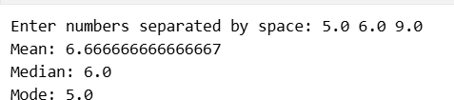
RECORD NO. :-05

AIM :- Write a python program to reverse only the vowels in a given string, keeping other characters in their original positions.

CODE :-

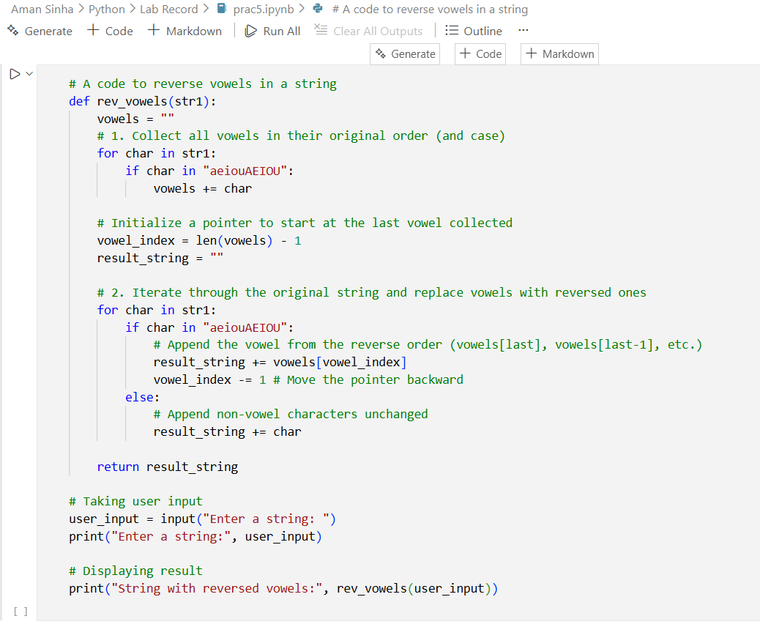

OUTPUT :-

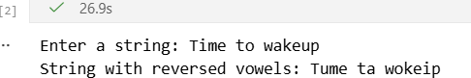
RECORD NO. :-06

AIM :- Create a script that takes an integer and display it’s binary, octal, and hexadecimal representations neatly formatted.

CODE :-

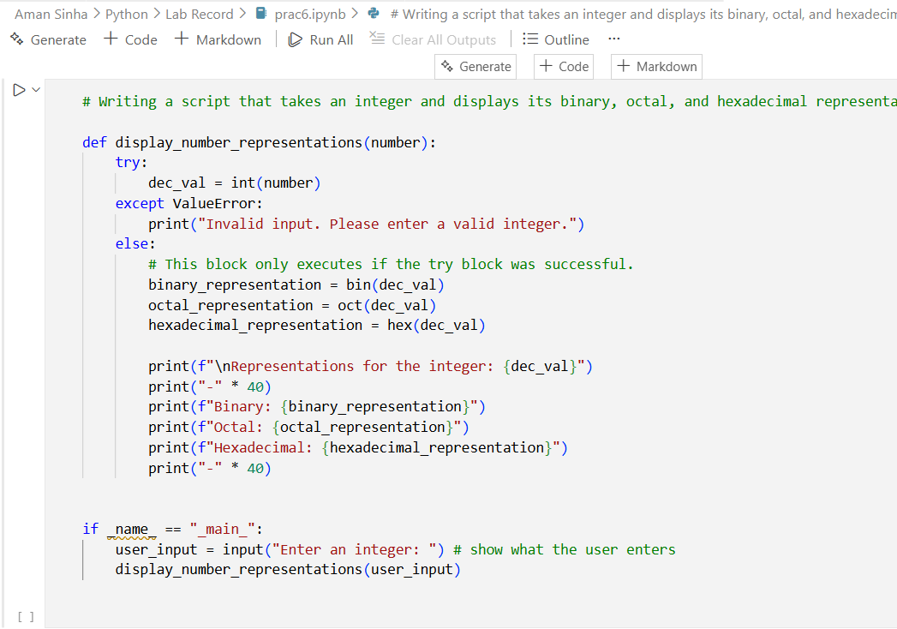

OUTPUT :-

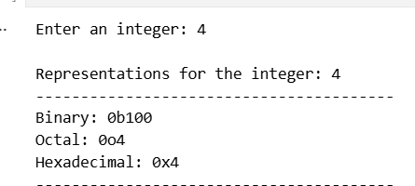
RECORD NO. :-07

AIM :- Given a list of items (possibly with duplicates), write a program that removes duplicates and displays the sorted lists.

CODE :-
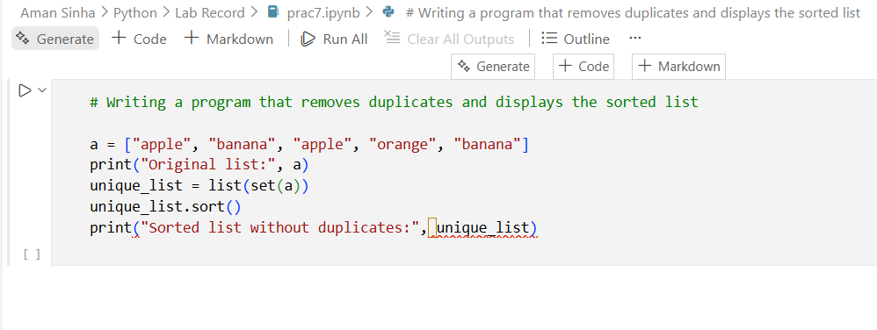

OUTPUT :-

RECORD NO. :-08

AIM :- Accept a list of students and their marks as tuples, Display the name of the student with the highest marks.

CODE :-

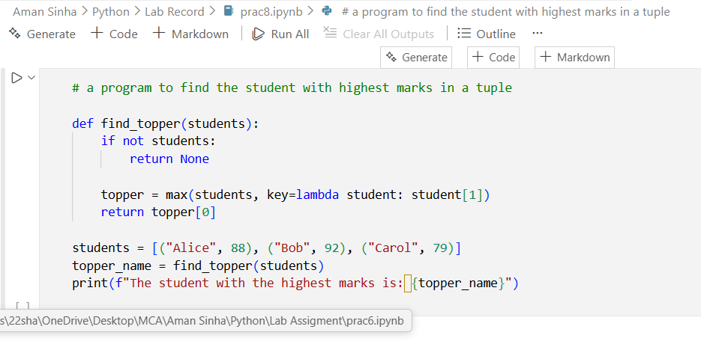

OUTPUT :-
RECORD NO. :-09

AIM :- Read data from a CSV file containing employee details (name, department, salary) display the average salary by department.

CODE :-

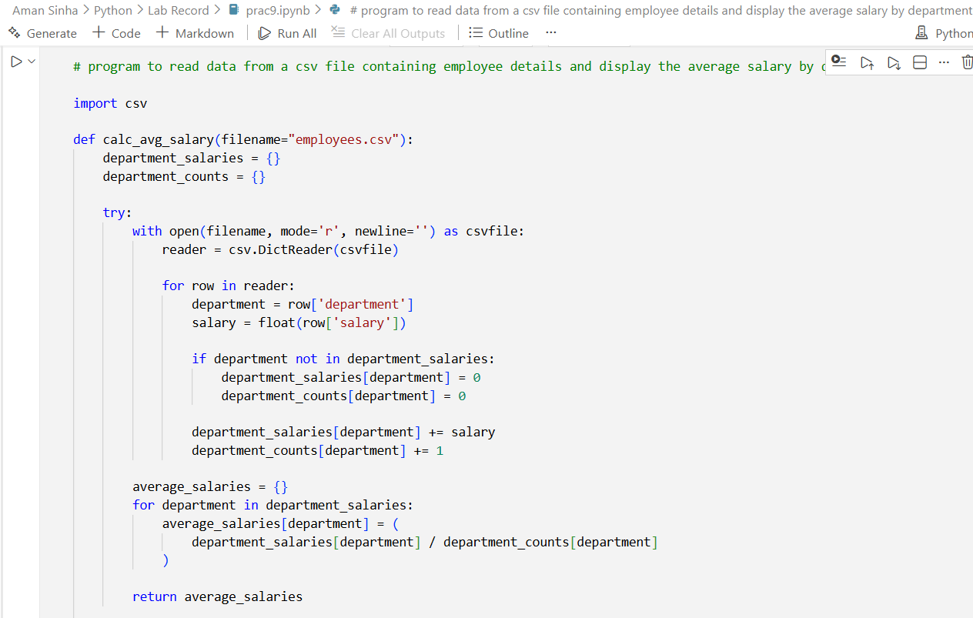

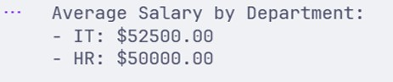
OUTPUT :-

RECORD NO. :-10

AIM :- Write a Python Program Using Math Module to Calculate (Take Input From User) :
- Square Root of a Number
- Factorial of a Number
- Power of a Number
CODE :-

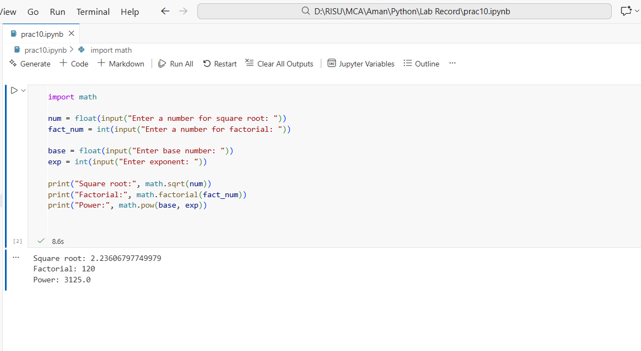

RECORD NO. :-11

AIM :- Write a python program to find the area and circumference of a circle using math module, take input from the user.

CODE :-

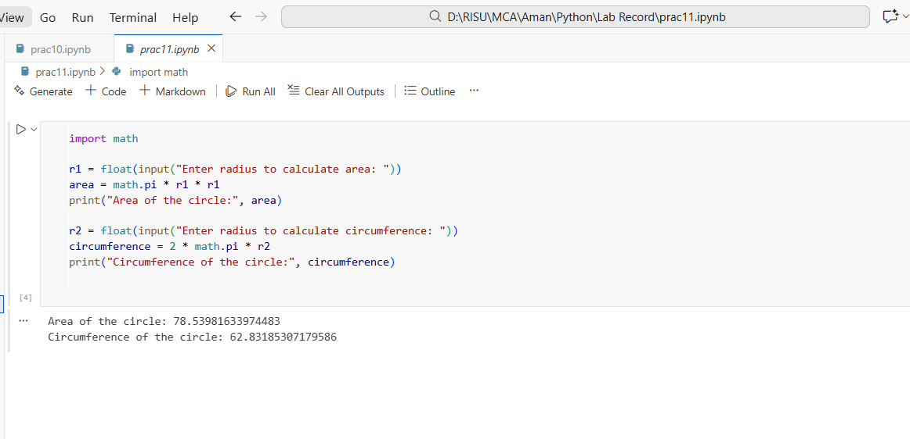

RECORD NO. :-12

AIM :- Create a list of student and select CR randomly, then shuffle the list and print it.

CODE :-

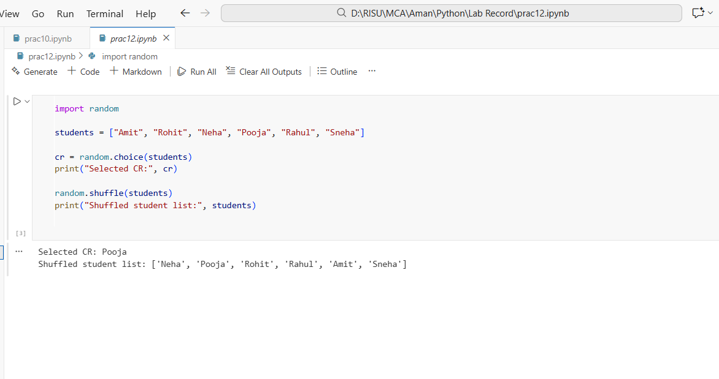

RECORD NO. :-13

AIM :- Write a python program to generate a random password of 12 characters using UPPERCASE, lowercase, digits and special symbols(!, @, #, $, *). Password should start with Capital letter or digits.

CODE :-

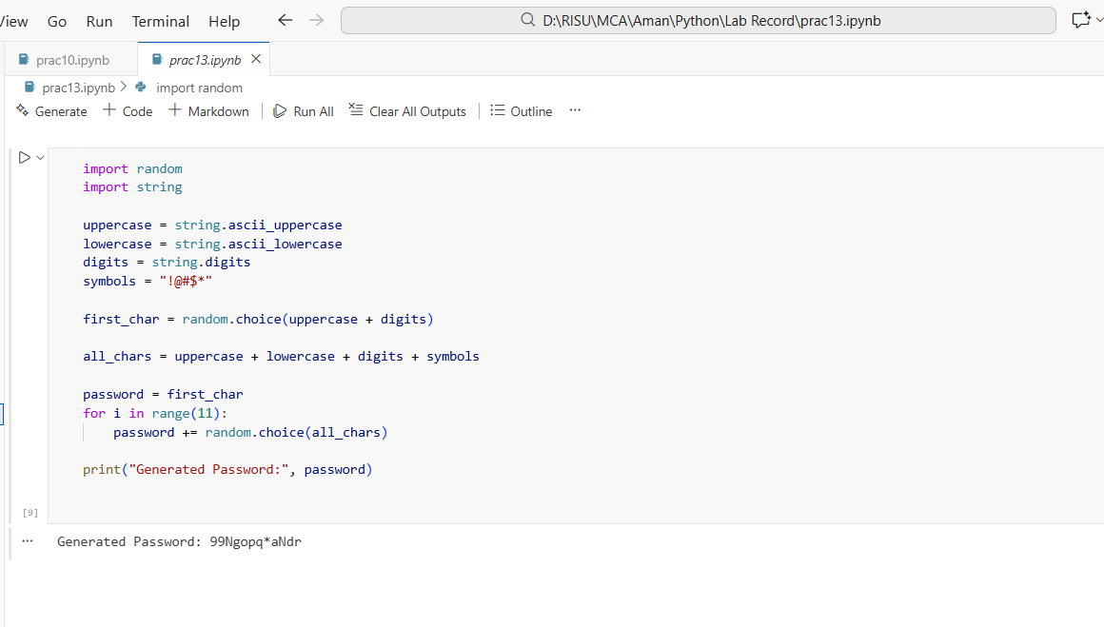

RECORD NO. :-14

AIM :- Create a package named shapes that contains two modules: circle.py and rectangle.py. Each module should compute area and perimeter of the shape. Write the complete directory structure and sample code.

CODE :-

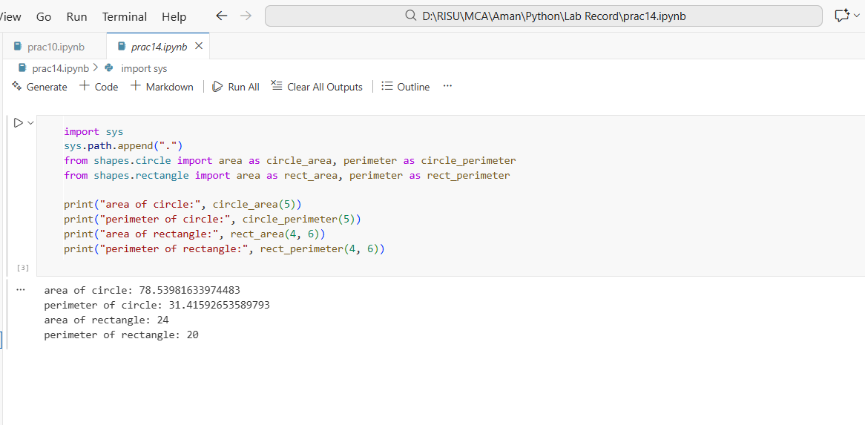
RECORD NO. :-15

AIM :- Write a program that asks the user for an index and prints the element at that index from a predefined list. Handle:

- IndexError (index out of range)
- TypeError (if user enters a non-integer index)
- Print the specific exception message using except Exception as e.

CODE :-

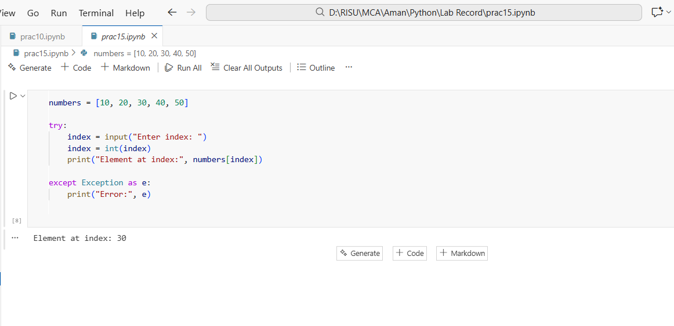
RECORD NO. :-16

AIM :- Implement a supervised learning model to classify flowers in the Iris dataset using decision tree classifier. Print the accuracy of the model.

CODE :-

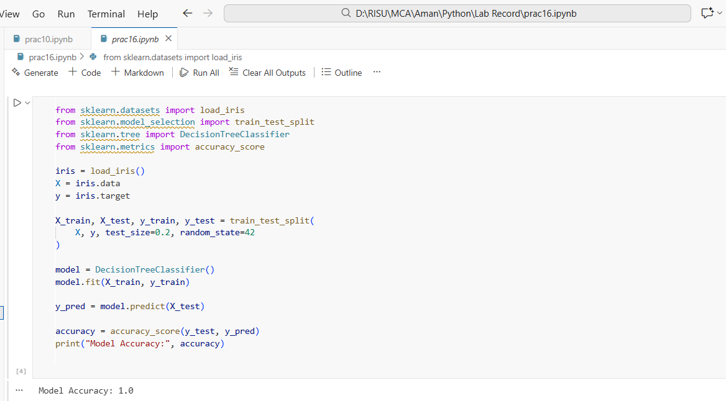
RECORD NO. :-17

AIM :- Use Support Vector Machine (SVM) on the breast cancer datasets to classify malignant vs benign tumors.

CODE :-

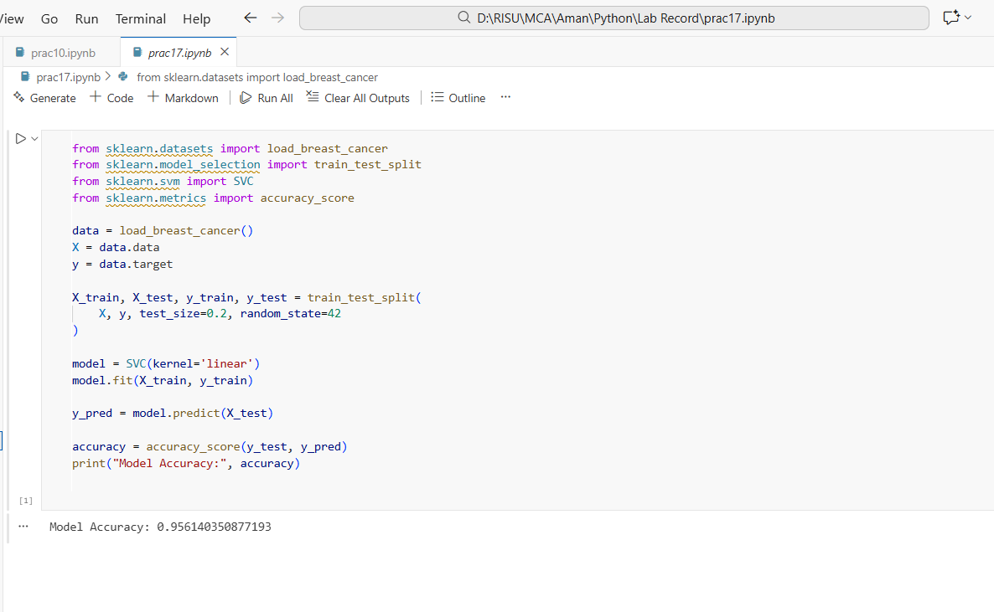

RECORD NO. :-18

AIM :- Perform Principal Component Analysis (PCA) on the digits dataset and reduce the dimension to 2. Print the explained variance ratio.

CODE :-

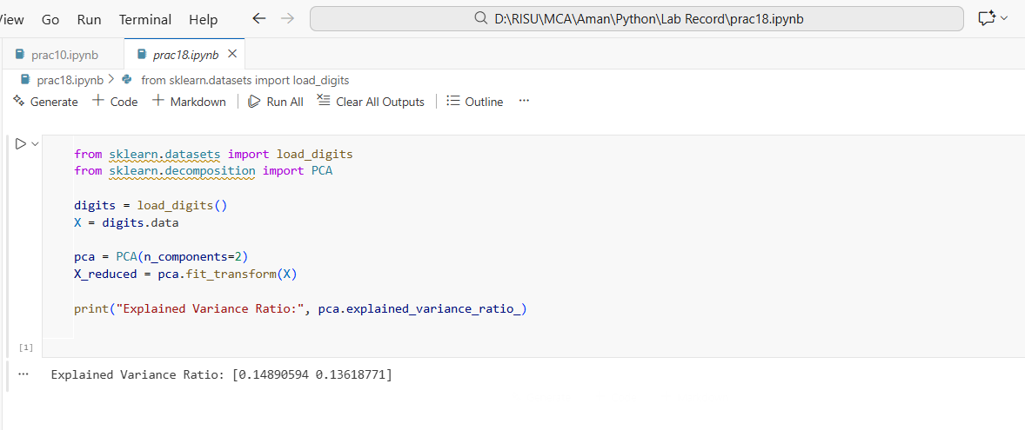
RECORD NO. :-19

AIM :- Apply K-Means clustering on the Iris Dataset and print cluster labels.

CODE :-

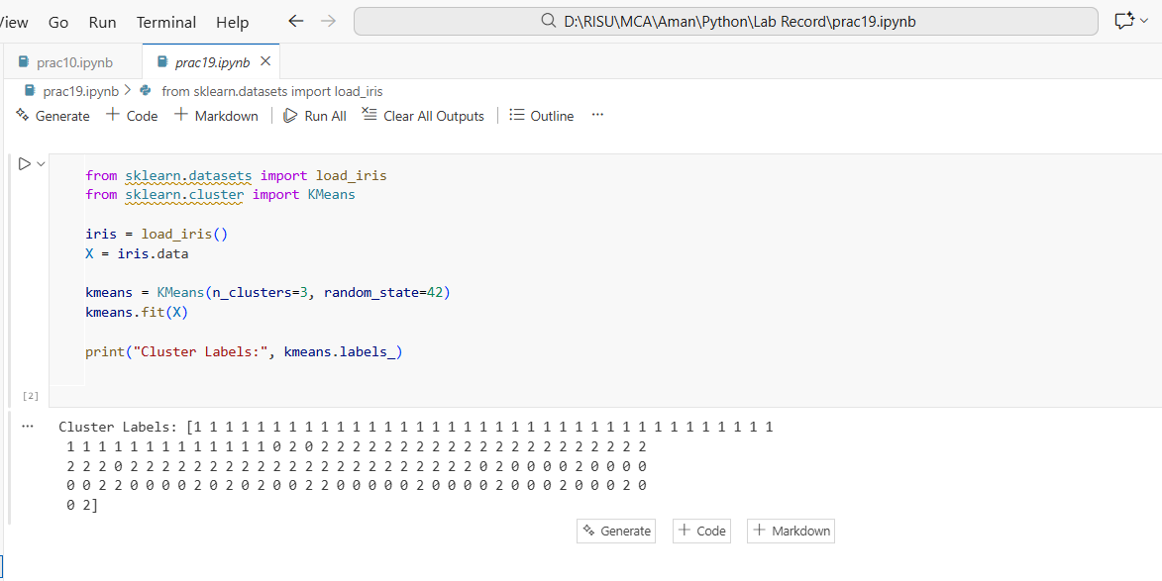

RECORD NO. :-20

AIM :- Write a Python program to perform basic EDA on a student performance dataset to understand its structure and summary statistics. (dataset attached along with filename – sample_dataset)
- Load the dataset into Python
- Display the first five records
- Display the shape of the dataset
- Show column names and data types
- Check for missing values
- Display basic statistical summary
CODE :-

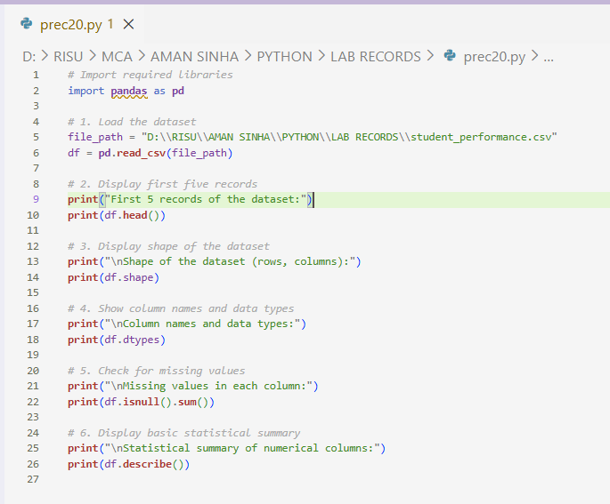

OUTPUT :-

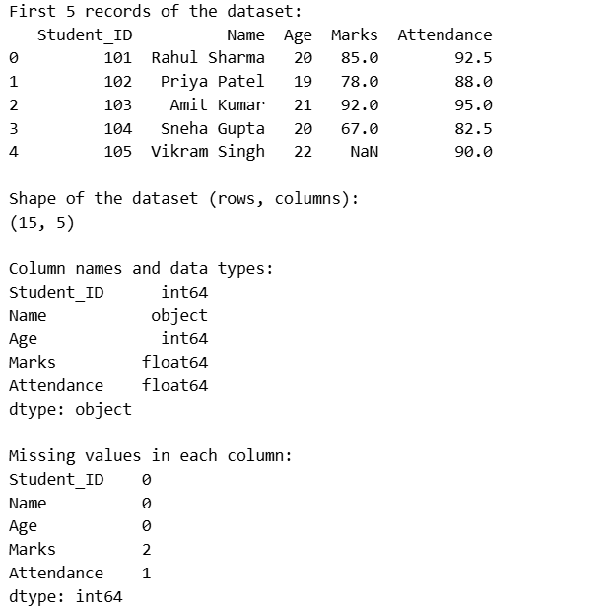
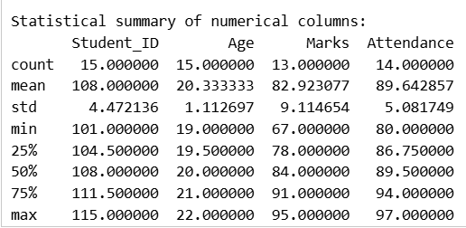
RECORD NO. :-21

AIM :- Write a Python program using pandas to analyze a sales dataset and extract meaningful insights.
- Load the dataset into a pandas DataFrame
- Create a new column Total_Revenue by multiplying Units_Sold and Price_Per_Unit
- Find the total revenue generated for each product
- Find the total units sold for each category
- Calculate the average price per unit for each category
- Find the product with maximum units sold
- Group the data by Month and calculate the total revenue for each month
- Filter and display products where Units_Sold is greater than 40
- Sort the dataset by Total_Revenue in descending order

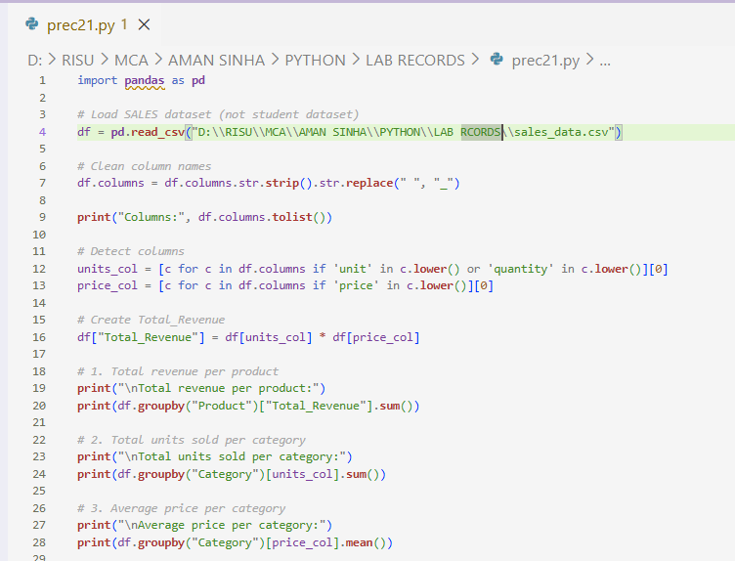
CODE :-
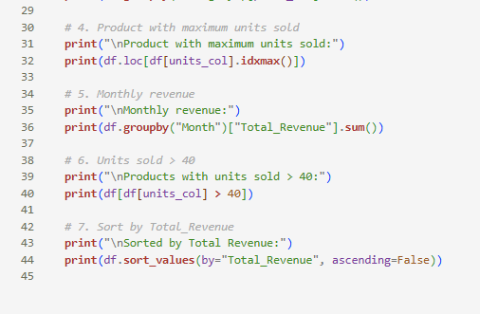

OUTPUT :-

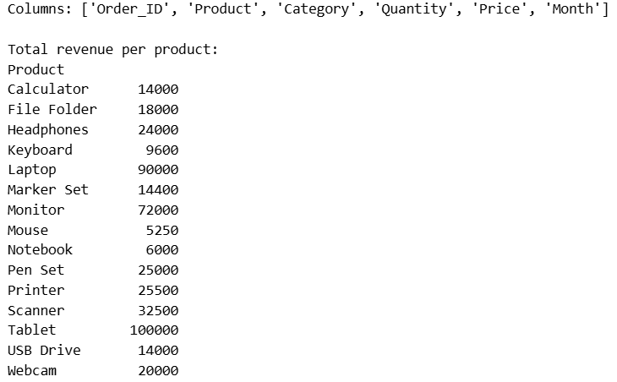
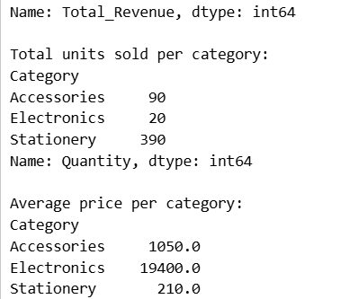
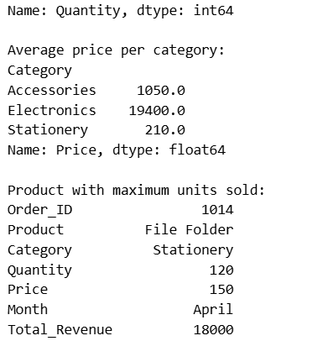

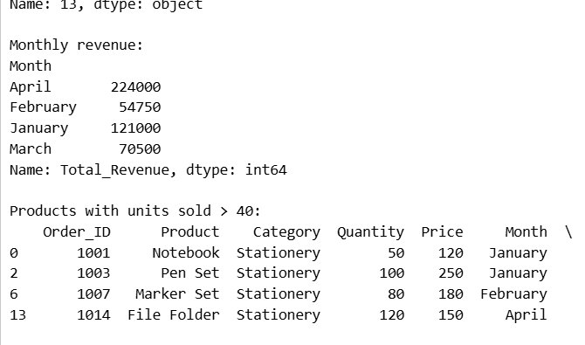
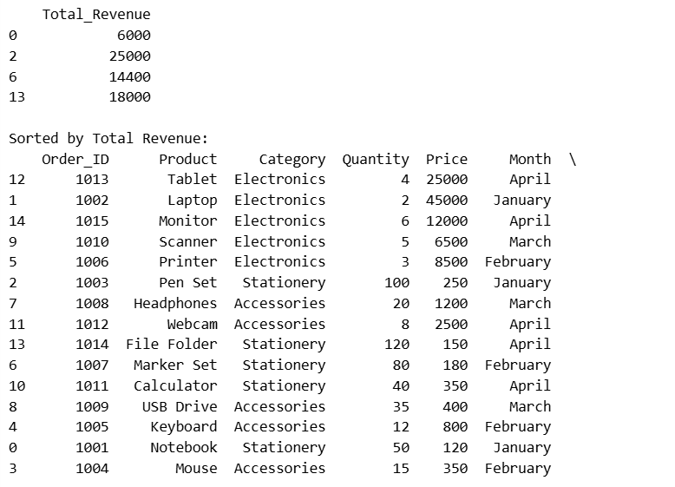

RECORD NO. :-22

AIM :- Write a Python program to visualize an employee dataset using matplotlib and seaborn to understand data distribution and relationships.
- Plot a histogram for Salary
- Draw a box plot for Age
- Create a bar chart showing department-wise employee count
- Plot a scatter plot between Experience and Salary
- Display a correlation heatmap

CODE :-

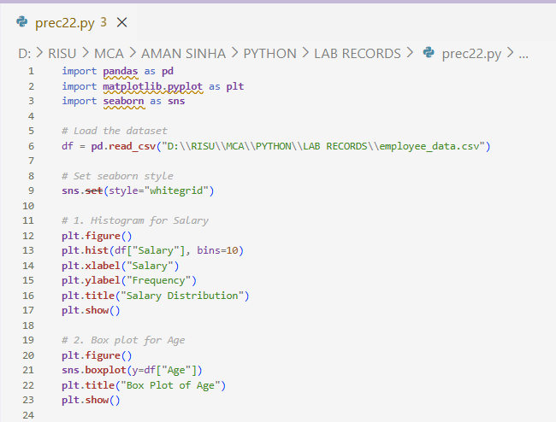
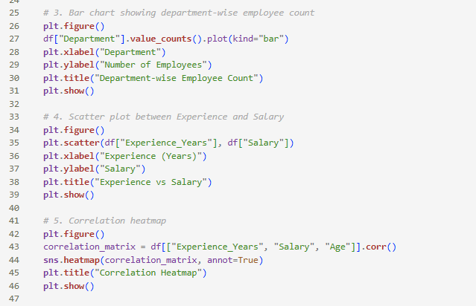

OUTPUT :-