### Study Finder

### A REPORT

### *Submitted to*

### Picture 1

### ASSAM DON BOSCO UNIVERSITY

### By

### Suplab Saha

### (DC2024MCA0024)

### Aman Sona

### (DC2024MCA0036)

### *in partial fulfilment for completion of Assignment*

### *of*

### 2nd SEMESTER

### OF

### MASTER OF COMPUTER APPLICATIONS

### DEPARTMENT OF COMPUTER APPLICATIONS

### SCHOOL OF TECHNOLOGY

### ASSAM DON BOSCO UNIVERSITY

### AZARA, GUWAHATI 781017,

### ASSAM, INDIA.

### BATCH (2024-2026)

Overview

Study Group Finder is a web-based application that allows students to register or log in, search for existing study groups by subject or course name, join them, or create a new group if one doesn't already exist. It is designed to encourage collaborative learning and help students connect with like-minded peers.

Technology used

Frontend:

* HTML5
* CSS3 (with responsive layout)
* JavaScript (for dynamic functionality)

Backend:

* Firebase (Authentication and Realtime Database)

Additional Tools:

* VS Code
* Git/GitHub (for version control)
* Materialize CSS (for responsive UI design)
* Firebase Console (for backend services)

Key features

* User Registration and Login – Students can create an account or sign in using Firebase Authentication.
* Search for Study Groups – Users can search for a study group using the group name or subject.
* Join Existing Group – If a group exists, users can join with one click.
* Create New Group – If no group is found, users can create one with a custom name.
* Responsive Design – The app is mobile-friendly and adjusts for smaller screens.

Screenshot(DESKTOP VIEW)

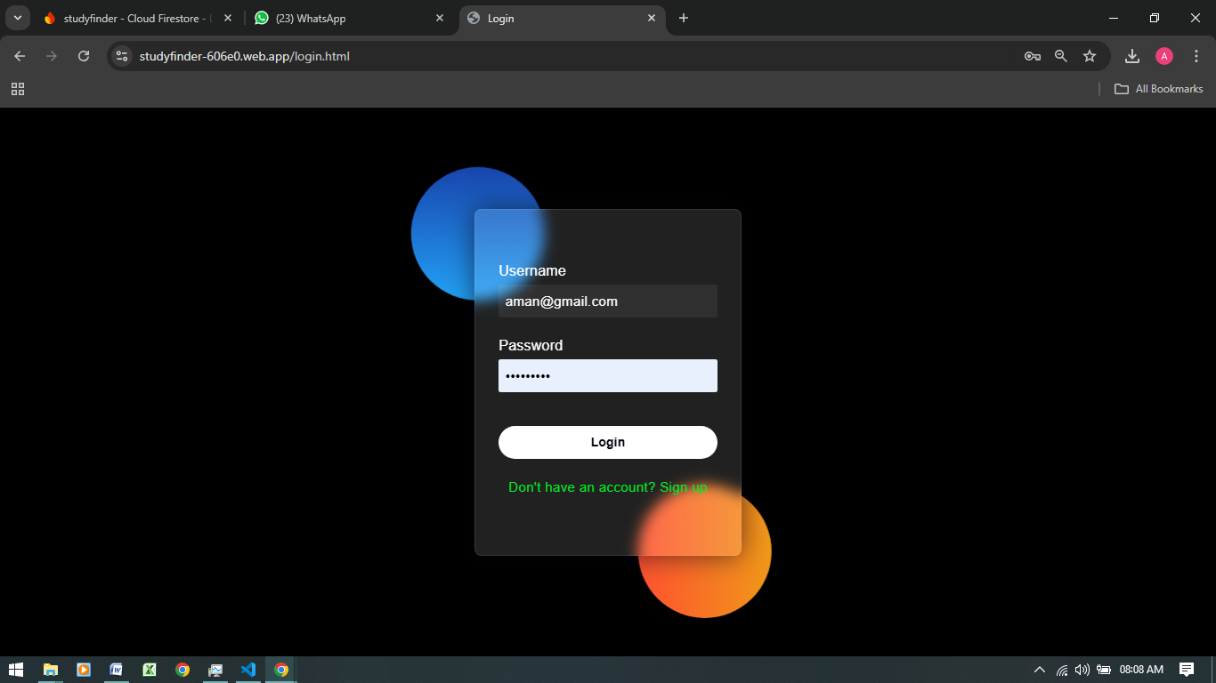

Login

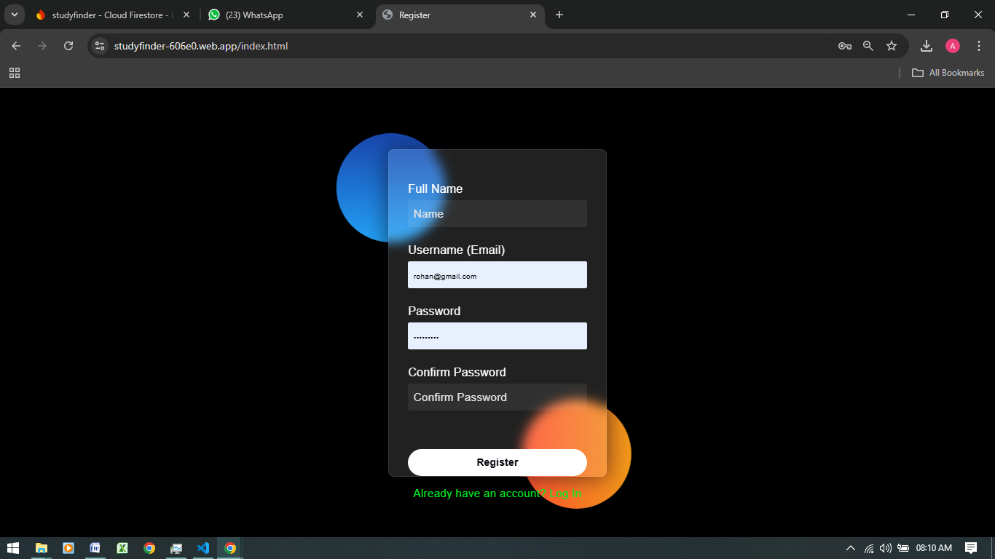

Registration

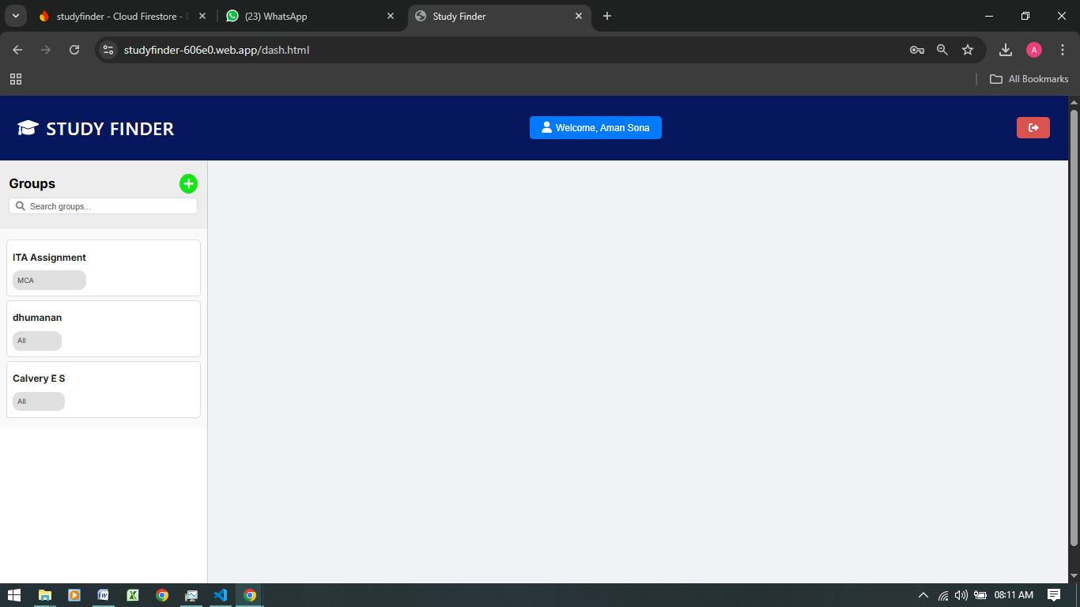

Dashboard

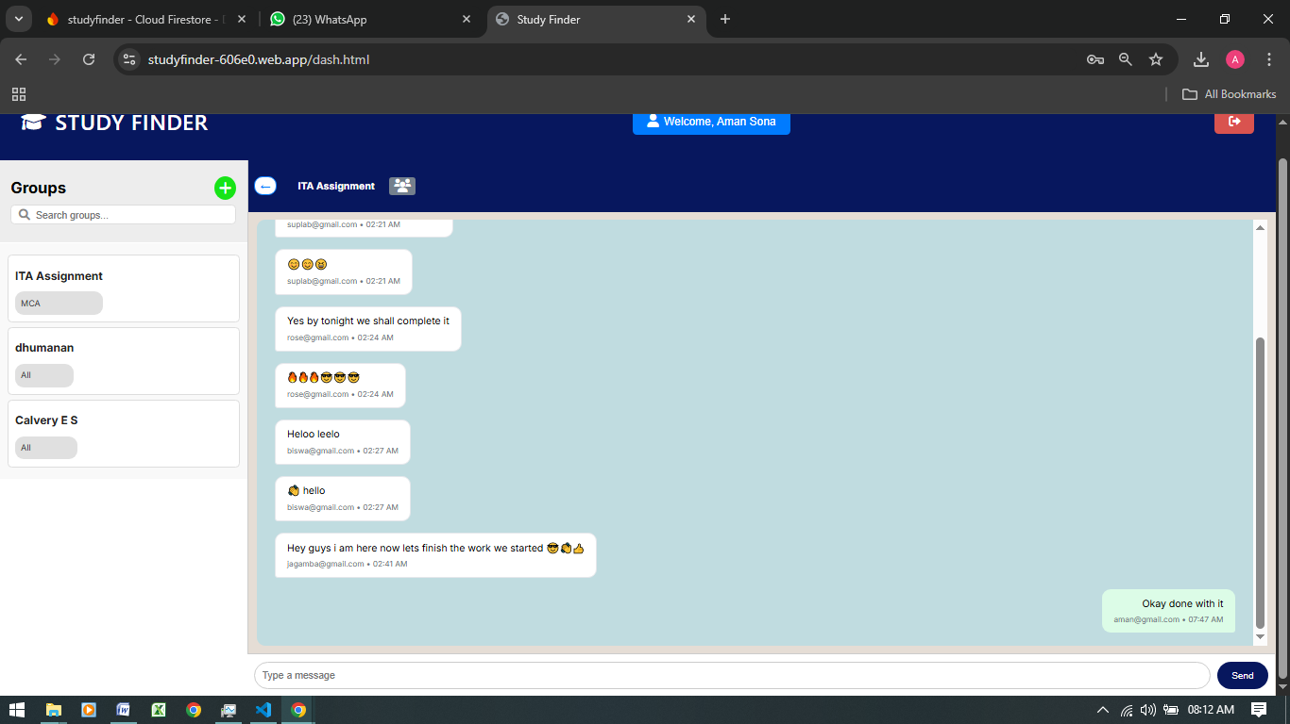

Chats

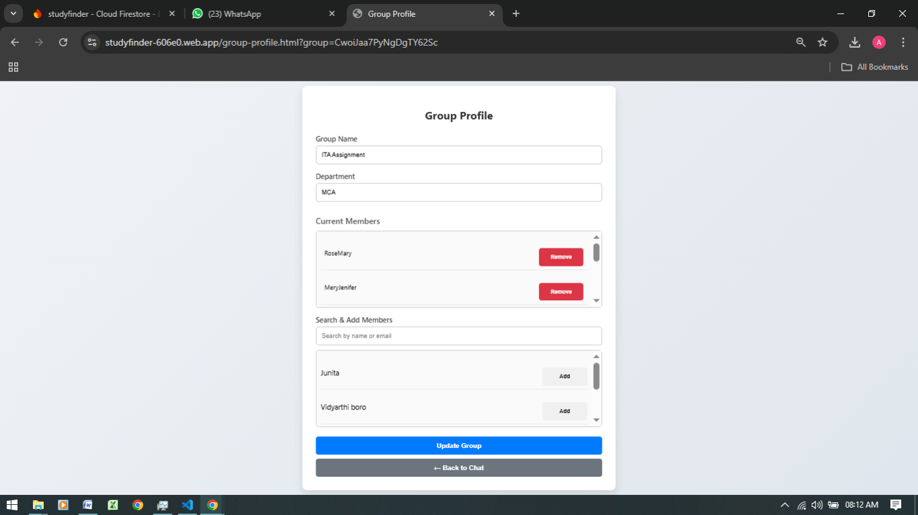

GroupProfile

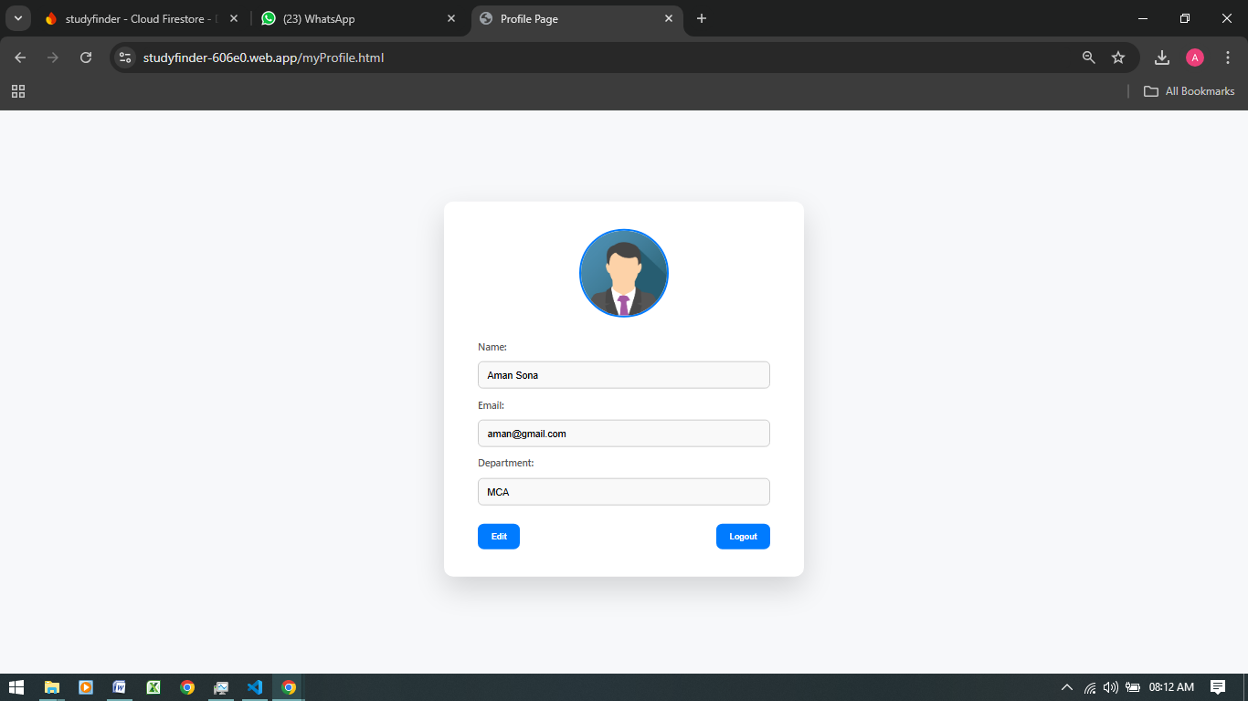

userProfile

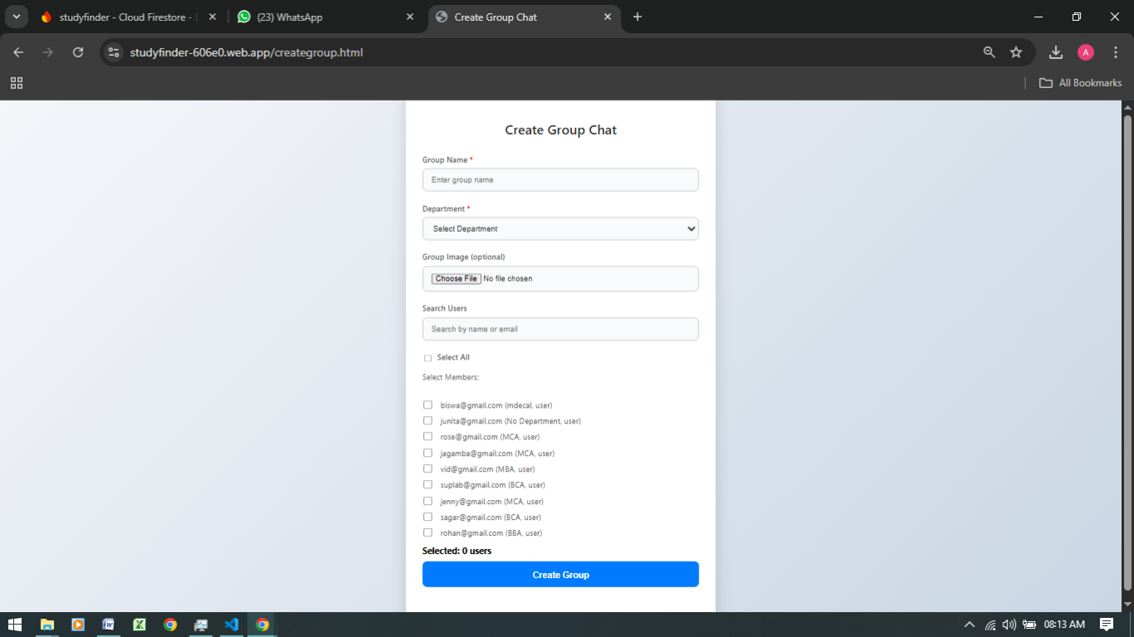

CreateGroup

Screenshot(MOBILE VIEW)

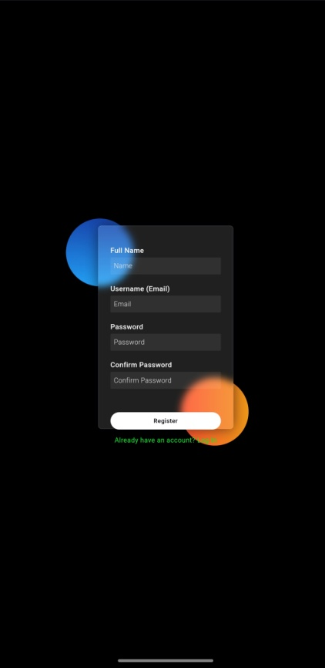 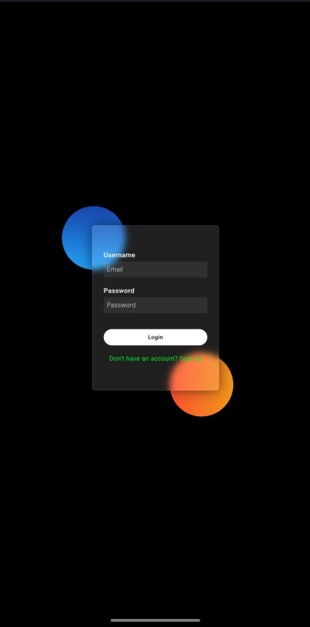 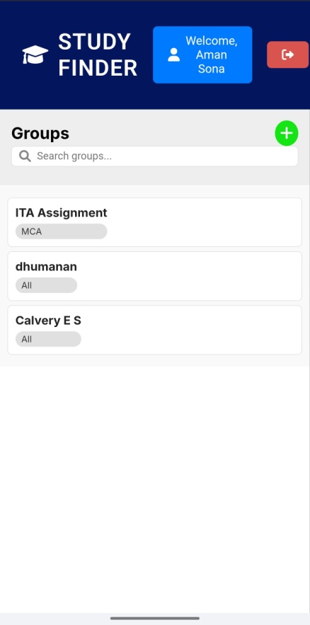

**Registration Login dashboard**

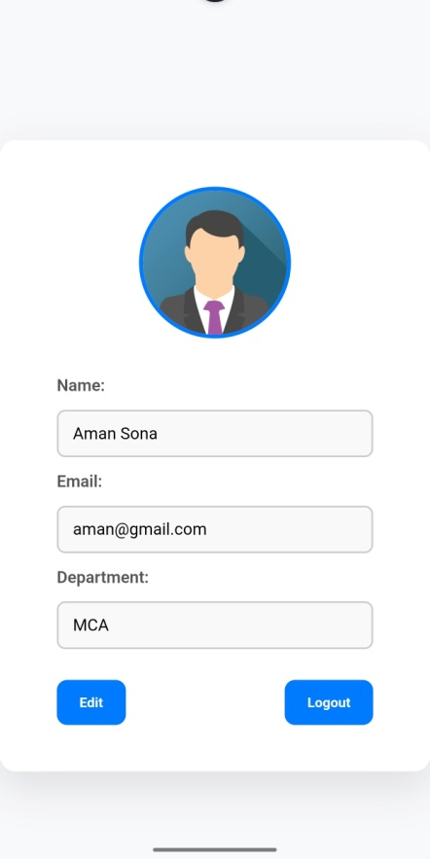 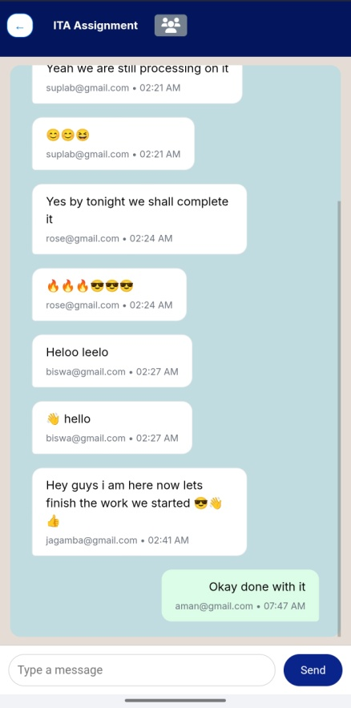 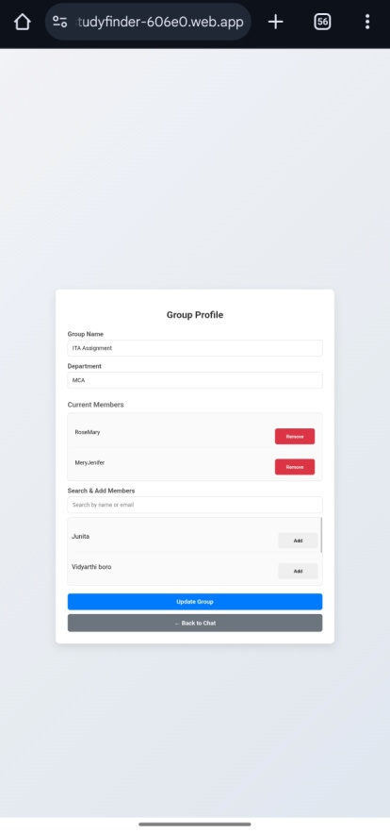

**UserProfile Chat GroupProfile**

Future Scope

* Users Avatars
* Notifications when new members join
* Video conferencing.
* Sharing of files and Doucments