AI-Powered Business Intelligence & Customer Risk Analytics Platform
PROJECT REPORT
B.Tech CSE (Data Science) • Streamlit Decision-Support Dashboard
Final dashboard-tested version

1. Project Overview
This project converts transactional business data into meaningful business intelligence through a decision-oriented Streamlit dashboard. The workflow follows the BI framework of data → information → insight → decision → action. Instead of focusing only on visualization, the dashboard emphasizes KPIs, trends, business drivers, customer behavior, risk signals, opportunities and recommended actions.

2. Problem Statement
Businesses can collect large volumes of sales and customer transaction data, but raw records do not directly explain what is happening, why performance changes, where risks exist, or what management should do next. The project addresses this gap by combining data preparation, KPI analysis, trend analysis, product and regional analysis, customer analytics, transparent risk scoring and action-oriented interpretation in one interactive application.

3. Objectives
- Clean and prepare transactional business data.
- Calculate meaningful sales, profit and customer KPIs.
- Identify revenue, product, category and regional performance drivers.
- Analyze customer value, purchase frequency and recency.
- Generate transparent customer risk signals using observable purchase behavior.
- Convert analytical findings into risk → driver → opportunity → action statements.
- Present results through an interactive dashboard that supports business decision-making.

4. Dataset
The final dashboard was tested using a publicly available Superstore-style transactional dataset, separate from the dataset used in the masterclass exercises. The dashboard accepts common Superstore fields such as Order ID, Customer ID, Order Date, Product Name, Category, Quantity, Sales, Profit, Region and Segment.
Dataset metric | Tested result
Rows before cleaning | 10,194
Rows after cleaning | 4,130
Rows removed | 6,064
Duplicates removed | 0
Analysis period | 2023-01-02 to 2026-12-11
Dataset source: Tableau Public / Sample Data — Sample Superstore. Source page: https://public.tableau.com/app/learn/sample-data

5. Technology Stack
- Python
- Pandas
- NumPy
- Plotly
- Streamlit
- Git/GitHub

6. Dashboard Architecture
The application follows the pipeline: CSV dataset → column standardization → type conversion and cleaning → KPI engine → trend and driver analysis → customer analytics → transparent risk scoring → recommended business actions → interactive Streamlit dashboard.

7. Dashboard Structure and Screenshots

7.1 Executive Overview
The Executive Overview presents revenue, profit, orders, customers, average order value and profit margin, followed by revenue/profit trends, category performance, regional performance and a business snapshot.
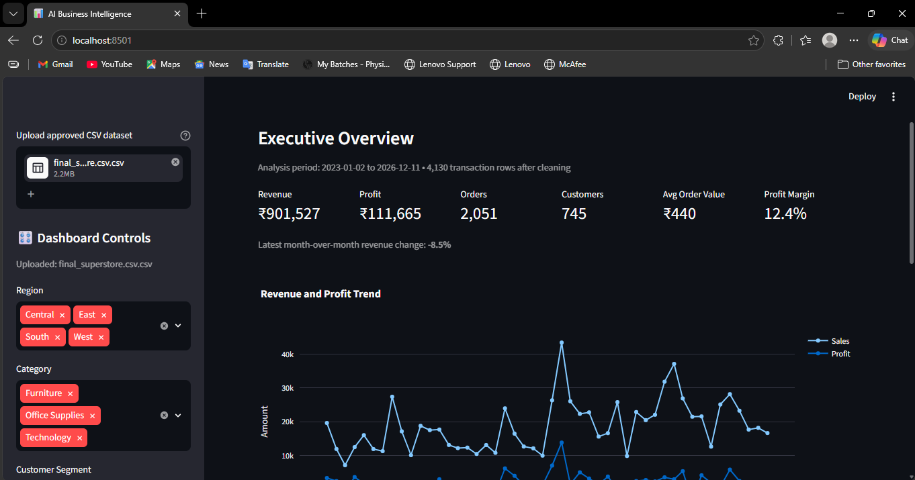
Figure 1. Executive Overview Dashboard.

7.2 Sales & Product Analysis
This section identifies the highest-revenue products, lowest-profit products, product revenue-versus-profit relationships and category/region driver combinations.
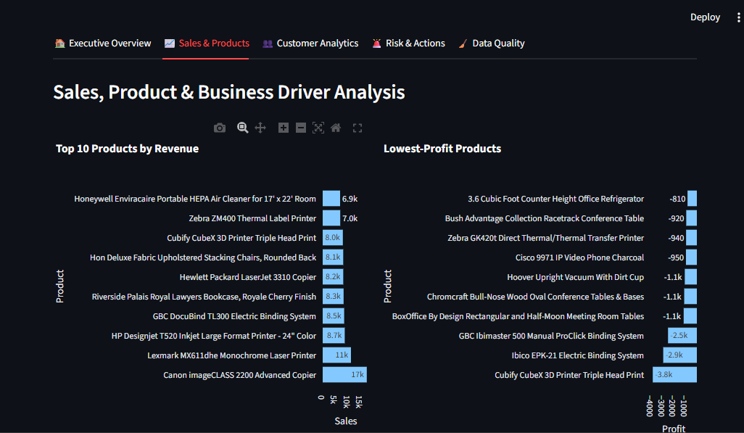
Figure 2. Sales, Product and Business Driver Analysis.

7.3 Customer Analytics
This section summarizes returning customers, high-value customers, average customer revenue and median recency, and visualizes customer value against purchase frequency.
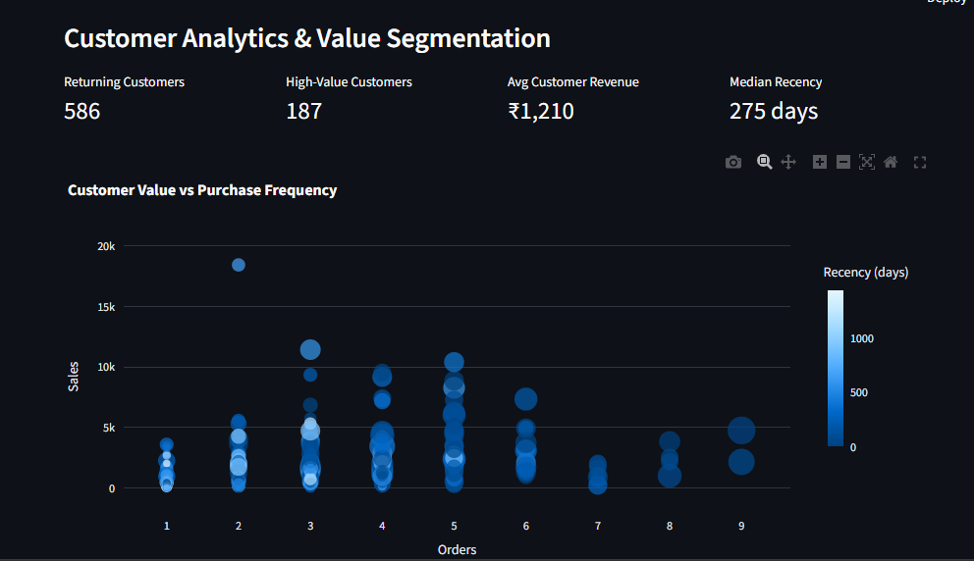
Figure 3. Customer Analytics and Value Segmentation.

7.4 Risk & Actions
The risk section groups customers into analytical risk bands and shows high-risk customer counts, revenue at stake, risk distribution and management actions.
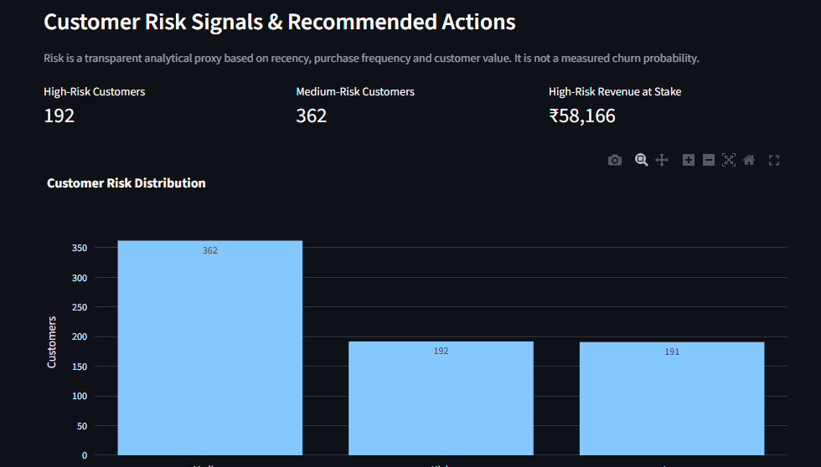
Figure 4. Customer Risk Signals and Recommended Actions.

7.5 Data Quality & Preparation
The data-quality section reports rows before and after cleaning, duplicates removed, removed records, cleaning steps, missing-value profile and dataset summary.
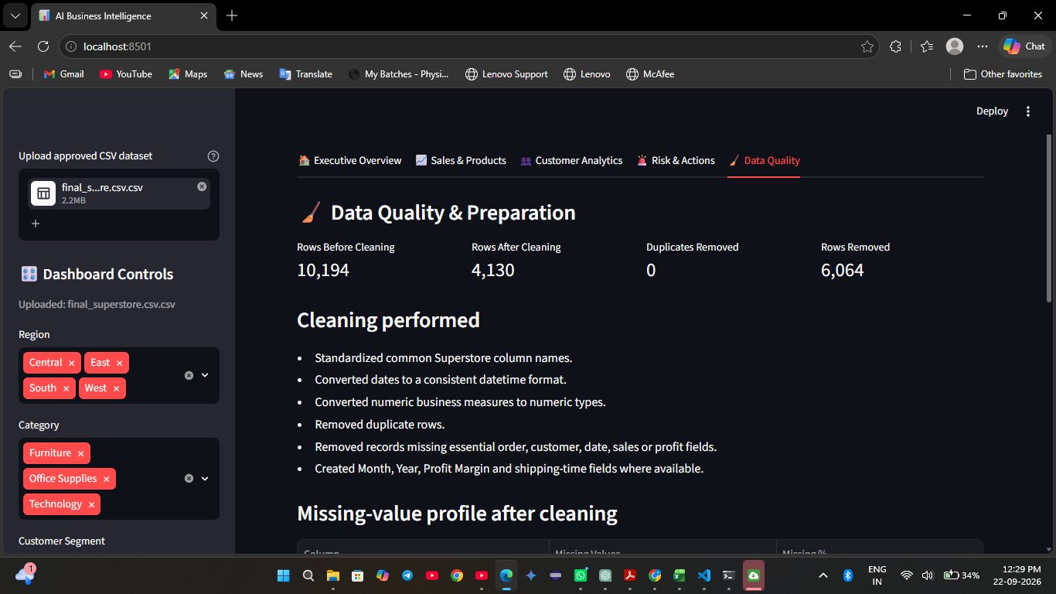
Figure 5. Data Quality and Preparation.

8. Tested Dashboard Results
The following values were observed during the final dashboard test with the uploaded Superstore CSV and the default filter selections:
KPI | Observed value
Revenue | ₹901,527
Profit | ₹111,665
Orders | 2,051
Customers | 745
Average Order Value | ₹440
Profit Margin | 12.4%
Returning Customers | 586
High-Value Customers | 187
Average Customer Revenue | ₹1,210
Median Recency | 275 days
High-Risk Customers | 192
Medium-Risk Customers | 362
High-Risk Revenue at Stake | ₹58,166

9. Data Preparation and Quality
- Standardized common Superstore column names.
- Converted dates to a consistent datetime format.
- Converted business measures to numeric types.
- Removed duplicate rows where present.
- Removed records missing essential order, customer, date, sales or profit fields.
- Created Month, Year, Profit Margin and shipping-time fields where available.
In the tested dataset, 10,194 rows were initially read and 4,130 rows remained after the analytical cleaning rules. No duplicate rows were reported by the dashboard. The removed-record count was 6,064.

10. Customer Risk Methodology
The final implementation uses a transparent, rule-based analytical risk score rather than claiming a validated churn-prediction model. The score combines customer recency, purchase frequency and customer value using relative ranks and assigns Low, Medium or High analytical risk bands. This is appropriate for the available public Superstore-style data because it does not provide an observed churn/retention outcome.
Therefore, the dashboard should be interpreted as identifying customers whose observed purchase behavior warrants review, not as predicting a definite future churn event.

11. Business Intelligence Logic
The dashboard follows a fact → insight → opportunity/risk → action structure. For example, weak product profitability can trigger a review of pricing, discounting and product costs; high recency combined with weaker purchase frequency can trigger targeted customer-retention review; and strong concentration in a category or region can trigger investigation of the underlying growth driver and diversification opportunities.

12. Key Findings from the Tested Dashboard
- The dashboard reported ₹901,527 in revenue and ₹111,665 in profit for the displayed analysis period and filter state.
- The dashboard identified 2,051 orders and 745 customers, with an average order value of ₹440 and profit margin of 12.4%.
- Customer analysis showed 586 returning customers and 187 customers in the high-value group under the dashboard definition.
- The analytical risk view identified 192 high-risk and 362 medium-risk customers, with ₹58,166 of high-risk revenue at stake.
- Product analysis demonstrates that high sales volume and profitability are separate dimensions, supporting product-level profitability review rather than relying on revenue alone.

13. Limitations
- The risk score is an analytical proxy and is not a validated churn probability.
- Results depend on the selected date range, region, category and customer-segment filters.
- Business recommendations are decision-support signals and should be evaluated using company-specific context before implementation.
- The public dataset does not contain all operational variables that might be required for a production-grade customer retention model.

14. Program Submission Checklist
- app.py — final Streamlit application
- requirements.txt — Python dependencies
- Project_Report.docx — this report with dashboard screenshots and tested results
- README.md — project documentation and run instructions
- GitHub repository link
- Public dataset source link

15. Important Dataset Constraint
The final project uses an independently selected public Superstore-style dataset rather than the exact dataset used in the masterclass exercises. The dataset source is documented above.

