**Major Exam- IA Python**

**AMAN TIWARI - 158173**

***Code(attached in zip file)***

|  |  |  |  |
| --- | --- | --- | --- |
| Strategy name | Average profit of buyer | Average profit of seller | Average profit of broker |
| 1 | 6 | 21 | - |
| 2 | -4.2 | -2 | - |
| 3 | -5.75 | -2 | - |
| Proposed |  |  | - |

**OUTPUT**

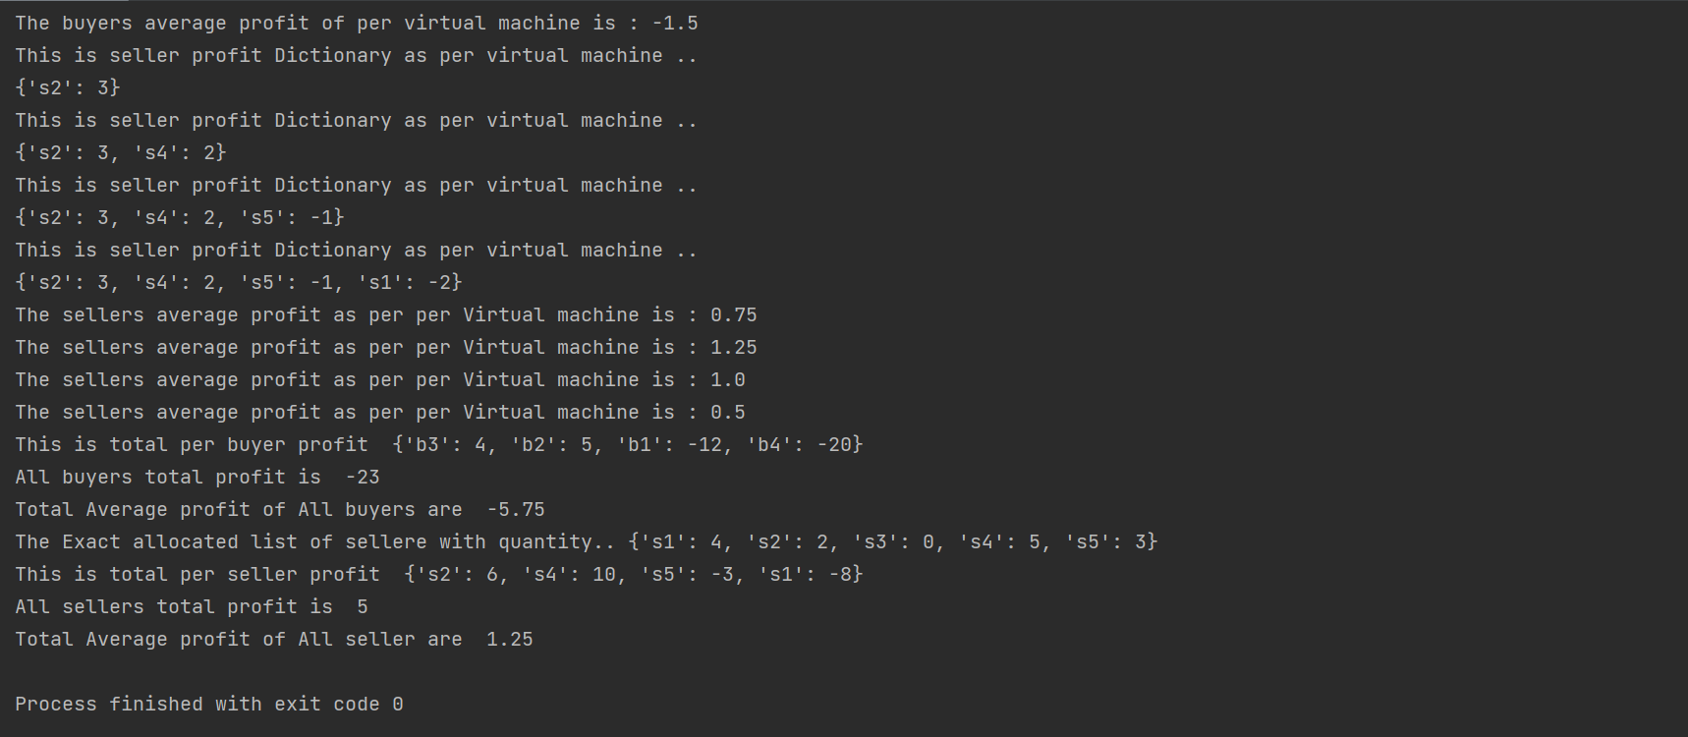

**Algorithm :**

buyer_bid={'b1':4,'b2':9,'b3':10,'b4':3,'b5':8}  
buyer_req={'b1':3,'b2':5,'b3':2,'b4':4,'b5':6}  
seller_bid={'s1':6,'s2':1,'s3':4,'s4':2,'s5':5}  
seller_req={'s1':5,'s2':4,'s3':2,'s4':6,'s5':4}  
seller_req_copy={'s1':5,'s2':4,'s3':2,'s4':6,'s5':4}