Discrete Automation Systems

Assignment 1

Dominik Walica

Md Aman Khan

# Controlled system

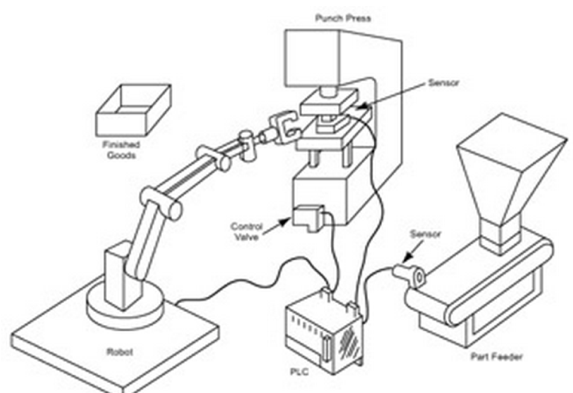

# Address/Variables

Motor - M – O0

Sensor - S – I1

Part available at the conveyor side - PA_IC – O1

Press has finished processing - PA_PR – O3

Part taken from the conveyor - R_IC – I3

Delivered part to the press - R_PR1 – I4

Taken part from the press- R_PR2 – I6

Press is in up the position - PR_Up – I2

Press is in the down position - PR_Dn – I5

Press goes down - PR_Act – O2

# Difficulties

* We had to imagine how the press and objects will move. And we had to simulate signals manually that object or press reached destination
* We also had to imagine actions of the robot. Since the robot is black box we had to use imagination to simulate his actions and output signals.
* Next problem is that, it is hard to debug the program, because we basically do not know, how the system is going to behave.

# Development

* We imagined the process step by step. At first, we tried to simulate how will the conveyor behave, then how will the robot behave and how will the press behave. Then we tried to simulate how will they act during interaction with each other.

# Main steps - Test

* Initially the press is in the up position -> PR_Up/I2
* Conveyor -> M/O0 -> runs until sensor -> S/I1 -> detects an object
* Sensor detects the object -> PA_IC/O1 -> Part available at conveyor side
* Robot takes the object -> R_IC/I3 -> And delivers it to the press, if press is in up position -> PR_Up/I2
* At this moment conveyor -> M/O0 -> Can run again until sensor -> S/I1 -> detects another object -> Motor cannot run until the robot picks this object and object cannot be picked until the previous object is processed
* If the part has been delivered -> R_PR1/I4 -> Press goes down -> PR_Act/O2 -> Until down position sensor sends signal that press is down -> PR_Dn/I5 -> The object has been processed -> PA_PR/O3
* After that press must return back to the initial position -> PR_Up/I2 -> And then Object can be taken to the box -> R_PR2/I6

# Contribution

* It is hard to describe involvement of each group member. But each member contributed to the assignment.