Submitted By: Aman Tariq
Roll No: 2023-SE-29
Course Name: DIP
Course Code: SE-3112
Session: 2023-2027
Submitted To: Engr. Ahmed Khawaja

DIP_Lab_Task # 01

Lab Task 1: Image Processing using OpenCV and Matplotlib
1. 1. Introduction
Image processing is a fundamental area of computer science that focuses on analyzing and modifying digital images to extract useful information. It is widely used in applications such as medical imaging, surveillance systems, robotics, and computer vision.
In this lab task, a colored image is used as an input image. Basic image processing operations such as RGB channel separation, grayscale conversion, and binary thresholding are applied using Python and OpenCV. The results are visualized as output images to understand the effect of each operation.
4. Methodology / Procedure
The following steps were performed in this lab:
- Input Image Loading
  - A colored image (coins.jpeg) was loaded using OpenCV.
  - This image is considered the input image for the lab.
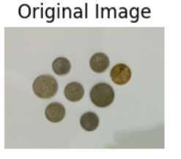
- Color Space Conversion
  - The image was converted from BGR to RGB format to display correct colors using Matplotlib.
- RGB Channel Separation
  - The image was split into Red, Green, and Blue channels.
  - Each channel was displayed as a separate output image.
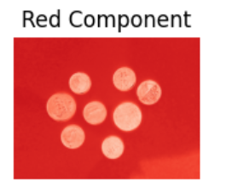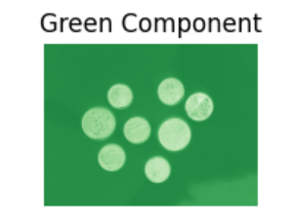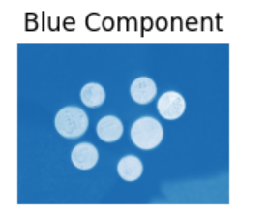
- Grayscale Conversion
  - The colored image was converted into a grayscale image to remove color information while preserving intensity.
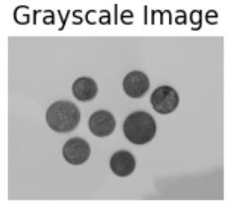
- Binary Image Creation
  - Binary thresholding was applied to the grayscale image to convert it into black and white pixels.
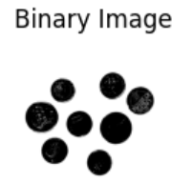
- Visualization
  - All images were displayed using Matplotlib in a 2×3 grid layout for better comparison.
5. Results and Discussion
The input image was successfully processed using basic image processing techniques. The RGB components clearly showed the contribution of each color channel in the image. The grayscale image simplified the image by removing color details while maintaining intensity information.
The binary image converted the grayscale image into black and white pixels based on a threshold value. These output images demonstrate how simple image processing operations help in understanding image structure and prepare images for further analysis such as segmentation and object detection.
6. Conclusion
This lab task successfully demonstrated basic image processing operations using OpenCV. RGB separation, grayscale conversion, and binary thresholding were performed effectively. These techniques form the foundation of advanced image processing and computer vision applications.

THE END

