Submitted By: Aman Tariq
Roll No: 2023-SE-29
Course Name: DIP
Course Code: SE-3112
Session: 2023-2027
Submitted To: Engr. Ahmed Khawaja

DIP_Lab_Task # 02
Lab Task 2: Image Processing using OpenCV and Matplotlib

1. Introduction
Image processing is widely used to analyze visual data and extract useful information from images. One important application of image processing is object detection and counting, which is commonly used in medical imaging, traffic analysis, and industrial inspection.
In this lab, a colored image is used as an input image. Different image processing techniques such as RGB channel separation, grayscale conversion, binary thresholding, and connected component analysis are applied. The final output images help in visualizing detected objects and counting them accurately.
4. Methodology / Procedure
The following steps were performed in this lab:
- Input Image Loading
  - A colored image (dip.jpeg) was loaded using OpenCV.
  - This image is considered the input image for the lab.
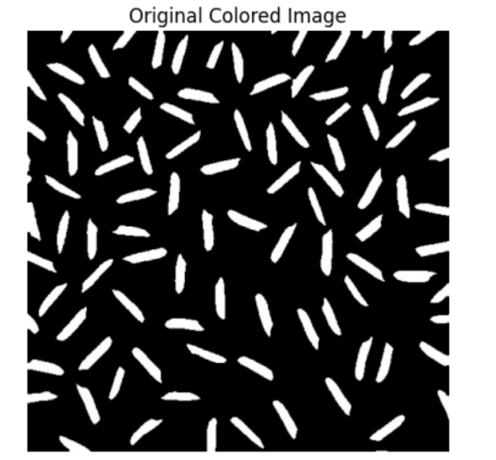
- Color Space Conversion
  - The image was converted from BGR to RGB format for correct visualization.
- RGB Channel Extraction
  - Red, Green, and Blue components were extracted by removing other color channels.
  - Each component was displayed as a separate output image.
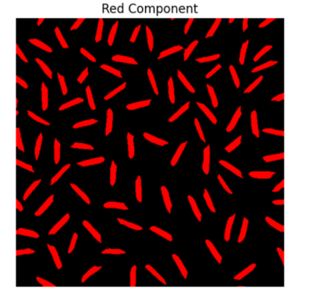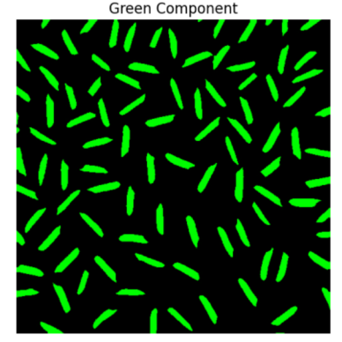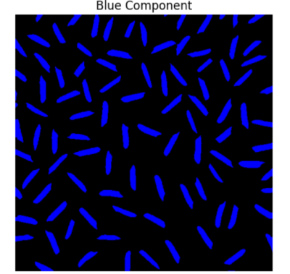
- Grayscale Conversion
  - The RGB image was converted into a grayscale image to reduce color information.
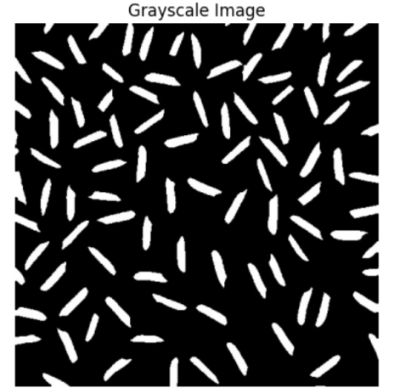
- Binary Image Creation
  - Binary thresholding was applied to the grayscale image to convert it into black and white pixels.
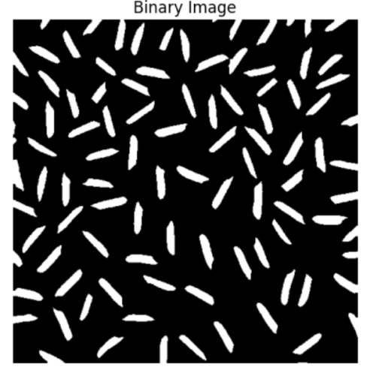
- Connected Component Analysis
  - Connected component labeling was applied to the binary image to detect individual objects.
  - Each detected object was assigned a random color for visualization.
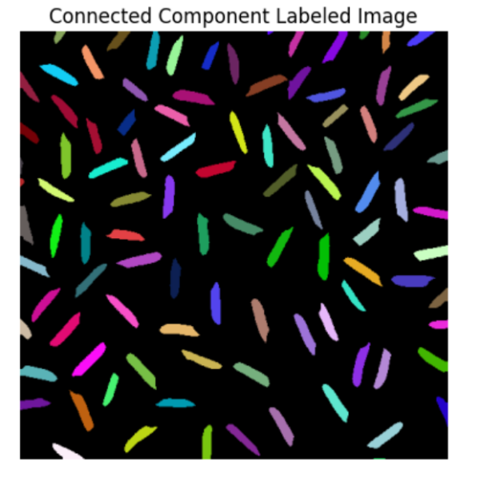
- Object Counting
  - The total number of detected objects was calculated by excluding the background.
5. Results and Discussion
The input image was successfully processed using different image processing techniques. The RGB components clearly showed the contribution of each color channel. The grayscale image simplified the image by removing color information while maintaining intensity.
The binary image separated foreground objects from the background using a fixed threshold. Connected component analysis detected and labeled individual objects with different colors. As a result, a total of 101 objects were detected from the input image.
These output images clearly demonstrate how image processing techniques can be used for object detection, segmentation, and counting.

6. Conclusion
This lab successfully demonstrated the application of basic image processing techniques for object detection and counting. A colored input image was processed using RGB channel separation, grayscale conversion, and binary thresholding. Connected component analysis was then applied to detect and label individual objects in the image.
The results showed that a total of 101 objects were accurately detected. This lab helped in understanding how simple image processing operations can be combined to perform object segmentation and analysis. These techniques form the foundation of many real-world computer vision applications.

THE END!

