Assignment 1

Python Programming Report
This report contains the description and testing details of all Python programs from Question 1 to Question 11.

Question 1: Create a diagram to show how Python works.
Program Description:
This diagram demonstrates the working flow of Python using Input, Processing, and Output components.
PYTHON WORKING DIAGRAM

Question 2: Program for arithmetic operations.
Program Description:
This program takes two numbers from the user and performs addition, subtraction, multiplication, division, modulo division, and floor division.
Testing Details:
The program was executed successfully with sample inputs and outputs.
Screenshot of Testing:
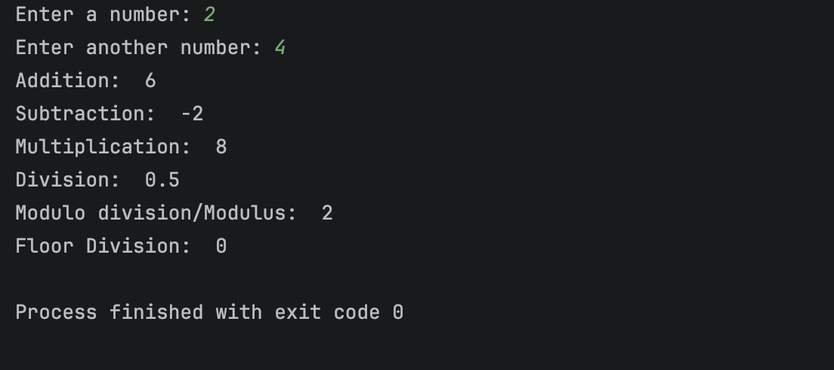

Question 3: Even or Odd checker.
Program Description:
This program checks whether the entered number is even or odd using conditional statements.
Testing Details:
The program was executed successfully with sample inputs and outputs.
Screenshot of Testing:
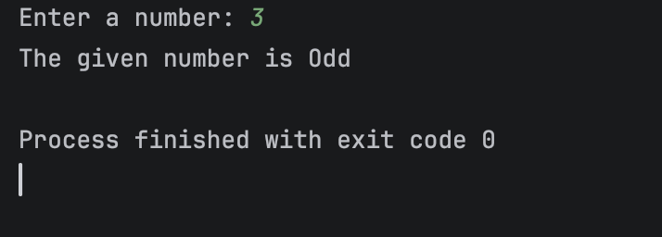
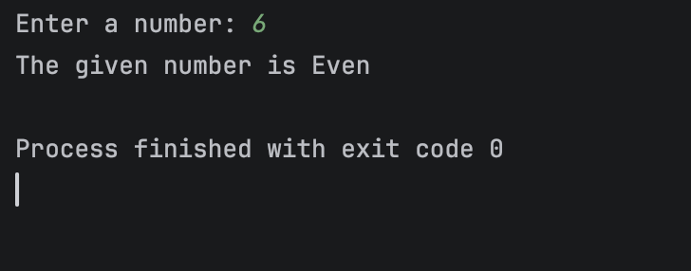

Question 4: Mathematical calculations.
Program Description:
This program performs square, square root, exponent, logarithm base 10, and powers of 3, 4, and 5 of a number.
Testing Details:
The program was executed successfully with sample inputs and outputs.
Screenshot of Testing:
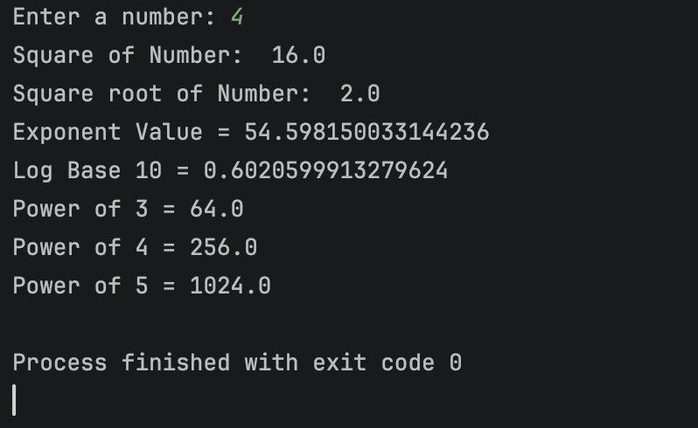
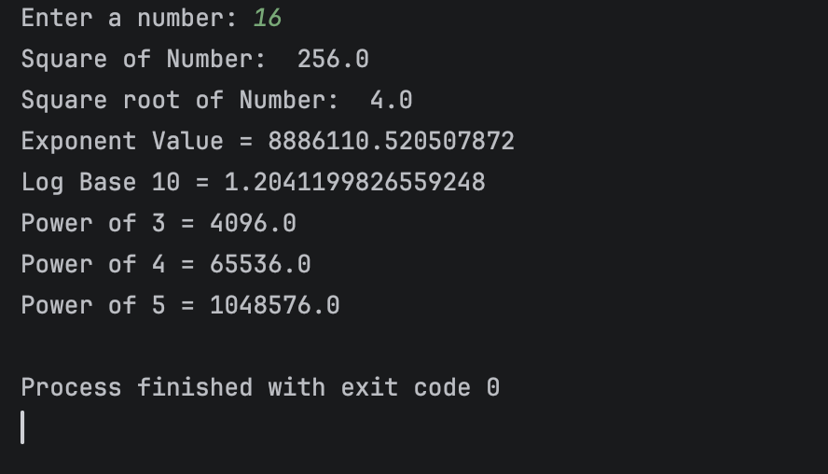

Question 5: Expression solver.
Program Description:
This program calculates algebraic expressions using user-provided values of variables a, b, and c.
Testing Details:
The program was executed successfully with sample inputs and outputs.
Screenshot of Testing:
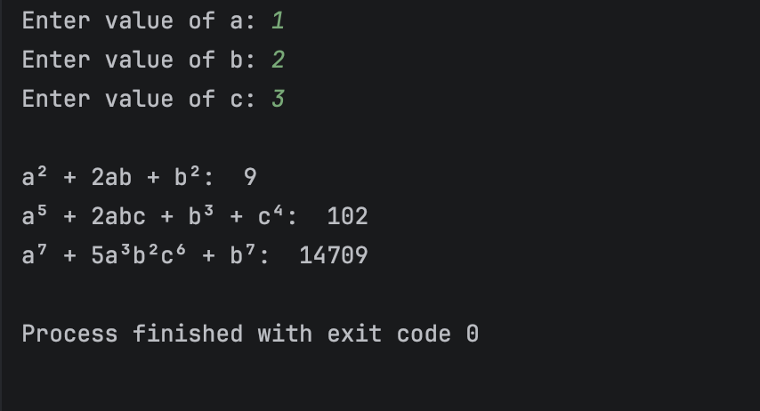

Question 6: Student marksheet system.
Program Description:
This program calculates total marks, average, percentage, and division of a student based on marks obtained in 5 subjects.
Testing Details:
The program was executed successfully with sample inputs and outputs.
Screenshot of Testing: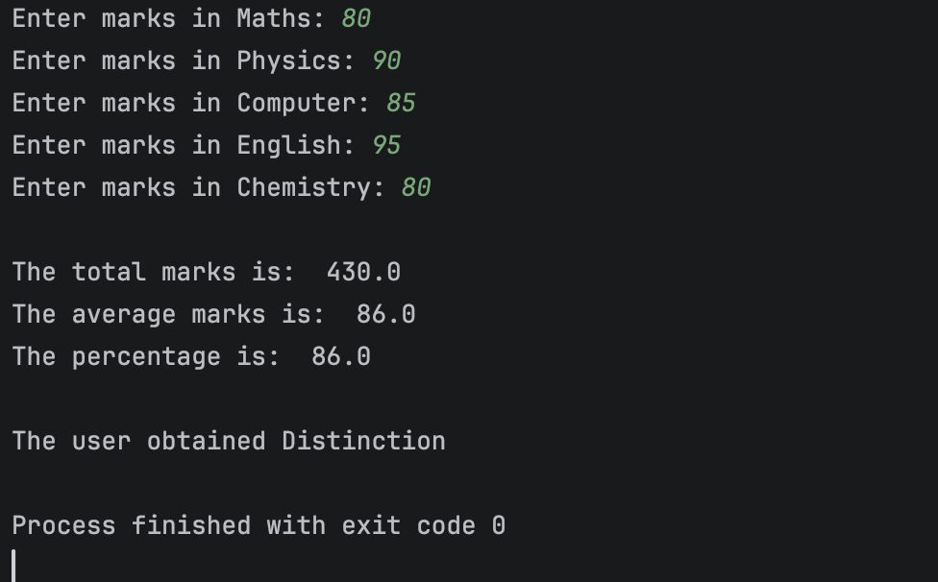
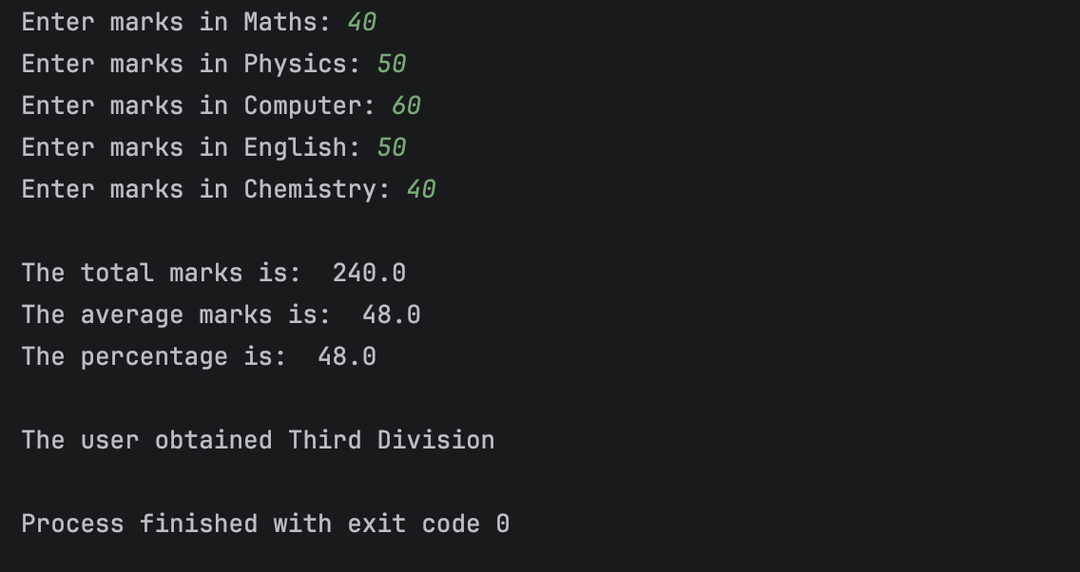
Question 7: Prime numbers between two numbers.
Program Description:
This program displays all prime numbers between two user-input numbers and also calculates the sum of prime numbers.
Testing Details:
The program was executed successfully with sample inputs and outputs.
Screenshot of Testing: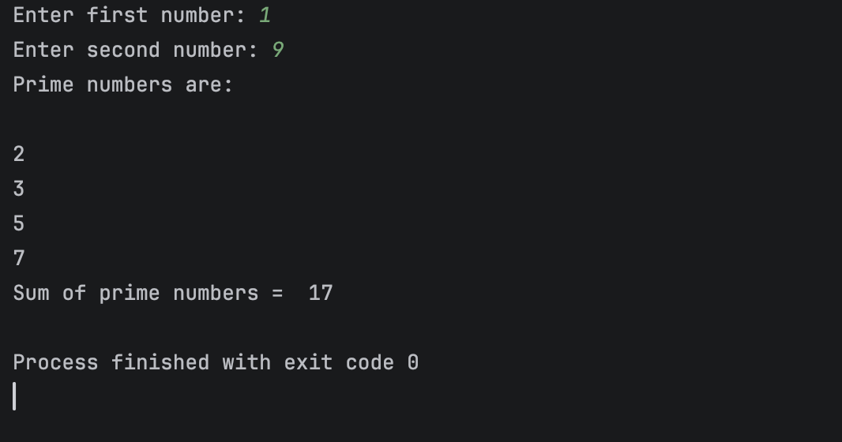

Question 8: Numbers divisible by 7 but not multiple of 5.
Program Description:
This program prints numbers divisible by 7 but not multiples of 5 between 2000 and 3200 and also allows user-defined ranges.
Testing Details:
The program was executed successfully with sample inputs and outputs.
Screenshot of Testing
- Between 2000 and 3200
Starting Ending User-Defined Ranges
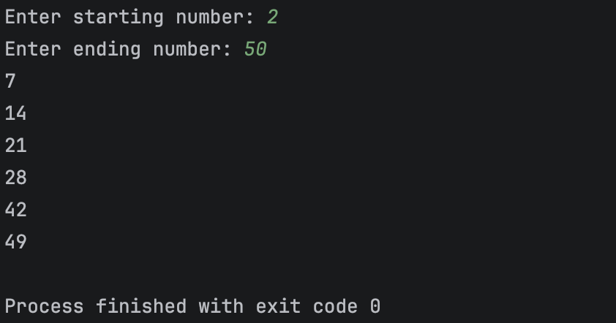
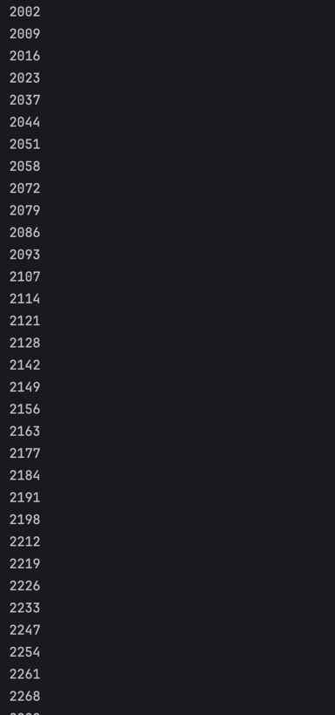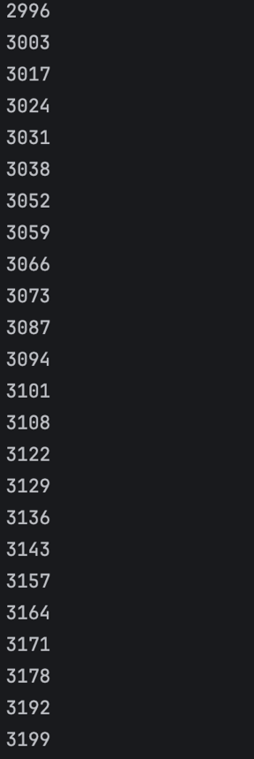

Question 9: Factorial finder with validation.
Program Description:
This program calculates the factorial of a number and validates whether the user input is numeric or not.
Testing Details:
The program was executed successfully with sample inputs and outputs.
Screenshot of Testing:
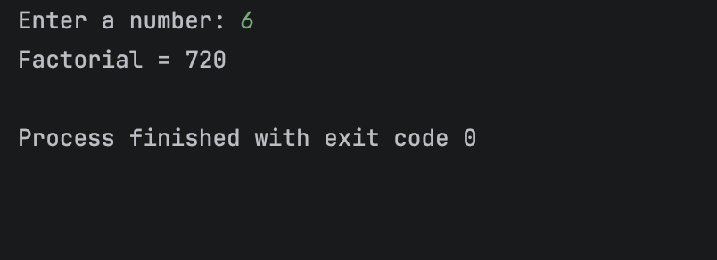
Validation Test:
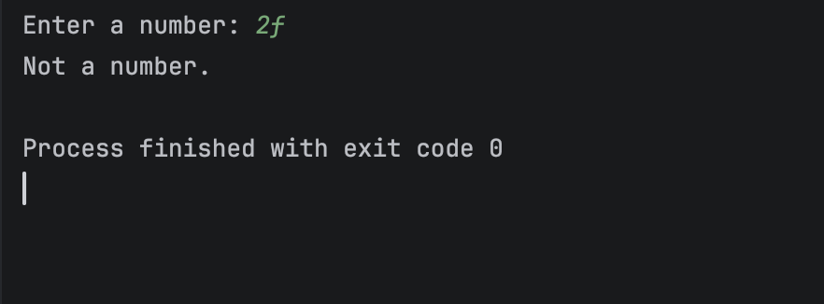

Question 10: Sum of odd and even numbers.
Program Description:
This menu-driven program continuously accepts numbers from the user ultil the user wants and calculates the sum of odd and even numbers.
Testing Details:
The program was executed successfully with sample inputs and outputs.
Screenshot of Testing:
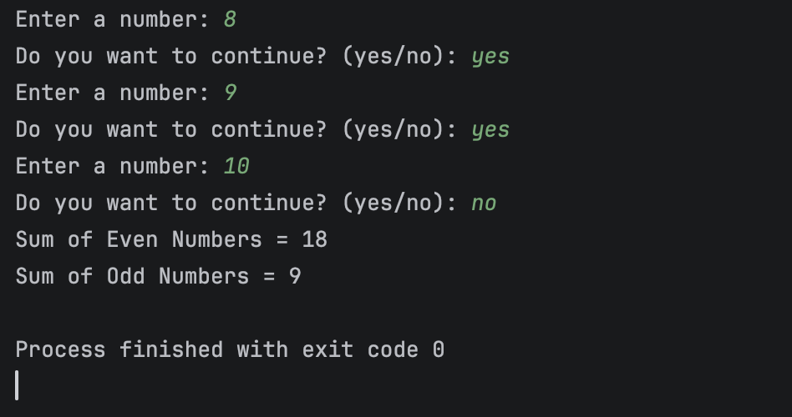

Question 11: Number guessing game.
Program Description:
This program generates a random number and allows the user to guess it within 5 attempts with feedback such as Too High, Too Low, or Correct.
Testing Details:
The program was executed successfully with sample inputs and outputs.
Screenshot of Testing:
