Assignment 2

Python Programs Report

Program 1
Description:
Function that accepts two numbers and displays sum, difference, product, and remainder.
Working:
The program accepts input (if required), processes the data using functions, loops, or dictionaries, and displays the result in the required format.
Testing Screenshot:
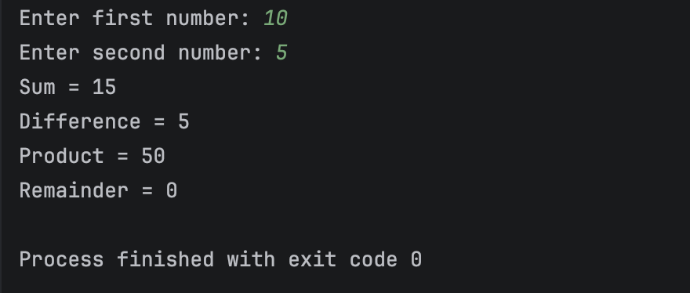
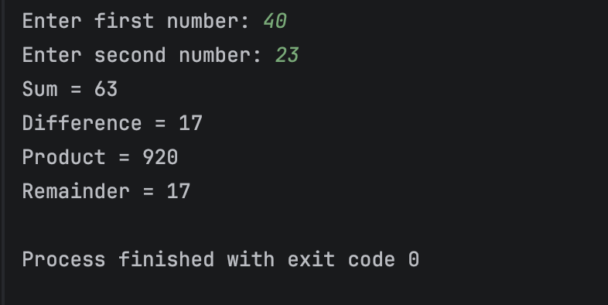

Program 2
Description:
Separate functions for addition, subtraction, multiplication, division, modulo division, and floor division.
Working:
The program accepts input (if required), processes the data using functions, loops, or dictionaries, and displays the result in the required format.
Testing Screenshot:
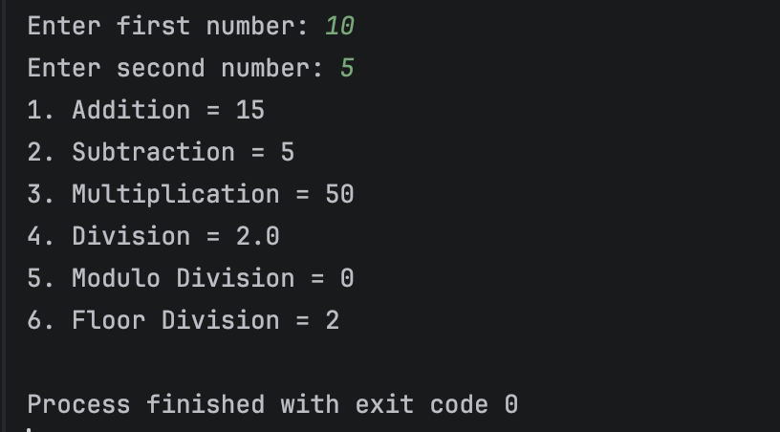
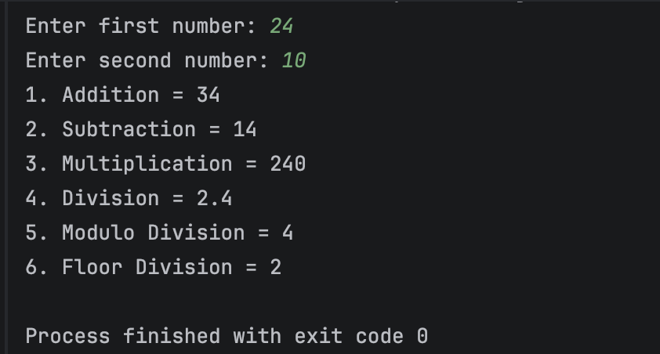

Program 3
Description:
Function that calculates and returns the factorial of a given number.
Working:
The program accepts input (if required), processes the data using functions, loops, or dictionaries, and displays the result in the required format.
Testing Screenshot:
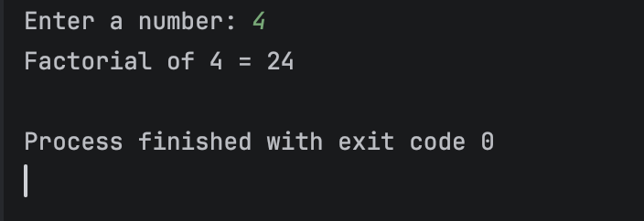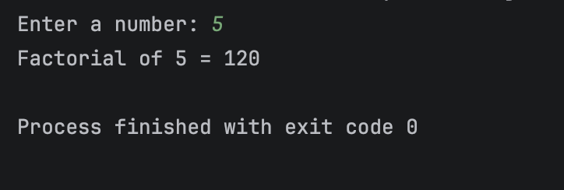

Program 4
Description:
Function that accepts a list of numbers and displays the occurrence of each number.
Working:
The program accepts input (if required), processes the data using functions, loops, or dictionaries, and displays the result in the required format.
Testing Screenshot:
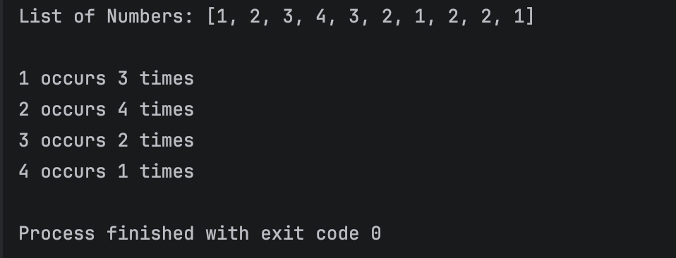

Program 5
Description:
Function that accepts a list of names and returns them in sorted order.
Working:
The program accepts input (if required), processes the data using functions, loops, or dictionaries, and displays the result in the required format.
Testing Screenshot:
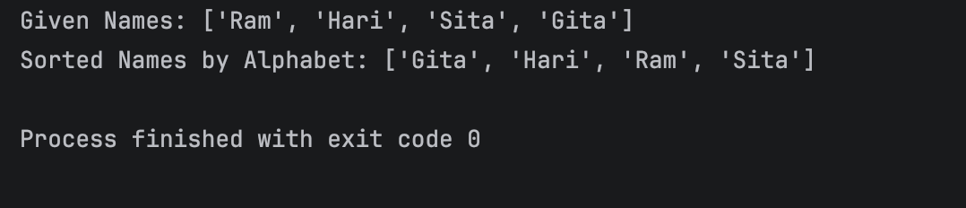

Program 6
Description:
Function that searches for a city in a list and returns its index if found.
Working:
The program accepts input (if required), processes the data using functions, loops, or dictionaries, and displays the result in the required format.
Testing Screenshot:
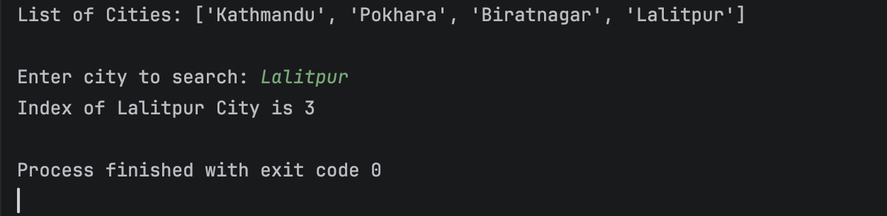
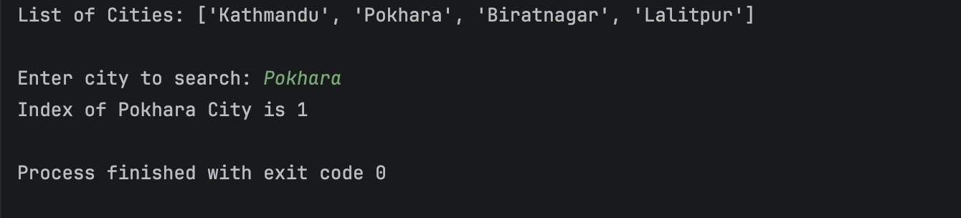

Program 7
Description:
Function that calculates the frequency of each word in a sentence.
Working:
The program accepts input (if required), processes the data using functions, loops, or dictionaries, and displays the result in the required format.
Testing Screenshot:
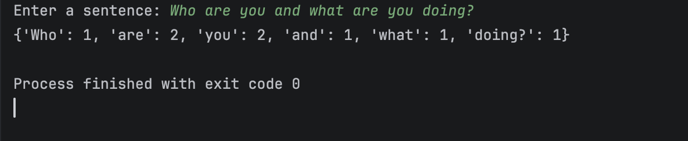

Program 8
Description:
Program that removes duplicate values from a list of numbers.
Working:
The program accepts input (if required), processes the data using functions, loops, or dictionaries, and displays the result in the required format.
Testing Screenshot:
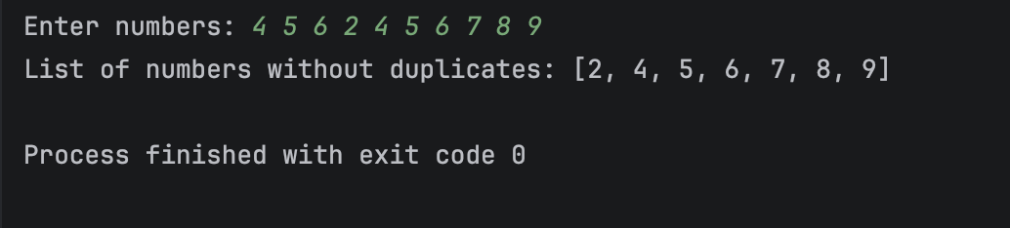

Program 9
Description:
Program that stores details of five books in a dictionary and displays them.
Working:
The program accepts input (if required), processes the data using functions, loops, or dictionaries, and displays the result in the required format.
Testing Screenshot:
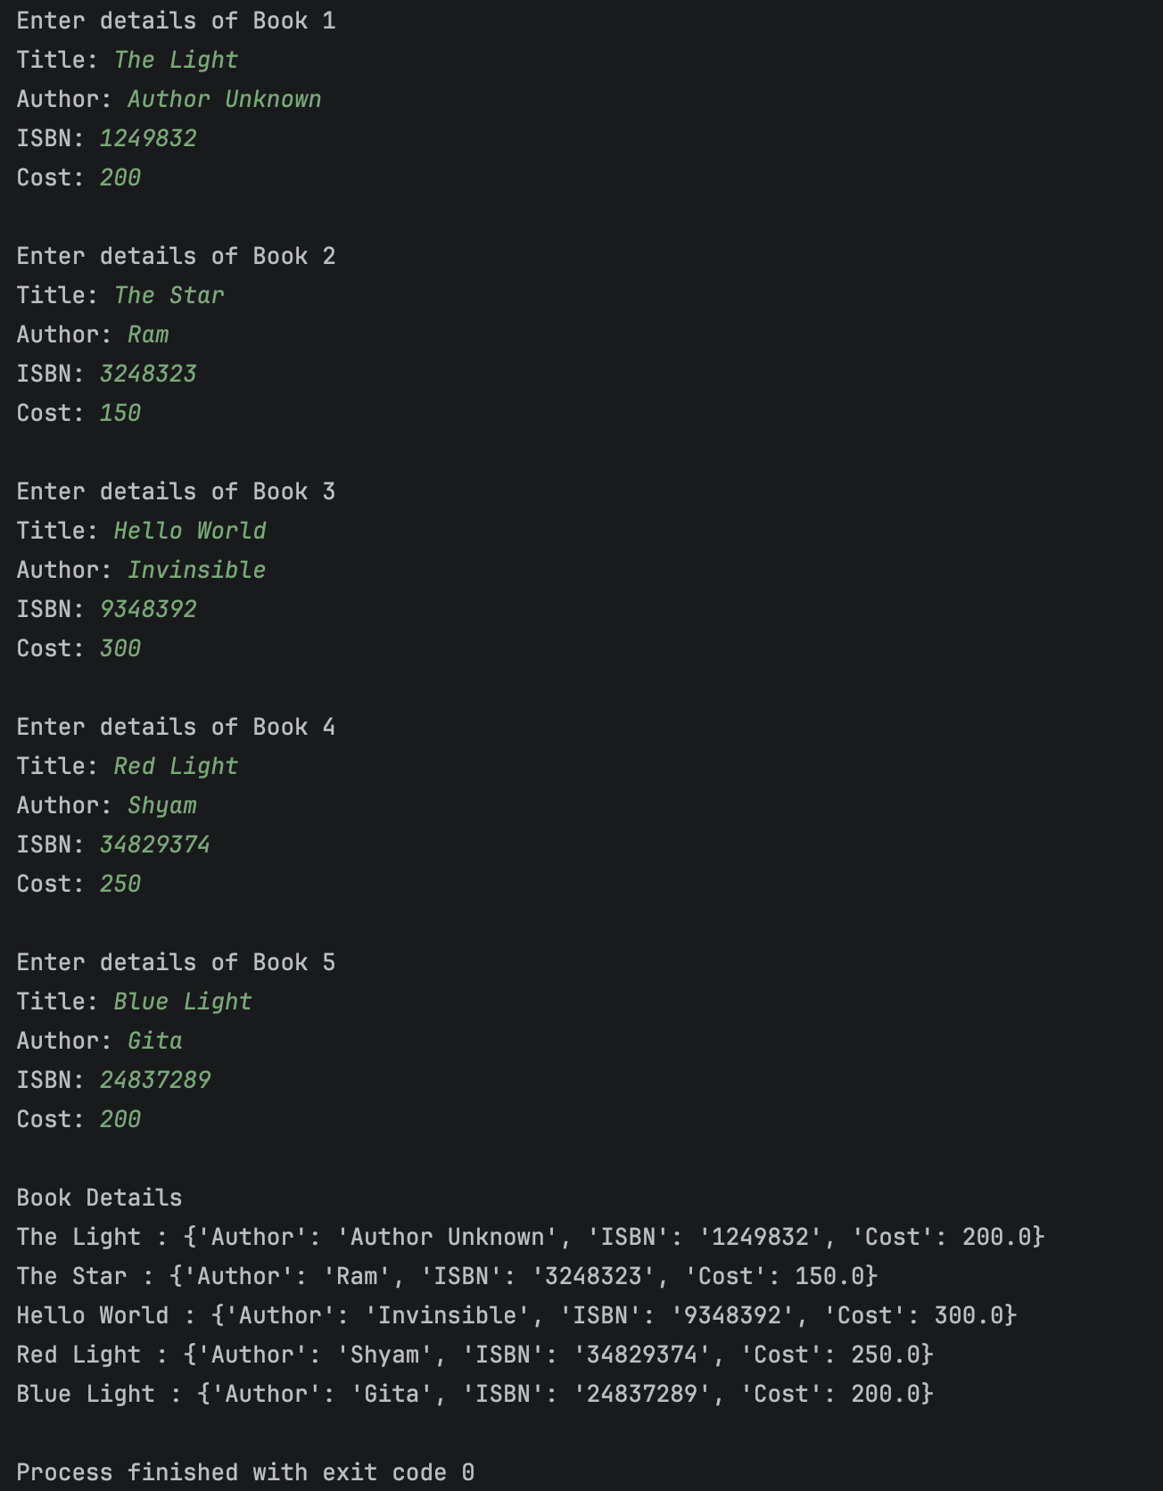

Program 10
Description:
Program that separates user-entered numbers into even and odd lists.
Working:
The program accepts input (if required), processes the data using functions, loops, or dictionaries, and displays the result in the required format.
Testing Screenshot:
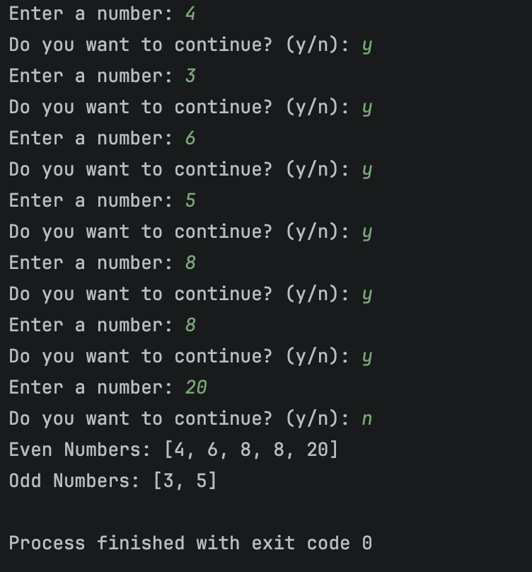

Program 11
Description:
Card guessing game using randomly selected card value and suit.
Working:
The program accepts input (if required), processes the data using functions, loops, or dictionaries, and displays the result in the required format.
Testing Screenshot:
