**SRI LANKA INSTITUE OF**

**INFORMATION TECHNOLOGY**



**ID No: IT20067342**

**Name: Jayasuriya J.A.D.A.S**

**Batch: DS weekday Assignment: 02**

# Step 1: Data source

Data warehouse designed at the Assignment I is used as the data source for this assignment. Data warehouse consists of 6 dimension tables and one fact tables to represent Accident data altogether.

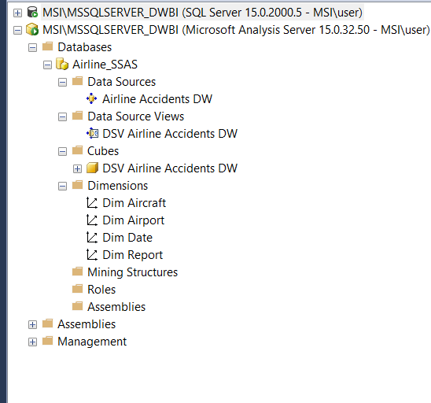

## ER Diagram for the source system

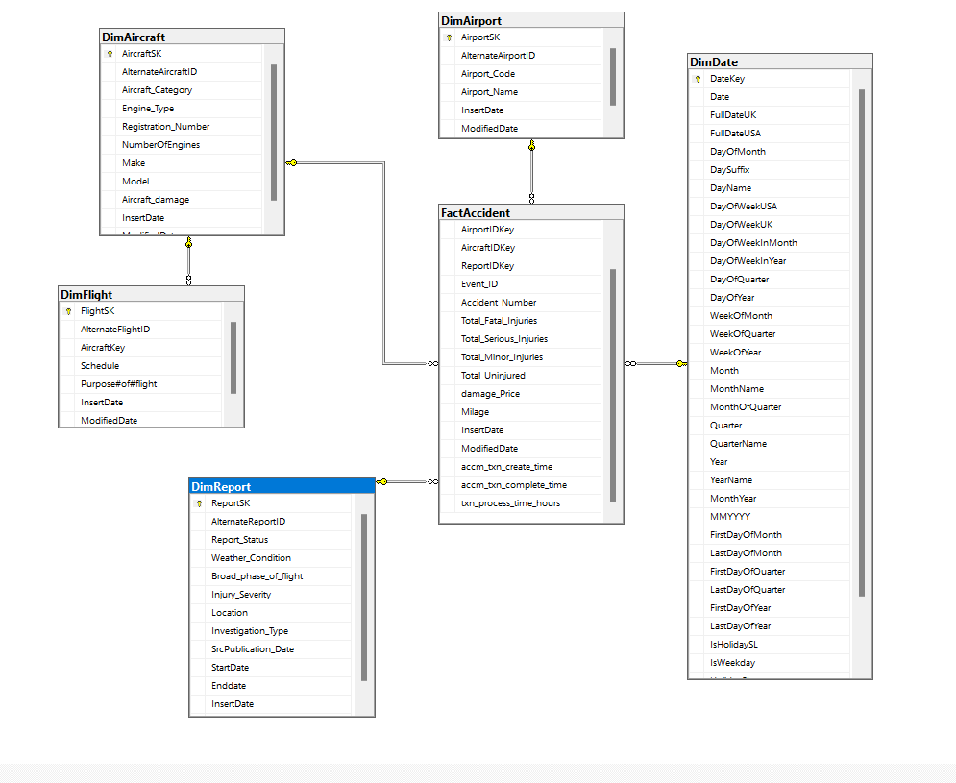

# Step 2: SSAS Cube implementation

SSAS cube implementation is followed with several steps.

## I. Project creation

SSAS project is created in Visual studio for the Airline Accident data in data warehouse. The project is renamed to Airline_SSAS

## II. Data Sources Configuration

In the created project, data source folder is selected under the Airline_SSAS package. After creating a connection to the MS SQL server, ‘DataWarehouse’ database in sql server has been selected as the data source.

## III. Data Source View Configuration

In the Data Source View Wizard, configured data source has been selected. Then the necessary tables and views required for cube design has been selected as shown below.

## Data Source View

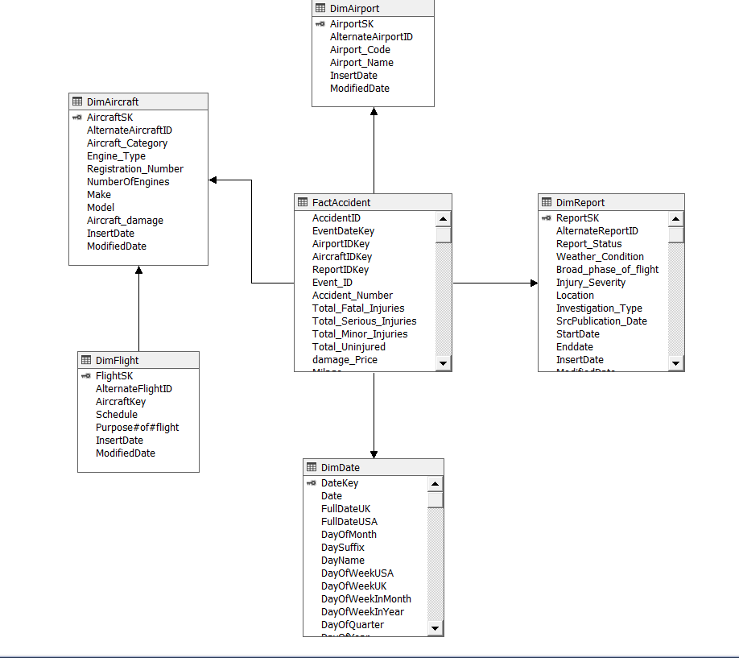

Data source view has been configured with its relevant tables as per the above design.

### IV. Cube Design

In the Cube wizard FactAccident has been selected as the Measure table and DimAircraft, DimAirport, DimReport, DimFlight as dimension tables for the cube.

Using measures and dimensions Cube is designed as below.

## Cube Design

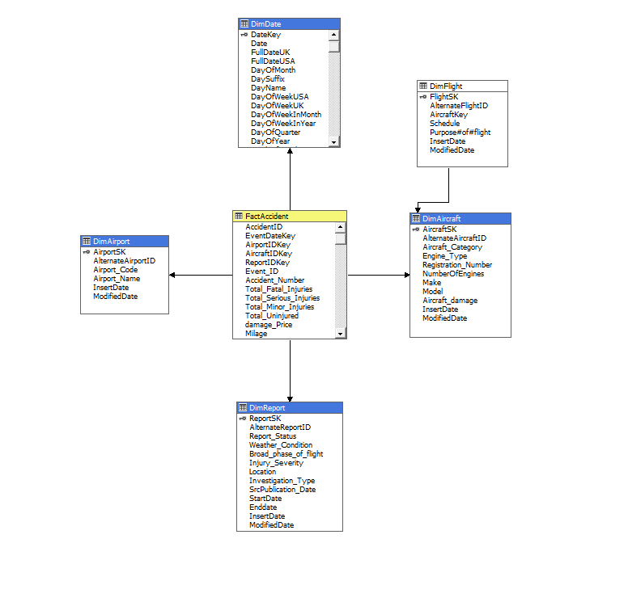

V.

Cube Implementation

Implementing Hierarchies

I.

Hierarchies on DimDate

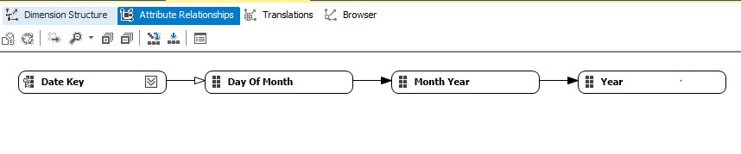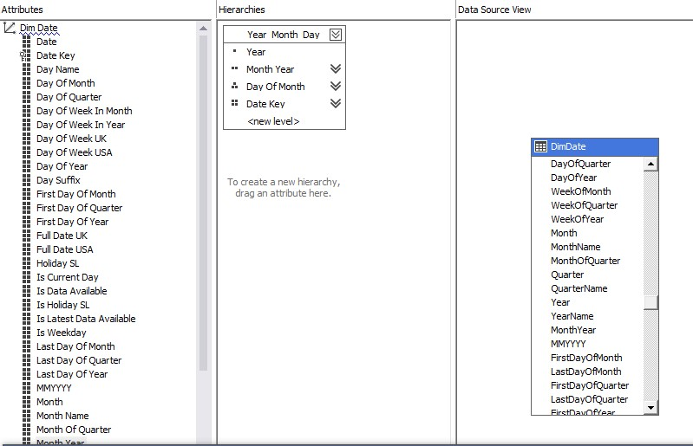

Then the SSAS was deployed in MSSQL server management studio. The deployed data cube contains the fact transaction measure table with Dim Report, Dim Airport , Dim Date, Dim Aircraft tables dimension tables.

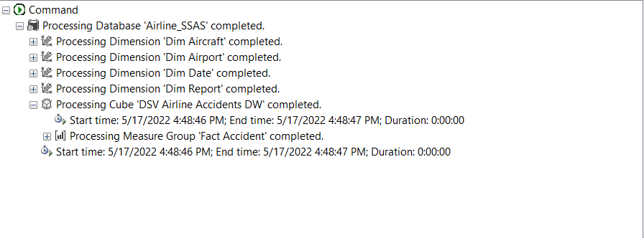

### KPI Creation

KPI is designed on damagePrice attribute of Measures. It checks if the estimated damage cost is more than $5000.If so value is set to success(True) else set to fail(False).

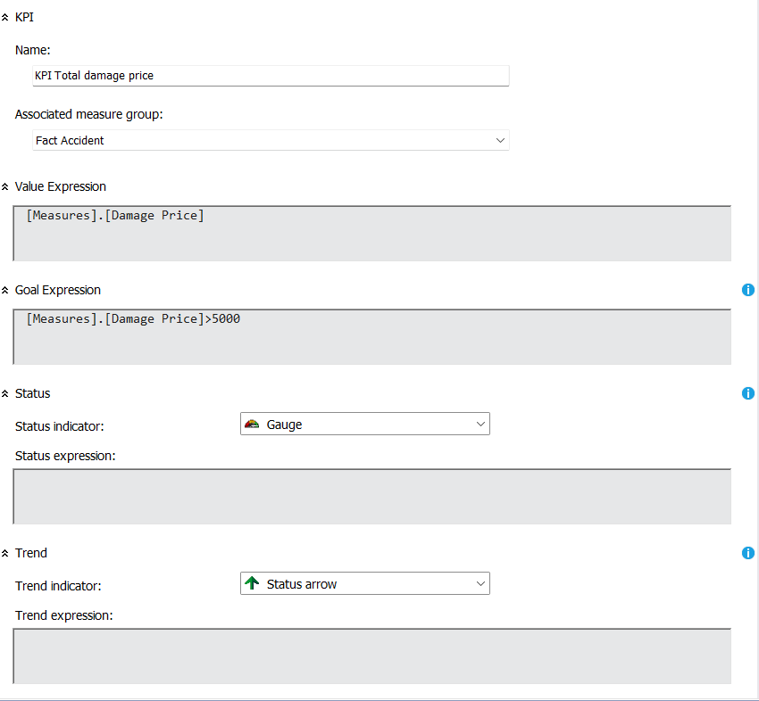

# Step 3: SSAS Cube implementation

In the data tab of excel Microsoft analysis services are selected from other sources. There the relevant database to create the pivot table

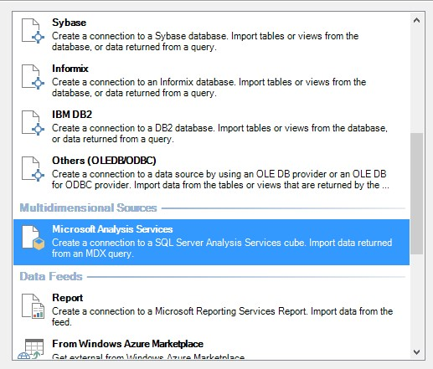

## I. Roll-Up

It can be seen about total amount of fatal injured passengers of each accidents and total accident count of the relevant airport. Category by Airport name.

## II. Drill-Down

In this graphs represent the total count of Accidents and total count od fatally injured passengers. According to the Airport. And also airport has child category called Accident_Type which describe the investigation type.

## III. Slice

We can get count of Accidents and count of totally injured persons according to the Investigation_Type.

## IV. Dice

a new column-wise which is called Airport Name categorization is introduced so that values can be filtered in two dimensions.

# Step 4: SSRS Reports

## I. Report 1: Report with a matrix

## II. Report 2: SSRS drill-down report

## IV. Report 3: SSRS drill-through report

Final set of reports:

