Mail to ajprofessionals@gmail.com for complete project synopsis, project report, source code and database

or visit for more details

http://www.readymadeproject.com/aj/academic_project_list.htm

Online Student Registration System

Synopsis

Submitted by

Mr. XXXXX XXXXXX

in partial fulfillment for the award of the degree

of

BCA (Bachelor of Computer Application)

IN

MUMBAI

XXX XXXXXXXX College

Mumbai University : Mumbai - 400001

January - 2010

A PROJECT REPORT ON
ONLINE STUDENT REGISTRION SYSTEM

A PROJECT REPORT

Submitted by

ATANU MAITY

in partial fulfillment for the award of the degree

of

Bachelor of Computer Application

XXX ENGINEERING COLLEGE, MUMBAI

MUMBAI UNIVERSITY:: MUMBAI 400001

JANUARY 2010

MUMBAI UNIVERSITY: MUMBAI 400 001

BONAFIDE CERTIFICATE

Certified that this project report “…………….Online Student Registration System…………………..”
is the bonafide work of “……………..…..Mr. ATANU MAITY…………” who carried out the project work under my supervision.

<<Signature of the Head of the Department>> <<Signature of the Supervisor>>
SIGNATURE SIGNATURE

<<Name>> <<Name>>
HEAD OF THE DEPARTMENT SUPERVISOR

<<Academic Designation>>

<<Department>> <<Department>>

<<Full address of the Dept & College >> <<Full address of the Dept & College >>

TABLE OF CONTENTS

1. Problem Definition and scope of project 5
1.1 Purpose 5
1.2 Objective 6
1.3 Project Scope 7
1.4 Technologies 8
1.4.1 Operating Environment 8
1.4.2 Deployment Environment 9
1.4.3 Development Tools and Technologies 10
1.4.4 Development Environment 13
7.4 Process Flow Chart 15
7.5 ER Diagram 16
7.7 Data Dictionary 17
7.7.1 Table: answer_master 17
7.7.2 Table: test_master 18
7.7.3. Table: registration 19
7.7.4 Table: question_master 20
7.8 Data Flow Diagram DFD 21
7.8.1 Context Level 21
7.8.2 Level 1 (High Level Diagram) 22
10. Future Enhancement 23
11. Bibliography 24
11.1 Websites 24
11.2 Books 24

1. Problem Definition and scope of project

1.1 Purpose

Currently student submits hardcopy of filled application form to the college/university, office staff enters all data into excel file and write same in manual register. Issue hall ticket / admit card to student and conduct test for student. Student comes to college and gives test for the specified date. Office staff check all the paper calculate results and type all the details for taking printout and display it in college premises. College inform student to check the result, student comes to college and view the results.

Proposed online student registration system will eliminate all the manual intervention and increase the speed of whole process. System will allow student to fill the form online, system has inbuilt validation system to validate the entered data. After successful submission, system will give unique registration no for each student. Student can login into system by using registration no and give online test. System will show the result after instantly and stored the results for further use.
Today internet become reality and usage of internet become very much popular and there is tremendous increase of internet in all over the world for education purpose. The Online Student Registration System is easy to use, full-featured and flexible Student Registration, Testing and Assessment web portal.

This project report describes the software functional and nonfunctional requirements for release 1.0 of the Online Student Registration system. This document is intended to be used by the members of the project team that will implement and verify the correct functioning of the system. Unless otherwise noted, all requirements specified here is high priority and committed for release 1.0.

1.2 Objective

Online Student Registration System –is complete end to end solution to cover all aspects of online student registration process

The basic objective of developing this project is:

- Provides complete web site solution, including student registration, giving tests, storing of results. Complete web based administration.

- The online examination system can automatically add the marks allocated in each question to determine the total mark for the test.

- Using this feature the questions can be selected from the question Bank, and also the appearance of questions in the Random Order.

- Student can registered and login into the system.

- Can view test result and give online test.

- Student must able to change his/ her own password.

- Complete web based system no installation required to run the application in client system.

- Student result must save and can be retrieving later on.

- Question must provide answer type like multiple right answer selection and one right answer selection. Test screen must provide options accordingly.

- System must able to evaluate the examination and display the result instantly, student must view the correct answer after complete the test.

- System has powerful logical access management in place, each user must be identified by login id and strict password policy is applied to secure the system

- Generate various reports for administration like, Total students/members registered for examination, no of available examination, test given by the student.

1.3 Project Scope

The Online Student Registration System will permit to register and take online examination and maintaining master information and generating various reports of test. The main users of the project are Student or Member and system Administrator.

From an end-user perspective, the Online Student Registration System Project consists of following functional elements: enhanced student registration module, giving examination, manage password.

OSRS-1: Home – It is the default page for the site. All links are available in this page.

OSRS -2: Login – Student need to login to view his old test result information and to give new test.

OSRS -3: Register – New Student need to register to give examination. Type all the details of the student like email id, name, address, contact details, course name and submit. System generates unique user id for each student and. Students need this user id to login into

OSRS -4: My Page – It shows the details of currently logged student details, previously saved test results can be viewed here and other links like New Test, Logout, and Change Password.

OSRS -5: Change Password – Student can change his password from this link. Student must type his old password to change the password with new password.

OSRS -6: Logout – By clicking this link user logged out from this site all user session reset to default value.

OSRS -7: Test – It display the test page, system randomly select questions from question bank and display one by one to the student. Student navigate the questions and select the right answer from available options, after complete the examination system display the results instantly and save the test details in system for future reference.

Both of these areas of functionality will be delivered as the first version of the online student registration system is released. Functionality is described in more detail later in this document.

1.4 Technologies

1.4.1 Operating Environment

OE-1: The online student registration system web application will operate with the following Web Browsers: Microsoft Internet Explorer version 5.0, 6.0. 7.0

OE-2: The online student registration system web application shall operate on a server running the latest versions of IIS (Internet Information Server).

OE-3: The online student registration system web application shall permit user access from Internet connection

OE-4: Operating System: Windows 2000. XP

OE-5: Software requirements: MS Access, ASP.

OE-6: Languages used ASP Script and scripting is done using JavaScript.

OE-7: Hardware Requirements: 256(minimum)/512(recommended) MB RAM

OE-8: Hard disc- nGB depending upon the requirement to store data minimum of 25GB.

1.4.2 Deployment Environment

DE-1: Database Server
OS – Win 2003 Enterprise Server
SQL Server 2005
HDD – Min 10 GB, Recommended 25 GB
RAM – Min 2 GB, Recommended 4 GB
Processor - Pentium Dual Xenon Processor

DE-2: Application Server
OS – Win 2003 Enterprise Server
IIS – Internet Information Server
HDD – Min 5 GB, Recommended 10 GB
RAM – Min 2 GB, Recommended 4 GB
Processor - Pentium Dual Xenon Processor

DE-3: The online student registration system web application will operate with the following Web Browsers: Microsoft Internet Explorer version 5.0, 6.0. 7.0.

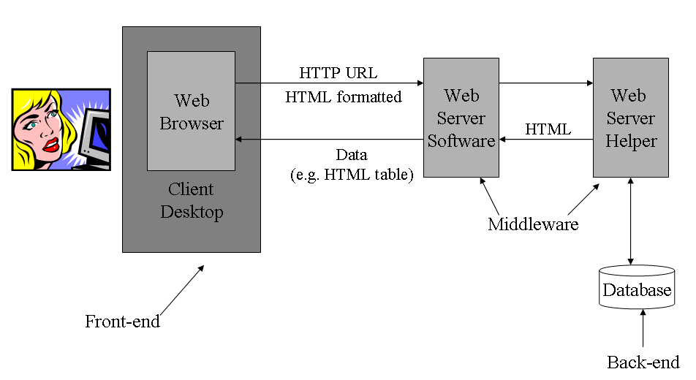

[ Online student registration system architecture]

1.4.3 Development Tools and Technologies

DT-1: ASP
ASP (Active Server Pages) is a platform for creating interactive web sites that was created by Microsoft. It was designed to be easier to use, faster to develop in, and to perform better than Perl/CGI. You can program ASP in a server side scripting languages, but the primary scripting languages used today are VBScript and JScript.

Active Server Pages (ASP) programming is writing code to facilitate ASP functionality on websites. Such functionality includes the delivery of dynamic, database-driven content to website viewers without taxing the server-side system. ASP programming involves writing ASP files and HTML files. The ASP code is placed within the HTML pages, enclosed in special tags. When you need to make changes in the ASP programming code, you need change only the ASP files; the HTML files, which do nothing but go and get the ASP files' coding, need not be changed.

ASP files have a file extension of .asp, much like HTML files have file extensions of either .htm or .html. The HTML files that contain the ASP instructions enclose those instructions within tags that look like this: . Notice that unlike HTML, the ASP ending tag does not include a slash. To send the results of an ASP instruction directly to a browser, you add an equals sign:

DT-2: MS Access

  - Microsoft Access is known for its ability to empower non-professional developers to create database applications on their own. Users can easily create tables, queries, forms and reports, and connect them together with macros. Advanced users can use VBA to write rich solutions with advanced data manipulation and user control.

  - The original concept of Access was for end users to be able to “access” data from any source. Access offers the ability to import and export data to many formats including Excel, Outlook, ASCII, dBase, Paradox, FoxPro, SQL Server, Oracle, ODBC, etc. It also has the ability to link to data in its existing location and use it for viewing, querying, editing, and reporting. This allows the existing data to change and the Access platform to always use the latest data. It can even perform heterogeneous joins between data sets stored across different platforms. Access is often used by people downloading data from enterprise level databases for manipulation, analysis, and reporting locally.
  - A significant strength of Microsoft Access is its Jet Database format (MDB or ACCDB in Access 2007) which can contain the application and data in one file. This makes it very convenient to distribute the entire application to another user, who can run it in disconnected environments.

  - One of the benefits of Access from a programmer's perspective is its relative compatibility with SQL (structured query language) — queries can be viewed graphically or edited as SQL statements, and SQL statements can be used directly in Macros and VBA Modules to manipulate Access tables. Users can mix and use both VBA and "Macros" for programming forms and logic and offers object-oriented possibilities. VBA can also be included in queries.

  - Microsoft Access offers parameterized queries. These queries and Access tables can be referenced from other programs like VB6 and .NET through DAO or ADO. From Microsoft Access, VBA can reference parameterized stored procedures via ADO.
  - Microsoft Access is a file server based database. Unlike client server RDBMS, Microsoft Access does not implement database triggers, stored procedures, or transaction logging.

Advantages of Microsoft Access

• Easy to use and easy to deployment.
• Integration with Windows OS
• Scalability
• Import and Export of data in all major database system.
• Centralized Management
• Reliability
• Automating Tasks
• ADO compatibility especially with ASP scripting.

1.4.4 Development Environment

DE-1: 1.Visual Studio 6.0

7.4 Process Flow Chart
Start
Registered

Student Registration
Login
YES
NO
Examination?

View Account Status?

NO
View/Search Examination
View Account Status
Select Examination
Give Examination
Complete Examination?

View Results
View Answers
Logout
Stop
YES
YES
NO
NO
YES

7.5 ER Diagram

Mail to ajprofessionals@gmail.com for complete project synopsis, project report, source code and database

or visit for more details

http://www.readymadeproject.com/aj/academic_project_list.htm

7.7 Data Dictionary

7.7.1 Table: answer_master

[answer_master table is used to store multiple answers for every questions]

7.7.2 Table: test_master

[test_master table is used to store test details]

7.7.3. Table: registration

[registration table is used to stores student registration details]

7.7.4 Table: question_master

[Table question_master is used to store question details]

7.8 Data Flow Diagram DFD

A data-flow diagram (DFD) is a graphical representation of the "flow" of data through an information system. DFDs can also be used for the visualization of data processing (structured design). On a DFD, data items flow from an external data source or an internal data store to an internal data store or an external data sink, via an internal process.

7.8.1 Context Level

Examination
Online Student Registration System

Question Bank

Student

Results

This context-level data flow diagram first, which shows the interaction between the system and external agents which act as data sources and data sinks. On the context diagram (also known as the Level 0 DFD) the system's interactions with the outside world are modelled purely in terms of data flows across the system boundary. This context diagram shows the entire Online Student Registration System as a single process,

7.8.2 Level 1 (High Level Diagram)

Student
Select Examination

1
Examination
Master
View Examination
Details
2
Give Examination
View Results

3
Question Bank

This level (level 1) shows all processes at the first level of numbering, data stores, external entities and the data flows between them. The purpose of this level is to show the major high-level processes of the Online Student Registration System and their interrelation. A level-1 diagram must be balanced with its parent context level diagram, i.e. there must be the same external entities and the same data flows, these can be broken down to more detail in the level 1, e.g. the "Select Examination" data flow could be spilt into "View Details" and "View Results" and still be valid.

10. Future Enhancement

This project was developed to fulfill user requirement; however there are lots of scope to improve the performance of the Online Student Registration System in the area of user interface, database performance, and query processing time. Etc.

So there are many things for future enhancement of this project. The future enhancements that are possible in the project are as follows.

- Web Based interface for system administrator to add modify question bank, which presently done from back end
- Web based interface for generate reports, student test details for system administrator
- Linking and integration of other online educational web sites.
- Integration with university database through Web Services
- Connection to third-party OLAP applications
- In the area of data security and system security.
- Provide more online tips and help.
- To optimize the query which is embedded in the system.

11. Bibliography

11.1 Websites
Following websites are referring to create this project reports.
- http://www.google.com
- http://www.microsoft.com
- http://www.programmer2programmer.net
- http://www.codeproject.com
- http://www.asp.net
- http://www.asp123.com
- http://www.wikipedia.org

11.2 Books
Following books and ebook are used to complete this project reports.
- Mastering C# (Paperback)
- SQL Server Bible (Paperback)
- .NET Black Book (Paperback)
- Professional C#, 2nd Edition (Paperback)
- Professional ASP.NET (Paperback)
- MCAD/MCSD Self-Paced Training Kit: Developing Web Applications with Microsoft® Visual Basic® .NET and Microsoft Visual C#® .NET, Second Edition
- MCAD/MCSE/MCDBA Self-Paced Training Kit: Microsoft SQL Server 2000 Database Design and Implementation, Exam 70-229, Second Edition

Mail to ajprofessionals@gmail.com for complete project synopsis, project report, source code and database

or visit for more details

http://www.readymadeproject.com/aj/academic_project_list.htm

