INDIRA GANDHI NATIONAL OPEN UNIVERSITY

PROJECT PROPOSAL (SYNOPSIS)

MCSP-060

ON

ONLINE BANKING SYSTEM

By

Aman Tiwari (186407279)

UNDER GUIDANCE

OF

Mr. Sabhya Verma

Submitted to the Shyamlal College (0769), IGNOU in

Partial fulfilment of the Requirements for the degree of

Masters

Of

Computer Applications



Indira Gandhi National Open University

Maidan Garhi

New Delhi-110068



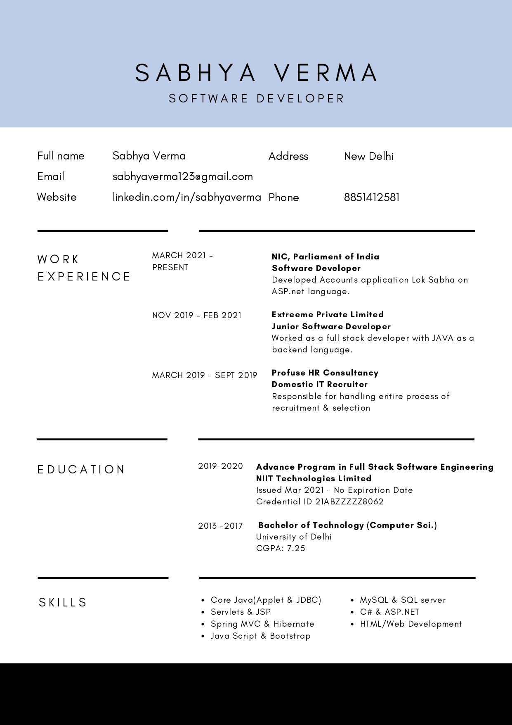

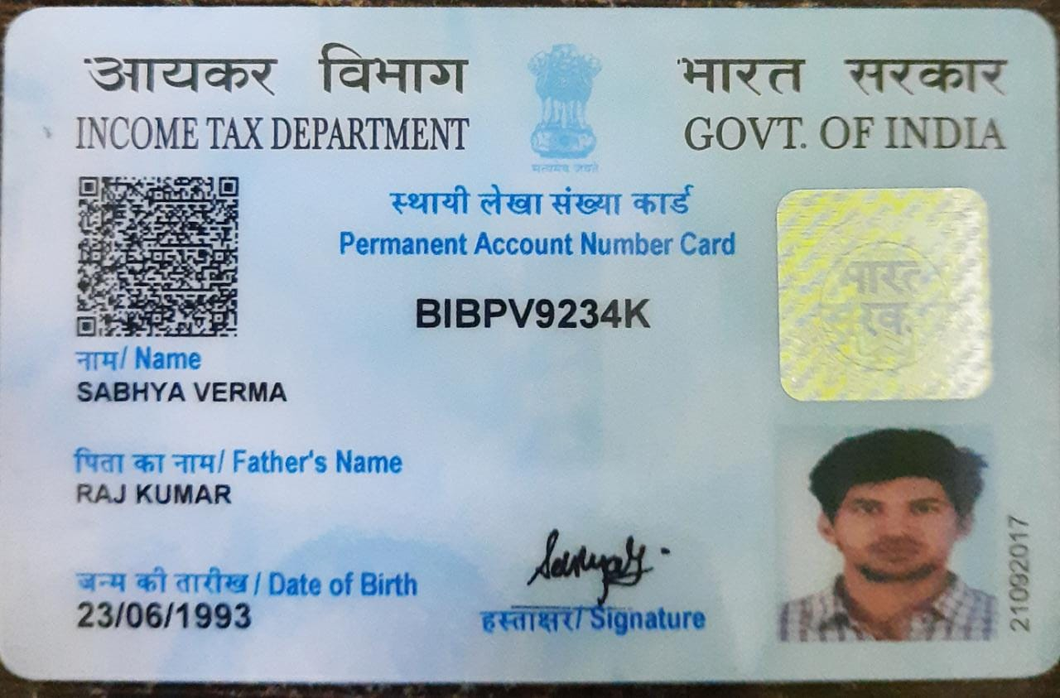



**Table of Content**

|  |  |  |  |  |
| --- | --- | --- | --- | --- |
| **S.NO.** | | **CONTENT** | | **PAGE NO.** |
| **1.** | **Title of the Project** | |  | |
| **2.** | **Introduction and Objectives of the Project** | |  | |
| **3.** | **Project Category** | |  | |
| **4.** | * 1. **Tools/Platform, Hardware and Software Requirement specifications.** | |  | |
| **5.** | * 1. **Problem Definition, Requirement Specifications, Planning and Scheduling.** | |  | |
| **6.** | **Scope of the solution** | |  | |
| **7.** | * 1. **Analysis** | |  | |
| **8.** | * 1. **complete Database Structure** | |  | |
| **9.** | * 1. **complete structure** | |  | |
| **10.** | **Implementation of security mechanisms** | |  | |
| **11.** | **Future scope and further enhancement of the project.** | |  | |
| **12.** | **Bibliography** | |  | |

1. **TITLE OF PROJECT**

# ONLINE BANKING SYSTEM



## INTRODUCTION AND OBJECTIVES OF PROJECT

Online Banking rnet Banking Site. This site enables the customers to perform the basic banking transactions by sitting at their office or at homes through PC or laptop. The system provides the access to the customer to create an account, deposit/withdraw the cash from his account, also to view reports of all accounts present. The customers can access the banks website for viewing their Account details and perform the transactions on account as per their requirements. With Internet Banking, the brick-and-mortar structure of the traditional banking gets converted into a click and portal model, thereby giving a concept of virtual banking a real shape. Thus, today's banking is no longer confined to branches. E-banking facilitates banking transactions by customers round the clock globally.

Online Banking  design methodology, which envisages the future expansion, and modification, which is necessary for a core sector like banking. This necessitates the design to be expandable and modifiable and so a modular approach is used in developing the application software. Anybody who is an Account holder in this bank can become a member of Bank Account Management System. He has to fill a form with his personal details and Account Number.

Bank is the place where customers feel the sense of safety for their property. In the bank, customers deposit and withdraw their money. Transaction of money also is a part where customer takes shelter of the bank. Now to keep the belief and trust of customers, there is the positive need for management of the bank, which can handle all this with comfort and ease. Smooth and efficient management affects the satisfaction of the customers and staff members,

indirectly. And of course, it encourages management committee in taking some needed decision for future enhancement of the bank.





world and is getting faster and faster day-by-day. Thus, considering above necessities, the software for bank management has become necessary which would be useful in managing the bank more efficiently.

All transactions are carried out online by transferring from accounts in the same Bank or international bank. The software is meant to overcome the drawbacks of the manual system.

The OBJECTIVE is to prepare a software or application, which could maintain data & provide a user-friendly interface for retrieving customer related details just in few seconds, with 100% accuracy. Software is completely computerized, so it is not time-consuming process.

No paper work required & can be implemented further.

The application should also facilitate the addition of new Customer A/c, deletion of A/c and modification of existing customer A/C. Block transactions for any A/c by Freeze/Unfreeze facility. Show all or required transaction.

Any account can be opened with zero (0) balance also.

## PROJECT CATEGORY

**ONLINE BANKING SYSTEM.** This

project aims to provide improved functionality and better user interactive



back end, this project falls in the category of Relational Database Management System (RDBMS) project.

HTML provides a fully user interactive windows-based environment that helps user to learn the system in a better way. While MySQL on the other hand, provides better functionality and effectiveness to the system while maintaining the database records. And JSP and Servlet act as a bridge between the front-end and the database All the tables are being used in this project are inter-related

#### ONLINE BANKING SYSTEM

ng Relational Database Management

System (RDBMS).

Hibernate is also used, which is an ORM tool which maps the object containing





language and has many advantages over JDBC.

### 4.TOOLS, SOFTWARE & HARDWARE REQUIREMENTS

We have a wide range of options of languages. From these options we can choose appropriate platform/ tools and languages for development of the project. Some of these are as follows: -

Project Category: Web-Based Application

#### SOFTWARE REQUIREMENTS:

**IDE:** Spring Tool Suite and VS Code.

**Front End:** HTML, CSS, JavaScript, jQuery, Bootstrap and React 18

**Programming Language:** JAVA

**Back End:** Hibernate and Spring boot

**RDBMS:** MySQL 8

**Server:** Apache Tomcat 9.0

**Browser:** Chrome, Firefox etc. (latest version)

**Operating System:** Windows 10 and above, Linux and Mac

#### HARDWARE REQUIREMENTS:

**Processor** : Intel Pentium, Core duo or more

**Ram** : 2GB or more

**Cache** : 512 KB

**Hard-disk** : 50 GB hard disk recommended Monitor, Keyboard & mouse.

#### PLANNING AND SCHEDULING

**PROJECT CONTROL SYSTEMS**

The purpose of controlling a project is to monitor the progress of the activities against the plans, to ensure that the goals are being approached and eventually achieved. Other aspects of control are to detect, as soon as possible, when deviations from the plan are occurring so that corrective action may be taken. Most project control techniques are based on breaking down the goal of the project into several Intermediate goals. Each Intermediate goal can turn be broken further. This process can be repeated until each goal can turn be broken further. This process can be repeated until each goal is small enough to be understood. We can plan for each goal individually its resource requirements, assignments of responsibility, scheduling, etc.

Two general scheduling techniques are GANTT charts and PERT Charts as discussed below.

#### GANTT CHART:

A bar chart is perhaps the simplest form of formal project management. The bar chart also known as GANTT CHART is used almost exclusively for scheduling purpose and therefore controls only the time dimension of projects. Gantt chart is a project control technique that can be used for several purposes, including scheduling, budgeting and resource planning. A Gantt chart is a bar chart, with each bar representing an activity. The bars are drawn against a time line. The length of each bar is proportional to the length of time planned for the activity. Gantt chart can take different forms depending on their Intended use. They are best for resource scheduling. Gantt charts are useful for resource planning and scheduling. Gantt chart they show the tasks and their duration clearly. However, they do not show Inter task dependencies plainly.

#### PERT CHART:

Unlike the bar chart, PERT can be both cost and a time management system PERT is organized by events and activities or tasks. PERT has several advantages over bar charts and is likely to be used with more complex projects. One advantage of PERT is that it is a scheduling device that also shows graphically which tasks must be completed before others are begun. PERT enable the calculation of a Critical path. Each path and cost associated with each task along a path is calculated, and the path that requires the greatest amount of elapsed time is the Critical path. Calculation of the critical path enables project manager to monitor this series of tasks more closely. PERT controls time and cost during the project the project and also facilities finding the right balance between completing a project on time and completing it within budget. PERT recognizes that projects are complex that some tasks must be completed before other can be started and that the appropriate way to manage a project is to be defined and control each task. Because projects often fall behind schedule, PERT is designed to facilitate getting back schedule. PERT is based in part on the premise that subjective estimates of the total completion time for a project are usually greatly inferior to the sum of subjective estimates for each task. The PERT chart gives a graphical representation of this information.

#### Advantages of PERT

It forces the manager to plan.

It shows an Interrelationship among the tasks in the project, in particular, clearly identifies the critical path of the project, thus helping to focus on it.

It exposes all possible parallelism in the activities and thus helps in allocating resources.

It allows scheduling and simulation of alternative schedule. It enables the manager to monitor and control the project.

Despite these advantages, PERT is just a tool, and its use does not automatically guarantee the success of the project. Gantt chart can be derived automatically from PERT charts.

The charts are shown in figure A (Gantt chart) and B (PERT Chart).

#### GANTT CHART

Design

8. Tests by User

7. Training

6. Documentation

5. Security

4. Testing

*3 Coding*

*2.3 Data Dictionary*

*2.2 ER-Diagram*

*2.1Creating DFD*

2. SRS And Design

1. Gathering Information and Requirement Analysis

**Month 6**

**Month 5**

**Month 4**

**Month 3**

**Month 2**

**Month 1**

**Work Tasks**

**PERT CHART**

SRS and Design

Testing (Alpha Testing)

Conversation

User Requirement

And Analysis

Testing (Beta Testing)

Programming

2

4

8

10

11

20 40

20

Training

20

User Test

20

1 Write

Manual

7

9

5

15

15

12

5

15

3 5

5

Dummy

Activity

6

Buy Hardware

Installation

**6. Scope of the Solution**

An online banking application developed using Spring Boot and Angular could have a wide range of features and functionality, depending on the specific requirements and goals of the project. Some potential features of an online banking application could include:

1. **Account management**: This could include features such as viewing account balances, transferring funds between accounts, and viewing transaction history.
2. **Bill payment:** Users should be able to pay bills online using the application.
3. **Mobile banking**: The application should be optimized for use on mobile devices, such as smartphones and tablets.
4. **Money transfer:** Users should be able to transfer money to other accounts, both within the same bank and to accounts at other banks.
5. **Investment management:** The application could provide tools and resources for managing investment accounts, such as stock portfolios.
6. **Financial planning:** The application could offer resources and tools for financial planning, such as budgeting and saving tools.
7. **Customer service:** The application should provide a way for users to contact customer service if they have any questions or issues.
8. **Security:** The application should implement strong security measures to protect user data and prevent unauthorized access.
9. **Convenience:** The application should be user-friendly and easy to navigate, to make it convenient for users to access their financial information and perform transactions.

## ANALYSIS

### DATA FLOW DIAGRAM (DFD):

USER INFO

USER INFO

TRANSACTION

REGISTRATION MONITORING

ONLINE HELP

PASSBOOK ENTRY

USER

USER

BANKING SYSTEM

**0-(Zero) Level DFD (Context Level DFD) for ONLINE BANKING SYSTEM**

**First Level of Data Flow Diagram for System Login**

**in ONLINE BANKING SYSTEM of Admin Login Details**

LOG IN

ENTER USERNAME OR PASSWORD

**SYSTEM ADMINISTRATOR**

USERNAME/PASSWORD VERIFICATION

VERIFICATION FAIL

EXIT FROM SYSTEM

VERIFY USERNAME AND PASSWORD

Verification

Success

ONLINE BANKING SYSTEM

**First Level of Data Flow Diagram for**

**CUSTOMER TRANSACTION in ONLINE BANKING SYSTEM**

LOGIN

ACCEPT INTO

CHECK

ACCOUNT

AMOUNTS INTO

PROMPTS

AMOUNT

UPDATES

DATABASE

REJECT INFO

**BANK SERVER DATABASE**

**BANK SERVER DATABASE**

ACCOUNT DETAILS

MONEY

PRINT DETAILS

**SECOND LEVEL DATA-FLOW-DIAGRAM OF ONLINE BANKING**

MANAGE

ROLES OF ACCESS

MANAGE ACCOUNT DETAILS

MANAGE BALANCE DETAILS

MANAGE BRANCH DETAILS

MANAGE REPORT

MANAGE USER PERMISSION

MANAGE LOGIN ACTIVITY

MANAGE USER ROLE

MANAGE SYSTEM ADMIN

**MANAGE MODULES**

CHECK CREDENTIALS

MANAGE TRANSACTION DETAILS

ADMIN

LOGIN TO SYSTEM

MANAGE BANK DETAILS

SEND EMAIL TO USER

FORGOT

PASSWORD

### ER-DIAGRAM

IFSC_CODE

ACCOUNT_NUM

USERNAME

NAME

EMP_ID

BALANCE

PASSWORD

MOBILE

NAME

EMAIL

EMPLOYEE

AADHAAR

EMAIL

CUSTOMER

M M

PASSWORD IFSC_CODE

1

SALARY

MOBILE

HAS

HAS

TYPE_OF_ACCOUN

USERNAME

1 1

BRANCH_NAME

NETBANKING_

ALLOWED

MANAGER_ID

BANK

1

NAME

HAS

CAN MAKE

TRANSACTION NO

DEBIT

CREDIT

1

M

EMAIL

MANAGER

USERNAME

PASSWORD

ADDRESS

IFSC_CODE

TRANSACTION

MOBILE

DATE_OF_TRANSACTION

### FLOWCHART

TRANSACTION

CUSTOMER

BEGIN

DEBIT

CREDIT

UPDATE BALANCE

UPDATE BALANCE

CURRENT BALANCE

END

BALANCE

#### DATA STRUCTURES OR DATABASE STRUCTURE

#### OF PROJECT

**Table: CUSTOMER**

|  |  |  |  |  |
| --- | --- | --- | --- | --- |
| **Field** | **Type** | **Null** | **Key** | **Default** |
| Account_number | Bigint | No | Primary | Null |
| IFSCCode | varchar | Yes |  | null |
| aadhaar | Varchar | yes |  | null |
| Balance | Double | yes |  | null |
| Date_of_creation | Date | yes |  | null |
| Email | Varchar | Yes |  | null |
| Mobile | Varchar | yes |  | null |
| Name | Varchar | yes |  | null |
| netBankingAllowed | varchar | yes |  | null |
| Pan | Varchar | yes |  | null |
| Password | Varchar | yes |  | null |
| Type_of_account | Varchar | yes |  | null |
| Username | Varchar | yes |  | null |
| IFSCcode_id | Int | yes | foreign | null |

#### Table: BANK:

|  |  |  |  |  |
| --- | --- | --- | --- | --- |
| **Field** | **Type** | **Null** | **Key** | **Default** |
| Id | Int | No | Primary | Null |
| Address | Varchar | Yes |  | Null |
| Branch_name | Varchar | Yes |  | Null |
| IFSC | Varchar | Yes |  | Null |
| Employee_emp_id | Bigint | Yes | Foreign | Null |
| Customer_account_number | Bigint | Yes | Foreign | Null |

**Table: EMPLOYEE:**

|  |  |  |  |  |
| --- | --- | --- | --- | --- |
| **Field** | **Type** | **Null** | **Key** | **Default** |
| Employee_id | Bigint | No | Primary | Null |
| IFSCcode | Varchar | Yes |  | Null |
| Aadhaar | Varchar | Yes |  | Null |
| Email | Varchar | Yes |  | Null |
| Mobile | Bigint | Yes |  | Null |
| Name | Varchar | Yes |  | Null |
| Salary | Double | Yes |  | Null |
| username | Varchar | Yes |  | Null |
| Password | Varchar | Yes |  | Null |
| IFSCcode_id | Int | Yes | Foreign | null |

#### Table: MANAGER:

|  |  |  |  |  |
| --- | --- | --- | --- | --- |
| **Field** | **Type** | **Null** | **Key** | **Default** |
| Manager_id | Bigint | No | Primary | Null |
| Email | Varchar | Yes |  | Null |
| Mobile | Varchar | Yes |  | Null |
| Name | Varchar | Yes |  | Null |
| Username | Varchar | Yes |  | Null |
| Password | Varchar | Yes |  | Null |
| Id | Int | Yes | Foreign | null |

**Table: TRANSACTIONS:**

|  |  |  |  |  |
| --- | --- | --- | --- | --- |
| **Field** | **Type** | **Null** | **Key** | **Default** |
| Transaction_no | Bigint | No | Primary | Null |
| Debit | Varchar | Yes |  | Null |
| Credit | Varchar | Yes |  | Null |
| Date_of_transaction | Varchar | Yes |  | Null |

## 9.COMPLETE STRUCTURE OF PROJECT

#### SOFTWAR ENGINEERING APPROACH:

The field of software engineering is related to the development software in systematic manner unlike simple programs which can be developed in isolation and there may not be any systematic approach being followed. As there is large difference between programming and software engineering. As it provides models that lead to the production of well documented software in a manner that is predictable. For a mature process, it should be possible to determine in advance how much time and effort will be required to produce the final product. To develop successful software, I have to follow some models, which act as guidelines.

The model I have used is **Waterfall Model or Classic Life Cycle**. In this model first of all the existed system is observed. Then customer requirements are taken in consideration then planning, modelling, construction and finally deployment.

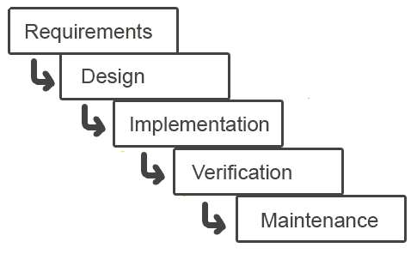

**Fig.1. Waterfall Model**

#### SYSTEM DESIGN:

**INTRODUCTION:**

System design is the specification of a detailed computer-based solution. (Bentley, L, D., & Whitten, J, L (2008)) Also known as physical design.

There were many techniques or approaches that are concerning to the aspect of the machine design and can be categorized as follow:

Model-Driven Approaches

Rapid Application Development (RAD) Joint Application Development (JAD)

Internet is among the most method for conducting more and more transactions between suppliers and large business because of the speed, flexibility and efficiency that it includes. In this way, new market has been opened to the planet and diffusion of knowledge has been accelerated to the internet. Internet markets or online commercial business has been widely used. Since a special way to design the system must have been by the web-based system and implement it.

Nowadays, internet bank operating system widely used to increase demand of online banking transactions. Internet banking system is looking to provide the best value with highly available, fast, secure and safe to work with. System analysis can be used to analyze and design any system. In such a report, the framework of system analysis and design, system design and system architecture for internet banking system are discussed. Furthermore, about the system architecture is so important so it is among the most foundation of the system analysis and design is also discussed.

Many organizations consider information systems in order to produce useful information by capturing and managing data to employees, customers, suppliers and partners. It's important for his or her ability to compute or gain competitive advantage. Information systems can be classified by the functions such as

Transaction processing systems Management information systems Decision support systems Executive information systems Expert systems

Communication and collaborative systems Office automation systems.

Various perspectives can view in information systems such as the players, business drivers, technology drivers and process. From the point of view of system stakeholder, the system analysts bridge the communication gap that can develop between system owners and users and also between designers and builders. System owners are usually executive managers for large systems and may be supervisors for small systems. Unlike system owners, costs and benefits of the system have a tendency to less concern by system users. You will discover two types of system users such as internal system users and external users.

For information systems, system designers are technology specialists such as Database administrators, Network architects, Web architects, Graphic artists, Security experts and Technology specialists. System users' business requirements and constraints are translated by system designer into technical solution. System builder is to create the system in line with the system designer's specifications. System designers and system builders will be the same in small system nonetheless they are often different jobs in large system.

Application programmers, system programmer, database programmer, network administrators and security administrators are technical specialties. System owners, users, designers, and builders frequently have different perspective for building and using on any systems.

Steps of System design in Internet banking are as follow: Firstly, the customer must request the URL.

Customer login the system, then the system checks User ID and Pin No.

After the system check User ID and Pin No., then your system check that this customer is valid or not.

If it is valid, then that customer needs to key in their OTP can access the machine so the customer can see the Main Menu page of the web banking website.

Then the customer can choose from many menus such as viewing USERNAME AND PASSWORDS, Funds Transfer, Payment, Trading and Investment Services, Opening New Account, Remittance, and Update Customer Profile and so forth.

For example, if the customer chooses the Funds transfer menu, then the customer needs to choose Funds Transfer type such as Funds Transfer to My very own A/C, Funds Transfer to Other A/C and Funds Transfer to Other Bank.

Then customer needs to choose From Account, To Account and Amount. After that, submit these details to the system.

And then ensure the detailed information and click Confirm button to accomplish the transaction.

Key in his/her bit Secure PIN (for OTP) to complete this transaction After logout, customer needs to clear cache for security reason.

**9.1TESTING AND DEBUGGING:**

Testing is the process of executing the program with the intent of finding errors and it establishes confidence that the program does what it is supposed to do. It can be done in many ways:

***Unit Testing:*** It is testing of individual module. Before initiating unit testing, it must be ensured that the code is peer previewed.

***Integration Testing:*** It is performed after all the software units are combined together. The objective here is to test the software interfaces. Project team conducts the integration testing. Before entering integration testing, it may be ensured that code review and unit testing have been performed on the individual software modules.

**System Testing:** The software is compiled as product and then it is tested as a whole. This can be accomplished using one or more of the following tests:

**Functionality testing -** Tests all functionalities of the software against the requirement.

**Performance testing -** This test proves how efficient the software is. It tests the effectiveness and average time taken by the software to do desired task. Performance testing is done by means of load testing and stress testing where the software is put under high user and data load under various environment conditions.

**Security & Portability -** These tests are done when the software is meant to work on various platforms and accessed by number of persons.

**Regression Testing:** Whenever a software product is updated with new code, feature or functionality, it is tested thoroughly to detect if there is any negative impact of the added code. This is known as regression testing

### REPORT GENERATION:

Any project or program is required what input it is giving. It is the input, which matters the most and any managements, which is decided for computerization of pay bills for their organization. Spending some money on it does the project designing of the organization. So, a cost analysis is also involved to see what benefits the organization can get out of the project.

  **ONLINE BANKING SYSTEM**

containing the list of Different Forms i.e., admin/developer form, manager form, employee form, login form, new user form, personal information form, reporting form, review form, transaction form and many other forms. The Project also includes the salary description of the employees given to their details and the balance description, transaction report(s) of individual customer. The Current system has been made so versatile that any Organization can implement it.

Any project or program is required on what output it is giving. Output is compulsory for any organization for management to take the decision for computerization of their organization. Spending money on it, the organization needs in what respect the project can be benefited, which is possible by viewing the output. So, a cost analysis is also involved to see what benefits the organization to give the output of the project.

The System has the facility to view different reports. It also contains the pages, which display the list of employees working in the Organization, their performances etc. which is the output of the project.

Any project or program is required on what output it is giving. Output is compulsory for any organization for management to take the decision for computerization of their organization. Spending money on it, the organization needs in what respect the project can be benefited, which is possible by viewing the output. So, a cost analysis is also involved to see what benefits the organization to give the output of the project.

The System has the facility to view different reports. It also contains the pages, which display the list of employees working in the Organization, their performances etc. which is the output of the project.

#### 9.3 NUMBER OF MODULES AND THEIR DESCRIPTION

The Online Banking System Project consists of 4 functional elements: *Customer transaction module*, *Employee Transaction Module*, *Manager Transaction Module and Developer/Administration Module*.

#### CUSTOMER TRANSACTION MODULE

An enhanced atomized system is developed to maintain customer transaction. Features include

Creation of new Bank Account

Create Type of Customer: Savings, Current

Account Opening Form/New Customer Sign Up Form Existing Customer Login Form

Each Customer Uniquely identified by A/c no.

Each customer having a unique User-id and Password Main Menu options are like:

* + - 1. Account Summary
      2. Funds Transfer to Another A/c
      3. Customer Profile
      4. Logout
      5. Transaction Report

#### EMPLOYEE TRANSACTION MODULE

An enhanced atomized system is developed to maintain employee role. Features include

Employee Details Update Customer Details Remove of Customer

View All Transaction made by customer Freeze/Un-freeze Account

Deposit into Customer Account

#### MANAGER TRANSACTION MODULE

An enhanced atomized system is developed to maintain manager role. Features include

* Manager details
* Update
* Employee
* Details Remove
* Employee
* List of Employee

#### DEVELOPER/ADMINISTRATOR MODULE

An enhanced module which is used to maintain the entire banking software application. Features include:

Add Manager Remove Manager

View all bank system tables

#### 9.4 PROCESS LOGIC FOR EACH MODULE

Here in the project, there will be a number of modules and each module is based on respective process logic. The process logic will be both, batch process and on-line processing for the respective modules and related tables. For different query purpose the logic will be online type. But different updating processes will be batched type.

On-line process is the key-press-events of controls when a user(customer) tries to write anything in the Bank Account Management System. If the user tries to make a transaction to another account after filling all the details in the respective form, then batch processing will occur. The manager, employee and admin module are also on-line process but, in those modules, batch 

frequent.

If a user exit from the system, then batch processing will save all the data in the table permanently and commits the tables of the database.

**10.Implementation of Security Mechanism**

There are many security mechanisms that can be implemented in a Spring Boot and Angular project to protect against threats such as unauthorized access, injection attacks, and data breaches. Some examples of security measures that can be taken include:

1. Implementing authentication and authorization: This can be done using Spring Security and JSON Web Tokens (JWTs).
2. Enforcing secure communication: This can be achieved by using Transport Layer Security (TLS) to encrypt data transmitted between the client and the server.
3. Validating user input: It is important to validate all user input to prevent injection attacks, such as SQL injection or cross-site scripting (XSS) attacks.
4. Using prepared statements: Prepared statements can help prevent SQL injection attacks by separating user input from the SQL command being executed.
5. Implementing password hashing: Instead of storing plaintext passwords, password hashing can be used to store the hashes of passwords, making it more difficult for attackers to obtain them.
6. Enforcing strong passwords: Ensuring that users choose strong passwords can help prevent brute force attacks.
7. Implementing two-factor authentication: Two-factor authentication adds an extra layer of security by requiring users to provide a second form of authentication in addition to their password.
8. Keeping software up to date: It is important to keep all software and libraries up to date to ensure that the latest security patches are applied.
9. Regularly monitoring and testing: Regularly monitoring and testing the system can help identify and fix any potential security vulnerabilities.

### FUTURE SCOPE AND ENHANCEMENT OF PROJECT

This project was developed to fulfill user requirement, however there are lots of scope to improve the performance of the Banking System in the area of user interface, database performance, and query processing time. Etc.

So, there are many things for future enhancement of this project. The future enhancements that are possible in the project are as follows.

Interest calculation system is not implemented yet. It can be enhanced later.

Linking and integration of any legacy system for accounting. Integration with other bank and government agencies through Web Services

Connection to third-party OLAP applications

Electronic Data Interchange (EDI) system for ATM machine Web Interface for net banking.

In the area of data security and system security. Loan Account creation and management.

#### 12. BIBLIOGRAPHY

**Websites**

[http://www.google.com](http://www.google.com/) [http://www.codeproject.com](http://www.codeproject.com/) [http://www.w3schools.com](http://www.w3schools.com/) [http://www.sqltuner.com](http://www.sqltuner.com/) https://getbootstrap.com/ https://[www.javatpoint.com/](http://www.javatpoint.com/)

**Books**

Head First (JAVA)

HTML & CSS: Design and Build Web Sites Head First SQL: Your Brain on SQL

SQL Bible, 2nd Edition (Paperback)

* React 18 by Packt Publication
* Spring Boot 3.0 Cookbook by Packt Publishing
* Spring Boot 3.0 By Example by Packt Publishing