PROJECT REPORT OF

INDIRA GANDHI NATIONAL OPEN UNIVERSITY

s

BCSP-064

ON

SCHOOL MANAGEMENT SYSTEM

By

Gauri (2003682335)

UNDER GUIDANCE

OF

Mr. Sabhya Verma

Submitted to the Shyamlal College (0769) in

Partial fulfilment of the Requirements for the degree of

BachelorOf

Computer Applications



Indira Gandhi National Open University

Maidan Garhi

New Delhi-110068

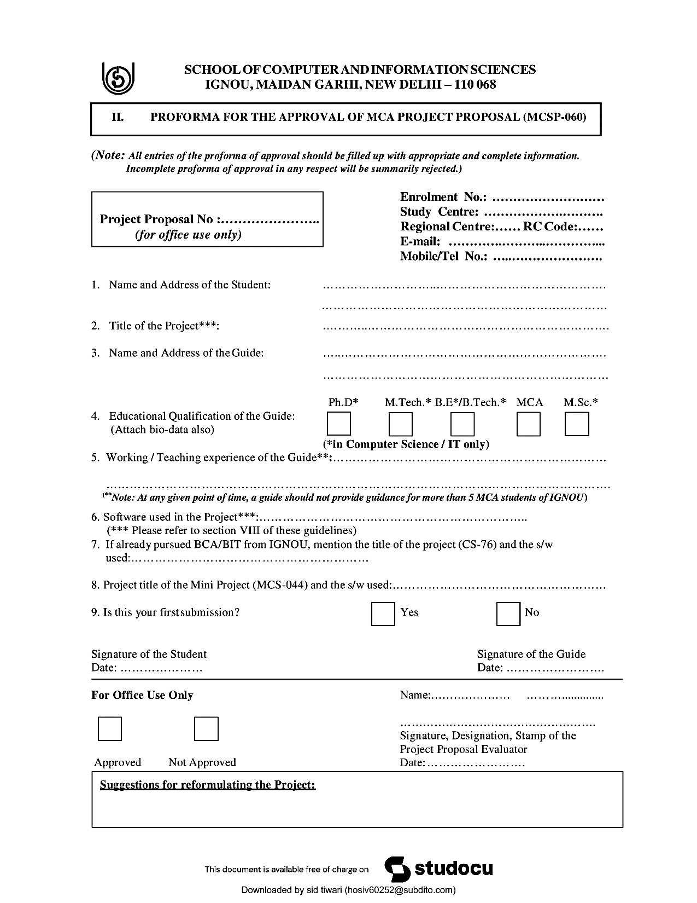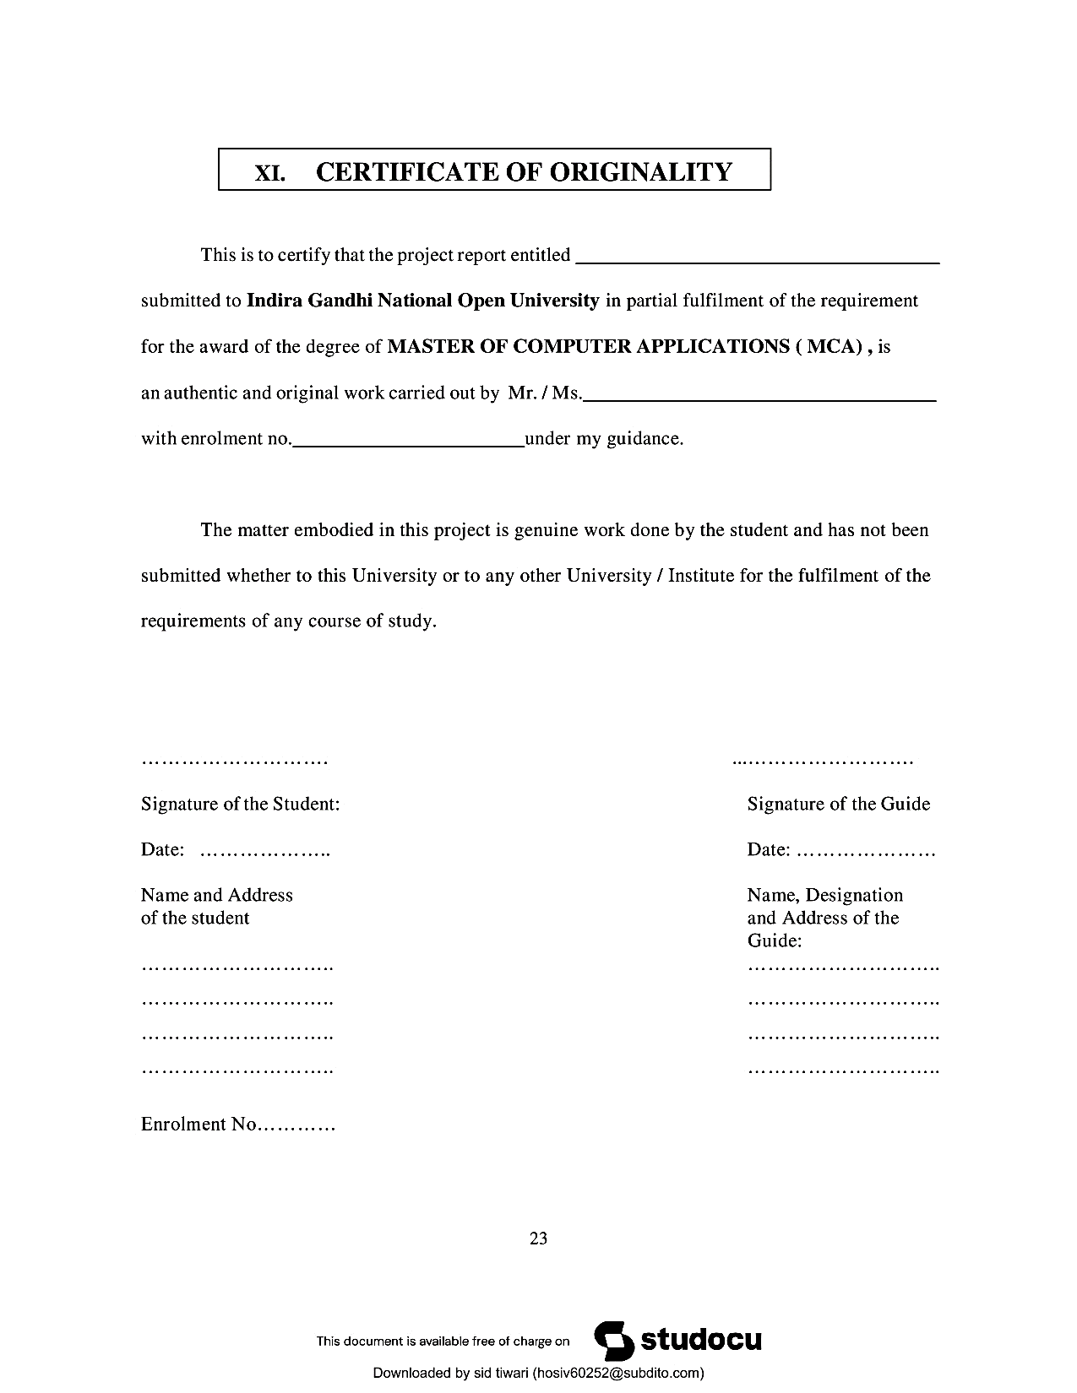

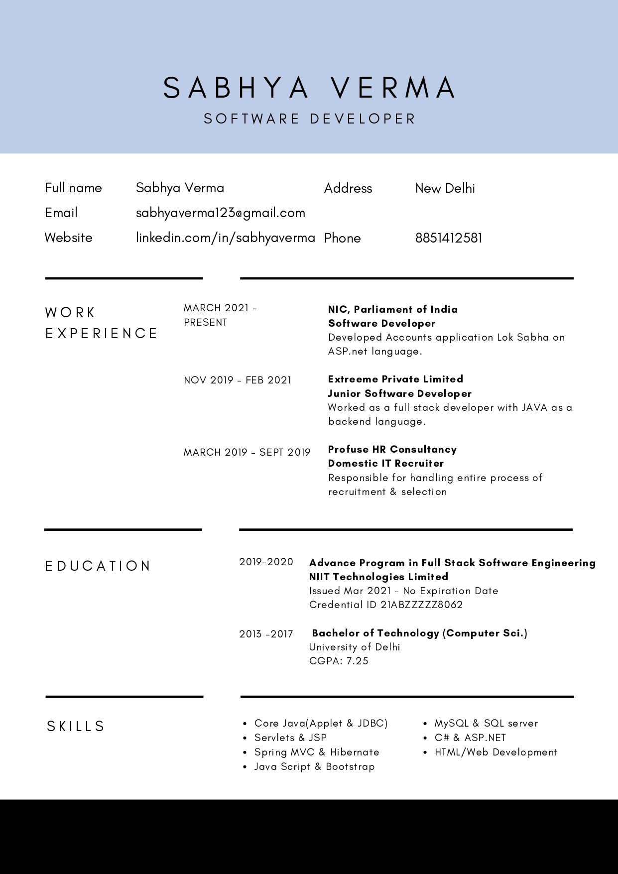

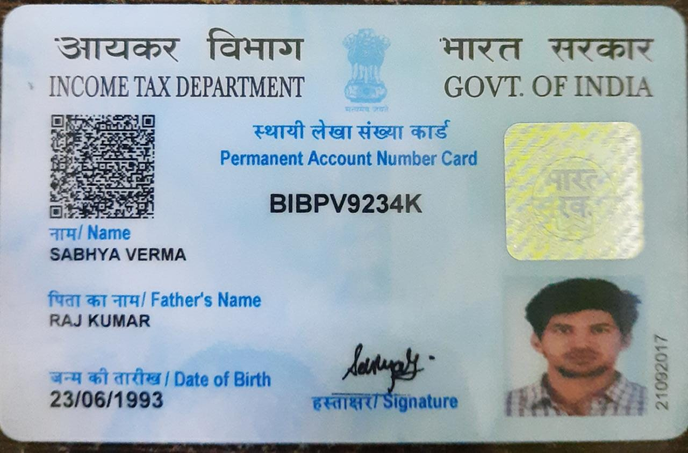

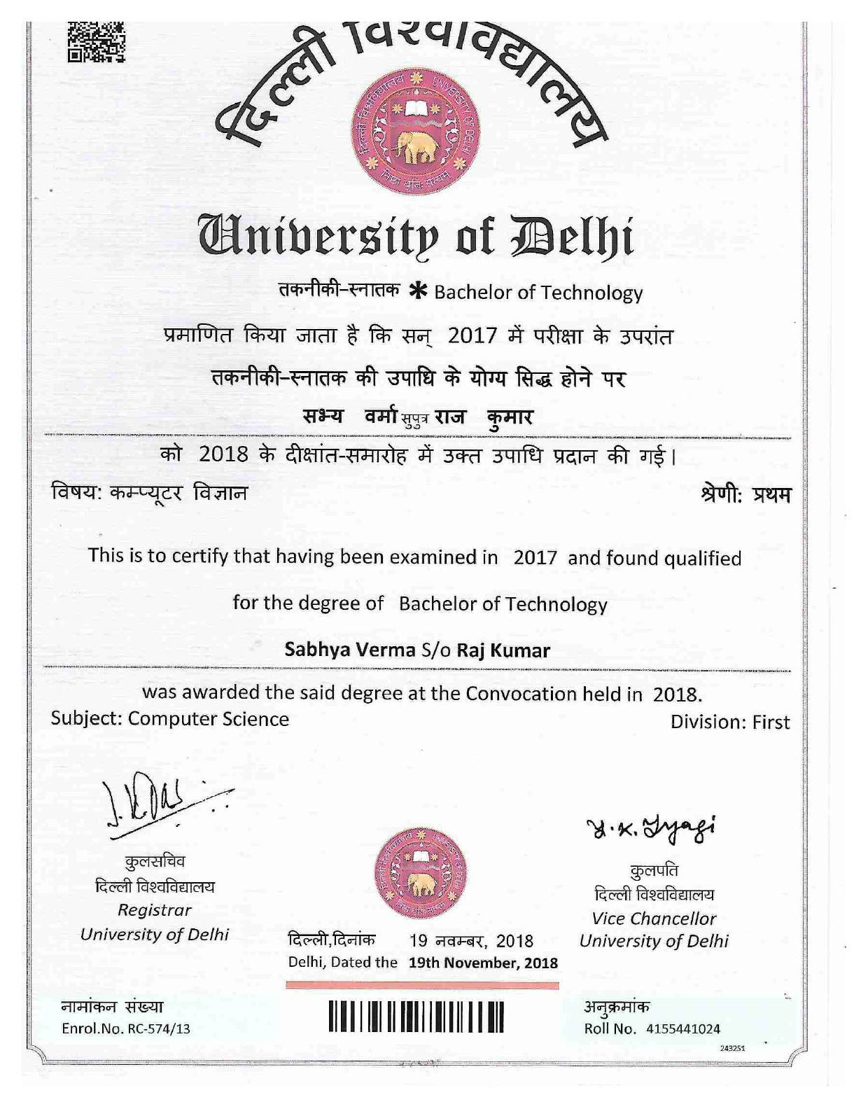

**Table of Content**

|  |  |  |
| --- | --- | --- |
| **S.NO.** | **CONTENT** | **PAGE NO.** |
| **1.** | **Title of the Project** |  |
| **2.** | **Introduction and Objectives of the Project** |  |
| **3.** | **Project Category** |  |
| **4.** | **Analysis** |  |
| **5.** | **A complete structure** |  |
| **6.** | **Tools / Platform, Hardware and Software Requirement specifications** |  |
| **7.** | **Are you doing this project for any Industry/Client?** |  |
| **8.** | **Future scope and further**  **enhancement of the project.** |  |
| **9.** | **Bibliography** |  |

## TITLE OF PROJECT



***SCHOOL MANAGEMENT SYSTEM***

1. **INTRODUCTION OF PROJECT AND IT’S OBJECTIVES**

**1.1 Abstract of the system**

Web based school managements systems are designed to manage and store project information that are used in web-based applications. The project is titled “school management system”. This package once developed will help the school/institute to manage various details pertaining to its students.

This will help accounts department in maintaining the details related to the fee & basic details like their security deposits, conveyance and etc., it will also help management or we can say administration

department in maintaining student’s basic details as well as keeping a check on fees details. This package is basically developed for the authorities of the school/ institute to make their task easier or we can say this package automate their task like maintaining student’s personal details, marinating cash details, printing of receipts. This package helps the administrative & accounts

## INTRODUCTION

The title of the project is “School Management system”. This project will handle whole the activities of the school. SMS has most of the facilities that a modern school requires to computerize its day-to-day jobs. It provides facilities to keep the records of student, fees, teaching and non-teaching staff with all their required details along with all required transaction handling. It has facilities to generate various types of reports, which are required by the management during normal business operations to operate the business effectively.

## OBJECTIVES

This project is based on the RDBMS technology the main objective of this project is to computerize the manual system & reduce the time consumption. In other words, we can say that our project has the following objectives: -

* Make all the system computerize
* Reduce time consumption
* Reduce error scope
* All system managements are automated
* Centralized database management
* Easy operations for operator of the system
* No paper work requirement

## PROJECT CATEGORY

This project as title “**School management system**” is comes under the **Relational Database Management System (RDBMS).** This application is developed with the help of Eclipse, VS Code and MySQL. This application can also be run on the network environment so it can be said as network application.

### **ANALYSIS**

### **DATA FLOW DIAGRAMS (DFD)**

The DFD was first developed by Larry Constance as a way of expressing system in a graphical form. A DFD, also known as Bubble Chart, has a purpose of clarifying system requirement and identifying major transformation that will become the programs in the system design.

## DFD SYMBOLS

1. A SQUARE defines a source or destination of system data
2. An ARROW identifies data flow or data in motion. It is a pipeline through which information flow.
3. A CIRCLE or a BUBBLE (Some people use an over bubble) represents a process transforms in coming data flow into outgoing data flow.
4. An OPEN RECTANGLE is a data store or data at rest or a temporary rest repository of data.

Note that a DFD describe what data flow (logical) rather than they are processed, so it does not depend on hardware, software and data structure or file organization.

# **PROCESSING OF SMS**

**Level 0 DFD**

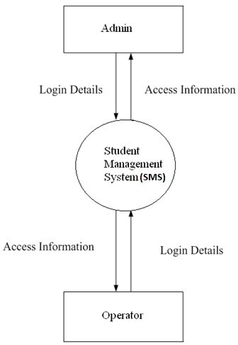

**Level 1 DFD**

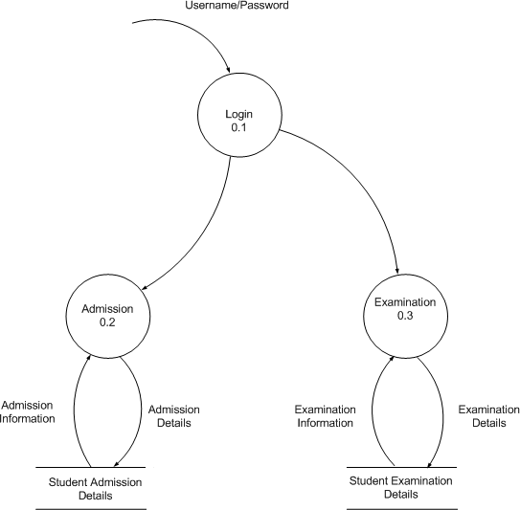

**Level 2 DFD**

## Student:

**School Management System**

**Admission**

**Student**

## Teacher:

**School Management System**

**Teacher DB**

**Teacher**

# **SYSTEM DESIGN**

* System Design is the solution to the creation of a new system. This is the important aspect made up of several steps. The complete, efficient and successful system should provide the following in succession: -
* From where should we start
* where we have to go
  + where we should stop
* if the project is to be successful, we will need answer this question. The answer of these questions is schema manner and is known as system design. A systematic manner will be followed so as to achieve beneficial result at the end. It involves starting with a vague idea and ultimately developing it up into a useful system. The design phase is transition from a user oriented to a document oriented to the programmers. Software report can be broken into a series of steps starting with the basic ideas and ending with the finished project
* The steps for the successful project are as follows: -
* We should define problem completely and the goals should be known before our destination
* In the next step, we should specify inputs and outputs of our interest
* Then the structure of various database should be designed which will be used during the programming
* Next, we should design our programs of user-friendly nature and always provide a way to the user to read back the origin if he/she find any complex problem at any stage
* We should know the function of each and every program which will leads us to or helps us to read at the specified goal.
* Then we write these individual programs which later on joining solve our problem
* Next step involves then testing of these programs and correction – if necessary

At last, linking all the programs in a well- specified manner and combining in the form of a menu, submenu etc. will be our defined problem. Out of these defined steps, few of the major steps will respect to Project.

## DATABASE DESIGN

* Database Design in most important in any project. We are using the following table to store
* the information related to staff of school
  1. **STAFF**

|  |  |  |
| --- | --- | --- |
| **Field Name** | **Constraints** | **Type** |
| **EMPNO** | **A.I/P. K** | **NUMBER (5)** |
| **EMPNAME** | **Not Null** | **VARCAHR (30)** |
| **ADDRESS** | **Not Null** | **VARCAHR (30)** |
| **CITY** | **Not Null** | **VARCAHR (15)** |
| **PIN** | **Not Null** | **VARCAHR (6)** |
| **STATE** | **Not Null** | **VARCAHR (15)** |
| **PHONE** | **Not Null** | **VARCAHR (15)** |
| **MOBILE** | **Not Null** | **VARCAHR (13)** |
| **EMAIL** | **Not Null** | **VARCAHR (30)** |
| **GENDER** | **Not Null** | **VARCAHR (1)** |
| **M_STATUS** | **Not Null** | **VARCAHR (15)** |
| **DOB** | **Not Null** | **DATE** |
| **DOJ** | **Not Null** | **DATE** |
| **DEPT** | **Not Null** | **VARCAHR (30)** |
| **NATURE_OF_JOB** | **Not Null** | **VARCAHR (10)** |
| **BASIC_PAY** | **Not Null** | **NUMBER (10.2)** |

**2.STUDENT**

|  |  |  |
| --- | --- | --- |
| **Field Name** | **Constraints** | **Type** |
| **REGNO** | **A.I/P. K** | **NUMBER (5)** |
| **ROLLNO** | **A. I** | **NUMBER (5)** |
| **CLASS** | **NOT NULL** | **VARCHAR (4)** |
| **NAME** | **NOT NULL** | **VARCHAR (25)** |
| **FNAME** | **NOT NULL** | **VARCHAR (25)** |
| **MNAME** | **NOT NULL** | **VARCHAR (25)** |
| **DOB** | **NOT NULL** | **DATE** |
| **DOR** | **NOT NULL** | **DATE** |
| **ADDRESS** | **NOT NULL** | **VARCHAR (30)** |
| **CITY** | **NOT NULL** | **VARCHAR (15)** |
| **STATE** | **NOT NULL** | **VARCHAR (15)** |
| **PIN** | **NOT NULL** | **VARCHAR (6)** |
| **PHONE** | **NOT NULL** | **VARCHAR (15)** |

**3.FEE**

|  |  |  |
| --- | --- | --- |
| **Field Name** | **Constraints** | **Type** |
| **REGNO** | **F. K** | **NUMBER (5)** |
| **ROLLNO** | **F. K** | **NUMBER (5)** |
| **CLASS** | **NOT NULL** | **VARCHAR (4)** |
| **FEEDEP** | **NOT NULL** | **NUMBER (5)** |
| **DEPDATE** | **NOT NULL** | **DATE** |
| **FINE** | **NOT NULL** | **NUMBER (3)** |

**4.RESULTS**

|  |  |  |
| --- | --- | --- |
| **Field Name** | **Constraints** | **Type** |
| **REGNO** | **F. K** | **NUMBER (5)** |
| **SUBJECT_NAME** | **NOT NULL** | **VARCHAR (15)** |
| **MAX_MARKS** | **NOT NULL** | **NUMBER (3)** |
| **PASS_MARKS** | **NOT NULL** | **NUMBER (3)** |
| **MARKS_OBT** | **NOT NULL** | **NUMBER (3)** |

## MODULES USED IN THE PROJECT

This project includes the following modules for development of the project. These are as follows: -

1. **LANDING PAGE MODULE**

This is first Page that displays the welcome screen for the user and also shows the Information of our school or staff etc.

### **LOGIN MODULE**

This module will contain a form that accepts the username and password when user enter a valid user name and Password then he/she can operate the application.

### **MAIN FORM**

This form is a menu-based form that displays the menu for operation of the application. It Includes various options for staff, student, fees and report related option.

### **STUDENT FORM**

This form provides the option to add, modify, delete or find the information of a student who Seeks the admission in the school.

### **STAFF FORM**

This form provides the option to add, delete, search and delete the information of staff (either Teaching or non-teaching) that is working in the school.

### **FEE MODULE**

This module provides the option to the user of the system to add, delete, modify and search the Information of the fee deposited by the student.

### **RESULT MODULE**

This module displays the result of students with other details

### **REPORT MODULE**

With the help of this option from menu user of the system can see or take the print out of report card.

### **CONTACT US MODULE**

With the help of this option from menu user of the system can contact us or take the contact details of our school.

## NAME OF REPORTS

Following are the reports names that are generated by the Project for the management of school or Staff members of the school.

1. Details of teaching staff
2. Details of non-teaching staff
3. Class wise detail of students
4. Date wise detail of students based on date of admission
5. Detail of student according to name wise
6. Teacher report based on the Date of joining
   1. **TOOLS, SOFTWARE & HARDWARE REQUIREMENTS**

We have a wide range of options of languages. From these options we can choose appropriate platform/ tools and languages for development of the project. Some of these are as follows: -

**Project Category**: Web-Based Application

**SOFTWARE REQUIREMENTS:**

**IDE:** Eclipse, VS Code.

**Front End:** HTML, CSS, JavaScript, jQuery, bootstrap.

**Back End:** Servlet and JSP

**RDBMS:** MySQL 8.0 or Higher

**Browser:** Chrome, Firefox etc. (latest version)

**Operating System:** Windows 7 and above, Linux etc.

**HARDWARE REQUIREMENTS:**

**Processor:** Intel Pentium, Core duo or more

**RAM:** 2GB or more

**Cache:** 512 KB

**Hard-disk:** 50 GB hard disk recommended Monitor, Keyboard & mouse.

* 1. **Are you doing this project for any Industry/Client?**

**Ans. NO.**

* 1. **FUTURE SCOPE OF THE PROJECT**

Nothing is perfect in this world. So, we are also no exception. Although, we have tried our best to present the information effectively, yet, there can be further enhancement in the Application.

We have taken care of all the critical aspects, which need to take care of during development of the Project.

Like the things this project also has some limitations and can further be enhances by someone, because there are certain drawbacks that do not permit the system to be 100% accurate.

* 1. BIBLIOGRAPHY

**Websites**

* <https://www.mysqltutorial.org/>
* <https://www.tutorialspoint.com/>
* <https://javatpoint.com/>
* [https://W3schools.com/](https://w3schools.com/)
* <https://edureka.co/>

**Books**

* **HTML & CSS: Design and Build Web Sites**
* **Head First SQL: Your Brain on SQL**
* **SQL Bible, 2nd Edition (Paperback)**