## CONTENTS

1. Introduction
   1. Purpose
   2. Scope
   3. Definition
   4. References
   5. Overview
2. Overall Description
   1. Product Perspective 2.1.1System Interfaces 2.1.2User Interfaces 2.1.3Hardware Interfaces 2.1.4Software Interfaces 2.1.5Communication Interfaces 2.1.6Memory Constraints
   2. Product Functions
   3. User Characteristics
   4. Assumptions
3. Specific Requirements
   1. Functional Requirements
   2. Software Product Features
   3. Performance Requirements
   4. Design Constraints
   5. Software System Attributes
   6. Logical Database Requirements

# Introduction

The following subsections are an overview of the entire Software Requirements Specification (SRS) document.

### Purpose

This document provides the technical description of all software requirements of STUDENT MANAGEMENT SYSTEM.

The document will not only define the product functions, user characteristics, constraints, and specific requirements of the system, but also serve as a basis for the Software Design Document that is prepared according to IEEE Std.

The objective of the software is to maintain information pertaining to the students with the purpose of:-

* Planned approach towards working
* Accuracy
* Reliability
* No Redundancy
* Immediate retrieval of information
* Immediate storage of information
* Easy to Operate

### Scope

“STUDENT MANAGEMENT SYSTEM” is a project with a mission of viewing and manipulating student information of IIMSR in a Web- based environment. Thus, the overall system will consist of a Student Database System and Web Interface.

The Student Database System will supply the fundamental database structure of the entire system whereas Web Interface will provide a secure Web interface between the users and the database.

The Software aims to create a “paperless office” rather than using a traditional record keeping system.

Although this project is presently being designed specifically for Integral Institute of Medical Sciences and Research but there exist the possibility in future to upgrade it to general level.

The software will not only help the following levels of user in viewing the information but also each user can alongside update changes within their respective access limits.

* Administrative Level
* User Level
* Management of Institute
* Faculty
* Students

#### Definition

Paperless Office: refers to an integrated working environment where all the data and documentation is represented in electronic format.

Student Personal Information: refers to personal records of individual students bio-data along with his performance throughout the course.

Traditional Record Keeping System: refers to a manual system where all records are kept on papers by manual in-charge.

### References

MCS-014 IGNOU Blocks

### Overview

This document is prepared in accordance with the IEEE Standard, IEEE Recommended Practice for Software Requirements Specifications.

It also provides product perspectives, product functions, user characteristics, general constraints, and assumptions and dependencies of the system.

It will contain functional and performance requirements, design constraints, attributes and external interface requirements for the Software.

# Overall Description

This section describes the general factors that affect software and its requirements. In order to be easily understandable, this part of SRS provides a background for the requirements.

### Product Perspective

This software is a totally self-contained system. Also it is not dependent of any larger system.

### System Interfaces

Since this student management system is a standalone system, there is no system interface with any other system.

### User Interfaces

The interfaces will involve check boxes, combo boxes, text boxes, and radio buttons. The combo boxes and the radio buttons will be used to prevent users from entering wrong type of information. They will also enable fast data entry. Text boxes will be controlled for avoiding invalid and inconsistent data.

Users can use “Tab” key to move cursor on screen items easily.

There will be two types of messages for constructive advice to the users: error and confirmation messages. There will be four types of error messages for application control: input, output, process and database/Web server error messages.

There will be several types of users, and each user will access the screens according to their types after entering their id and passwords. Standard screen format (fixed colors, fonts, background, the page layout, etc.) will be used throughout the interfaces.

The language of the user interfaces will be English.

### Hardware Interfaces

Processor **:** 1 GHz Processor

RAM **:** 1 GB (minimum recommended)

Hard Disk **:** 20 GB (minimum recommended)

Monitor **:** 11”inch DISPLAY or more

Keyboard **:** 108 key normal

### Software Interfaces

On the client side the required software product is Internet Explorer supporting at least HTML version 3.2, java enabled, and any operating system that can run the browsers.

The project will use following software

Front End **:** Html,css,bootstrap,jquery

Back End **:** Servlet

Database : MySQL

Web Server **:** Apache Tomcat 9.0 or higher

Documentation Tool : Microsoft Office

### Communication Interfaces

The default communication protocol for data transmission between server and the client is Transmission Control Protocol/ Internet Protocol (TCP/IP). At the upper level Hyper Text Transfer Protocol (HTTP, default port=80) will be used for communication between the web server and client.

### Memory Constraints

The client computer, which runs the web browser, should have enough physical memory to run this program.

### Product Functions

* Track Students
* Keep record of Staff
  1. Keep record of students achievement User Characteristics

Administrator – The dean will hold full access to view as well as manipulate anywhere in the software and the information.

User- The other user like staff or faculty can view only their individual report and analyze their own performance based on that.

### Assumptions

Every user will be having the appropriate hardware and software configuration as per the necessary requirement.

# Specific Requirements

### Functional Requirements-

The software is meant to generate a student id which will provide unique identity to individual students. It is through this student id that each student’s data can accessed on this platform. The requirements under Student Management System are to maintain information relevant to the following fields:

* **Students Profile**- The full information of each and every student must be maintained in System along with the facility to regularly update it from time to time at regular intervals which will be easily possible through each student’s Enrollment number.
* **Providing statistical reports-** It is meant to analyze each student performance on the individual level as well as among the group.

**Software Product Features**

The software feature is to provide easy accessibility to student details on IIMSR to the management of the institute. But it requires authentication of user through login id and password at various diferent levels for safety of the system.

### Performance Requirements

The performance of the software will be as smooth as possible with special consideration on the following parameters-

* Planned approach towards working
* Accuracy
* Reliability
* No Redundancy
* Immediate retrieval of information
* Immediate storage of information
* Easy to Operate

### Design Constraints

* GUI is only in English.
* Login and password is used for identification of user and there is no facility for guest.

### Software System Attributes

#### Reliability

The system has to operate in a reliable manner with no scope for any flaws. This is to ensure efficient working and processing of information.

#### Availability

The site should be available all the time without any issues. A backup must be available for recovery issues so that the existing is not lost in case of any issue.

#### Security

The system has an authorization mechanism for users to identify their personal profiles. Therefore, diferent users will have diferent authorization levels to access the data. Data integrity for critical variables will also be checked.

#### Maintainability

The system can meet the changing requirements easily, since the infrastructure of the system would not need major changes. The requirements of the software while evolving will be met by just adding new sub-functions. Therefore, the maintainability of the system would not be a complex issue.

#### Portability

All of the code which will be deployed at the web server will be written in ASP.Net 4.5 and using SQL Server for database storage. So, using IIS (Internet Information Server) the software will remain portable.

* 1. **Logical Database Requirements**

Level 0 DFD

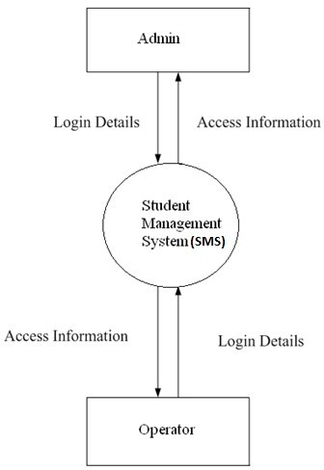

Level 1 DFD

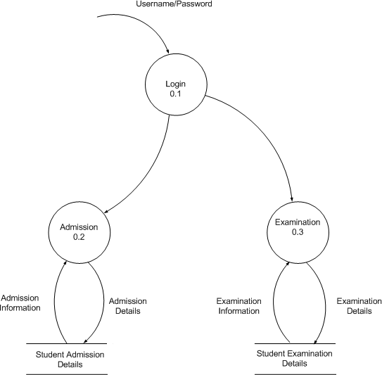

## Level 2 DFD

## Student :

**School Management System**

**Admission**

**Student**

## Teacher :

**School Management System**

**School Management System**

**TeacherDB**

**Teacher**

ER Diagram Examination

