Project Name: SmartCommute

**INDEX**

Programming Languages and Database used 4

INTRODUCTION 5

Architecture and Design of the project 6

Data Flow Diagram (DFD) 7

Entity Relationship Diagram (E-R Diagram) 9

Database Table Structure 13

Screen Layout 17

Forms Coding 35

Problem Faced During Developed Project 352

# Programming Languages and Database used

# 

**Inputs Provided by the Client:**

* Inputs for the application
* Outputs from the application
* Process Involved in the application
* List of Report

**Hardware Requirements:**

* A minimum computer computer system that will help you access all the tools in the course is a Pentium 3.0 or higher capability CPU
* 1 GB of RAM or higher
* Mother 945 or higher capability.

**During the development of this Project Software:**

Used as Frontend – **React Native** **Version** 0.60

Used as Backend – Database

**Pre Requirements:**

People should have knowledge of Core-Java and Android.

# INTRODUCTION

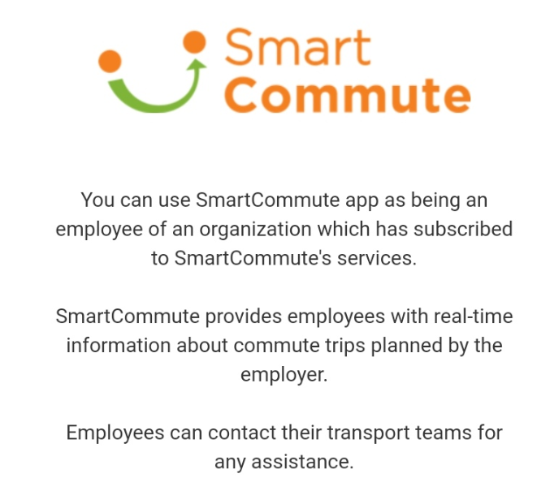

# Architecture and Design of the project

**Tier 1**

**Presentation Tier**

**Tier 2**

**Database Tier**

**User Interface**

**GUI Components**

**Database Access**

# 

# Data Flow Diagram (DFD)

**SalesPerson**

**Administrator**

**Sales Manager**

**Inventory Manager**

**Administrator**

**Sales Person**

**Sales Manager**

**Inventory Manager**

**Sales Person**

**Sales Person**

# Entity Relationship Diagram (E-R Diagram)

Employees

Administrator

Database Table Structure

|  |  |  |  |
| --- | --- | --- | --- |
| **Table:Employees** | | | |
| **Column Name** | **Data Type** | **Allow Nulls** | **Description** |
| IM_ID | varchar(50) | Yes | Stores the ID of Employees |
| IM_Name | varchar(50) | Yes | Stores the Name of Employees |
| IM_Password | varchar(50) | Yes | Stores the Password of Employees |
| IM_DOB | varchar(50) | Yes | Stores the Date of Birth of Employees |
| IM_ADD | varchar(50) | Yes | Stores the Address of Employees |
| IM-Phone | varchar(50) | Yes | Stores the Phone Number of Employees |
| IM-Email | varchar(50) | Yes | Stores the Email Address of Employees |
| IM-Designation | varchar(50) | Yes | Stores the Designation of Employees |

|  |  |  |  |
| --- | --- | --- | --- |
| **Table:Administrator** | | | |
| **Column Name** | **Data Type** | **Allow Nulls** | **Description** |
| Admin_ID | varchar(50) | Yes | Stores the ID of Administrator |
| Admin_Name | varchar(50) | Yes | Stores the Name of Administrator |
| Admin_Password | varchar(50) | Yes | Stores the Password of Administrator |

# Screen Layout

**Login Screen**

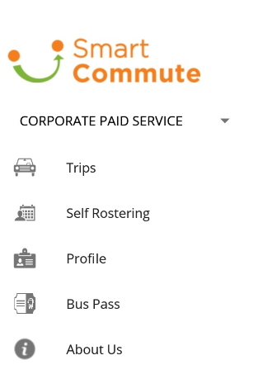Smart Commute is travelling application, helps you to plan your trips easily.

Trips will help to decide your trip and selection of vehicle.

Self Rostering will help you to schedule the date.

Profile you provide you thhe information related to the user.

Bus pass will give you the offers updates and prices for different passes for different time periods.

About us will provide you information about the smart commute services.

**Trip Form**

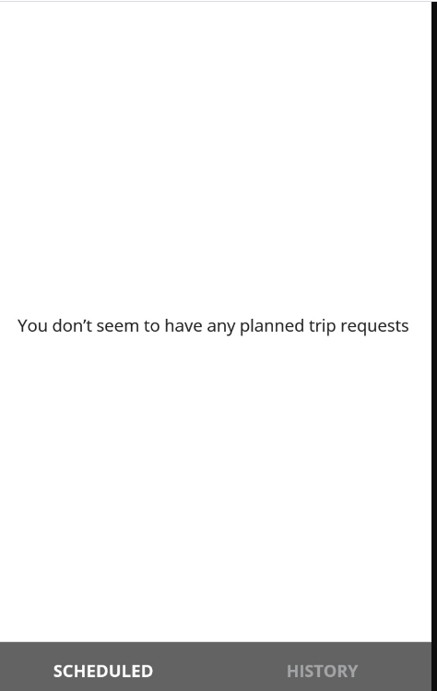

Trip form is a detailed form for the trips you selected or if not any the message popped will be “ You don’t seem to have any planned trip requests”.

Scheduled will provide you information related to the trip I future. History will provide the old records for the trips.

**Self Rostering Login Form**

This form will give you information of all the travels which includes both the cancelled trips and trips occur. This information is available weekly and monthly basis.

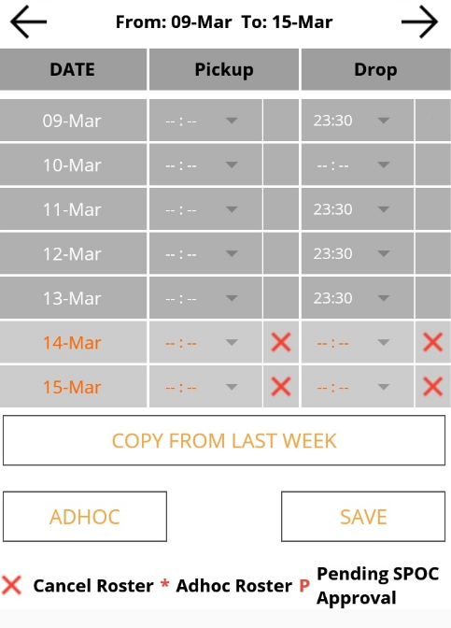

**History Login Form**

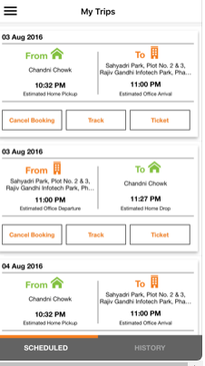

This will provide user information about past and present trips locations of pick up and drops.

**NewBooking Login Form**

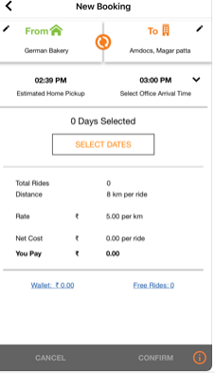

This new booking login form will provide you information of rates and distance. Which also includes net cost of trip.

**Active Trip Form**

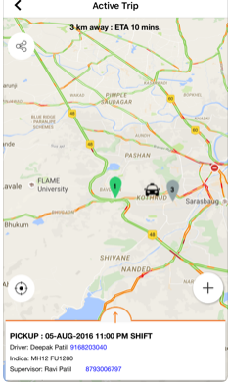

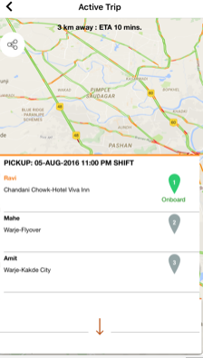

This will provide multiple users exact location at one time. Which will be available group-wise or from user’s permission.

**Add New Item Form**

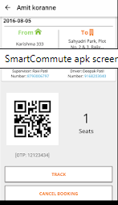

Users booking can be confirmed by OTP or by bar code.

**Detail Form**

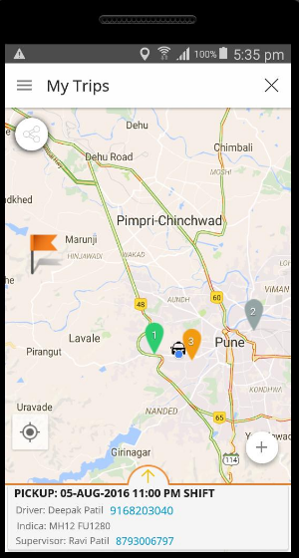

This will give user the information of his current location and ongoing trip all related information.

**New Booking Form**

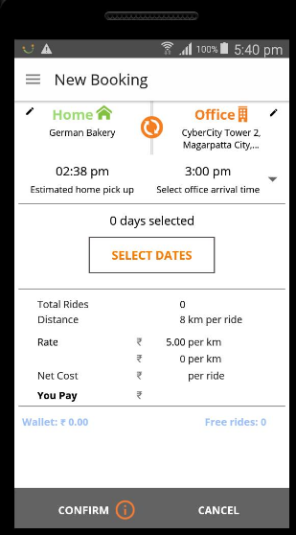

User can set new booking from this form event for future dates.

**Weekly statistics**

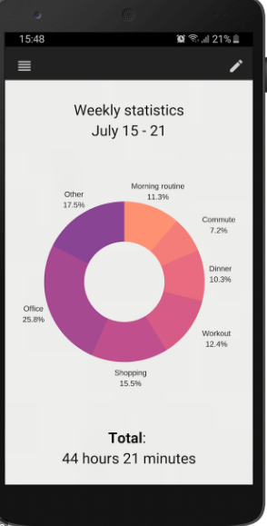

This is a complete detail of all trips conducted in week or timetable of full day.

**Buy Ticket Form**

User can buy Ticket from this form details related to price and bank detail or wallets is available here in form of various options available.

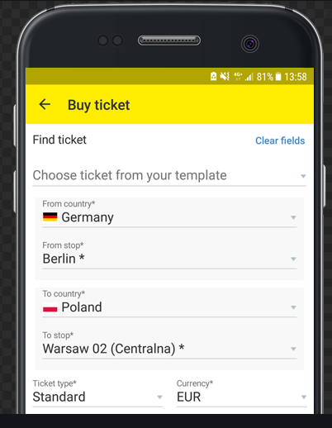

**Offer Form**

This from will contain information’s of all available or applicable offers.

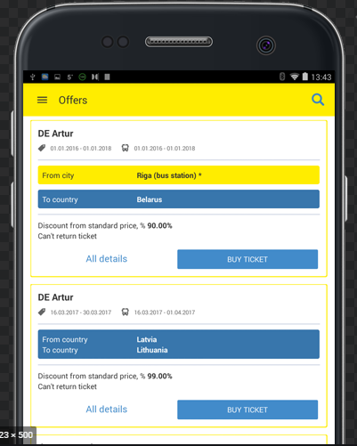

**Administrator Form**

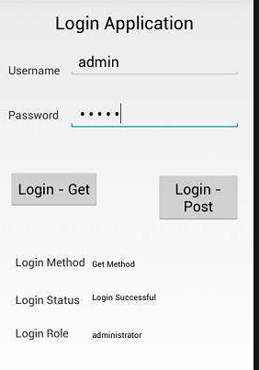

This form is available for administer only for making changes in the application.

**Registration Form**

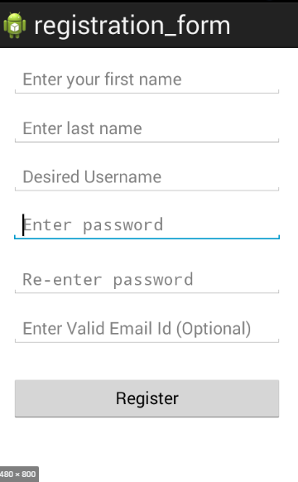

Registration from is a primary form form the guest users.

**Change Password Form**

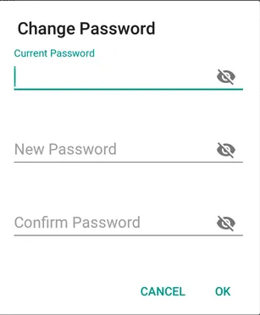

This form can be used to set new password and change password options.

**Modify Form**

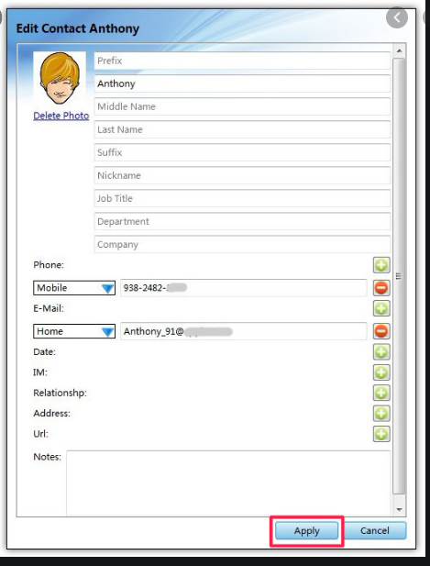

All the basic personal information will be recorded in this form.

**Check Report**

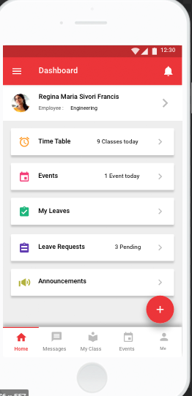

This dashboard will provide you information for the events and leaves and even user can set their timetable also all the announcements related to any changes and other will be available individually.

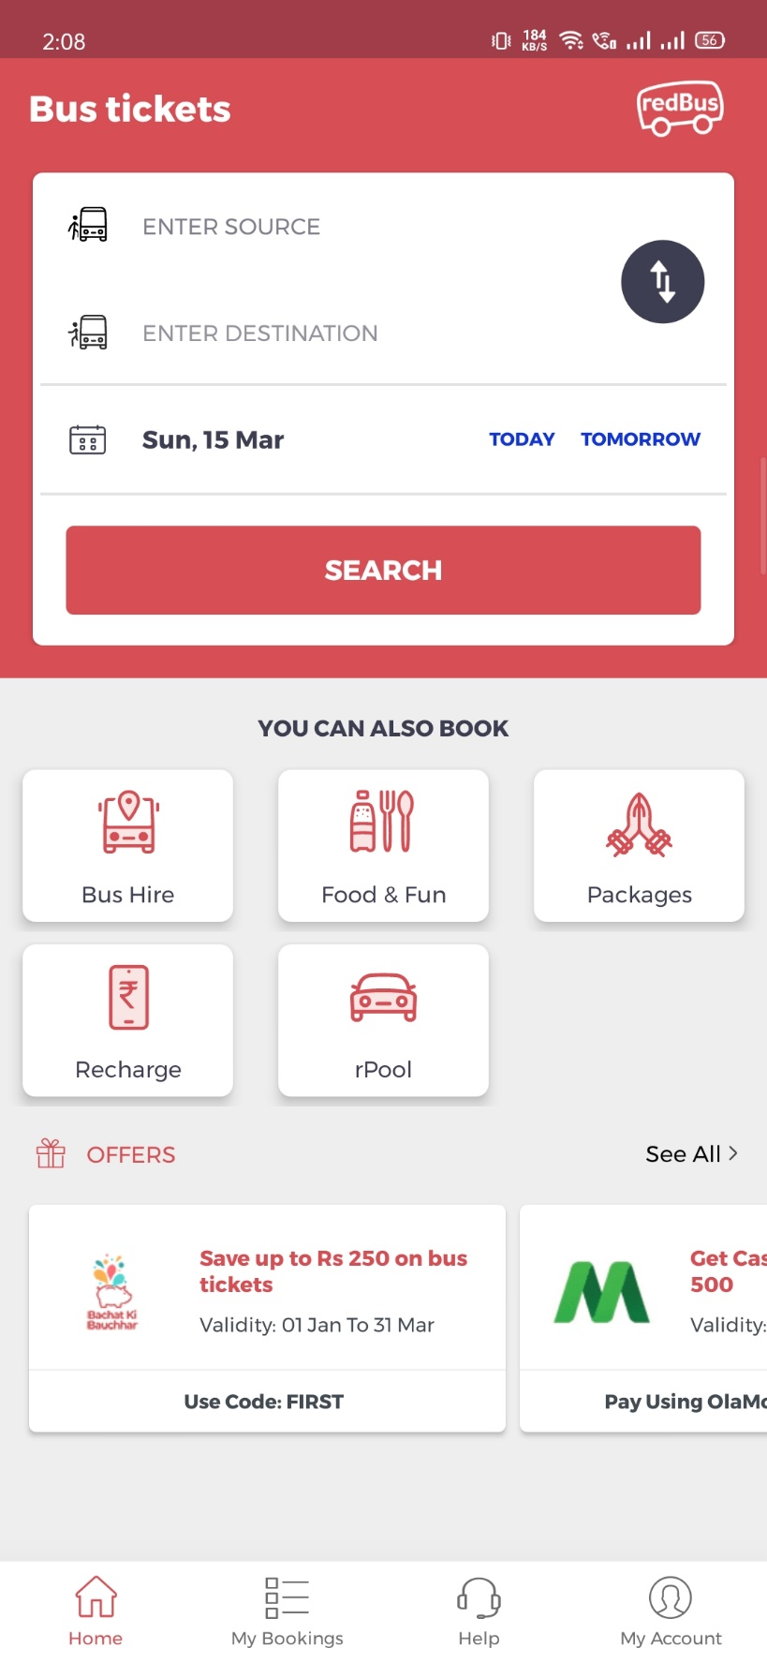

**Bus Ticket :**

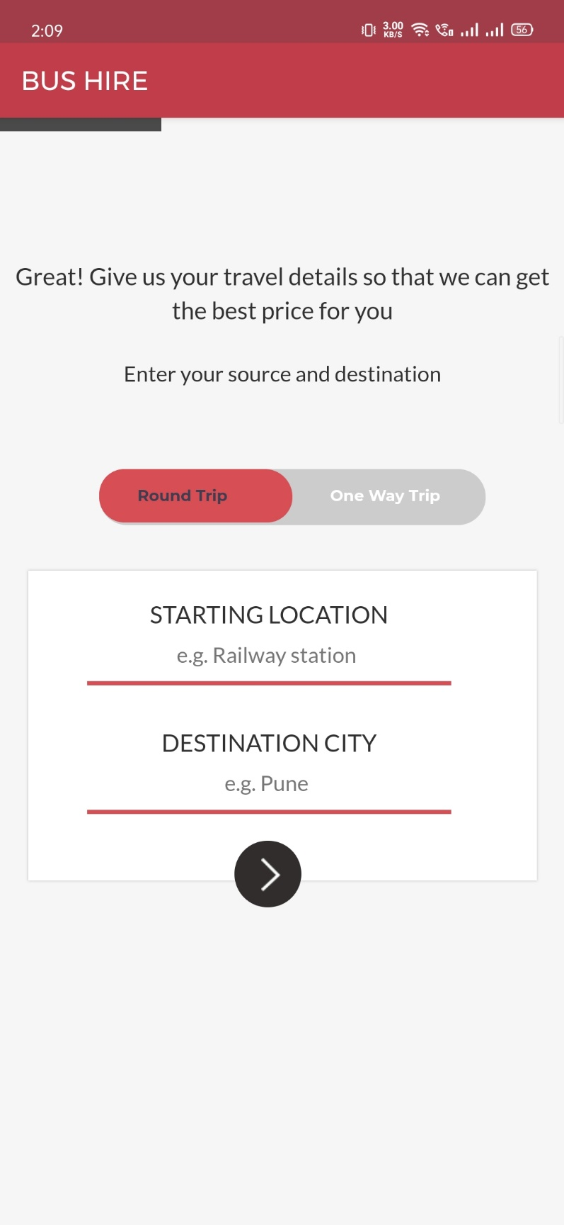 Bus Hire :-

My Rides :

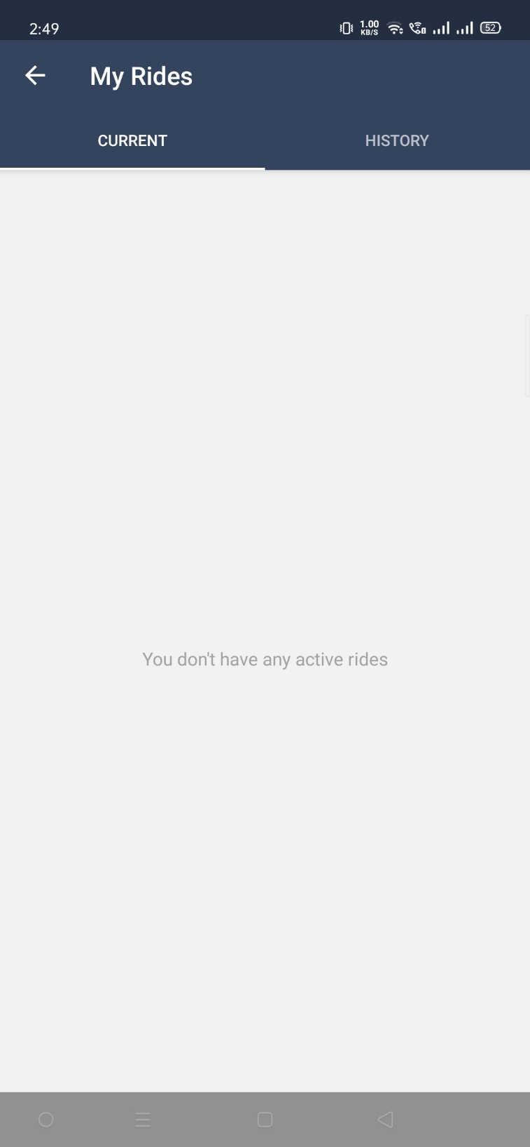

Corporate Office : -

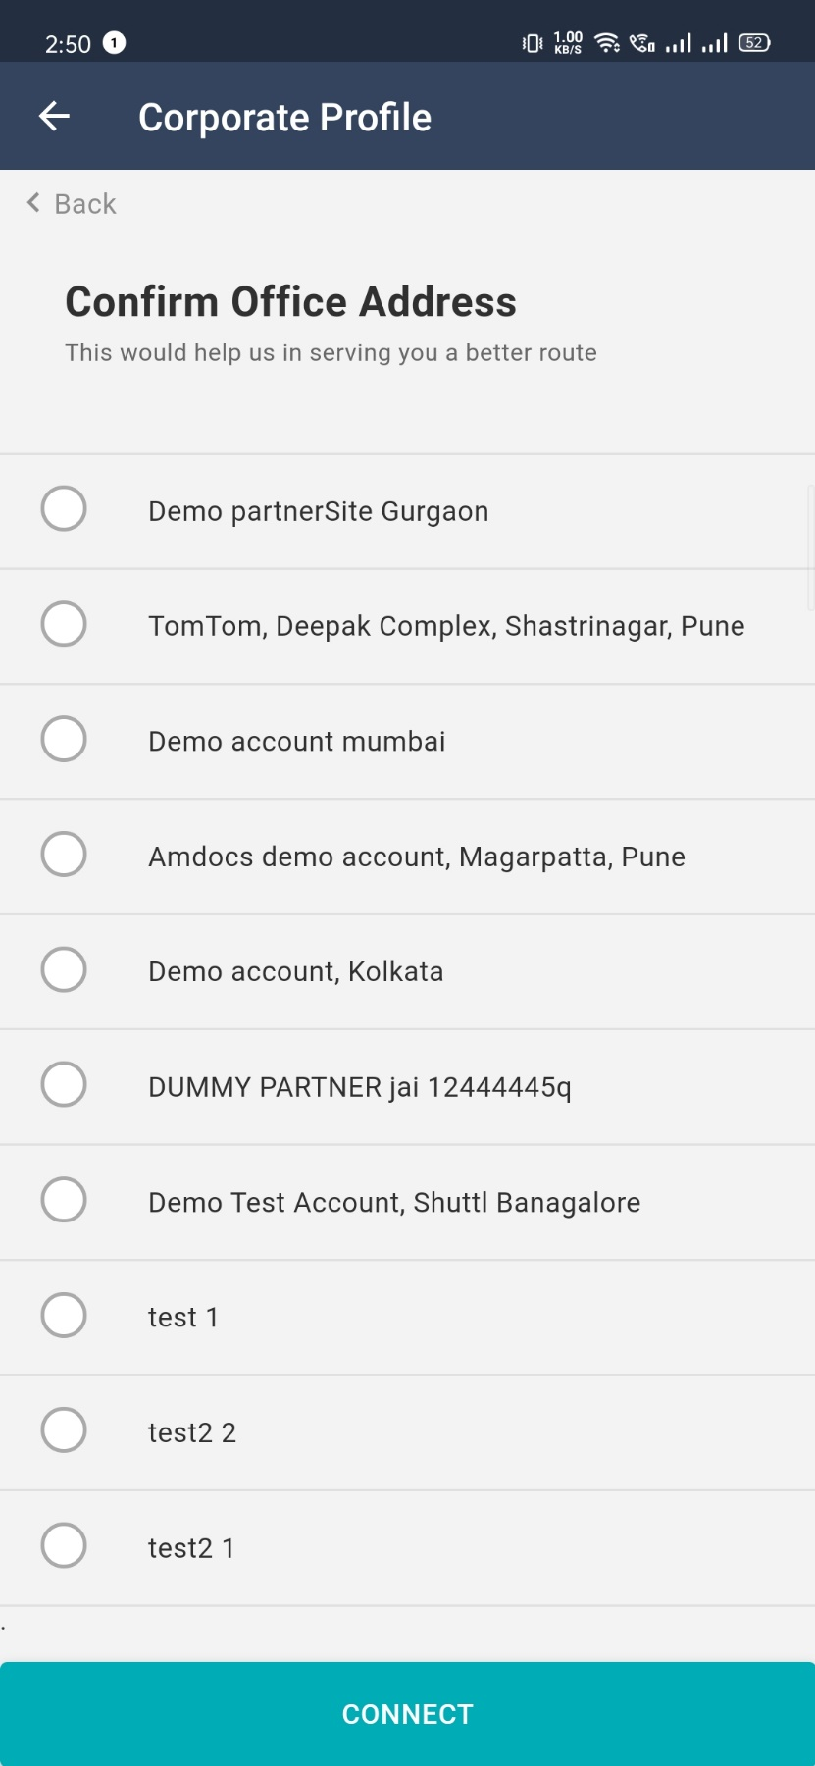

Bus Hire : -

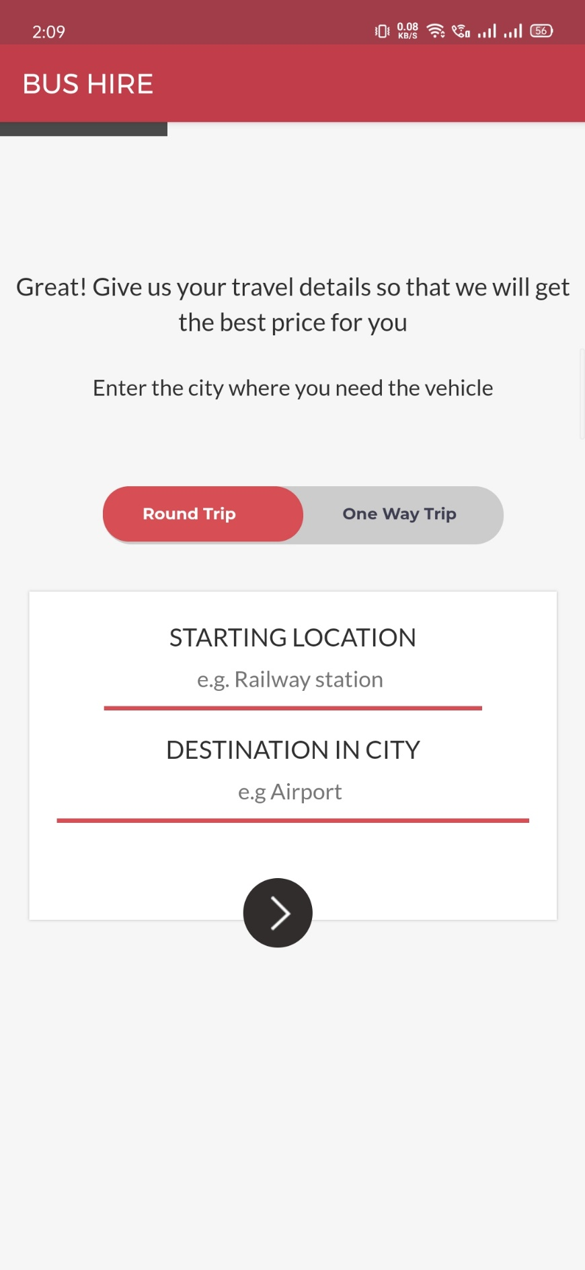

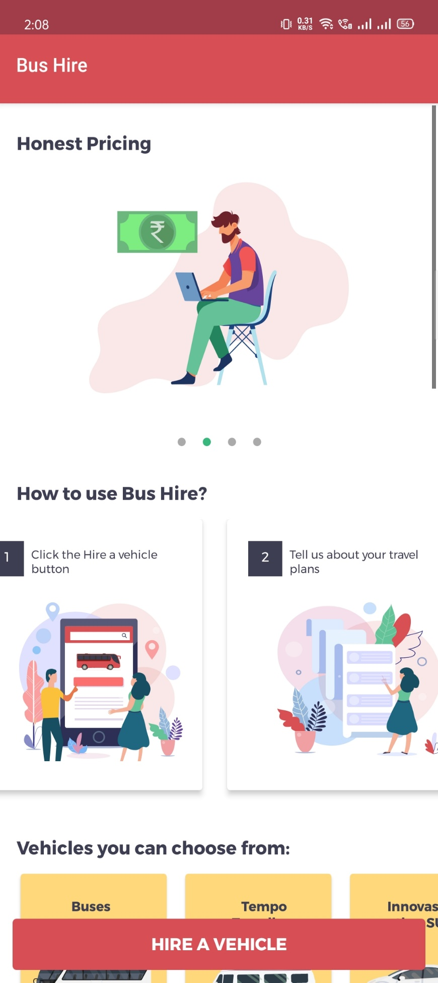Instructions : -

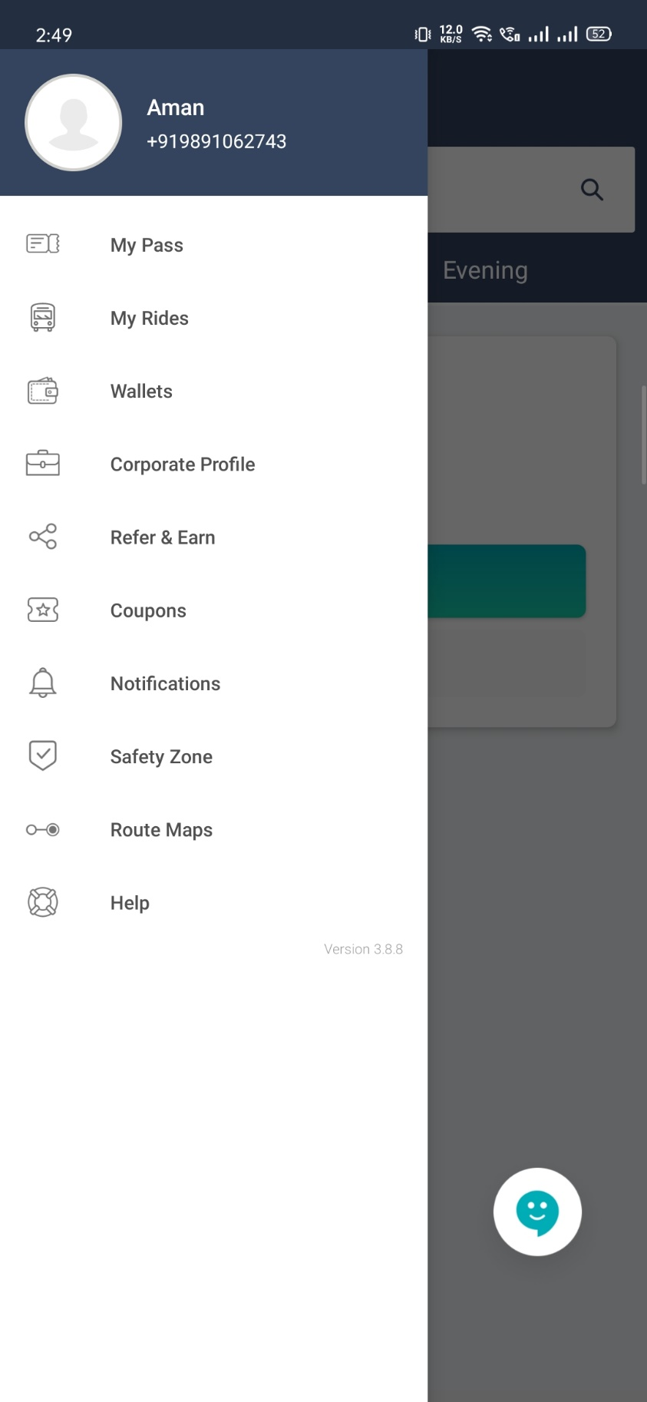Menu : -

Booking : -

