**Food Pay App**



**About Project**

* Order food online
* Live tracking of order
* Best Quality food
* Food get delivered to home
* Search for and discover great restaurants

**Food**

**Pay**

2



**Course Content**

**Course Overview**

* **Hello React Native**
* **What is React Native?**
* **What does it do for us? Why choose it?**
* **Pros and cons**
* **Architecture**
* **Sharing with web projects**
* **What React Native code looks like**
* **Leveraging your React knowledge**
* **React and Redux reviews (when needed)**
* **Redux reminder**
* **Reducers, actions, state, store, and middleware**
* **React reminder**
* **SFCs vs class-based component**
* **Composition**
* **JSX structure and rules**
* **props**
* **state**
* **Controlled and uncontrolled components**
* **Virtual DOM vs the real DOM**
* **The Development Process**
* **Where do I even start?**
* **react-native vs. create-react-native-app**
* **Which is better for given situations**
* **The React Native team's recommendations**
* **What is expo?**
* **Creating a new React Native app**
* **How to run it on a tethered device**
* **How to run it on a wireless device**
* **How to run it in an Android emulator**
* **How to run it on an iOS simulator**
* **Debugging in a browser window**
* **Logging, breakpoints, stepping through**
* **YellowBoxes and RedBoxes**
* **Single-value Controls**
* **Components overview**
* **Categories of components**
* **Text**
* **Text props and events**
* **TextInput**
* **props and events and the event object**
* **Image**
* **Differences between HTML and React Native images**
* **Reserving space for them**
* **Local images vs remote images**
* **resizeMode**
* **Platform-specific Development**
* **How can we develop differently on the different platforms?**
* **Why would we ever do this?**
* **Technical roadblocks**
* **The DatePicker - iOS vs Android**
* **Using the Platform module**
* **Layout Components**
* **Components review**
* **View**
* **SafeAreaView**
* **ScrollView**
* **Pinch-to-zoom**
* **KeyboardAvoidingView**
* **How to create modal views**
* **Controlling the OS's status bar**
* **Flexbox for Native Layouts**
* **Why flexbox?**
* **Where it came from**
* **Flexbox on the web is NOT flexbox on native**
* **Containers and items**
* **flexDirection**
* **flexBasis vs width/height**
* **flexShrink, flexGrow**
* **The flex shorthand**
* **justifyContent and alignContent**
* **flexWrap**
* **Styling React Native Apps**
* **How React Native styles differ from CSS**
* **How to apply styles**
* **How to control style inheritance**
* **Style arrays**
* **Four methods of defining styles**
* **Common properties**
* **Cross-platform fonts**
* **Conditional and programmatic styles**
* **Navigation**
* **What is navigation, really?**
* **How to get React Navigation**
* **The three types of navigators**
* **StackNavigator**
* **Routing object**
* **Navigation config**
* **How to pass params when navigating**
* **TabNavigators**
* **Three types of TabNavigators**
* **How to set icons**
* **DrawerNavigator**
* **Examples and demos**
* **Ajax in React Native**
* **Why it must be different on a device**
* **The fetch API**
* **How to show a loading indicator**
* **How to make requests and populate affordances**
* **Security in a native environment**
* **List Components**
* **Components review**
* **Pickers**
* **FlatList**
* **SectionList**
* **Touchables and Buttons**
* **The Button API**
* **Button events and prop**
* **Why touchables?**
* **TouchableWithoutFeedback**
* **TouchableNativeFeedback**
* **TouchableOpacity**
* **TouchableHighlight**
* **How to disable a touchable**



**Proposal**

**Duration: 60 Hours**

### **Major and Minor Project Training**

### The Major/Minor Project work segment is exclusively planned to help students to work and implement new ideas. The segment can help you to learn correct strategy used by software companies in projects. For example

#### How to gather/collect requirement – Problem Identification

#### How to analyze requirement

#### Finding the feasible solution of problem

#### Study of tools needed to solve problems

#### What to model and how to model?

#### Learn Prototyping, Use-Case, Test-Case

#### Now how to dive into Finally Development (coding phase)

#### How to test a project?

#### Packaging and Distribution of software

#### How to implementation project in production environment (deployment)

### **Benefits of this course**

#### We can help you to implement your innovative idea

#### Adopting standard procedure of software development

#### Hands on experience, you have to develop your project under supervision of our expert developers.

#### Learn best practices of analysis, planning, coding and optimization

#### Learn database best practices

#### Learn UI best practices including UX (User Experience)

#### You will get chance to work with professional developers

#### On time project completion

#### We help you for interview and preparation

#### We also recruit students for our development-division

### **Major Benefits of this course**

#### **Live Project:** One of the most important aspects of project development training is to be sure of hands-on experience. The project development training comes with wide teaching experience in React Native. The live project offers an instructions to finish the assignment after each session.

#### **Jobs**: With a lot of job opportunities in Project development, once the course concludes, the placement team will assist students in creating a resume that can fetch the best jobs in the React Native market.

**Project Development Course**

Training is designed for students and professionals who want to be a React Native

Developer. This 60-hour course which will cover concepts like React Native. You will also learn various frameworks like Hibernate and spring.

### **Objectives of Project Development Course?**

Our Project Development Course is designed by industry experts to make you a Certified React Native Developer. Following are the objectives our course offers:

* In-depth knowledge of React Native
* Comprehensive knowledge of object-oriented programming through React Native using Classes, Objects and various React Native concepts like Abstract, Final etc. and parse XML files using DOM and SAX
* The capability to implement arrays, functions and string handling techniques, JDBC to communicate with Database, SOA using web services
* The exposure to many real-life industry-based projects
* Projects which are diverse in nature covering banking, telecommunication, social media, insurance, and e-commerce domains
* Rigorous involvement of an SME throughout the React Native Training to learn industry standards and best practices

**What are the skills that you will be learning with our Project Development Course?**

Project Development Training will help you to become a React Native expert. It will hone your skills by offering you comprehensive knowledge of React Native Language, and the required hands-on experience for solving real-time industry-based React Native projects.

During the React Native course, you will be trained by our expert instructors to:

* Develop the code with various React Native App
* Implement arrays, functions and string handling techniques
* Understand object-oriented programming through React Native using Classes, Objects and various React Native concepts.
* Implement multi-threading and exception handling
* Use parse XML files using DOM and SAX in React Native
* Write a code in JDBC to communicate with Database
* Develop web applications and JSP pages
* Interact with the database using hibernate framework
* Write code with spring framework components like Dependency Injection and Auto Wiring
* Implement SOA using web services

**What is the prerequisite knowledge for Project Development Course?**

* Actually React Native is a high level language. That is it contains OOP concepts and other high level things. You probably are thinking to do some software development and android development kind of stuffs. Here’s what I think that you should go ahead and learn it. If you’ve been through any programming language it’s plus for you, but even if you’ve not its fine to start with it.
* If you are thinking React Native for coding purpose I would suggest you first go through C, C++ and Java. But if you are planning to build any software and all start React Native today.

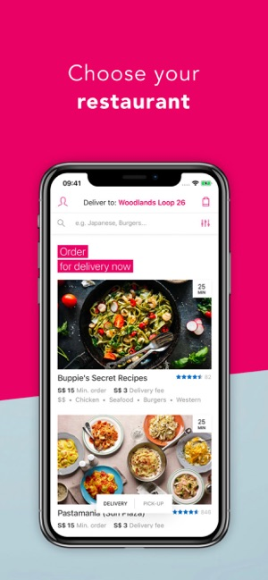

* **You can choose the best restaurants**
* **Order your favourite dish at home**
* **Get best Prices for your food**

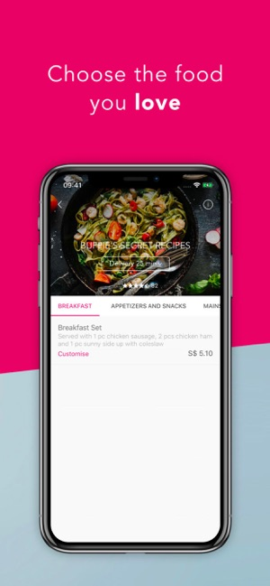



* **Get full description of your food**
* **Compare between multiple restaurants**

**Food at effective price**

* **Get best hygenic and Tasty food**

**delivered**

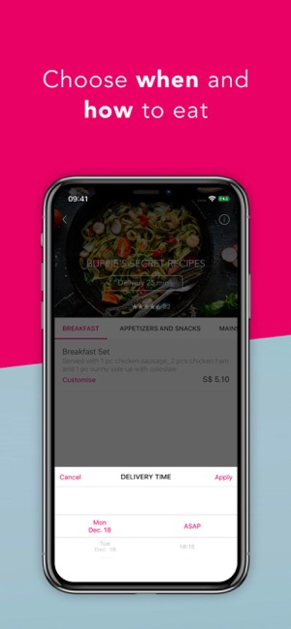

* **Schedule your food arrival**
* **Choose your locality and street**
* **Select the quantity of foods and beverages**

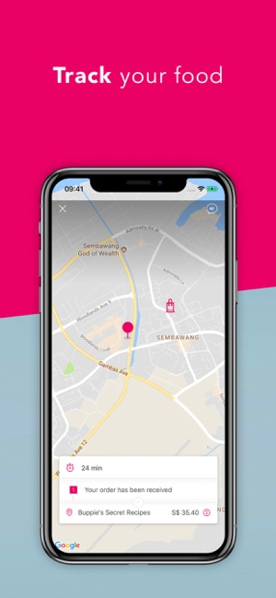

* **Select the food pickup and drop location**
* **Track your order with us**
* **Check real time updates with time**

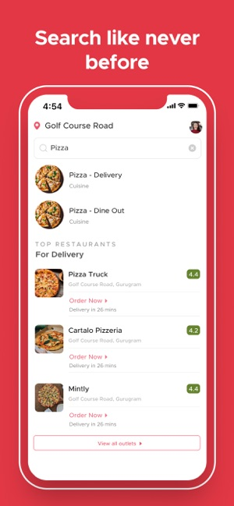

* **Give rating to your food**
* **Search for best foods**
* **Get the expected time of food arrival**

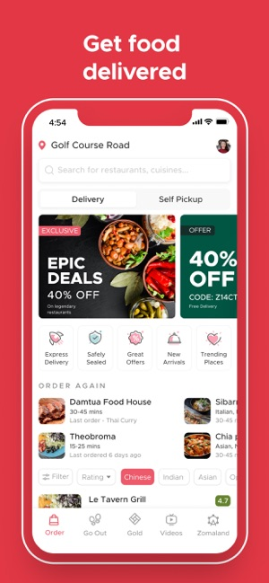

* **Get Details of your last order**

**By login and logout feature**

* **Switch to the various section of app**
* **Get the recipie tutorial videos online**

.



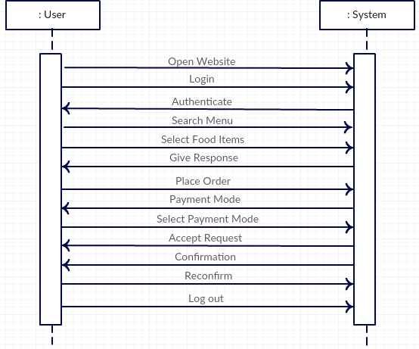



**Activity Diagram**

