**Smart Commute**



**About Project**

**Smart Commute™ - It’s the new way of commuting to office and back. Our moto is On Time! Safe Arrival!.**

**Our award winning solution will bring in much needed Convenience**

**, Safety and Reliability to your daily office commute experience.**

**If your company is subscribed to our services – you can enjoy charge**

**free rides daily (as per your company policy).**

**As an individual you can pay and enjoy our services within in the Pune (India) city.**

**We are soon expanding our services to other cities too.**

**With the Smart Commute™ app you can,**

**- Register yourself through a simple registration process**

**- View seat availability and reserve a seat on a shared cab**

**- View all the routes that Smart Commute™ serves**

**- Track your cab in real time and know the Estimated Time of Arrival (ETA)**

**- Cancel your bookings and give driver rating**

2



**Key features of the system**

▰Admin can add bus owner and user.

▰Bus owner can add travel, bus and route.

▰Bus owner can schedule bus to route.

▰User can search bus and book tickets for available buses.



**Proposal**

**Duration: 60 Hours**

### **Major and Minor Project Training**

### The Major/Minor Project work segment is exclusively planned to help students to work and implement new ideas. The segment can help you to learn correct strategy used by software companies in projects. For example

#### How to gather/collect requirement – Problem Identification

#### How to analyze requirement

#### Finding the feasible solution of problem

#### Study of tools needed to solve problems

#### What to model and how to model?

#### Learn Prototyping, Use-Case, Test-Case

#### Now how to dive into Finally Development(coding phase)

#### How to test a project?

#### Packaging and Distribution of software

#### How to implementation project in production environment(deployment)

### **Benefits of this course**

#### We can help you to implement your innovative idea

#### Adopting standard procedure of software development

#### Hands on experience, you have to develop your project under supervision of our expert developers.

#### Learn best practices of analysis, planning, coding and optimization

#### Learn database best practices

#### Learn UI best practices including UX(User Experience)

#### You will get chance to work with professional developers

#### On time project completion

#### We help you for interview and preparation

#### We also recruit students for our development-division

### **Major Benefits of this course**

#### **Live Project:** One of the most important aspects of project development training is to be sure of hands-on experience. The project development training comes with wide teaching experience in React Native. The live project offers an instructions to finish the assignment after each session.

#### **Jobs**: With a lot of job opportunities in Project development, once the course concludes, the placement team will assist students in creating a resume that can fetch the best jobs in the React Native market.

**Project Development Course**

Training is designed for students and professionals who want to be a React Native

Developer. This 60-hour course which will cover concepts like React Native.You will also learn various frameworks like Hibernate and spring.

### **Objectives of Project Development Course?**

Our Project Development Course is designed by industry experts to make you a Certified React Native Developer. Following are the objectives our course offers:

* In-depth knowledge of React Native
* Comprehensive knowledge of object-oriented programming through React Native using Classes, Objects and various React Native concepts like Abstract, Final etc and parse XML files using DOM and SAX
* The capability to implement arrays, functions and string handling techniques, JDBC to communicate with Database, SOA using web services
* The exposure to many real-life industry-based projects
* Projects which are diverse in nature covering banking, telecommunication, social media, insurance, and e-commerce domains
* Rigorous involvement of an SME throughout the React Native Training to learn industry standards and best practices

**What are the skills that you will be learning with our Project Development Course?**

Project Development Training will help you to become a React Native expert. It will hone your skills by offering you comprehensive knowledge of React Native Language, and the required hands-on experience for solving real-time industry-based React Native projects.

During the React Native course, you will be trained by our expert instructors to:

* Develop the code with various React Native App
* Implement arrays, functions and string handling techniques
* Understand object-oriented programming through React Native using Classes, Objects and various React Native conceptes.
* Implement multi-threading and exception handling
* Use parse XML files using DOM and SAX in React Native
* Write a code in JDBC to communicate with Database
* Develop web applications and JSP pages
* Interact with the database using hibernate framework
* Write code with spring framework components like Dependency Injection and Auto Wiring
* Implement SOA using web services

**What is the prerequisite knowledge for Project Development Course?**

* Actually React Native is a high level language. That is it contains OOP concepts and other high level things. You probably are thinking to do some software development and android development kind of stuffs. Here’s what I think that you should go ahead and learn it. If you’ve been through any programming language it’s plus for you, but even if you’ve not its fine to start with it.
* If you are thinking React Native for coding purpose I would suggest you first go through C ,C++ and Java. But If you are planning to build any software and all start React Native today.

## Admin can Manage User

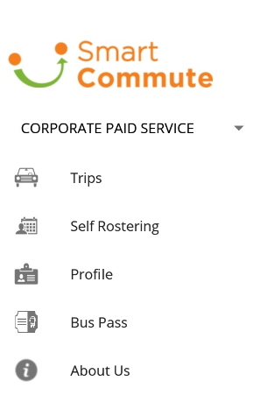

▰ List all user.

▰ Add bus owner and user.

▰ Edit user details.

▰ Remove users.



**Bus owner can manage**

Travel

Bus

Route

Schedule

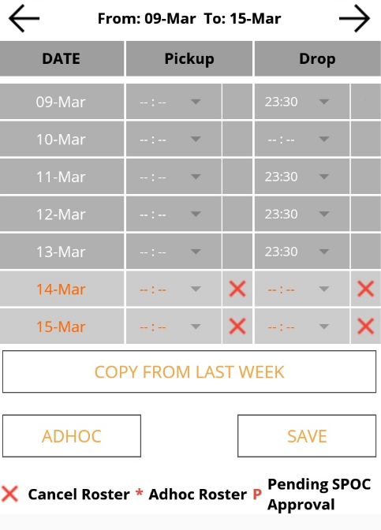

## Manage Travel

▰ List all travels.

▰ Add travel.

▰ Edit travel’s details.

▰ Remove travels.

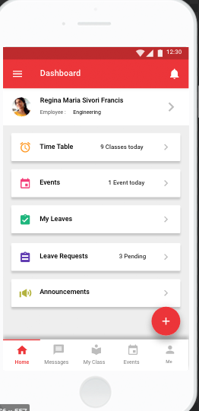

## Manage Bus

▰ List all buses.

▰ Add new buses.

▰ Edit bus details.

▰ Remove buses.

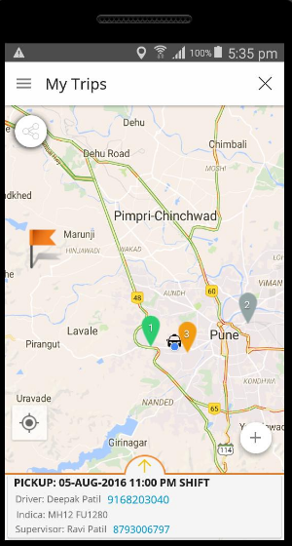

## Manage Route

▰ List all routes.

▰ Add routes.

▰ Edit route details.

▰ Remove routes.

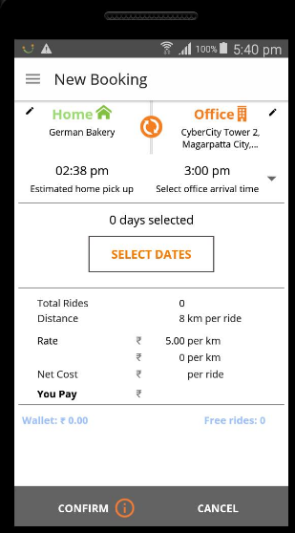

## Manage Schedule

▰ List all schedules.

▰ Add new schedules.

▰ Edit schedules details.

▰ Remove schedules.



**User can**

Search View Bus Book Seat



**Additional features of the system**

▰Admin and bus owner can view booking details.

▰Users can view booking history.

▰Users can cancel tickets.

▰All users can update their profile